Australian Capital Territory
Planning and Development (Draft Variation No 359) Consultation Notice 2018
Notifiable instrument NI2018—507
made under the
Planning and Development Act 2007, s 63 (Public consultation—notification) and s 64 (Public consultation—notice of interim effect etc)

1 Name of instrument
This instrument is the Planning and Development (Draft Variation No 359) Consultation Notice 2018.
2 Draft variation to the Territory plan
The planning and land authority (the Authority) has prepared the draft plan variation set out in the schedule and named Draft plan variation No 359 – Changes to the Tharwa Precinct Map and Code and removal of public land overlay
(Draft Variation).

Note: The Draft Variation is to vary the Territory Plan. In summary, the Draft Variation proposes to vary the Tharwa Precinct Map and Code and also remove the sport and recreation reserve public land overlay from the Territory Plan Map for Block 10 Section 6 Tharwa.
3 Documents available for public inspection
(1) The Authority gives notice that the Draft Variation is available for public inspection and purchase.
(2) Copies of the documents mentioned in section 3(1) are available for inspection and purchase at Access Canberra, Environment, Planning and Sustainable Development Directorate Shopfront, Ground Floor South, Dame Pattie Menzies House, 16 Challis Street, Dickson, Monday to Friday (except public holidays) between 8:30am and 4:30pm for the period commencing on the day this notice commences and ending on
24 October 2018 (the Consultation Period).
(3) Copies of the documents mentioned in section 3(1) are also available for inspection during the Consultation Period online at http://www.planning.act.gov.au/tools_resources/legislation_plans_registers/plans/territory_plan/draft_variations_to_the_territory_plan
4 Invitation to give written comments
(1) The Authority invites written comments about the Draft Variation during the Consultation Period. Comments should include reference to the Draft Variation and be addressed to the Territory Plan Section of the Environment, Planning and Sustainable Development Directorate (EPSDD). Please also provide your name and contact details to assist in the assessment of the comments provided and to enable the Authority to contact you in relation to your comments, if required.
(2) Written comments should be provided to the Authority by:
(a) email to terrplan@act.gov.au; or
(b) mail to Territory Plan Section, EPSDD, GPO Box 158, Canberra, ACT 2601; or
(c) hand delivery to Access Canberra, EPSDD Shopfront, Ground Floor South, Dame Pattie Menzies House, 16 Challis Street, Dickson.
5 Public inspection of written comments
(1) Copies of written comments about the Draft Variation given in response to the invitation in section 4, or otherwise, or received from the National Capital Authority will be available (unless exempted) for public inspection for a period of at least 15 working days starting 10 working days after the day the consultation period ends, at Access Canberra, EPSDD Shopfront, Ground Floor South, Dame Pattie Menzies House, 16 Challis Street, Dickson, Monday to Friday (except public holidays) between 8:30am and 4:30pm and may be published on the EPSDD website at www.planning.act.gov.au.
(2) You may apply under section 411 of the Planning and Development Act 2007 (the Act) for part of your consultation comments to be excluded from being made available to the public. A request for exclusion under this section must be in writing, clearly identifying what you are seeking to exclude and how the request satisfies the exclusion criteria. Please note that your name and contact details and other personal information will not be made public unless you request otherwise.
Note Personal information will be managed in accordance with the Information Privacy Act 2014 and the EPSDD Information Privacy Policy which are available through the EPSDD website.
6 Effect of the Draft Variation
Section 65 of the Act does not apply to the Draft Variation. This means that the Draft Variation does not have interim effect. The current Territory Plan continues to apply.
7 Obtaining further information
Further information about the Draft Variation can be obtained through email correspondence with the Territory Plan Section, EPSDD, at terrplan@act.gov.au, a reference to the Draft Variation should be included in any email.

Kathy Cusack
Delegate of the planning and land authority
6 September 2018

Planning and Development Act 2007

Draft
Variation to the
Territory Plan
No 359

Changes to the Tharwa Precinct Map and Code and removal of public land overlay

September 2018

Draft variation for public consultation prepared
under s60 of the Planning and Development Act 2007

This page is intentionally blank.

Contents

1. INTRODUCTION 4
1.1 Summary of the Proposal 4
1.2 Outline of the process 4
1.3 This document 6
1.4 Public Consultation 6
2. EXPLANATORY STATEMENT 8
2.1 Background 8
2.2 Site Description 8
2.3 Current Territory Plan Provisions 10
2.3.1 Current Territory Plan Map 11
2.4 Proposed Changes 12
2.4.1 Proposed Changes to the Territory Plan Map 12
2.4.2 Proposed Changes to Territory Plan Written Statement 13
2.5 Reason for the Proposed Draft Variation 13
2.6 Planning Context 14
2.6.1 National Capital Plan 14
2.6.2 ACT planning framework 14
2.7 Interim Effect 15
2.8 Consultation with Government Agencies 16
3. DRAFT VARIATION 19
3.1 Variation to the Territory Plan Map 19
3.2 Variation to the Tharwa Precinct Map and Code 20

APPENDICES
Appendix 1 Tharwa Precinct Map and Code

This page is intentionally blank.

- INTRODUCTION
  - Summary of the Proposal
Draft variation to the Territory Plan No 359 (DV359) incorporates the outcomes and recommendations of the Tharwa Village Plan into the Territory Plan. The draft variation proposes to:
- remove the sport and recreation reserve public land overlay from the Territory Plan Map for Block 10 Section 6 Tharwa as this is a historical mapping error and is not applicable to this block; and
- introduce built form controls into the Tharwa Precinct Map and Code including building and height controls, setbacks and plot ratio restrictions to reflect the existing or desired character of the village.
  - Outline of the process
The Commonwealth’s Australian Capital Territory (Planning and Land Management) Act 1988 allows for the Legislative Assembly to make laws to establish a Territory Planning Authority and for that Authority to prepare and administer a Territory Plan. The Planning and Development Act 2007 (the Act) establishes the planning and land authority as the Authority which prepares and administers the Territory Plan, including continually reviewing and proposing amendments as necessary. The functions of the planning and land authority are administered by the Environment, Planning and Sustainable Development Directorate (EPSDD).
The Territory Plan is comprised of a written statement and a map. The written statement contains a number of parts, namely governance; strategic directions; zones (including objectives and development tables and zone or centre development codes); precinct codes; general codes; overlays; definitions; structure plans, concept plans and development codes for future urban areas.
The Territory Plan Map graphically represents the applicable land use zones (under the categories of residential, commercial, industrial, community facility, urban parks and recreation, transport and services and non-urban), precincts and overlays. The zone, precinct and overlay requirements are detailed in the volumes of the Territory Plan.
Draft variations to the Territory Plan are prepared in accordance with the Act. Following the release of the draft variation under section 63 of the Act, submissions from the public are invited. At the conclusion of the consultation period the EPSDD submits a report on consultation and a recommended final variation to the Minister responsible for planning for approval. The Minister has the discretion to determine if referral to the Legislative Assembly standing committee responsible for planning is warranted prior to approval, depending on the nature and significance of the proposal. If the draft variation is referred to the committee by the Minister or otherwise, the Minister must consider the findings of the committee before deciding whether to approve the draft variation. If the Minister approves the variation, the variation and associated documents will be tabled in the Legislative Assembly. Unless disallowed by the Legislative Assembly within five sitting days, the variation commences on a day nominated by the Minister.

  - This document
This document contains the background information in relation to the proposed variation. It comprises the following parts
Part 1 This Introduction
Part 2 An Explanatory Statement, which gives reasons for the proposed variation and describes its effect
Part 3 The Draft Variation, which details the precise changes to the Territory Plan that are proposed
  - Public Consultation
Written comments about the draft variation are invited from the public by 24 October 2018.
Comments should include reference to the draft variation and be addressed to the Territory Plan Section. Please also provide your name and contact details to assist in the assessment of the comments provided, and to enable EPSDD to contact you in relation to your comments, if required. Your personal information will be managed in accordance with the Information Privacy Act 2014 and the EPSDD Information Privacy Policy, which is available for viewing on EPSDD’s website.
Comments can be:
- emailed to terrplan@act.gov.au
- mailed to Territory Plan Section, GPO Box 158, Canberra, ACT 2601
- delivered to the Access Canberra Customer Service Centre at 16 Challis Street, Dickson
Copies of written comments will be made available for public inspection for no less than 15 working days starting 10 working days after the closing date for comment. The comments will be available at the Access Canberra customer service centre in Dickson and may be published on EPSDD’s website. Please note that comments made available will include personal contact details, unless exempted as noted below.
A request may be made for parts of a submission to be excluded under section 411 or 412 of the Planning and Development Act 2007. A request for exclusion under these sections must be in writing, clearly identifying what parts of your submission you are seeking to exclude and how the request satisfies the exclusion criteria.

Further Information
The draft variation and background documents are available online at www.act.gov.au/draftvariations until the closing date for written comments.
Printed copies of the draft variation (this document) and background documents are available for inspection and purchase at the Access Canberra Customer Service Centre, 16 Challis Street, Dickson, Monday to Friday (except public holidays) between 8:30am and 4:30pm. Please call 6207 1923 to arrange a copy for purchase.

- EXPLANATORY STATEMENT
  - Background
The Tharwa Village Plan provides an overview and background analysis of the area including the cultural and planning history for the area. Feedback from key stakeholders and the community was sought through the process of developing the plan. As a result of the gathering and analysing of information and feedback, existing and potential opportunities for the village have been identified.
The Tharwa Village Plan recommends a vision and overarching spatial framework with planning principles and strategies that identify the outcomes and actions to be implemented. The plan recommends changes to planning policies, opportunities for some residential land release, public domain upgrades and further studies.
DV359 incorporates the key planning policy recommendations contained within the Tharwa Village Plan and Design Guidelines. The Tharwa Village Plan was developed to
- provide a long-term vision and planning framework to guide its enhancement and viability into the future, and
- define what is important about Tharwa and how its rural character and qualities can be kept while providing sustainable lifestyle opportunities to live and work in a unique rural village setting.
The Tharwa Village Plan and Design Guidelines are available at:
http://www.planning.act.gov.au/tools_resources/legislation_plans_registers/plans/master_plans/tharwa_village_plan
  - Site Description
Tharwa is located beside the Murrumbidgee River and at the foot of Mount Tennant. It is at the gateway to the Namadgi National Park and Tidbinbilla Nature Reserve.
The village is located approximately 9km from the Tuggeranong town centre and 34 km south of the city centre. The village is bounded by the Murrumbidgee River to the east, Sawyers Gully to the south and rural holdings to the west and north.
Tharwa is located within the Murrumbidgee River Corridor and is subject to the provisions of the plan of management. The village core is excluded from these provisions as it is zoned urban land.
Development along the Murrumbidgee River Corridor is managed in accordance with the general policies of the National Capital Plan, including the Special Requirements for Murrumbidgee River Corridor and Lanyon Bowl Area.
The Lanyon Bowl Area is an area of approximately 5000 hectares in the Murrumbidgee Valley, comprising the visual catchment of the Lanyon Homestead complex which is located approximately 2.3 kilometres north of Tharwa village. Special Requirements for the Lanyon Bowl Area specify that no development can be undertaken that would adversely affect the historic landscape and heritage values of the Lanyon Bowl Area.
Other policies and plans affecting development along the Corridor include the Murrumbidgee River Corridor Policy Plan, the requirements of the Territory Plan and the Murrumbidgee River Corridor Plan of Management 1998.
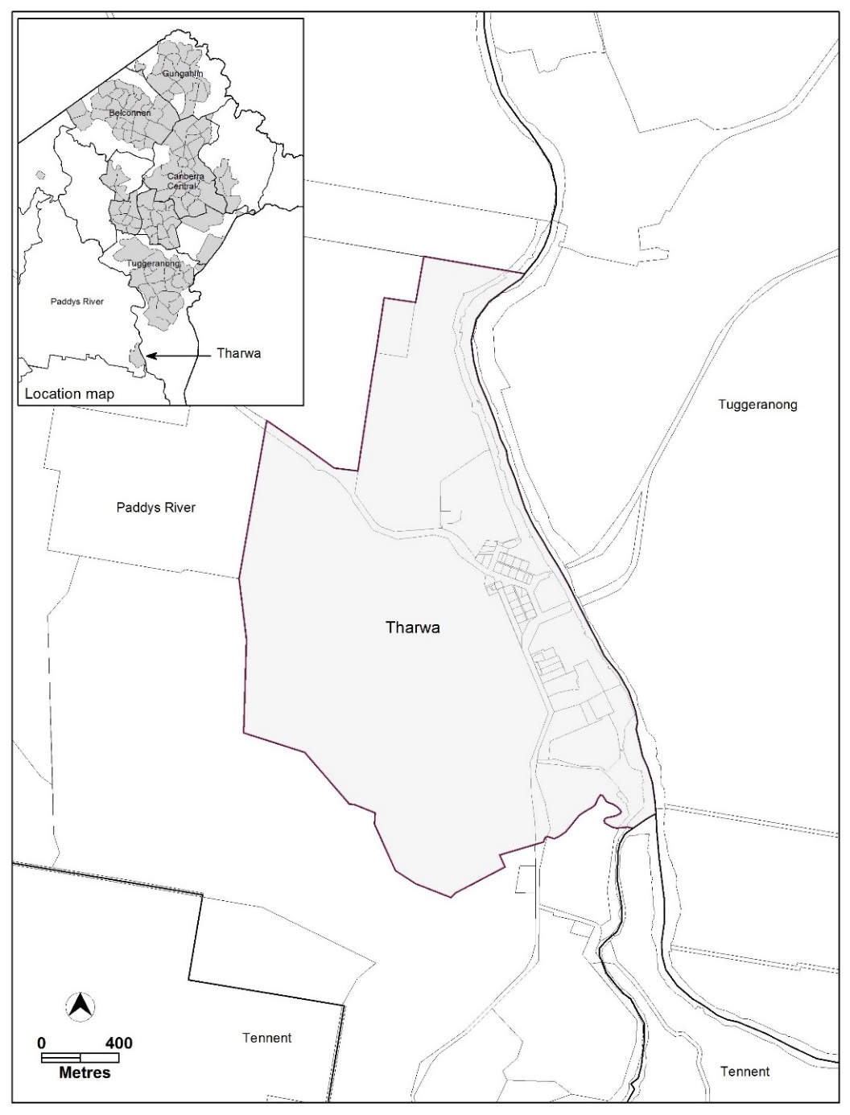
Figure 1 Location Plan - Tharwa
  - Current Territory Plan Provisions
The northern part of Tharwa village is predominately zoned residential RZ1 Suburban Zone with several CFZ Community Facility Zone (CFZ) blocks and the store which has a commercial CZ4 Local Centre zoning. The southern portion of the village containing a number of leased blocks, including Cuppacumbalong Homestead, is zoned non-urban NUZ4 River Corridor zone. The surrounding land to the north, east and south is also zoned NUZ4 River Corridor zone, while the land to the west is zoned non-urban NUZ3 Hills, Ridges and Buffer zone.
Development is generally subject to the Tharwa Precinct Map and Code, while the residential area is also subject to the Single Dwelling Housing Development Code, Multi Unit Housing Development Code and Residential Zones Development Code. The commercial site is subject to the Commercial Zones Development Code while the Community Facility zoned land is subject to the Community Facility Zone Development Code. The River Corridor and Hills, Ridges and Buffer zoned land is subject to the Non-Urban Zones Development Code. The general codes may also apply to development across all zones. These codes are all located in the Territory Plan and have statutory effect.
Selected areas are also subject to Territory Plan overlays, which normally identify where additional controls or measures are applicable. Block 10 Section 6 Tharwa currently has a public land overlay, identified as a sport and recreation reserve (shown as ‘Pi’ on the Territory Plan Map). The River Corridor land along the Murrumbidgee River also has a public land overlay, identified as a special purpose reserve (shown as ‘Pd’ on the Territory Plan Map. The entire subject area is also contained within the Lanyon Bowl Special Requirements area identified in the National Capital Plan.
A substantial number of sites within Tharwa are also either nominated or registered on the ACT Heritage Register, which places additional requirements on the sites identified with heritage value, separate from the Territory Plan requirements.

    - Current Territory Plan Map
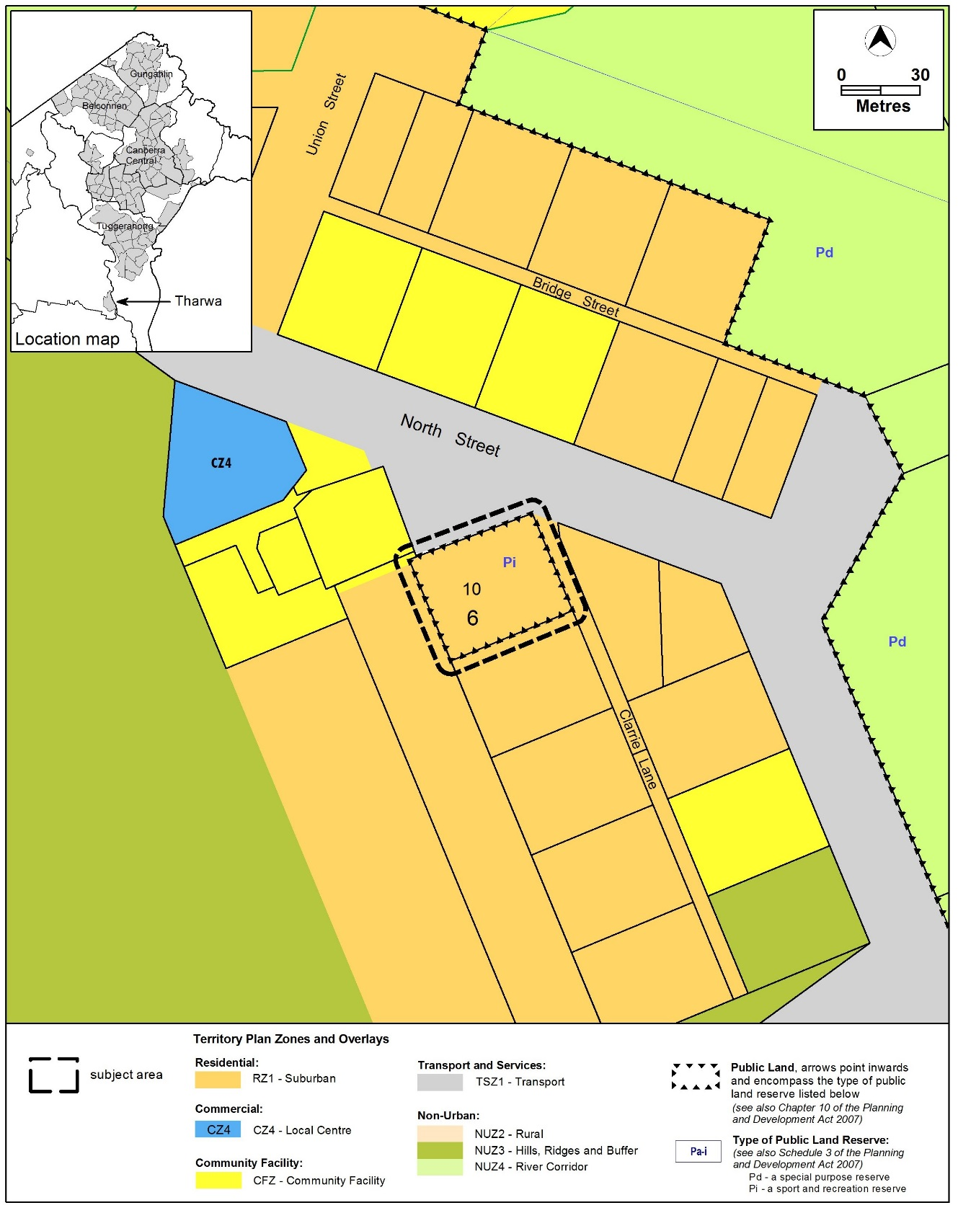

Figure 2 Current Territory Plan Map

  - Proposed Changes
    - Proposed Changes to the Territory Plan Map
The proposed changes to the Territory Plan map are indicated in Figure 3 and are detailed as follows:
- remove the Pi – a sport and recreation reserve – Public Land overlay from Block 10 Section 6 Tharwa
The draft variation map indicates the proposed zone boundaries as accurately as possible but may be subject to adjustments following detailed surveys.
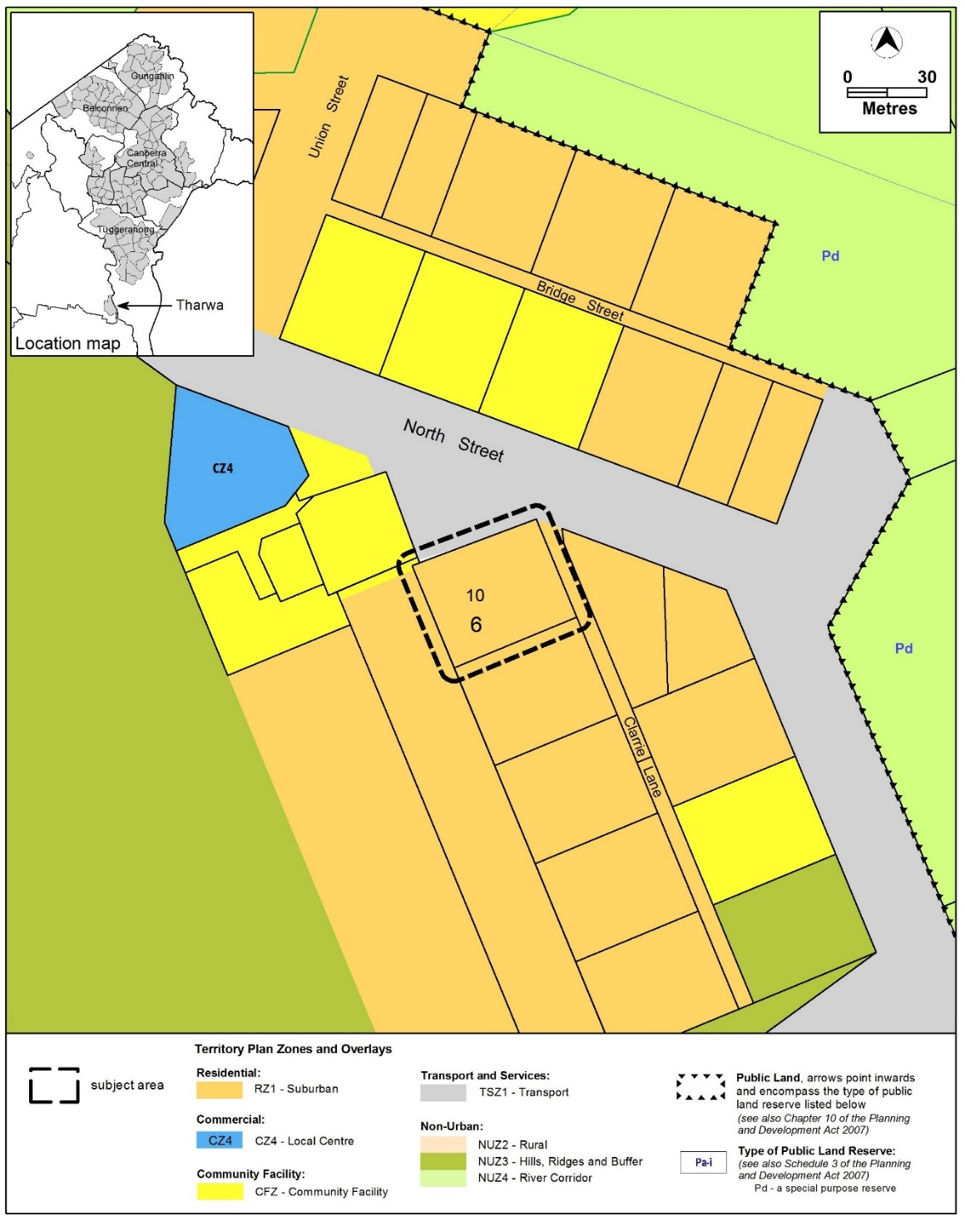
Figure 3 Proposed Territory Plan Map
    - Proposed Changes to Territory Plan Written Statement
It is proposed to amend the Tharwa Precinct Map and Code in accordance with the Tharwa Village Plan recommendations by nominating setbacks and other built form and infrastructure requirements for residential blocks.
The proposed Tharwa Precinct map and Code is at Appendix 1.
  - Reason for the Proposed Draft Variation
The reason for the draft variation is to incorporate the planning policy recommendations of the Tharwa Village Plan into the Territory Plan.

  - Planning Context
    - National Capital Plan
The Australian Capital Territory (Planning and Land Management) Act 1988 established the National Capital Authority (NCA) with two of its functions being to prepare and administer a National Capital Plan (NCP) and to keep the NCP under constant review and to propose amendments to it when necessary.
The NCP, which was published in the Commonwealth Gazette on 21 January 1990 is required to ensure that Canberra and the Territory are planned and developed in accordance with their national significance. The Planning and Land Management Act 1988 also required that the Territory Plan is not inconsistent with the NCP.
    - ACT planning framework
Territory Plan - Statement of Strategic Directions
The Statement of Strategic Directions sets out the principles for giving effect to the main objective of the Territory Plan as required by the Planning and Development Act 2007. This proposal is consistent with the following Territory Plan - Statement of Strategic Directions in terms of the principles for sustainable development and spatial planning and urban design principles:
1. Principles for Sustainable Development
General Principles
  - Planning processes and decisions will be focused on the combined achievement of economic vitality, community wellbeing, and environmental quality. Broad community involvement will be a key element in the pursuit of sustainable development, as will complementary regional strategies and agreements.
  - Matters of broader National Capital, metropolitan and regional significance will be carefully considered when formulating Territory Plan policies and when making decisions about development proposals and sequencing.
  - Economic, social and environmental objectives will be pursued in a balanced and integrated way, having regard to both short-term and long-term factors, such that present needs can be met without prejudicing the welfare of future generations, and without serious or irreversible loss of life-supporting natural resources or damage to the environment.

Environmental sustainability
  - The pattern of development is to reflect land capability constraints resulting from topography, soils, geotechnical factors, drainage, natural hazards, microclimate and the sensitivity of ecosystems. Particular attention will be given to the need to conserve soil, water and vegetation; maintain biological diversity; safeguard important ecosystems and ecological processes; and provide and protect wildlife corridors.
2. Spatial Planning and Urban Design Principles
Non-urban areas
2.11 Planning policies will protect the landscape and environmental qualities of the hills and ridges surrounding urban areas, the Murrumbidgee and other river corridors, the mountains and forests west of the Murrumbidgee River, and productive rural landscapes.
Urban design
2.16 Retention of Canberra’s unique landscape setting, including the integration of natural and cultural elements that create its ‘garden city’ and ‘bush capital’ qualities, will be accorded the highest priority. Special attention will be given to safeguarding visual amenity, protecting vegetation and other important features within the established urban landscape, and ensuring the high quality of environmental design in new developments or redevelopment.
  - Interim Effect
Section 65 of the Planning and Development Act 2007 does not apply in relation to the draft variation so it does not have interim effect. The current Territory Plan will continue to apply while the variation remains in draft form.

  - Consultation with Government Agencies
The EPSDD is required to, in preparing a draft variation under section 61(b) consult with each of the following in relation to the proposed draft variation:
- the National Capital Authority
- the Conservator of Flora and Fauna
- the Environment Protection Authority
- the Heritage Council
- the Land Custodian, if the draft variation would, if made, be likely to affect unleased land or leased public land – each custodian for the land likely to be affected
National Capital Authority
National Capital Authority provided the following comments on 21 June 2018:
“Tharwa Village is identified as being within Urban Areas under the National Capital Plan (the Plan) and is outside Designated Areas. The NCA does not consider the proposed changes to the Territory Plan map or Precinct Map and Code to be inconsistent with the Plan. The NCA therefore has no objection to DV359 proceeding.

The draft variation document states that development along the Murrumbidgee River Corridor is managed in accordance with various aspects of the National Capital Plan (the Plan). Please note that the Plan does not contain Special Requirements for either the Murrumbidgee River Corridor or Lanyon Bowl. Special Requirements for the River Corridor were removed from the Plan through Amendment 86 in 2016, although general principles and policies for the river corridor remain in place. Lanyon Bowl is subject to a general policy (refer section 3.1.5(d)) of the Plan.”

EPSDD response
Noted.
Conservator of Flora and Fauna
The Conservator of Flora and Fauna provided comments on 26 June 2018:
“In accordance with Section 61(b) of the Planning and Development Act 2007 I advise that I have examined Draft Variation No 359, changes to the Tharwa precinct map and code and removal of public land overlay.
There are no issues of concern to the Conservator of Flora and Fauna with the proposed amendment. The removal of the public land overlay from Block 10 Section 6 Tharwa can be supported as this overlay provision was for a sport and recreation reserve over a privately leased residential block which was obviously a mapping error. “
EPSDD response
The comments are noted.
Environment Protection Authority
The Environment Protection Authority provided comments on 22 June 2018:
“A contamination assessment must be undertaken of all blocks subject to a change of use by a suitably qualified environmental consultant in accordance with EPA endorsed guidelines. The findings of the assessment into the sites’ suitability from a contamination perspective for their proposed uses must be reviewed and endorsed by the EPA prior to any change of use.

EPSDD response
The comments are noted.
The five blocks that have been identified for residential land release are currently zoned residential RZ1 (suburban zone) and are not identified for rezoning as part of this draft variation, therefore the use of the land for residential purposes is already permitted.
ACT Heritage Council
The ACT Heritage Council provided advice on 22 June 2018:
“Review of DV359 has identified that the planning principles set out in [the] Plan are consistent with the continued conservation of registered heritage places within the Village including: Onyongs Grave site; Tharwa Bridge; St Edmunds Anglican Church; [Tharwa] School; Cuppacumbalong Homestead and the Cuppacumpalong (De Salis) Cemetery.
Within the draft TPV itself, Element 4.2 ‘Heritage significance’ should be amended to ‘Heritage character and significance’ – as it includes aspects of Tharwa such as the road pattern that do not meet Heritage Act 2004 heritage significance criteria; although they are considered to be part of the heritage character of the place by the Village Plan.
Separate to Territory Plan requirements, Heritage Act 2004 provisions will continue to apply to nominated and registered heritage places, and to all Aboriginal places and objects.
Where the Plan anticipates future change, such as in the release of five vacant Territory land blocks, Heritage Act 2004 provisions will guide the future heritage assessment and management process.
In this context, the Council has no objections to the amendments proposed by DV359.
EPSDD response
The comments are noted.
The Tharwa Precinct Code has been revised to incorporate the Council’s advice to refer to ‘Heritage character and significance.
Land Custodian - Transport Canberra and City Services (TCCS)
TCCS provided comments on 26 June 2018:
“TCCS comments on DV359 Tharwa Village Plan:
- Care and caution should be exercised in the construction of new buildings as the stormwater in the Village is mostly overland flows.
- The design of new buildings reflecting the existing rural village character with plot ratio not exceeding 25% of the block area is ok.
- Block 10/Section 11 is incorrectly reported in the Tharwa Village Plan, June 2018 report (Page 61), instead of Block 10/Section 6.”

EPSDD response
The comments are noted.
The Tharwa Village Plan has been amended to rectify the block and section description.

Land Custodian – ACT Property Group
ACT Property Group advised on 22 June 2018 that no comments were forthcoming at this time.
EPSDD response
The response is noted.

- DRAFT VARIATION
  - Variation to the Territory Plan Map
Substitute
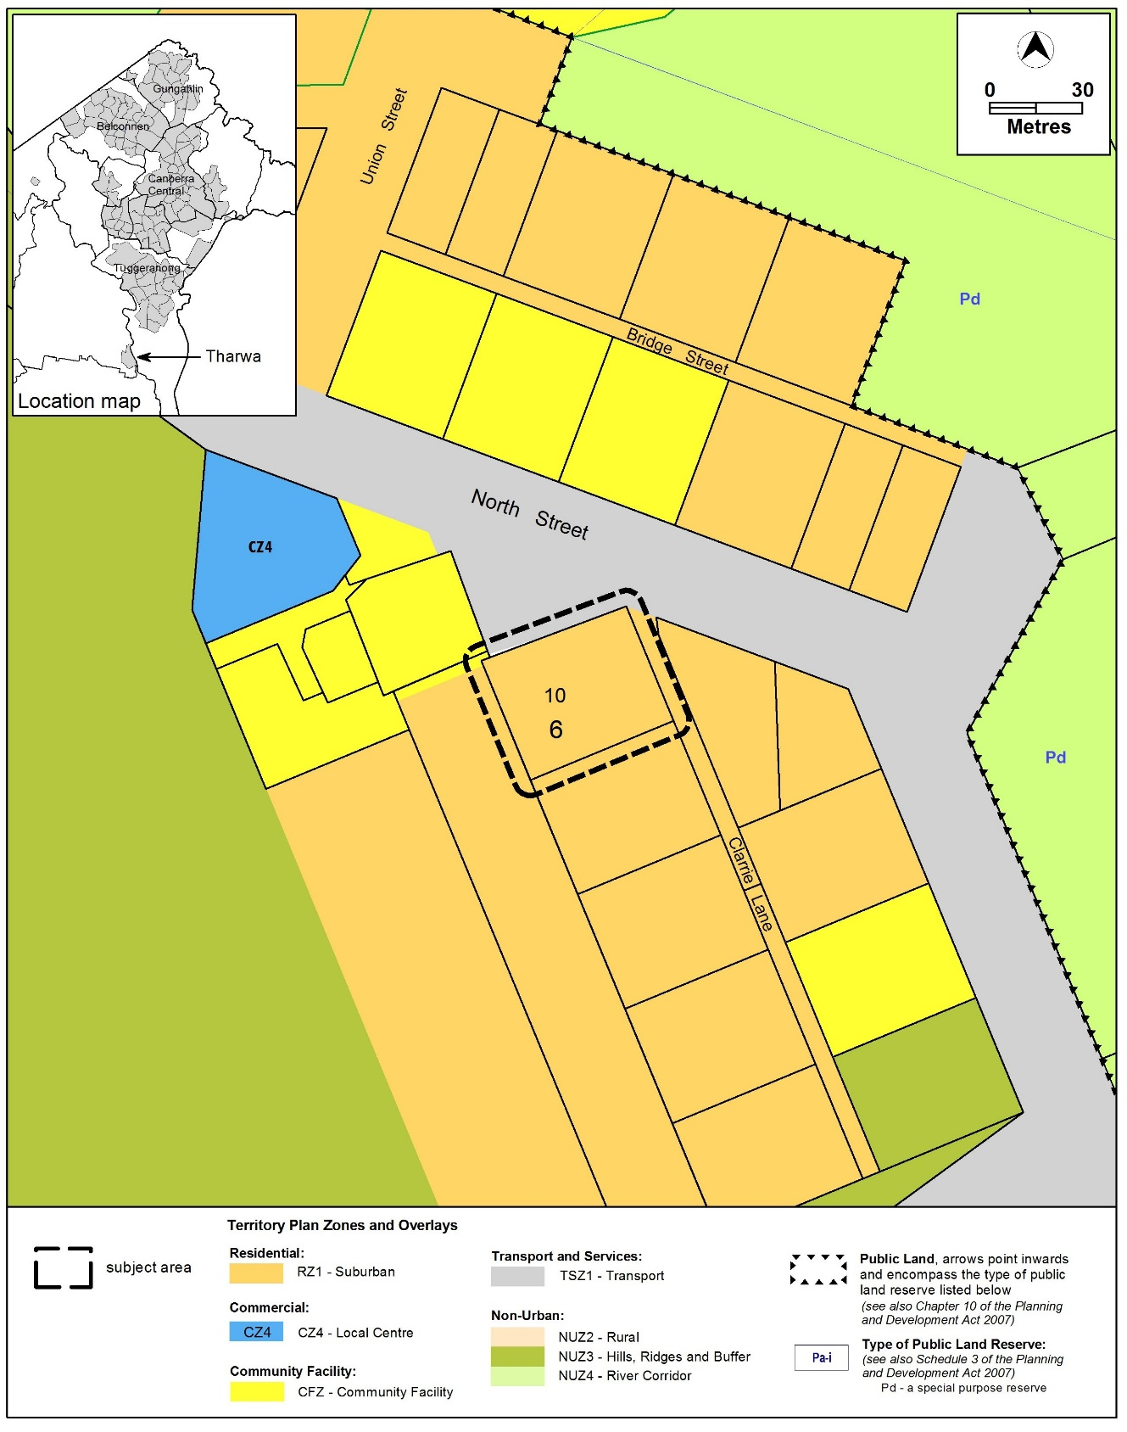
  - Variation to the Tharwa Precinct Map and Code
Substitute
Tharwa Precinct Map and Code at Appendix 1

Interpretation service
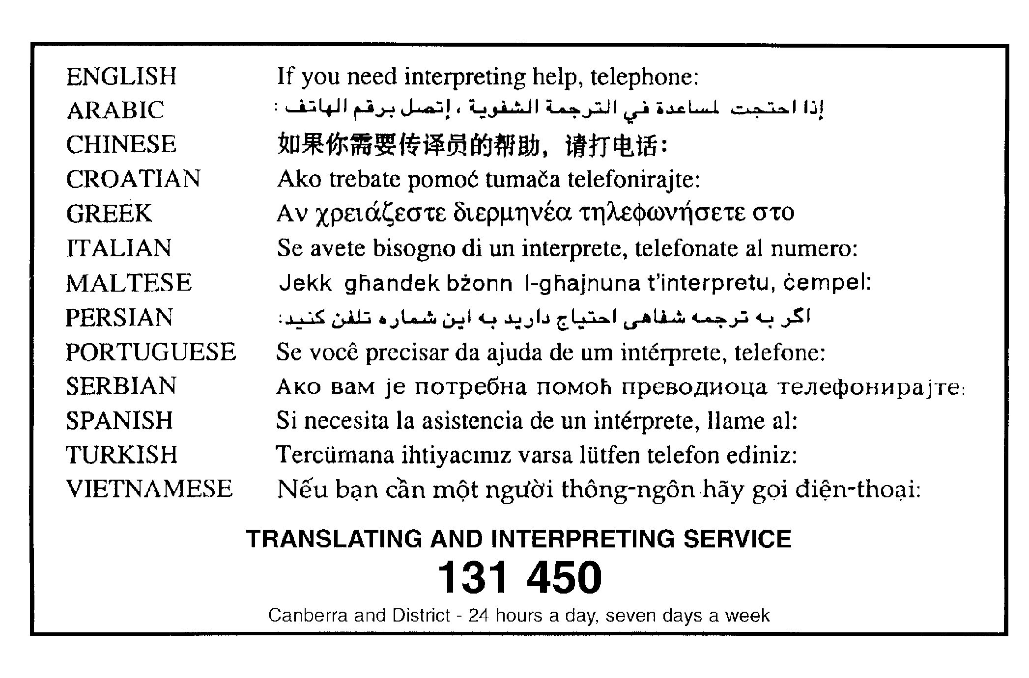

Appendix 1
Tharwa Precinct Map and Code

This page is intentionally blank.

Tharwa Precinct Map and Code

This page is intentionally blank.

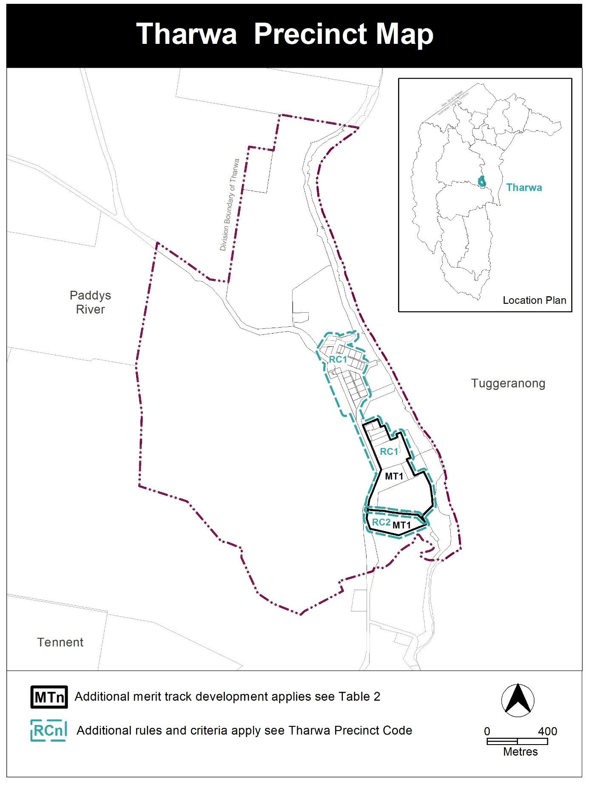

Assessment Tracks

The following tables identify the additional prohibited development and additional merit track development for blocks and parcels shown in the Tharwa Precinct Map (identified as PDn or MTn). Development that is exempt from requiring development approval, other prohibited development and the minimum assessment track applicable to each development proposal is set out in the relevant zone development table.

The following table constitutes part of the relevant zone development table.

Table 2 – Additional merit track development
Additional merit track development that may be approved subject to assessment
Suburb precinct map label | Zone | Development
MT1 | NUZ4 | group or organised camp  overnight camping area  tourist facility

Tharwa Precinct Code

Contents

Introduction 3
Additional rules and criteria 5
RC1 – Tharwa Village 5
Element 1: Use 5
1.1 Campsite and tourist facility 5
1.2 Restrictions on use 5
Element 2: Buildings and Structures 8
2.1 Bushfire protection 8
2.2 Building height 9
2.3 Setbacks 9
2.4 Verandahs 9
2.5 Roofs 9
2.6 Garages, carports and sheds 10
2.7 Driveways 10
2.8 Fences and courtyard walls 10
2.9 Rainwater tanks 11
Element 3: Environment 12
3.1 Topography 12
3.2 On-site wastewater treatment 12
3.3 Water sensitive urban design 12
Element 4: Heritage 12
4.1 Heritage character and significance 12
RC2 – River Corridor 13
Element 5: Use 13
5.1 Development 13
Element 6: Environment 13
6.1 On-site wastewater treatment 13
Figures
Figure 1 – Area 1 6
Figure 2 – Area 2 7
Figure 3 – Residential Bushfire protection 8

This page is intentionally blank

Introduction
Name
The name of this code is Tharwa Precinct Code.
Application
The code applies to the Division of Tharwa.
Purpose
This code provides additional planning, design and environmental controls for specific areas or blocks and may also contain references to provisions in other codes.
In conjunction with other relevant codes it will be used by the Authority to assess development applications and offer guidance to intending applicants in designing development proposals and preparing development applications.
Structure
This code contains additional rules and/or criteria for particular blocks or parcels identified as areas RCn on the precinct map, to be read in conjunction with the relevant development code. It may also contain sub-parts.
Each element has one or more rules and, unless the respective rule is mandatory, each rule has an associated criterion. Rules provide quantitative, or definitive, controls. By contrast, criteria are chiefly qualitative in nature.
In some instances rules are mandatory. Such rules are accompanied by the words “This is a mandatory requirement. There is no applicable criterion.” Non-compliance with a mandatory rule will result in the refusal of the development application. Conversely, the words “There is no applicable rule” is found where a criterion only is applicable.
Code hierarchy
Under the Planning and Development Act 2007, where more than one type of code applies to a development, the order of precedence if there is inconsistency of provisions between codes is: precinct code, development code and general code.
If more than one precinct code applies to the site, the most recent precinct code takes precedence to the extent of any inconsistency.
Definitions
Defined terms, references to legislation and other documents are italicised.
Definitions of terms used in this code are listed in part 13 of the Territory Plan or, for terms applicable only to this code, associated with the respective rule.
Acronyms
EPA ACT Environment Protection Authority
ESA ACT Emergency Services Agency
EPSDD Planning, Environment and Sustainable Development Directorate
NCA National Capital Authority
P&D Act Planning and Development Act 2007
TCCS Transport Canberra and City Services Directorate

Additional rules and criteria
This part applies to blocks and parcels identified in the Tharwa Precinct Map (RCn). It should be read in conjunction with the relevant zone development code and related codes.
Desired character
New buildings and associated utility buildings will reflect the existing rural village character and scale of traditional houses within the streetscape. New buildings will complement the historic features of Tharwa’s older houses, heritage places and community buildings.
RC1 – Tharwa Village
This part applies to blocks and parcels identified in area RC1 shown on the Tharwa Precinct Map.
- Use
Rules | Criteria
  - Campsite and tourist facility
There is no applicable rule. | This provision applies to ‘Area 2’ in Figure 2.  Development is of low intensity on large blocks permitting point source retention of storm water runoff and opportunities for large scale landscaping. Stormwater runoff should be containable on site.
There is no applicable rule. | This provision applies to ‘Area 2’ in Figure 2.  Development, including existing uses, incorporates measures to minimise impacts on the ecology and improve the visual character of the locality.
  - Restrictions on use
R3  Maximum plot ratio for residential buildings is 25%. | This is a mandatory requirement. There is no applicable criterion.
R4  This rule applies to ‘Area 1’ in Figure 1.  The maximum number of detached dwellings on each block within the residential zone is 1. | This is a mandatory requirement. There is no applicable criterion.
R5  This rule applies to ‘Area 1’ in Figure 1.  Subdivision or consolidation of blocks is not permitted. | This is a mandatory requirement. There is no applicable criterion.

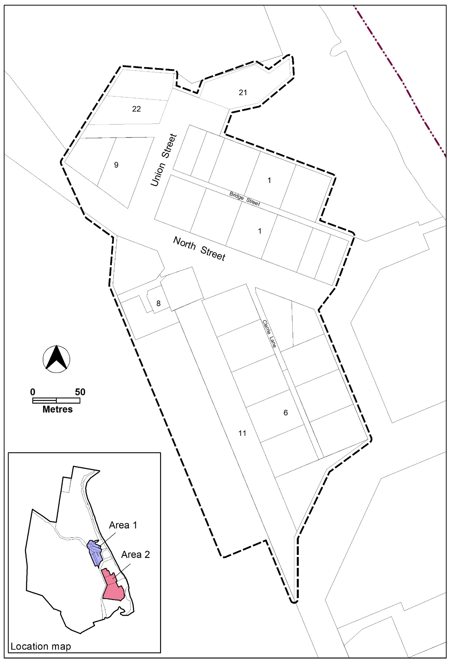
Figure 1 – Area 1

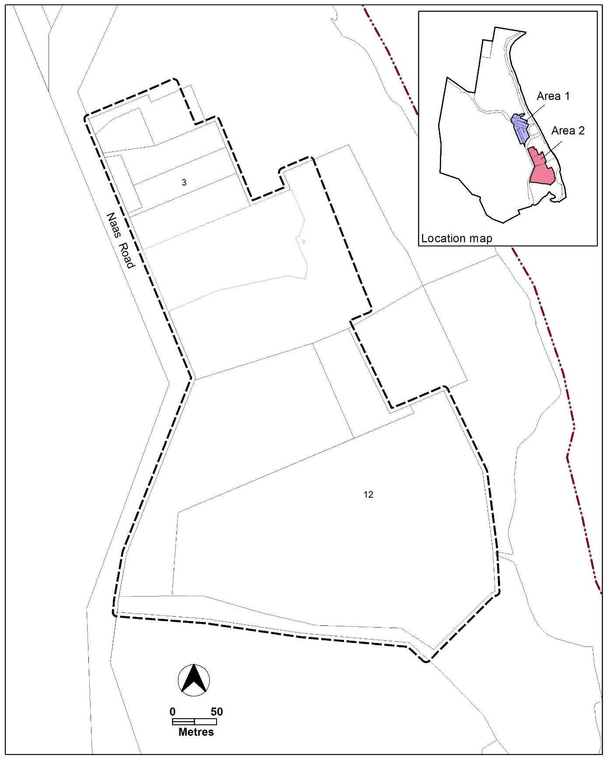
Figure 2 – Area 2

- Buildings and Structures
Rules | Criteria
  - Bushfire protection
R6  This rule applies to the blocks identified in Figure 3.  Development meets the required Bushfire Attack Level (BAL) ratings. | C6  The Bushfire Attack Level rating may be reviewed through an independent bushfire risk assessment undertaken by a suitably qualified person, and with written endorsement by the relevant government agency.

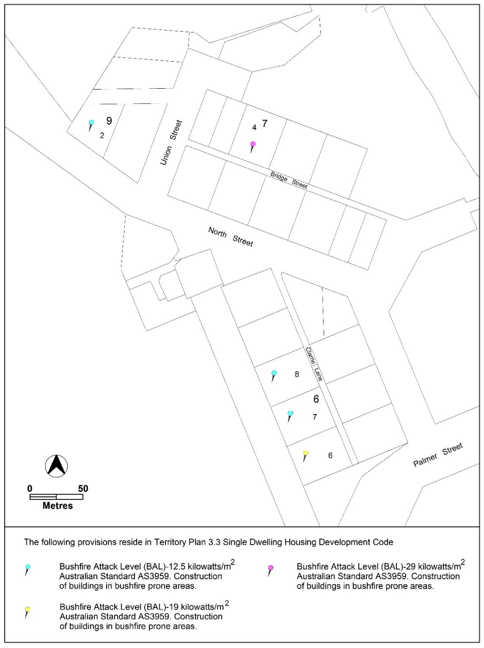
Figure 3 – Residential Bushfire protection

Rules | Criteria
  - Building height
R7  Buildings are a maximum of one storey. | This is a mandatory requirement. There is no applicable criterion.
R8  Maximum floor to roof apex height of buildings is 6m. | This is a mandatory requirement. There is no applicable criterion.
R9  Minimum floor to ceiling height for residential buildings is 2.7m at the front of the building. | C9  Roofs are a prominent feature of dwellings and recognisable as a separate element to the verandah.
  - Setbacks
R10  This rule applies to ‘Area 1’ in Figure 1.  Minimum front setback for buildings is 7m. | C10  This criterion applies to ‘Area 1’ in Figure 1.  Buildings in the village respect the predominant front setback and orientation of Tharwa’s traditional buildings, with the front façade facing the front boundary and oriented to the street.
R11  This rule applies to ‘Area 1’ in Figure 1.  Minimum side boundary setback 1 is 3m.  Minimum side boundary setback 2 is 4.5m. | C11  This criterion applies to ‘Area 1’ in Figure 1.  Buildings in the village respect the predominant side setbacks and orientation of Tharwa’s traditional buildings.
  - Verandahs
R12  All residential buildings incorporate a verandah for at least 50% of the width of the front façade. | This is a mandatory requirement. There is no applicable criterion.
R13  Minimum depth of verandahs is 2m. | This is a mandatory requirement. There is no applicable criterion.
  - Roofs
R14  Roofs are of a steep pitched gable and/or hip roof design (between 30º and 45º). | This is a mandatory requirement. There is no applicable criterion.
There is no applicable rule. | C15  Roofs are constructed using corrugated metal, or similar, in a neutral and non-reflective colour or traditional galvanised finish.
  - Garages, carports and sheds
R16  Garages and carports are permitted where they meet all of the following:  - Detached from the primary building and external walls are separated by a minimum of 1.5m  - Located a minimum distance of 5m behind the front facade of the primary building  - Do not impact on the scale of the primary building and the streetscape | C16  Attached garages may be considered where they are located behind the front façade of the primary building and screened from the street.  Basement garages may be considered only where the access is located at the rear of the primary building and screened from the street.
There is no applicable rule. | C17  Detached sheds may be considered where these are located in the rear zone, are single storey, and are secondary in scale to the primary building.
There is no applicable rule. | C18  Materials and finishes used in the construction of garages, carports and sheds are consistent with those used in the primary building.
  - Driveways
R19  Driveways are predominantly constructed of permeable surfaces such as gravel, concrete wheel strips or permeable paving in order to minimise sealed hardstand areas and minimise stormwater run-off.  Note: Concrete surfacing is permitted between the road edge and the front property boundary, including where required for footpath cross-overs in accordance with the requirements of the ACT Government agency responsible for approving offsite works. | C19  Concrete driveways may be considered in areas where site topography and overland stormwater run-off present a high likelihood of erosion.
  - Fences and courtyard walls
R20  Fences are permitted in the front zone where they meet all of the following:  - Maximum 1.2m height above ground level  - Made using transparent materials such as wire, wire mesh or open timber  - Privacy screening is provided through landscape planting  Note: non-transparent fences such as sheet metal are not permitted. | This is a mandatory requirement. There is no applicable criterion.
R21  Fences are permitted in the primary building zone and rear zone where they meet all of the following:  - Maximum 1.8m height above ground level  - Made of transparent materials such as wire, wire mesh and open timber  - Privacy screening is provided through landscape planting  Note: non-transparent fences such as sheet metal are not permitted. | This is a mandatory requirement. There is no applicable criterion.
R22  Courtyard walls are not permitted in the front zone or for use as boundary fencing. | This is a mandatory requirement. There is no applicable criterion.
There is no applicable rule. | C23  Courtyard walls may be considered for use as a landscape feature where they are located in the rear zone, or are integrated with the primary building.
  - Rainwater tanks
R24  This rule applies to all new dwellings.  The minimum size of rainwater tanks required to provide adequate water supply to dwellings is:  - For dwellings less than or equal to 150m² in size – 45,000l  - For dwellings greater than 150m² in size – 90,000l  Note: These are required minimum sizes only. Consideration should be given to ensure appropriate tank size to provide optimal capacity and meet bushfire safety requirements. | This is a mandatory requirement. There is no applicable criterion.
There is no applicable rule. | C25  Tanks are to be constructed using corrugated metal, or similar, in a neutral and non-reflective colour or traditional galvanised finish.
There is no applicable rule. | C26  Tanks are to be placed behind the primary building, or placed underground, or screened using landscape planting.
- Environment
Rules | Criteria
  - Topography
There is no applicable rule. | C27  The natural ground level of the site shall be retained to respect the natural topography and overland stormwater run-off.
There is no applicable rule. | C28  Where earthworks are required, battered soil slopes in conjunction with ground-cover plantings should be used to accommodate level changes in preference to engineered retaining walls. Where they are used, retaining walls should be a maximum of 1m in height and incorporated with the primary building to minimise visual impacts.
  - On-site wastewater treatment
R29  Any new development or re-development of on-site wastewater treatment systems located within 300m of a waterway will be required to be referred to the ACT EPA for assessment. | This is a mandatory requirement. There is no applicable criterion.
  - Water sensitive urban design
There is no applicable rule. | C30  This provision applies to ‘area 1’ in Figure 1.  Development encourages urban design that reduces water consumption and increases recycling of wastewater.
- Heritage
Rules | Criteria
  - Heritage character and significance
There is no applicable rule. | C31  The existing road pattern, cottages and other items of heritage significance are conserved, consistent with relevant heritage requirements.
RC2 – River Corridor
This part applies to blocks and parcels identified in area RC3 shown on the Tharwa Precinct Map.
- Use
Rules | Criteria
  - Development
There is no applicable rule. | C32  Development is of low intensity on large blocks permitting point source retention of storm water runoff and opportunities for large scale landscaping. Stormwater runoff should be containable on site.
There is no applicable rule. | C33  Development, including existing uses, incorporates measures to minimise impacts on the ecology and improve the visual character of the locality.

- Environment
Rules | Criteria
  - On-site wastewater treatment
R34  Any new development or re-development of on-site wastewater treatment systems located within 300m of a waterway will be required to be referred to the ACT EPA for assessment. | This is a mandatory requirement. There is no applicable criterion.

