Australian Capital Territory
Heritage (Decision about Provisional Registration of the ACT Family and Juvenile Court Building, City) Notice 2018
Notifiable Instrument NI2018–530
made under the
Heritage Act 2004, s32 (Decision about provisional registration) and s34 (Notice of decision about provisional registration)

1 Name of instrument
This instrument is the Heritage (Decision about Provisional Registration of the ACT Family and Juvenile Court Building, City) Notice 2018.
2 Decision about provisional registration
On 20 September 2018, the ACT Heritage Council (the Heritage Council) decided not to provisionally register the ACT Family and Juvenile Court Building, Block 4, Section 28, City (the Place).
3 Description of the Place
The description of the Place is in the schedule.
4 Reasons for the decision
The Heritage Council is not satisfied on reasonable grounds that the Place is likely to have heritage significance as defined by section 10 of the Heritage Act 2004. A detailed statement of reasons, including an assessment against the heritage significance criteria, is provided in the schedule.
5 Date decision takes effect
The decision not to provisionally register the Place takes effect on 21 September 2018 (being the day after the Heritage Council made its decision in writing as set out in the schedule).

Jennifer O’Connell (as delegate for)
ACT Heritage Council
20 September 2018

Schedule
(See sections 3 and 4)

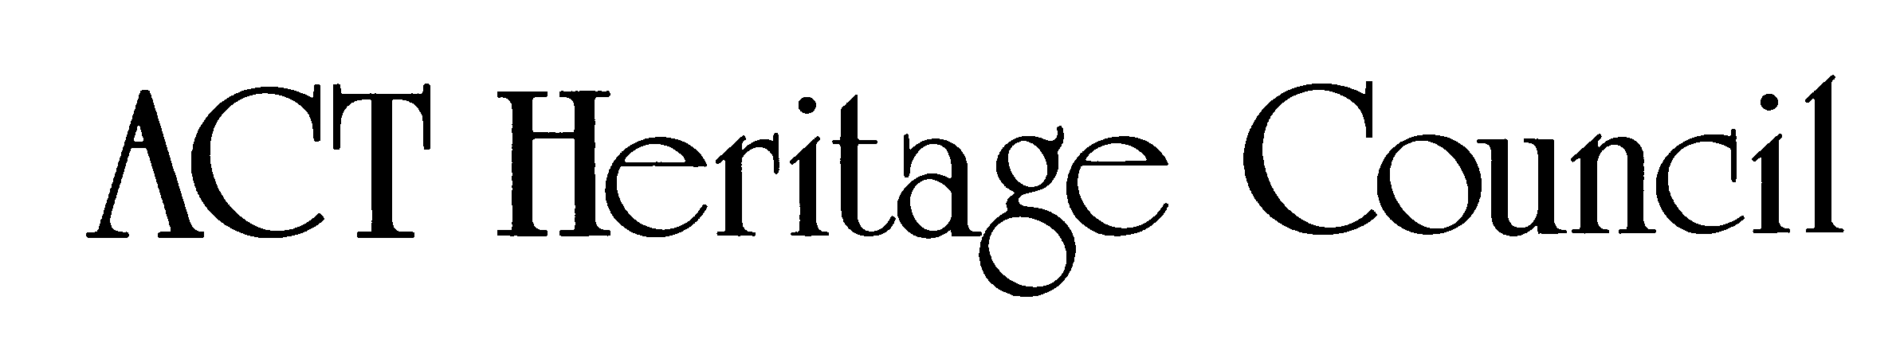

STATEMENT OF REASONS

DECISION NOT TO PROVISIONALLY REGISTER
ACT FAMILY AND JUVENILE COURT BUILDING
(BLOCK 4 SECTION 28 CITY)
IN THE ACT HERITAGE REGISTER

Assessment
The Council has decided not to enter the ACT Family and Juvenile Court, City, in the ACT Heritage Register because:

- the Commonwealth Government holds freehold interest in Block 4 Section 28 City ACT;
- under the Australian Capital Territory Self-Government Act 1988 (Cth), the Crown in right of the Commonwealth is not bound by a Territory Act unless the regulations provide otherwise;
- the regulations do not provide that the Heritage Act 2004 binds the Crown in right of the Commonwealth;
- current as of 2018, the place is tenanted by the Family Court of Australia, the Federal Court of Australia, and the Federal Magistrates Court, and is in use for an intrinsically Commonwealth purpose;
- in consideration of the information outlined above at items (a) to (d), the operation of the Heritage Act 2004 has limited effect.

The Council has therefore decided not to enter the place in the ACT Heritage Register.

The Council has not made an assessment of the place against the heritage significance criteria and therefore has not formed a view on the heritage values of the place.

