Australian Capital Territory
Heritage (Decision about Registration of Red Hill Historic Plantings, Red Hill) Notice 2018
Notifiable instrument NI2018—642
made under the
Heritage Act 2004, s 40 (Decision about registration)

1 Name of instrument
This instrument is the Heritage (Decision about Registration of Red Hill Historic Plantings, Red Hill) Notice 2018.
2 Decision about registration
On 15 November 2018, the ACT Heritage Council (the Heritage Council) decided to register Red Hill Historic Plantings, Red Hill (the Place).
3 Registration details of the Place
The registration details of the Place are in the schedule.
4 Reasons for the decision
The Heritage Council is satisfied on reasonable grounds that the Place has heritage significance as it meets one or more of the heritage significance criteria in section 10 of the Heritage Act 2004. A detailed statement of reasons including an assessment against the heritage significance criteria is provided in the schedule.
5 Date registration takes effect
The registration of the Place takes effect on the day after this notice is notified.
6 Revocation
The Heritage (Decision about Provisional Registration of Red Hill Historic Plantings, Red Hill) Notice 2018 (No 2) (NI2018—357) is revoked.
Fiona Moore
Secretary (as delegate for)
ACT Heritage Council
15 November 2018

Schedule
See sections 3 and 4

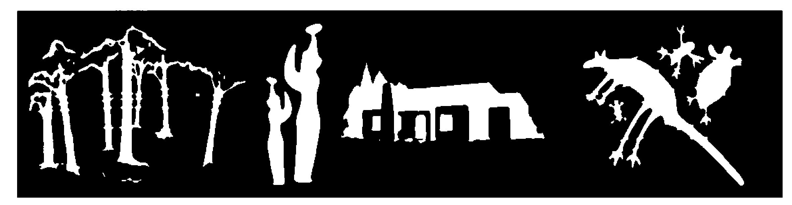
AUSTRALIAN CAPITAL TERRITORY
HERITAGE REGISTER
(Registration)

For the purposes of s. 40 of the Heritage Act 2004, an entry to the heritage register has been prepared by the
ACT Heritage Council for the following place:

Red Hill Historic Plantings

Block 2 and Block 15 Section 57, Red Hill
DATE OF REGISTRATION
15 November 2018 Notifiable Instrument: 2018–
Copies of the Register Entry are available for inspection at ACT Heritage. For further information please contact:

The Secretary

ACT Heritage Council

GPO Box 158

CANBERRA ACT 2601

This statement refers to the location of the place as required in s. 12 (b) of the Heritage Act 2004.
LOCATION OF THE PLACE

Red Hill Historic Plantings, Block 2 and Block 15, Section 57, Red Hill

This statement refers to the description of the Red Hill Historic Plantings as required in s.12(c) of the

Heritage Act 2004. The attributes described in this section form part of the heritage significance of the place. For the purposes of s. 12(c) of the Heritage Act 2004, the boundary of the place is at Image 1.
DESCRIPTION OF THE PLACE

Red Hill Historic Plantings, consist of the following attributes:
- the surviving historic red flowering plants located on the summit of Red Hill, including;
- Callistemon citrinus (723 plants); Grevillea rosmarinifolia (1700 plants); and Swainsona galegifolia (>6);
- noting the need for continued horticultural care and maintenance of the plantings (such as replacement of plantings and pruning); and;
- the surviving Callistemon citrinus historic planting rows.

This statement refers to the heritage significance of the Red Hill Historic Plantings as required in s.12(d) of the Heritage Act 2004.
STATEMENT OF HERITAGE SIGNIFICANCE
The Red Hill historic plantings of various red flowering plants are evidence of the Griffins’ vision to ‘paint’ the once denuded hills of Canberra using different vegetation at different locations. The plantings provide a direct, living connection to the Griffins’ vision expressed over a century ago which was an innovative, unique approach to revegetation and is one of the earliest known plantings in the ACT for landscape restoration [criteria (a), (b), (h)].
CONSERVATION OBJECTIVE

The guiding conservation objective is that Red Hill Historic Plantings shall be conserved and appropriately managed in a manner respecting its heritage significance.

The ACT Heritage Council may adopt heritage guidelines applicable to the place under s25 of the Heritage Act 2004.

For further information on guidelines applicable to the place, or for advice on proposed works or development, please contact ACT Heritage on 13 22 81.
REASON FOR REGISTRATION

The Council has assessed the Red Hill Historic Plantings, Red Hill against the heritage significance criteria and is satisfied that the place has heritage significance when assessed against criteria [(a), (b), and (h)] under s.10 of the Heritage Act 2004.

ASSESSMENT AGAINST THE HERITAGE SIGNIFICANCE CRITERIA

The Council’s assessment against the criteria specified in s.10 of the Heritage Act 2004 is as follows.

In assessing the heritage significance of Red Hill Historic Plantings, Red Hill, the Council considered:
- the original nomination and documentary evidence supplied by the nominator;
- the Council’s Heritage Assessment Policy (March 2018);
- information provided by a site inspection on 11 May 2018 by ACT Heritage;
- the report by ACT Heritage titled, Background Information Red Hill Historic Plantings, November 2018, containing photographs and information on history, description, condition and integrity; and
- Comments received during the public consultation period under s.37 of the Act:
- 17 submissions in total were received during the public consultation period all of which supported registration; and
- Three of the submissions suggested extending the registration boundary to allow for management and protection or to allow the plantings to spread. In order for the Council to thoroughly assess these submissions, the Minister issued a direction for the Council to further consider these issues and extended the provisional registration period for three months The Council considered an expanded boundary, but decided that the current extent was most appropriate because for heritage purposes the site boundary should reflect the extent of the original historic planting rows and that outside of this the management of the Red Hill Nature Reserve is best vested in ACT Parks and Conservation.

Pursuant to s.10 of the Heritage Act 2004, a place or object has heritage significance if it satisfies one or more of the following criteria. Future research may alter the findings of this assessment.
- importance to the course or pattern of the ACT’s cultural or natural history;
The Council has assessed Red Hill Historic Plantings against criterion (a) and is satisfied that the Red Hill Historic Plantings meet this criterion.
The Red Hill Historic Plantings are a unique response to environmental, conservation and city design challenges, resulting in the innovative plantings realised by the then Officer in Charge of Afforestation, Thomas Charles George Weston. Weston used exceptional propagation and planting approaches that have resulted in the survival of these plantings for over a century. The plantings are amongst the earliest plantings in Australia that were undertaken for the reason of landscape restoration. An innovative approach to environmental degradation that became mainstream activity fifty years later.
They are also the last vestiges of Walter Burley Griffin’s audacious scheme to ‘paint’ the hills surrounding his planned city by revegetating the denuded hills with various coloured flowering plants. This was a part of his and Marion Mahoney Griffin’s wider plan for the ACT region.
- has uncommon, rare or endangered aspects of the ACT’s cultural or natural history;
The Council has assessed Red Hill Historic Plantings against criterion (b) and is satisfied that the Red Hill Historic Plantings meet this criterion.
The Red Hill Historic Plantings are considered uncommon and endangered aspects of the ACT’s cultural history. The extraordinary vision expressed by the Griffins to paint Canberra’s hills with coloured flowering plants was a unique and no longer practised arboricultural process, which reflected both a desire to revegetate the denuded hills, and their desire that Canberra should ‘unite nature and culture’.
This partially completed vision is most readily observed and most easily accessible on Red Hill, especially when the Callistemon citrinus, Grevillea rosmarinifolia and Swainsona galegifolia plants exhibit their red flowers. The original plantings of Callistemon citrinus can still be observed in rows on the summit of Red Hill. Whilst other partial plantings were attempted on Mount Pleasant and Mount Mugga Mugga, they survive as inferior examples in both size and distribution.
The unique plantings by Weston over a century ago, in response to the vision of the Griffins, and the survival and comparative intactness of these historic plantings make them a rare, living example of historical horticultural planting practices and the only example where this vision was realised in Australia.
- potential to yield important information that will contribute to an understanding of the ACT’s cultural or natural history;
The Council has assessed Red Hill Historic Plantings against criterion (c) and is satisfied that the Red Hill Historic Plantings do not meet this criterion.
As the partial realisation of a much broader, grand vision that never eventuated there is little potential for the Red Hill Historic Plantings to yield important information that will contribute to an understanding of the ACT’s cultural history. The Council notes that important information on the landscape design of the plantings is better represented by the planning documents and design of the Griffins’ vision for these plantings in the ACT.
- importance in demonstrating the principal characteristics of a class of cultural or natural places or objects;
The Council has assessed Red Hill Historic Plantings against criterion (d) and is satisfied that the Red Hill Historic Plantings do not meet this criterion.
The Red Hill Historic Plantings are notable as the most intact surviving example of the Griffins’ unique response to the environmental, conservation and city design challenges that the ACT presented at that time.
They demonstrate a living representation of the Griffins’ plan to ‘paint’ the denuded Canberra Hills. There were minor plantings at Mount Pleasant and Mount Mugga Mugga, but the Red Hill plantings are the only site where this vision was realised. It is also the only place at which the original planting rows can still be seen today. In this way they are important as a place that demonstrates the principle characteristics of the painted hills schema.
As a unique response to the revegetation movement that was beginning to gain acceptance in Australia at the time, the plantings are a significant early example of landscape architecture undertaken in the ACT for the purpose of landscape restoration. However, as a revegetation concept, the uncommon practice of colour coding planting for revegetation in itself is too narrow a definition to meet the current standards of diversity in revegetation planting. And does not therefore meet the principle characteristics of class as required by this criterion.

- importance in exhibiting particular aesthetic characteristics valued by the ACT community or a cultural group in the ACT;
The Council has assessed Red Hill Historic Plantings against criterion (e) and is satisfied that the Red Hill Historic Plantings do not meet this criterion.
The historic plantings on Red Hill provide a living example of the Griffins’ outstanding landscape design, which embodied aesthetic principles in addition to horticultural and arboricultural principles.
Whilst these plantings are valued by members of special interest groups, including the Red Hill Regenerators, Walter Burley Griffin Society, Australian Garden History Society, Institute of Landscape Architects and local residents, there is insufficient evidence before Council to suggest that this site is valued by the ACT community as a whole. Further, despite its prominent position, the Red Hill Historic Plantings are not widely known by the ACT community.
The Council notes that the ‘ACT community’ encompasses the broad community of the ACT, across the full geographical context, and a broad spectrum of society; while ‘a cultural group’ has a narrower focus, taken to be a ‘group of people within a society with a shared ethnic or cultural background’ or ‘a group of people connected through the same way of living, which has been transmitted from one generation to another’. The definition specifically precludes professional organisations or special interest groups.
- importance in demonstrating a high degree of creative or technical achievement for a particular period;
The Council has assessed Red Hill Historic Plantings against criterion (f) and is satisfied that the Red Hill Historic Plantings do not meet this criterion.
The Red Hill historic plantings demonstrate a degree of horticultural design which was inspired by the Griffins’ grand vision to ‘paint’ the hills of Canberra each in a single colour of flowering plants. By responding to the extensive clearing which had degraded the hills around Canberra, the plantings represent an innovative solution to revegetation that was in contrast to established practices.
Weston’s experience and horticultural knowledge led to propagation and planting approaches, including experimental seedling trials to test for the suitability of plantings on the summit of Red Hill, which were relatively uncommon for their time and certainly uncommon with regard to the use of native species.
The Griffins’ incorporation of landforms and geological features into their planning design created something unique to the ACT region. The use of red flowering plants on Red Hill was in response to the geological make-up of Red Hill and the red coloured formations of weathered Hornfels which make up the hill.
Yet, despite the originality and innovation associated with this concept, the plan itself never fully eventuated. As an incomplete achievement it does not therefore reach the high threshold required for classification under this criterion.

- has a strong or special association with the ACT community, or a cultural group in the ACT for social, cultural or spiritual reasons;
The Council has assessed Red Hill Historic Plantings against criterion (g) and is satisfied that the Red Hill Historic Plantings do not meet this criterion.
While the Red Hill Historic Plantings may be held in high regard and be visited by community groups, such as the Red Hill Regenerators, there is no evidence that the place has a strong or special association with the ACT community as a whole, or a cultural group in the ACT for social, cultural or spiritual reasons.
The Council notes that the ‘ACT community’ encompasses the broad community of the ACT, across the full geographical context, and a broad spectrum of society; while ‘a cultural group’ has a narrower focus, taken to be a ‘group of people within a society with a shared ethnic or cultural background’ or ‘a group of people connected through the same way of living, which has been transmitted from one generation to another’. The definition specifically precludes professional organisations or special interest groups.
- has a special association with the life or work of a person, or people, important to the history of the ACT.
The Council has assessed Red Hill Historic Plantings against criterion (h) and is satisfied that the Red Hill Historic Plantings meet this criterion.
The Red Hill historic plantings have a strong association with Walter Burley Griffin and Marion Mahony Griffin in relation to their grand visionary design to make Canberra an important example of city garden planning principles. The Griffin legacy resulted in the inclusion of the ACT’s integral hills and landscape elements in the region’s planning principles. Further, they exemplify the planning intentions of the ACT from the earliest days of Canberra’s inception.
Weston, Officer in Charge of Afforestation, was instrumental in the development of this vision on Red Hill. He was responsible for the acquisition and cultivation of seeds and was directly involved in establishing the plantings on Red Hill. Not only did Weston take instruction from the Griffins, but he used his extensive horticultural knowledge and experience to foster an experimental phase of testing plant suitability.
Clear evidence can be found in communications between Griffin and Weston accounting for the documentation of the location and flower colour of proposed plantings. The Yarralumla Nursery plant cards and Weston’s planting records (of the surviving historic red flowering plantings on Red Hill of Callistemon citrinus, Grevillea rosmarinifolia and Swainsona galegifolia are directly and strongly associated with the brief tenure of the Griffins in establishing significant urban and landscape design principles in Canberra over a century ago.
The Griffins’ personal reverence for nature and appreciation for conservation informed their planning of Canberra as a city designed to suit the landscape. This is evidenced by Marion Mahony Griffin’s compilation of her own botanical notebooks on Australian native flora. Their bold vision to ‘paint the hills’ of Canberra each in a single colour of flowering plants was both innovative urban and landscape planning and signalled the beginning of the ACT’s foray into nature conservation.

SITE PLAN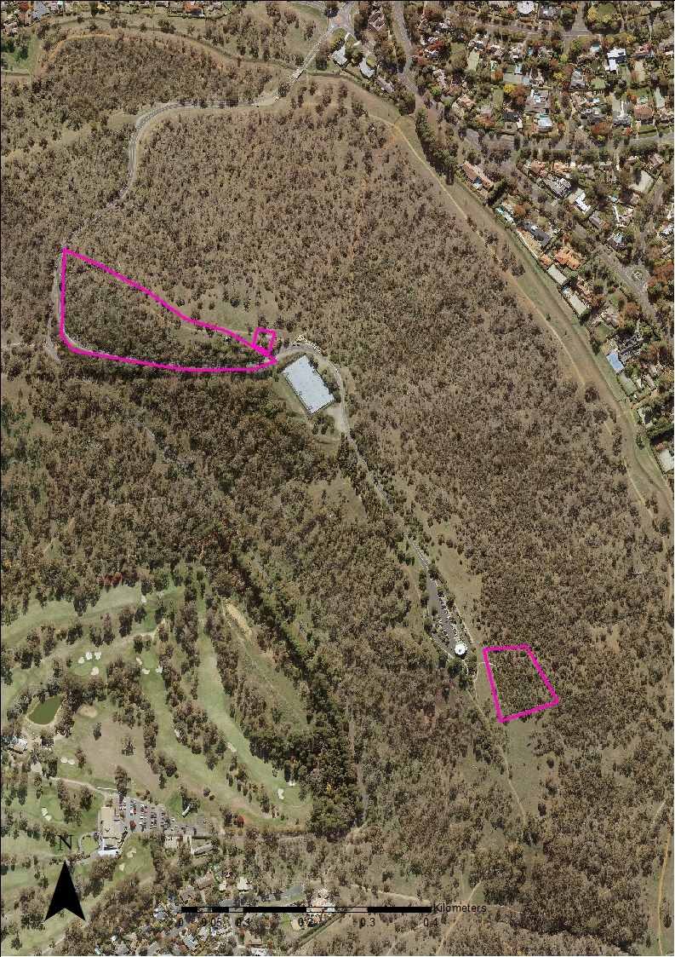
Image 1. Red Hill Historic Plantings site boundary.

