Australian Capital Territory
Electoral (Quarterly amount of administrative expenditure funding for 2019) Declaration 2018

Notifiable instrument NI2018 — 673
made under the
Electoral Act 1992, s215F (Working out indexation for administrative expenditure)

1 Name of instrument
This instrument is the Electoral (Quarterly amount of administrative expenditure funding for 2019) Declaration 2018.
2 Commencement
This instrument commences on 1 January 2019.
3 Calculation
The quarterly amount for the period 1 January 2019 to 31 December 2019 is determined by the formula:
INS1 x P
INS2
where:
INS1 means the index number* published for the September quarter in the preceding year.
INS2 means the index number* published for the September quarter in the year immediately before the preceding year.
P means, for 2018 - $5,581.16, according to Notifiable Instrument NI2017 - 575.
* The index number, in relation to a quarter, means the all groups consumer price index number, being the weighted average of the 8 capital cities, published by the Australian Statistician for that quarter.
INS1 for the September 2018 quarter is 113.5.
INS2 for the September 2017 quarter is 111.4.
The quarterly amount is:
113.5 x $5,581.16 = $5,686.37
111.4
4 Declaration
I declare the quarterly amount for 2019 for the purposes of -
- section 215C(3), definition of A, paragraph (b); and
- section 215E(2), definition of A, paragraph (b);
to be $5,686.37
5 Expiry
This instrument expires on 31 December 2019.

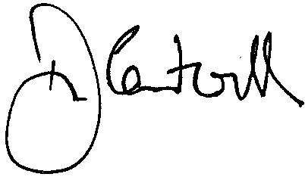

Damian Cantwell AM
Electoral Commissioner

20 November 2018

