Australian Capital Territory
Liquor (Temporary Alcohol-Free Place) Declaration 2018 (No 3)
Notifiable instrument NI2018-676
made under the
Liquor Act 2010, s 198 (alcohol-free places)

1 Name of instrument
This instrument is the Liquor (Temporary Alcohol-Free Place) Declaration 2018 (No 3).
2 Commencement
This instrument commences at 10am on 3 January 2019.
3 Declaration
I declare the following locations as temporary alcohol-free areas:
  - The Federal Highway within the Australian Capital Territory;
  - Northbourne Avenue, north of the southernmost point of its intersection with Macarthur Avenue and Wakefield Avenue;
  - The hatched area shown on the attached map in Attachment 1 that is within the heavy black line on the map and is a public place.
  - Any unleased land adjoining a public place mentioned in paragraphs a) to c).
But excluding:
  - The areas designated for Summernats 32, highlighted by the bold red line on the map at Attachment 2.
4 Expiry
This instrument expires at midday on 7 January 2019.

David Snowdon
Commissioner for Fair Trading
11 December 2018
Attachment 1
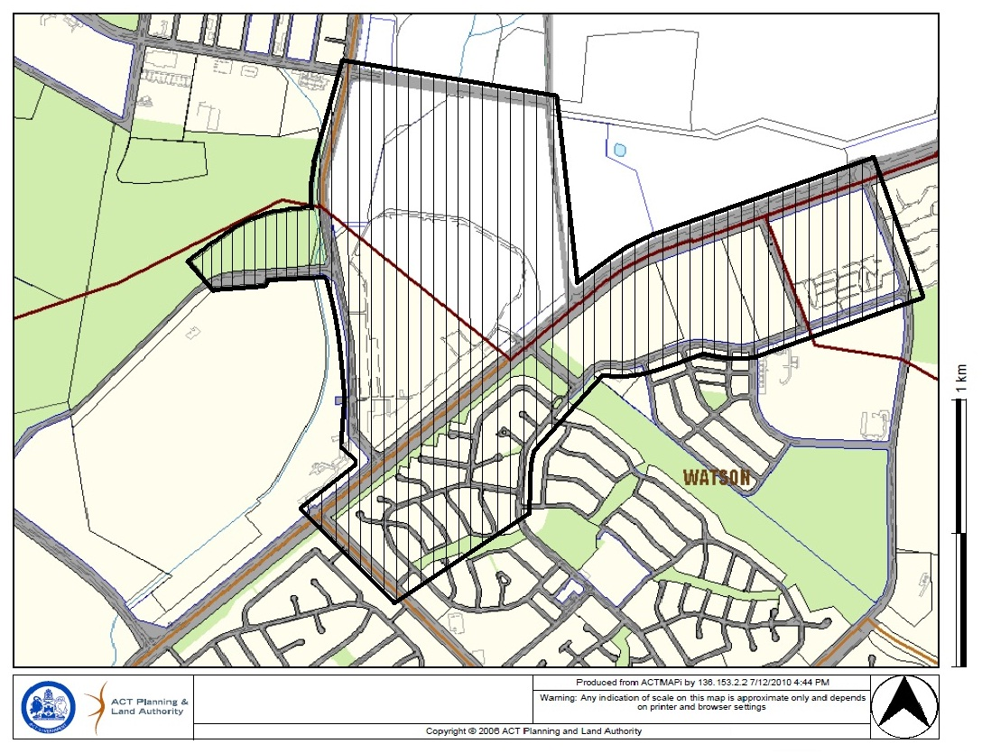

Attachment 2
