Australian Capital Territory
Planning and Development (Draft Variation No 362) Consultation Notice 2018
Notifiable instrument NI2018—686
made under the
Planning and Development Act 2007, s 63 (Public consultation—notification) and s 64 (Public consultation—notice of interim effect etc)

1 Name of instrument
This instrument is the Planning and Development (Draft Variation No 362) Consultation Notice 2018.
2 Draft variation to the territory plan
The planning and land authority (the Authority) has prepared a draft plan variation No 362—Amendments to the West Belconnen Concept Plan for Ginninderry Stage 2 Development (the Draft Variation) to vary the Territory Plan. The Draft Variation proposes to vary the West Belconnen Concept Plan by making the provision of gas utility services to blocks in Stage 2 of Ginninderry Estate, West Belconnen, an optional rather than a mandatory requirement.
3 Documents available for public inspection
(1) The Authority gives notice that the Draft Variation is available for public inspection and purchase.
(2) Copies of the documents mentioned in section 3 (1) are available for inspection and purchase at Access Canberra, Environment, Planning and Sustainable Development Directorate Shopfront, Ground Floor South, Dame Pattie Menzies House, 16 Challis Street, Dickson, Monday to Friday (except public holidays) between 8:30am and 4:30pm for the period commencing on the day this notice commences and ending on 8 February 2019 (the Consultation Period).
(3) Copies of the documents mentioned in section 3 (1) are also available for inspection during the Consultation Period online at
https://www.planning.act.gov.au/tools-resources/plans-registers/plans/territory_plan/draft_variations_to_the_territory_plan

4 Invitation to give written comments
(1) The Authority invites written comments about the Draft Variation during the Consultation Period. Comments should include reference to the Draft Variation and be addressed to the Territory Plan Section of the Environment, Planning and Sustainable Development Directorate (EPSDD). Please also provide your name and contact details to assist in the assessment of the comments provided and to enable the Authority to contact you in relation to your comments, if required.
(2) Written comments should be provided to the Authority by:
(a) email to terrplan@act.gov.au; or
(b) mail to Territory Plan Section, EPSDD, GPO Box 158, Canberra, ACT 2601; or
(c) hand delivery to Access Canberra, EPSDD Shopfront, Ground Floor South, Dame Pattie Menzies House, 16 Challis Street, Dickson.
5 Public inspection of written comments
(1) Copies of written comments about the Draft Variation given in response to the invitation in section 4, or otherwise, or received from the National Capital Authority will be available (unless exempted) for public inspection for a period of at least 15 working days starting 10 working days after the day the consultation period ends, at Access Canberra, EPSDD Shopfront, Ground Floor South, Dame Pattie Menzies House, 16 Challis Street, Dickson, Monday to Friday (except public holidays) between 8:30am and 4:30pm and may be published on the EPSDD website at www.planning.act.gov.au.
(2) You may apply under section 411 of the Planning and Development Act 2007 (the Act) for part of your consultation comments to be excluded from being made available to the public. A request for exclusion under this section must be in writing, clearly identifying what you are seeking to exclude and how the request satisfies the exclusion criteria. Please note that your name and contact details and other personal information will not be made public unless you request otherwise.
Note Personal information will be managed in accordance with the Information Privacy Act 2014 and the EPSDD Information Privacy Policy, which are available through the EPSDD website.

6 Effect of the Draft Variation
(1) Section 65 of the Act applies to the draft variation. This means that the provisions of Draft Variation No 362 have interim effect, and apply to development applications lodged on or after 7 December 2018.
(2) During the period of interim effect, the Territory, the Executive, a Minister or a territory authority must not do or approve the doing of anything that would be inconsistent with the Territory Plan if it were varied in accordance with the draft plan variation. Where there is an inconsistency between provisions in the current Territory Plan and provisions in the draft variation, then the draft variation takes precedence for the extent of the inconsistency.
(3) Interim effect will end on the day the earliest of the following happens:
- the day the public availability notice under section 70 for the draft variation being recommended to the Minister is notified in accordance with the Legislation Act 2001;
- the day the draft variation, or the corresponding variation, is withdrawn under section 68 (1) (b) or section 76 (2) (b) (v) of the Act;
- 1 year after the date of the consultation notice.
7 Obtaining further information
Further information about the Draft Variation can be obtained through email correspondence with the Territory Plan Section, EPSDD, at terrplan@act.gov.au. A reference to the Draft Variation should be included in any email.
8 Dictionary
In this instrument:
Draft plan variation No 362—Amendments to the West Belconnen Concept Plan for Ginninderry Stage 2 Development means the draft plan variation in the schedule.
Kathy Cusack
Delegate of the planning and land authority

6 December 2018

Planning and Development Act 2007

Draft
Variation to the
Territory Plan
No 362

Amendments to the West Belconnen Concept Plan for
Ginninderry Stage 2 Development

December 2018

Draft variation for public consultation prepared
under s60 of the Planning and Development Act 2007

This page is intentionally blank.

Contents

1. INTRODUCTION 1
1.1 Summary of the Proposal 1
1.2 Outline of the process 1
1.3 Public Consultation 3
2. EXPLANATORY STATEMENT 4
2.1 Background 4
2.2 Site Description 4
2.3 Current Territory Plan Provisions 6
2.4 Proposed Changes 6
2.5 Reasons for the Proposed Draft Variation 6
2.6 Planning Context 7
2.6.1 National Capital Plan 7
2.6.2 ACT Planning Framework 7
2.7 Interim Effect 8
2.8 Consultation with Government Agencies 8
3. DRAFT VARIATION 11
3.1 Variation to the Territory Plan 11

This page is intentionally blank.

- INTRODUCTION
  - Summary of the Proposal
The draft variation (DV 362) proposes to vary the West Belconnen Concept Plan by making the provision of reticulated gas to all blocks in Stage 2 of Ginninderry Estate, West Belconnen an optional, rather than a mandatory requirement.
DV 362 amends a rule in the West Belconnen Concept Plan to include Stage 2 of the Ginninderry Estate. This rule currently only apples to Stage 1 of Ginninderry Estate, West Belconnen.
.
  - Outline of the process
The Commonwealth’s Australian Capital Territory (Planning and Land Management) Act 1988 allows for the Legislative Assembly to make laws to establish a Territory Planning Authority and for that Authority to prepare and administer a Territory Plan. The Planning and Development Act 2007 (the Act) establishes the planning and land authority as the Authority which prepares and administers the Territory Plan, including continually reviewing and proposing amendments as necessary. The functions of the planning and land authority are administered by the Environment, Planning and Sustainable Development Directorate (EPSDD).
The Territory Plan is comprised of a written statement and a map. The written statement contains a number of parts, namely governance; strategic directions; zones (including objectives and development tables and zone or centre development codes); precinct codes; general codes; overlays; definitions; structure plans, concept plans and development codes for future urban areas.
The Territory Plan Map graphically represents the applicable land use zones (under the categories of residential, commercial, industrial, community facility, urban parks and recreation, transport and services and non urban), precincts and overlays. The zone, precinct and overlay requirements are detailed in the volumes of the Territory Plan.
Draft variations to the Territory Plan are prepared in accordance with the Act. Following the release of the draft variation under section 63 of the Act, submissions from the public are invited. At the conclusion of the consultation period the EPSDD submits a report on consultation and a recommended final variation to the Minister responsible for planning for referral to the Legislative Assembly standing committee responsible for planning. The Minister must consider the findings of the committee before deciding whether to approve the draft variation.
If the Minister approves the variation, the variation and associated documents will be tabled in the Legislative Assembly. Unless disallowed by the Legislative Assembly within five sitting days, the variation commences on a day nominated by the Minister.

  - Public Consultation
Written comments about the draft variation are invited from the public by 8 February 2019.
Comments should include reference to the draft variation and be addressed to the Territory Plan Section. Please also provide your name and contact details to assist in the assessment of the comments provided, and to enable EPSDD to contact you in relation to your comments, if required. Your personal information will be managed in accordance with the Information Privacy Act 2014 and the EPSDD Information Privacy Policy, which is available for viewing on EPSDD’s website.
Comments can be:
- emailed to terrplan@act.gov.au
- mailed to Territory Plan Section, GPO Box 158, Canberra, ACT 2601
- delivered to the Access Canberra Customer Service Centre at 16 Challis Street, Dickson

Copies of written comments will be made available for public inspection for no less than 15 working days starting 10 working days after the closing date for comment. The comments will be available at the Access Canberra customer service centre in Dickson and may be published on EPSDD’s website. Comments made available will not include personal contact details unless you request otherwise.
A request may be made for parts of a submission to be excluded under section 411 or 412 of the Planning and Development Act 2007. A request for exclusion under these sections must be in writing, clearly identifying what parts of your submission you are seeking to exclude and how the request satisfies the exclusion criteria.
Further Information
The draft variation is available online at www.act.gov.au/draftvariations until the closing date for written comments.
Printed copies of the draft variation (this document) and background documents are available for inspection and purchase at the Access Canberra Customer Service Centre, 16 Challis Street, Dickson, Monday to Friday (except public holidays) between 8:30am and 4:30pm. Please call 6207 1923 to arrange a copy for purchase.

- EXPLANATORY STATEMENT
  - Background
DV 362 proposes to vary the West Belconnen Concept Plan by making the provision of reticulated gas to each block an optional, rather than a mandatory requirement for Stage 2 of Ginninderry Estate, West Belconnen.
Stage 1 of Ginninderry Estate is currently subject to the rule that allows optional provision of gas to each block. This variation will amend the rule by extending it to each block in Stage 2 of Ginninderry Estate.
Given the increasing supply and affordability of renewable energy sources, mandating the provision of gas is not considered to be consistent with the principles and policies of the West Belconnen Structure Plan.
The Structure Plan states that ‘subdivision design will facilitate energy efficient housing consistent with current best practice.’ Additionally, the Structure Plan allows for the concept plan to depart from the relevant development code in response to contemporary best practice for energy efficiency.
There is currently an agreement for a pilot project to apply to Stage 1 of Ginninderry Estate, which will develop houses on the basis that no reticulated gas will be provided for residential use. With DV 362 applying to Stage 2 of Ginninderry Estate, the pilot project will be expanded to a larger area, assessing whether houses are able to work efficiently and cost effectively without gas and then evaluated in terms of both customer experience and energy use. The ACT is the only jurisdiction in Australia that has a mandatory requirement for gas infrastructure to be provided in new estates and subdivisions.
The mandatory utility service provisions of water, sewer, stormwater, electricity, and telecommunications to each block will be retained.

  - Site Description
The subject site is Stage 2 of Ginninderry Estate in West Belconnen. It is located immediately west of the existing suburbs of Holt and Macgregor, east of Murrumbidgee River and south of the NSW state border.

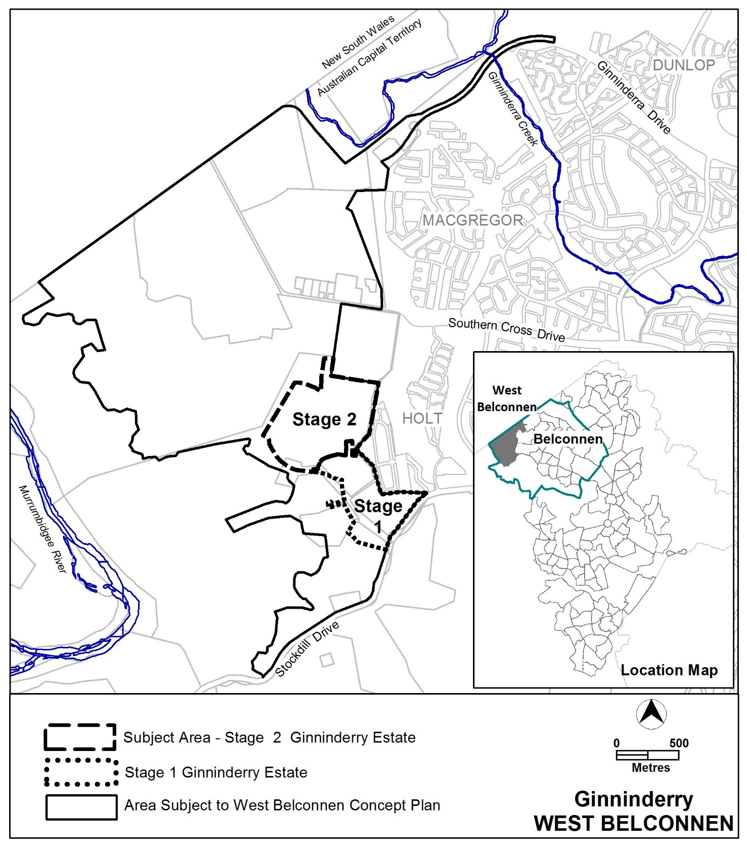
Figure 1 Location of Stage 2 Ginninderry Estate, West Belconnen

  - Current Territory Plan Provisions
Under the Territory Plan, all estate planning and subdivision of land in the ACT must comply with any relevant development code, concept plan or precinct code.
The requirement for the supply of utility services in Ginninderry Estate is currently subject to provisions in the Estate Development Code and the West Belconnen Concept Plan:
- Under Rule 43 of the Estate Development Code, it is mandatory for utility services, including gas, to be provided to each block in new suburbs; and
- Rule 33 A of the West Belconnen Concept Plan overrides the mandatory requirement in the Estate Development Code for gas to be supplied to each block in Stage 1 of Ginninderry Estate

DV 362 varies the existing provision in the West Belconnen Concept Plan to include Stage 2 of Ginninderry Estate. The provision will allow for both Stage 1 and Stage 2 to override the mandatory requirement in the Estate Development Code for gas to be supplied to each block.
Under the Planning and Development Act 2007 (the Act), where more than one type of code applies to a development and there is inconsistency between provisions, the provisions in the concept plan take precedence over those in the Estate Development Code.
*Note: A concept plan is deemed to be precinct code under the Act.

  - Proposed Changes
It is proposed to vary the West Belconnen Concept Plan by amending Rule 33A to permit the optional provision of gas supply to each block in Stage 1 and 2 of Ginninderry Estate.

  - Reasons for the Proposed Draft Variation
- As part of Ginninderry Estates green credentials to supply highly efficient all–electric housing packages, the proponent has sought the option to not supply gas, a non-renewable resource, to residential areas.
- The proposed change is considered complementary to and would support the ACT Government’s current policy commitment to achieve net zero greenhouse gas emissions by 2050.
- The change does not prohibit gas reticulation in Ginninderry Estate, but gives the option to supply electricity as the only source of energy in line with the government’s commitments to supply 100% of renewal electricity to the Canberra community.
- The pilot project applying to Stage1, will now include Stage 2 of Ginninderry Estate to allow for a larger study area.

  - Planning Context
    - National Capital Plan
The Australian Capital Territory (Planning and Land Management) Act 1988 established the National Capital Authority (NCA) with two of its functions being to prepare and administer a National Capital Plan (NCP) and to keep the NCP under constant review and to propose amendments to it when necessary.
The NCP, which was published in the Commonwealth Gazette on 21 January 1990 is required to ensure that Canberra and the Territory are planned and developed in accordance with their national significance. The Planning and Land Management Act 1988 also required that the Territory Plan is not inconsistent with the NCP.

    - ACT Planning Framework
Statement of Strategic Directions
The Statement of Strategic Directions sets out the principles for giving effect to the main objective of the Territory Plan as required by the Planning and Development Act 2007.
The proposal is consistent with the Territory Plan’s statement of strategic directions in terms of environmental, economic and social sustainability and spatial planning and urban design principles.
1.5 Planning policies will seek to ensure the efficient use of all resources and to reduce consumption of non-renewable resources. Waste minimisation, reuse and recycling will be encouraged, whilst energy-rating and conservation measures will be applied wherever appropriate, particularly in transport, subdivision planning, and building design and construction.
DV362 is consistent with this principle as the variation to the West Belconnen Concept Plan seeks to reduce gas consumption, a non-renewable resource.

The ACT Planning Strategy 2012
7. Improve the city’s efficiency, resilience to change and environmental sustainability by designing and incorporating innovative technologies and ‘clean’ initiatives into the physical infrastructure.

The proposed change is consistent with the ACT Planning Strategy 2012, as it is complementary to and would support the ACT Government’s current policy commitment to achieve net zero greenhouse gas emissions by 2050.

  - Interim Effect
Section 65 of the Planning and Development Act 2007 applies to the draft variation. This means that the provisions of Draft Variation No 362 have interim effect, and apply to development applications lodged on or after 7 December 2018.
During the period of interim effect the ACT Government must not do or approve anything that would be inconsistent with the Territory Plan as if it were amended by the draft variation. Where there is an inconsistency between provisions in the current Territory Plan and provisions in the draft variation, then the draft variation takes precedence for the extent of the inconsistency.
Interim effect will end on the day the earliest of the following happens:
- the day the public availability notice under section 70 for the draft variation being recommended to the Minister is notified in accordance with the Legislation Act
- the day the draft variation, or the corresponding variation, is withdrawn under section 68 (1)(b) or section 76 (3)(b)(v)
- 1 year after the date of the consultation notice.

  - Consultation with Government Agencies
The EPSDD is required to, in preparing a draft variation under section 61(b) consult with each of the following in relation to the proposed draft variation:
- the National Capital Authority
- the Conservator of Flora and Fauna
- the Environment Protection Authority
- the Heritage Council
- the Land Custodian, if the draft variation would, if made, be likely to affect unleased land or leased public land – each custodian for the land likely to be affected

National Capital Authority
The National Capital Authority provided the following comment on 2 October 2018
The National Capital Authority has no comment to make on DV362, and has no objection to the draft variation proceeding to public consultation.
Response
The comments are noted.

Conservator of Flora and Fauna
The Conservator of Flora and Fauna provided the following comment on 3 October 2018
I have no comments to provide other than to note my support.

Response
The comments are noted.

Environment Protection Authority
The Environment Protection Authority provided the following comment on 24 October 2018
As per advice provided in response to DV356 which proposed the same amendment for Stage 1 of the Ginninderry estate, the proposed variation is supported in principle however will limit the choices available for space heating in homes and could result in an increased reliance on solid fuel heating options in the area.
The air quality impact assessment titled “West Belconnen Strategic Environmental Assessment Air Quality Review by Aecom dated 18-June-2014” (the Air Quality Review) completed as part of the Ginninderry environment assessment process indicates particulate pollution from solid fuel heaters could present air quality issues in the area.
Consistent with the recommendations from the Air Quality Review, planning and building approval requirements similar to those in the Dunlop and Molonglo areas should be developed and implemented to specifically require that solid fuel heaters are restricted to pellet heaters or units greater than 1g/kg. In addition second-hand heaters are also prohibited. These planning requirements should be included in all leases issued in the Ginninderry development, not just the area subject to this variation.
Consideration should also be given to noise from air-conditioning systems which is becoming more problematic. Limiting the available technologies will also result in more split system air-conditioning units which are common sources of noise complaints.
The Territory Plan should provide guidance to builders and developers to ensure these matters are duly considered at the design stage to prevent issues arising after construction.

Response
The comments are noted. The space heating and cooling of homes is not specifically related to this variation, and will be addressed at a later stage in the detailed planning and development assessment process for Ginninderry development.

Heritage Council
The Heritage Council provided the following comment on 19 October 2018
The Council does not identify any heritage objections to the proposed amendment, as it will not affect the continued relevance of the Heritage Act 2001 to Stage 2 of the Ginninderry Estate.

Response
The comments are noted.

Land Custodian – Suburban Land Agency
Land custodian provided the following comment on 3 October 2018
The Suburban Land Agency supports the Draft Variation

Response
The comments are noted.
- DRAFT VARIATION
  - Variation to the Territory Plan
The Territory Plan is varied in all of the following ways:

Variation to the West Belconnen Concept Plan
- Part B Subdivision

Delete

16A Utility Services

R35A  Utility services, including water, sewer,  stormwater, electricity, gas and  telecommunications are provided to each block.  For Stage 1 Ginninderry Estate, the provision of gas to each block is not a mandatory requirement.  Note: A condition of development approval may be imposed to ensure compliance with this rule. | This is a mandatory requirement. There is no applicable criterion.

Substitute

16A Utility Services

R35A  Utility services, including water, sewer,  stormwater, electricity, gas and  telecommunications are provided to each block.  For Stages 1 and 2 Ginninderry Estate, the provision of gas to each block is not a mandatory requirement.  Note: A condition of development approval may be imposed to ensure compliance with this rule. | This is a mandatory requirement. There is no applicable criterion.

Interpretation service
