Australian Capital Territory
Planning and Development (Technical Amendment—Phillip) Plan Variation 2019 (No 1)

Notifiable instrument NI2019—148
Technical Amendment No 2019-02
made under the
Planning and Development Act 2007, s 89 (Making technical amendments)

- Name of instrument
This instrument is the Planning and Development (Technical Amendment—Phillip) Plan Variation 2019 (No 1).
2 Commencement
This instrument commences on the day after its notification day.
3 Technical amendment
I am satisfied under section 89 (1) (a) of the Planning and Development Act 2007 (the Act) that the Phillip plan variation is a technical amendment to the Territory Plan.
4 Meaning of Phillip plan variation
In this instrument:
Phillip plan variation means the technical amendment to the Territory Plan, variation 2019-02, in the schedule.
Note Limited consultation was undertaken in relation to the Phillip plan variation in accordance with section 90 of the Act.
Kathy Cusack
Delegate of the planning and land authority
19 March 2019

Planning & Development Act 2007

Technical Amendment
to the Territory Plan

2019-02

Amendments to the Phillip Precinct Code

March 2019

Commencement version
under section 89 of the Planning and Development Act 2007

Table of Contents
1. INTRODUCTION 1
1.1 Purpose 1
1.2 Public consultation 1
1.3 National Capital Authority 1
1.4 Process 1
1.5 Types of technical amendments under the Act 2
2. EXPLANATORY STATEMENT 3
2.1 Background 3
2.2 Variation to the Phillip Precinct Code 3
3. TECHNICAL AMENDMENT 7
3.1 Variation to the Phillip Precinct Code 7

- INTRODUCTION
    - Purpose
This technical amendment amends the Phillip Precinct Map and Code to:
- Amend Rule R16 and Criterion C16 to permit development addressing Townshend Street, Colbee Court or Dundas Court up to a maximum building height of five storeys.
- Amend Rules R16 and R17 to italicise reference to storeys as a defined term.
- Add a new Criterion C17 to permit reduced setbacks for development above two storeys for sections 37, 40, 42, 46 and 112 Phillip.
    - Public consultation
Under section 87 of the Planning and Development Act 2007 (the Act) this type of technical amendment is subject to limited public consultation under section 90 of the Act.
TA2019-02 was released for limited public consultation on 1 February 2019 and concluded on 1 March 2019.
One public submission was received during the consultation period. The key issue raised were as follows:
- Inconsistency of the allocation of the maximum building height to selected properties
Further information on the submission received and responses are contained in the Report on Consultation.
Comments received from the public and the National Capital Authority have been considered in the preparation of the final version of TA2019-02. No amendments were made to the final version after consultation.
    - National Capital Authority
The National Capital Authority were advised of TA2019-02 on 1 February 2019. NCA comments are included at Appendix A (section 3) of the Report on Consultation.
    - Process
This technical amendment has been prepared in accordance with section 87 of the Act.

    - Types of technical amendments under the Act
The following categories of technical amendments are provided under section 87 of the Act:
- Each of the following territory plan variations is a technical amendment for which no consultation is needed before it is made under section 89:
(a) a variation (an error variation) that –
- would not adversely affect anyone’s rights if approved; and
- has as its only object the correction of a formal error in the plan;
(b) a variation to change the boundary of a zone or overlay under section 90A (Rezoning – boundary changes);
(c) a variation, other than one to which subsection (2)(d) applies, in relation to an estate development plan under section 96 (Effect of approval of estate development plan);
(d) a variation required to bring the territory plan into line with the national capital plan;
(e) a variation to omit something that is obsolete or redundant in the territory plan.
- Each of the following territory plan variations is a technical amendment for which only limited public consultation is needed under section 90:
- a variation (a code variation) that –
- would only change a code; and
- is consistent with the policy purpose and policy framework of the code; and
- is not an error variation;
- a variation to change the boundary of a zone under section 90B (Rezoning – development encroaching on adjoining territory land);
- a variation in relation to a future urban area under section 90C (Technical amendments – future urban areas);
- a variation in relation to an estate development plan under section 96 (Effect of approval of estate development plan) if it incorporates an ongoing provision that was not included in the plan under section 94 (3) (g);
- a variation to clarify the language in the territory plan if it does not change the substance of the plan;
- a variation to relocate a provision within the territory plan if the substance of the provision is not changed.
Following each item in Part 2 Explanation of this technical amendment is a statement of compliance against the specific criteria for the relevant category of technical amendment.
TA2019-02 has been prepared in accordance with section 87(2)(a) of the Act.
- EXPLANATORY STATEMENT
    - Background
This part of the technical amendment document explains the changes made to the Territory Plan, the reasons for the change, and a statement of compliance against the relevant section of the Act.
    - Variation to the Phillip Precinct Code
2.2.1 Location Plan
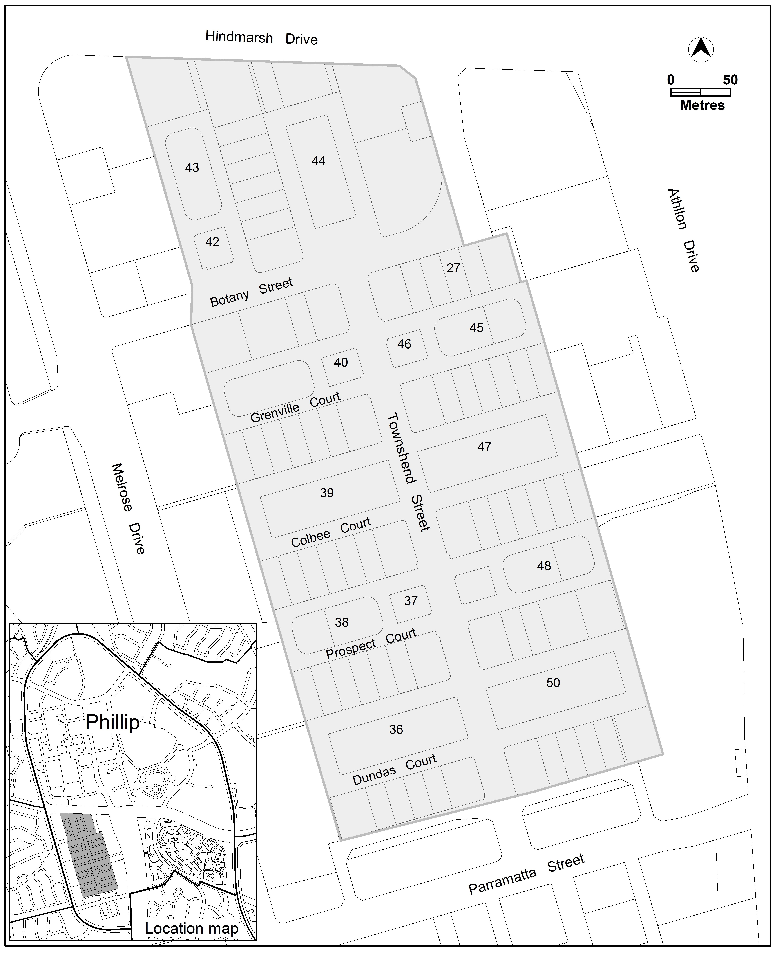

2.2.2 Rule R16 and Criterion C16
Variation to the Territory Plan No. 344 Woden town centre (V344) introduced amendments to the Phillip precinct map and code, and zone changes to the Territory Plan map from the recommendations of the Woden Town Centre Master Plan.
V344 and the Woden Town Centre Master Plan are available at:
https://www.planning.act.gov.au/tools_resources/plans-registers/plans/master_plans/woden_and_mawson_master_plans
https://www.planning.act.gov.au/tools_resources/plans-registers/plans/territory_plan/approved_variations
A review of the operation of the amended Phillip precinct code identified departures from the master plan recommendations that would result in adverse outcomes for development in the CZ3 commercial services zone.
The previous version of the Phillip precinct code contained a rule R10 and criterion C10 that permitted five storey development on corner blocks fronting Townshend Street. The Woden town centre master plan recommended amending this requirement by permitting five storeys along Townshend Street, Colbee Court or Dundas Court.
This extension of the fifth storey height allowance was not correctly transcribed into the precinct code introduced with V344, which retained the restriction on only allowing fifth storey elements where development addressed both Townshend Street and Colbee Court or Dundas Court.
The wording of criterion C16 is amended to permit five storey elements along either Townshend Street, Colbee Court or Dundas Court, correctly reflecting the master plan recommendation. The three metre setback for five storey elements will remain applicable for each street frontage.
In addition, minor edits are included to clarify that the reference to storeys within the rule and criterion is the defined term as described in the Territory Plan definitions.
Existing rule (text to be changed underlined)
R16  This rule applies to CZ3.  The maximum height of building for area ‘e’ and area ‘f’ shown in figure 2 is four storeys:  - Plant room set back a minimum of 3m from the building facade of the floor immediately below is not included in the number of storeys. | In area ‘e’:  - five storeys is permitted where development complies with all of the following:  - development fronts on to Townshend Street, and either Colbee Court or Dundas Court  - the fifth storey is setback a minimum of 3 metres from the front boundary  - six storeys is permitted for development facing Altree Court.  Plant room set back a minimum of 3m from the building facade of the floor immediately below is not included in the number of storeys.

Proposed rule (see underlined text)
R16  This rule applies to CZ3.  The maximum height of building for area ‘e’ and area ‘f’ shown in figure 2 is four storeys.  Plant room set back a minimum of 3m from the building facade of the floor immediately below is not included in the number of storeys. | C16  In area ‘e’:  - five storeys is permitted where development complies with all of the following:  - development fronts on to either Townshend Street, and either Colbee Court or Dundas Court  - the fifth storey is setback a minimum of 3 metres from the front boundary  - six storeys is permitted for development facing Altree Court.  Plant room set back a minimum of 3m from the building facade of the floor immediately below is not included in the number of storeys.

Compliance with the Planning and Development Act 2007
Section | Statement
s87(2)(a)  (a) a variation (an code variation) that—  (i) would only change a code  (ii) is consistent with the policy purpose and policy framework of the code; and  (iii)is not an error variation | Compliant.  The adjustment to the criterion brings it in line with the master plan recommendations to permit higher levels of development adjoining the green spaces within the CZ3 services area of Woden. This is consistent with the intent of the Code.

2.2.3 Criterion C17
Variation to the Territory Plan No. 344 Woden town centre (V344) introduced amendments to the Phillip precinct map and code, and zone changes to the Territory Plan map from the recommendations of the Woden town centre master plan.
A review of the operation of the amended Phillip precinct code has identified departures from the master plan recommendations that would result in adverse outcomes for development in the CZ3 commercial services zone.
Six metre setbacks to street frontages within Divine Court, Grenville Court and Prospect Court was introduced through Territory Plan Variation No. 344 (V344) for the portion of development above two storeys in the new rule R17. The setbacks were intended to ensure upper floor level development around the outer edge of the Courts were set back from the street to provide separation to the services areas on the ground floor within the courts. An unintended outcome was that the six metre setback substantially reduced the ability to develop a number of isolated ‘island’ blocks located at the intersection of the Courts and Townshend Street. These blocks are surrounded on three or four sides by roads requiring the setback, meaning that development above two storeys would be unviable. The master plan intended for development facing Townshend Street to frame the street through encouraging higher building elements up to four storeys addressing the street.
A new criterion C17 is introduced to permit reduced setbacks for the upper floor levels of the ‘island’ blocks, provided development does not adversely impact on neighbouring residential development. This will increase the likelihood that sites will be able to develop up to the maximum building height fronting Townshend Street, consistent with the recommendations of the Woden town centre master plan.
Existing rule and criterion
R17  This rule applies to CZ3.  The portion of development above the first floor fronting on to Grenville Court, Prospect Court, Bellona Court or Devine Court is set back a minimum of 6m from the street front boundary. | This is a mandatory requirement. There is no applicable criterion.

Proposed criterion (see underlined text)
R17  This rule applies to CZ3.  The portion of development above the first floor fronting on to Grenville Court, Prospect Court, Bellona Court or Devine Court is set back a minimum of 6m from the street front boundary. | C17  Setbacks for development above the first floor in sections 37, 40, 42, 46 and 112 may be reduced, up to 0m from each boundary, where development does not significantly impact on adjoining dwellings through overlooking or overshadowing.

Compliance with the Planning and Development Act 2007
Section | Statement
s87(2)(a)  (a) a variation (an code variation) that—  (i) would only change a code  (ii) is consistent with the policy purpose and policy framework of the code; and  (iii)is not an error variation | Compliant.  The adjustment to the criterion clarifies that the intent of this part of the provision was not to limit setbacks for isolated blocks fronting Townshend Street for development above two storeys. This is consistent with the intent of the rule.

- TECHNICAL AMENDMENT
This section of the technical amendment document provides the actual instructions for implementing the changes to the Territory Plan.

    - Variation to the Phillip Precinct Code
- Additional rules and criteria – RC1 – Woden Town Centre; Element 2: Buildings; Item 2.1 Building heights; Rule R16 and Criterion C16

Substitute

Rules | Criteria
R16  This rule applies to CZ3.  The maximum height of building for area ‘e’ and area ‘f’ shown in figure 2 is four storeys.  Plant room set back a minimum of 3m from the building facade of the floor immediately below is not included in the number of storeys. | C16  In area ‘e’:  - five storeys is permitted where development complies with all of the following:  - development fronts on to either Townshend Street, Colbee Court or Dundas Court  - the fifth storey is setback a minimum of 3 metres from the front boundary  - six storeys is permitted for development facing Altree Court.  Plant room set back a minimum of 3m from the building facade of the floor immediately below is not included in the number of storeys.

- Additional rules and criteria – RC1 – Woden Town Centre; Element 2: Buildings; Item 2.1 Building heights; Rule R17

Substitute

Rules | Criteria
R17  This rule applies to CZ3.  The portion of development above the first floor fronting on to Grenville Court, Prospect Court, Bellona Court or Devine Court is set back a minimum of 6m from the street front boundary. | C17  Setbacks for development above the first floor in sections 37, 40, 42, 46 and 112 may be reduced, up to 0m from each boundary, where development does not significantly impact on adjoining dwellings through overlooking or overshadowing.

Interpretation service
