Australian Capital Territory
Heritage (Decision about Provisional Registration of Gibraltar School and Tennis Court, Paddys River) Notice 2019
Notifiable instrument NI2019–185
made under the
Heritage Act 2004, s 32 (Decision about provisional registration) and s 34 (Notice of decision about provisional registration)

1 Name of instrument
This instrument is the Heritage (Decision about Provisional Registration of Gibraltar School and Tennis Court, Paddys River) Notice 2019.
2 Decision about provisional registration
On 4 April 2019, the ACT Heritage Council (the Heritage Council) decided not to provisionally register Gibraltar School and Tennis Court, Block 240, Paddys River (the Place).
3 Description of the Place
The description of the Place is in the schedule.
4 Reasons for the decision
The Heritage Council is not satisfied on reasonable grounds that the Place is likely to have heritage significance as defined by section 10 of the Heritage Act 2004. A detailed statement of reasons, including an assessment against the heritage significance criteria, is provided in the schedule.
5 Date decision takes effect
The decision not to provisionally register the Place takes effect on 5 April 2019 (being the day after the Heritage Council made its decision in writing as set out in the schedule).

Fiona Moore
Secretary (as delegate for)
ACT Heritage Council
4 April 2019

Schedule
(See sections 3 and 4)
STATEMENT OF REASONS
DECISION NOT TO PROVISIONALLY REGISTER
Gibraltar School and Tennis CourtWamboinName of Place
Paddys River
IN THE ACT HERITAGE REGISTER

In accordance with Section 32 of the Heritage Act 2004, the ACT Heritage Council has decided not to provisionally register Gibraltar School and Tennis Court, Paddys River. This Statement of Reasons provides an assessment of Gibraltar School and Tennis Court, Paddys River and finds that the place does not meet any of the criteria under s.10 of the Heritage Act 2004.

Gibraltar School and Tennis Court was nominated by an ACT Parks and Conservation Service (ACT PCS) Ranger as ‘Paddys River School and Tennis Court’ in approximately 1996. The nomination was tied in with development of the ‘Birrigai Time Trail’ following the Bulbeck and Boot (1991) cultural resource survey and conservation plan for Tidbinbilla. The two school buildings associated with the place from 1907 to 1942 had been removed or destroyed prior to the work of Bulbeck and Boot. The researchers however, mapped the condition of the site and recorded its surface archaeology. The site was burned in the 2003 Canberra fires which impacted 90% of Tidbinbilla Nature Reserve. The site is now adversely impacted by the regrowth of vegetation following the fire.

This statement refers to the location of the place as required in s.34(5)(b)(ii) of the Heritage Act 2004.
LOCATION OF THE PLACE

The Gibraltar School and Tennis Court is located within Paddys River Block 240 which is encompassed by Tidbinbilla Nature Reserve. The site is located between the Tidbinbilla Visitor Centre and the intersection of Paddys River Road with the Tidbinbilla Ring Road. It is interpreted as a site on the ‘Birrigai Time Trail’ and is located directly south of the original Tidbinbilla to Tharwa Road which is now a service road within the reserve used by ACT PCS staff.

This section refers to the description of the place as required in s.34(5)(b)(iii) of the Heritage Act 2004. The boundary of the place and extent of features listed below is illustrated at Image 1.

DESCRIPTION OF THE PLACE

The Gibraltar School and Tennis Court site encompasses areas known to have been associated with the location of two school buildings, horse paddock and tennis court, including any archaeological material below the surface.

This statement refers to the Council’s reasons for its decision as required in s.34(5)(b)(iv) of the Heritage Act 2004.
REASONS FOR DECISION

The Council is not satisfied on reasonable grounds that the place is likely to have heritage significance as defined by s.10 of the Heritage Act 2004.

This statement refers to the Council’s assessment of the place against the heritage significance criteria as a part of its reasons for its decision as required in s.34(5)(b)(iv) of the Heritage Act 2004.

ASSESSMENT AGAINST THE HERITAGE SIGNIFICANCE CRITERIA

The Council’s assessment against the criteria specified in s.10 of the Heritage Act 2004 is as follows.

In assessing the heritage significance of Gibraltar School and Tennis Court, Paddys River, the Council considered:
- the Council’s Heritage Assessment Policy (March 2018);
- information provided by a site inspection on 14 February 2019 by ACT Heritage; and
- the report by ACT Heritage titled, Background Information Gibraltar School and Tennis Court, April 2019, containing photographs and information on history, description, condition and integrity.

Pursuant to s.10 of the Heritage Act 2004, a place or object has heritage significance if it satisfies one or more of the following criteria. Future research may alter the findings of this assessment.
- importance to the course or pattern of the ACT’s cultural or natural history;
The Council has assessed Gibraltar School and Tennis Court against criterion (a) and is not satisfied that the place meets this criterion.
The place is associated with the period of European settlement of the Tidbinbilla valley and surrounding area. Within this period, the place is most strongly associated with attempts to provide primary education in the sparsely populated areas. This association however, is not reflected in the fabric of the place as the two school buildings used between 1907 and 1942 have been removed or destroyed. While some secondary remnants of the place as a school remains, such as cultural plantings, these are in very poor condition. The tennis court was a later addition, likely in use from 1919 into the 1940s and not directly associated with the main use of the site as a school. The absence of built fabric relating to the primary association of the place as a school and the lack of integrity and intactness of remaining fabric means this place does not meet this criterion.
- has uncommon, rare or endangered aspects of the ACT’s cultural or natural history;
The Council has assessed Gibraltar School and Tennis Court against criterion (b) and is not satisfied that the place meets this criterion.
While the place is associated with providing education in the sparsely populated areas of early European settlement, the absence of physical fabric relating to the main use of the site as a school reduces the ability for the site to be assessed against this criteria. Additionally, the length of association of the site as a school – 35 years – is short compared to that of Hall School’s 95 years and Tharwa School’s 107 years. Whilst archaeological evidence relating to the use of the site as a school may remain in-situ the surface scatters of the site have been documented and the site was additionally burned in the 2003 fires. Aside from providing education to children, there is no evidence before Council that the site made a strong, noticeable or influential contribution to ACT society including, beyond that made by other already registered and intact schools – such as Hall School and Tharwa School.
- potential to yield important information that will contribute to an understanding of the ACT’s cultural or natural history;
The Council has assessed Gibraltar School and Tennis Court against criterion (c) and is not satisfied that the place meets this criterion.
The two buildings associated with the primary function of the place as a school have been removed or destroyed. The surface archaeology of the site was documented by Bulbeck & Boot (1991) as bricks, cement and other building debris, and the site was burned in the 2003 fires. Very little physical evidence of the place remains and that which does lacks integrity and intactness. Due to the short period of use as a school (35 years), previous recording by Bulbeck and Boot, and fire damage to the site, it is not considered that there exists a reasonable likelihood that the place retains substantial physical evidence of archaeology or other defined research interest. Additionally, there is insufficient documented evidence before Council to suggest that further study of the physical evidence of the site would yield any new information contributing to an understanding of the ACT’s cultural history.
- importance in demonstrating the principal characteristics of a class of cultural or natural places or objects;
The Council has assessed Gibraltar School and Tennis Court against criterion (d) and is not satisfied that the place meets this criterion.
The absence of school buildings and the poor condition of remaining elements such as cultural plantings; plus the secondary importance and poor condition of the tennis court do not enable the place to be read as belonging to a class of place important to the ACT’s cultural history.
- importance in exhibiting particular aesthetic characteristics valued by the ACT community or a cultural group in the ACT;
The Council has assessed Gibraltar School and Tennis Court against criterion (e) and is not satisfied that the place meets this criterion.
While the place is in the relatively picturesque rural setting of Tidbinbilla Nature Reserve the lack of physical fabric relating to the main education function of the place, combined with the lack of integrity and intactness of remaining elements, means the place cannot be assessed against this criteria. Whilst the Tidbinbilla Pioneers Association and ACT Parks and Conservation Service (ACT PCS) staff have an interest in the site, there is also no clear evidence that these groups or other community or cultural groups in the ACT, value the specific aesthetic qualities of the Gibraltar School and Tennis Court site. Additionally, according to the ACT Heritage Assessment Policy (2015) these groups cannot be considered to represent the ACT community as follows;

- Professional groups and special interest groups do not constitute a community or cultural group for the purposes of this criterion. Common expertise or interest is not sufficient by itself to define a community or cultural group
- ‘Community’ is defined as follows; ‘all the people of a specific locality or country’ plus ‘a particular locality, considered together with its inhabitants’
- For the purposes of the Heritage Act 2004, ‘the community’ is defined as ‘the ACT community’ or ‘the community of the ACT’.
- importance in demonstrating a high degree of creative or technical achievement for a particular period;
The Council has assessed Gibraltar School and Tennis Court against criterion (f) and is not satisfied that the place meets this criterion.
The lack of physical fabric relating to the main education function of the place, combined with the lack of integrity and intactness of remaining elements means the place cannot be assessed against this criteria.
- has a strong or special association with the ACT community, or a cultural group in the ACT for social, cultural or spiritual reasons;
The Council has assessed Gibraltar School and Tennis Court against criterion (g) and is not satisfied that the place meets this criterion.
The Tidbinbilla Pioneers Association and staff within ACT PCS have ensured the site is interpreted on the ‘Birrigai Time Trail’. Beyond ensuring the site is commemorated there is no evidence that the place evokes connections that are strong or special beyond the ordinary to these groups. Additionally, according to the Heritage Assessment Policy (2015) these groups cannot be considered to represent the ACT community as follows;

- Professional groups and special interest groups do not constitute a community or cultural group for the purposes of this criterion. Common expertise or interest is not sufficient by itself to define a community or cultural group
- ‘Community’ is defined as follows; ‘all the people of a specific locality or country’ plus ‘a particular locality, considered together with its inhabitants’
- For the purposes of the Heritage Act 2004, ‘the community’ is defined as ‘the ACT community’ or ‘the community of the ACT’.
- has a special association with the life or work of a person, or people, important to the history of the ACT.
The Council has assessed Gibraltar School and Tennis Court against criterion (h) and is not satisfied that the place meets this criterion.
There is no historical evidence to suggest the place is connected with any person or group of people whose life or work made a contribution beyond the ordinary to the history of the ACT, or that any such achievement relates directly to the Gibraltar School and Tennis Court site. The absence of fabric at the site relating to its main use as a school and the assessed absence of significant archaeology make it additionally difficult to state a claim against this criteria.

SITE PLAN

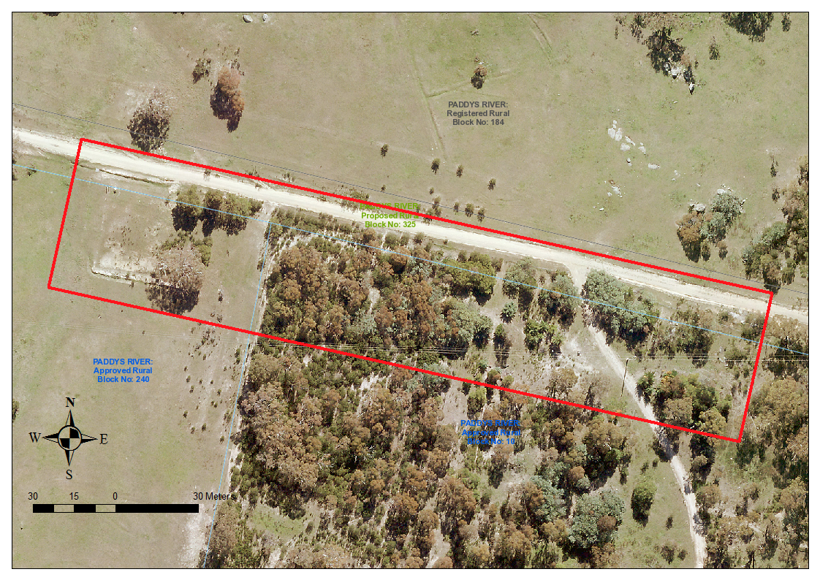
Image 1 Gibraltar School and Tennis Court site boundary

