Australian Capital Territory

Nature Conservation (Koala) Conservation Advice 2019

Notifiable instrument NI2019–230
made under the
Nature Conservation Act 2014, s 90C (Conservation advice)

- Name of instrument
This instrument is the Nature Conservation (Koala) Conservation Advice 2019.
- Commencement
This instrument commences on the day after its notification day.
- Conservation advice for the Koala
Schedule 1 sets out the conservation advice for the Koala (Phascolarctos cinereus).

Arthur Georges
Chair, Scientific Committee
1 May 2019
Schedule 1
(see s 3)

Conservation Advice
Koala
Phascolarctos cinereus

Conservation Status
The Koala Phascolarctos cinereus (Goldfuss, 1817) is recognised as threatened in the following jurisdictions:
International Vulnerable, International Union of Conservation of Nature (IUCN) Red List
National Vulnerable (QLD/NSW/ACT populations), Environment Protection and Biodiversity Conservation Act 1999
Vulnerable, The Action Plan for Australian Mammals 2012
ACT Vulnerable, Nature Conservation Act 2014
NSW Vulnerable, Biodiversity Conservation Act 2016
QLD Vulnerable, Nature Conservation Act 1992

ELIGIBILITY
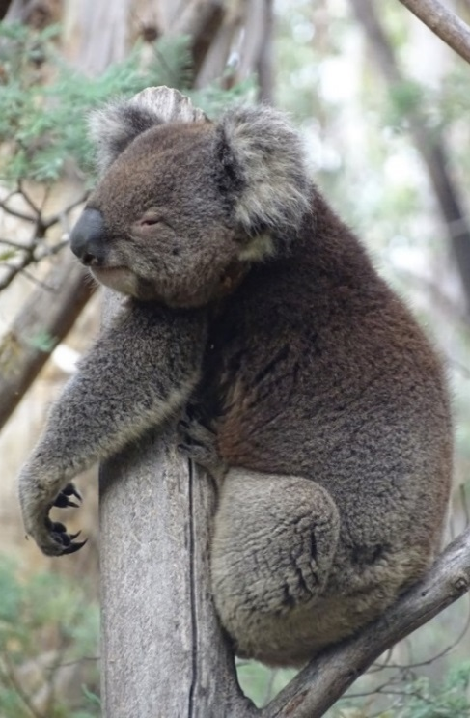
The Koala is listed as Vulnerable in the ACT Threatened Native Species List under IUCN Criterion A —A2(b), A3(b)(c)(e), A4(b)(c)(e). The factors that make it eligible include a substantial decline over the past three generations (18–24 years) with this decline expected to continue into the future with the likelihood of additional compound impacts due to climate change (Department of Environment (DoE) 2012 and Woinarski and Burbidge 2016)

DESCRIPTION AND ECOLOGY
The Koala is a tree-dwelling, medium-sized marsupial with a stocky body, large rounded ears, sharp claws and variable but predominantly grey-coloured fur. It is one of Australia’s most distinctive and iconic wildlife species (DoE 2012).
The Koala is an arboreal folivorous marsupial. It occurs in forests and woodlands, typically dominated by Eucalyptus species. The Koala has a specialist diet, mostly limited to foliage of Eucalyptus species, with occasional intake of leaves of other plant (mostly Myrtaceous) genera (Martin and Handasyde 1999; Moore and Foley 2000, 2005). The Koala is mostly solitary, but individuals have extensive overlap in home ranges.
Koala (Roy McDowall – Canberra Nature Map)
Breeding is seasonal, with births (typically of single young) in October–May. Females can produce young at annual intervals, but births per adult female per year average 0.3–0.8 (McLean 2003). Sexual maturity is reached at 18 months (Jackson 2007). In the wild, longevity of 12 (for males) to 15 years (for females) has been reported (Martin and Handasyde 1999). Generation length is 6–8 years (Phillips 2000).

Distribution and Habitat
The Koala is endemic to Australia, and is widely distributed in coastal and inland areas from north-eastern Queensland to Eyre Peninsula in South Australia. The range extends over about one million square kilometres with populations separated into areas of suitable habitat (Martin and Handasyde 1999; NSW DECC 2008). Koalas inhabit a range of temperate, sub-tropical and tropical forest, woodland and semi-arid communities dominated by Eucalyptus species (Martin and Handasyde 1999).
The Australian Capital Territory (ACT) falls in the natural range of the Koala’s distribution and it was a commonly reported species in the region when the ACT was established in 1927. In the 1870s and 1880s koalas were common around Lake George and were shot for their skins (REF). A review of koala records in the ACT and region found that the majority of post 1980 records were close to the Orroral valley and Bushfold Flats, where koalas were released in 1978 (Lintermans and Crisp 1986). Escapees from releases at Tidbinbilla Nature Reserve in 1939, 1969-71 and 1984 were also the likely origin of koala records prior to 1980 from outside this reserve (Lintermans and Crisp 1986). There are records of Koalas in the wild on Canberra Nature Map for the late 1980s to early 1990s, however, they were likely to be in low abundance. No live animals were sighted in surveys after the 2003 bushfires with the remains of one animal found at south-east slopes of Gibraltar Creek valley (Carey et al. 2003).
In 2014, reports of a koala crossing the highway between Canberra Airport and Queanbeyan were made. It was believed the lone koala was likely to be a young male pushed out of its home range in the Queanbeyan area by dominant adult males. Koala records on the western border of the ACT are possibly dispersing animals from the Brindabella near Wee Jasper (Lintermans and Crisp 1986).
Surveys undertaken in 2018 did not detect any Koalas (or evidence of koala habitation such as scats or characteristic scratch marks) in the wild in the ACT, however, it is possible that koalas may still be present. While the best possible survey sites were selected for this study only a relatively small number of sites (42) and trees (1,260 in total) were surveyed and several sites of high quality/potential habitat were either not accessible or were on Commonwealth owned Defence land (Capital Ecology 2018).
A captive population of Koalas exists at Tidbinbilla.

Threats
The main identified threats to this species are loss and fragmentation of habitat, vehicle strike, disease, and predation by dogs. Drought and incidences of extreme heat are also known to cause very significant mortality, and post-drought recovery may be substantially impaired by the range of other threatening factors (DoE 2012).

Major Conservation Objectives
The primary objective in the Commonwealth Conservation Advice (DoE 2012) is to support the recovery of the Koala in Queensland, NSW and the ACT. The Mammal Action Plan (Woinarski et al. 2014) summarises the conservation objectives for the Koala as:
      - manage threats to secure the overall population size
- maintain most subpopulations, and especially those with high genetic diversity or other management significance.

Conservation Issues and Proposed Management Actions
Recommended management actions are provided and prioritised in the Commonwealth Conservation Advice (DoE 2012) and Mammal Action Plan (Woinarski et al. 2014). The following summary of actions may be relevant in the ACT.
- maintain habitat extent, and restore habitat connectivity to now-fragmented habitat
- implement broad-scale management of feral and domestic dogs; and intensive local-scale implementation at and around important sub-populations
- implement fire control measures that benefit this species.

Other Relevant Advice, plans or Prescriptions
- Commonwealth Conservation Advice — Koala (DoE 2012)
- Commonwealth Listing Advice — Koala (TSSC 2012)
- The Action Plan for Australian Mammals (Woinarski et al. 2014)

Listing Background
The NSW, Queensland and ACT population of the Koala Phascolarctos cinereus was listed as Vulnerable under the Environment Protection and Biodiversity Conservation Act 1999 (EPBC Act) on 5 May 2016. In 2019, under the Nature Conservation Act 2014, the ACT Scientific Committee recommended the Koala be listed in the Vulnerable category in the ACT Threatened Native Species List to align with the EPBC Act listing.

References
ACT Government 2015. Nil Desperandum Homestead and Surrounds – Background Information. ACT Heritage Council, Canberra. http://www.environment.act.gov.au/__data/assets/pdf_file/0004/717394/Nil-Desperandum-Background-Information-ENDORSED-HCM-20150730.pdf.
Capital Ecology 2018. Koala Phascolarctos cinereus surveys in the Australian Capital Territory, 2018. A Report to the Environment, Planning and Sustainable Development Directorate, ACT Government, Canberra. http://www.environment.act.gov.au/__data/assets/pdf_file/0020/1255142/Koala-Survey-Report-Web-Accessible.pdf.
Carey A, Evans M, Hann P, Lintermans M, MacDonald T, Ormay P, Sharp S, Shorthouse D. and Webb N 2003. Wildfires in the ACT 2003: Report on initial impacts on natural ecosystems. Technical Report No. 17 for Environment ACT by Wildlife Research & Monitoring, Canberra. http://www.environment.act.gov.au/__data/assets/pdf_file/0006/576816/wildfiresintheact.pdf
Department of Environment (DoE) 2012. Approved Conservation Advice for Phascolarctos cinereus (combined populations in Queensland, New South Wales and the Australian Capital Territory). Department of Sustainability, Environment, Water, Population and Communities, Australian Government, Canberra. http://www.environment.gov.au/biodiversity/threatened/species/pubs/197-conservation-advice.pdf

Goldfuss GA 1817. In Schreber JCD von (1774–1855). Die Säugethiere, in Abbildungen nach der Natur, mit Beschreibungen. Fortgesetzt von A. Goldfuss. pl.CVL.Aa p.338. https://www.biodiversitylibrary.org/item/97341.
Jackson S 2007. Koala: Origins of an Icon. Allen and Unwin, Sydney.
Le Lievre K 2014. Two baby koalas born at Tidbinbilla, the first since the 2003 bushfires decimated the population. Canberra Times 22 July 2016 https://www.canberratimes.com.au/national/act/two-baby-koalas-born-at-tidbinbilla-the-first-since-the-2003-bushfires-decimated-the-population-20160722-gqbqkl.html.
Lintermans M and Crisp C 1986. The status of the Koala (Phascolarctos cinereus) in the ACT. Unpublished Report to the Australian National Parks and Wildlife Service.
Martin R and Handasyde K 1999. The Koala: Natural History, Conservation and Management. UNSW Press, Sydney.
McLean N 2003. Ecology and management of overabundant koala (Phascolarctos cinereus) populations. Thesis. University of Melbourne.
Moore BD and Foley WJ 2000. A review of feeding and diet selection in koalas (Phascolarctos cinereus). Australian Journal of Zoology 48(3): 317–333.
Moore BD and Foley WJ 2005. Tree use by koalas in a chemically complex landscape. Nature 435: 488–490.
NSW Department of Environment and Climate Change (NSW DECC) 2008. Recovery Plan for the Koala (Phascolarctos cinereus). DECC NSW, Sydney.
Phillips S 2000. Population trends and the Koala conservation debate. Conservation Biology 14(3):650–659.
Threatened Species Scientific Committee (TSSC) 2012. Listing advice for Phascolarctos cinereus (Koala).
Woinarski J and Burbidge AA 2016. Phascolarctos cinereus. The IUCN Red List of Threatened Species 2016. Accessed: 5 November 2018 from: http://dx.doi.org/10.2305/IUCN.UK.2016-1.RLTS.T16892A21960344.en.
Woinarski JCZ, Burbidge AA and Harrison PL 2014. The Action Plan for Australian Mammals 2012. CSIRO Publishing, Collingwood.

Further Information
Further information on this species or other threatened species and ecological communities can be obtained from Environment, Planning and Sustainable Development Directorate (EPSDD).
Phone: (02) 132281, EPSDD Website: http://www.environment.act.gov.au/cpr

