Australian Capital Territory

Nature Conservation (Southern Brown Bandicoot) Conservation Advice 2019

Notifiable instrument NI2019–231
made under the
Nature Conservation Act 2014, s 90C (Conservation advice)

- Name of instrument
This instrument is the Nature Conservation (Southern Brown Bandicoot) Conservation Advice 2019.
- Commencement
This instrument commences on the day after its notification day.
- Conservation advice for the Southern Brown Bandicoot
Schedule 1 sets out the conservation advice for the Southern Brown Bandicoot (Isoodon obesulus obesulus).

Arthur Georges
Chair, Scientific Committee
1 May 2019
Schedule 1
(see s 3)

Conservation Advice
Southern Brown Bandicoot (eastern)
Isoodon obesulus obesulus

Conservation Status
The Southern Brown Bandicoot (eastern) Isoodon obesulus obesulus (Shaw, 1797) is recognised as threatened in the following jurisdictions:
National Endangered, Environment Protection and Biodiversity Conservation Act 1999
Near Threatened, The Action Plan for Australian Mammals 2012
ACT Endangered, Nature Conservation Act 2014
NSW Endangered, Biodiversity Conservation Act 2016
VIC Threatened, Flora and Fauna Guarantee Act 1988
Near Threatened, Advisory List of Threatened Vertebrate Fauna 2013
SA Vulnerable, National Parks and Wildlife Act 1972

CRITERIA
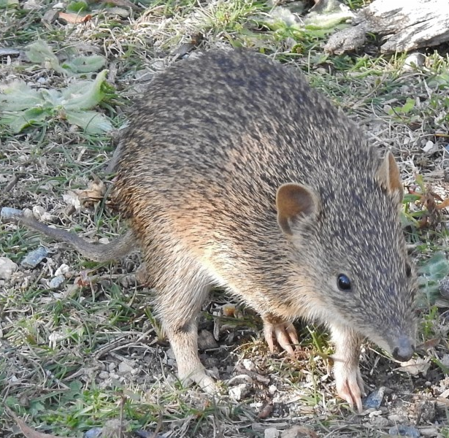
The Southern Brown Bandicoot (eastern) is listed as Endangered in the ACT Threatened Native Species List under IUCN Criterion A — A2(b), A3(b)(c). The factors that make it eligible include a continuing decline across its range with existing habitat fragmentation exacerbating threats that continue to operate over much of its range, particularly: predation by foxes and feral cats; too frequent and extensive burning; and further habitat clearing and fragmentation (Threatened Species Scientific Committee (TSSC) 2016).

DESCRIPTION AND ECOLOGY
The Southern Brown Bandicoot (eastern) is a medium-sized, ground-dwelling marsupial with a backward opening pouch. Males weigh around 890 g and females around 620 g. It has small, rounded ears and small, black eyes, a long tapering snout, a naked nose and a compact body (30 cm in length including head) and a short tail around 11–12 cm long (NSW DEC 2006 and Paull 2008).
Southern Brown Bandicoot (eastern) (John Bundock – Canberra Nature Map)
  - Southern Brown Bandicoot (eastern) (John Bundock – Canberra Nature Map)
The dorsal surface of the body bears black spiny bristle-hairs and softer, dark grey underfur that appears brown at a distance with a creamy-white, softer underbelly. The forelegs are short with curved claws on the digits and the hind limbs are much longer, resembling those of macropods (NSW DEC 2006 and Paull 2008).
The species is omnivorous and forages for food mainly by digging in the leaf litter and soil to find insects, fungi, plant root nodules and bulbs. It also eats fruit, seeds and other plant material found above ground (NSW DEC 2006 and Paull 2008).
The Southern Brown Bandicoot breeds throughout the year peaking in spring, rearing two or three litters per year, although this is dependent upon food being available. A study in the Mount Lofty Ranges found that litter size was 1-4 with an average of two pouch young per litter (Packer 2013). Generation time is estimated at two years (Woinarski et al. 2014).

Distribution and Habitat
The Southern Brown Bandicoot has experienced severe range contractions and population declines since European settlement (Zenger et al. 2005; Bilney et al. 2010). Maxwell et al. (1996) estimate that the Southern Brown Bandicoot (eastern) has experienced a 50–90 percent decline in its range. Its distribution is now highly fragmented with many discontinuous subpopulations (Paull 2003; Zenger et al. 2005; Le Duff and Stratman 2009).
The distribution of the Southern Brown Bandicoot (eastern) extends from the southern side of the Hawkesbury River in New South Wales to Kangaroo Island in South Australia. Within this range, it occurs mostly in coastal areas (Woinarski et al. 2014).
The Australian Capital Territory (ACT) had not been considered to be in the current range for the species/sub-species and it was presumed to be extinct until remains were discovered in 2003. Since then there have been opportunistic sightings and the Southern Brown Bandicoot was recorded in Tidbinbilla Nature Reserve from 2016 to 2018 (Canberra.naturemapr.org (CNM) 2018).
The Southern Brown Bandicoot inhabits areas of dense vegetation, including wetland fringes and heathland (Paull 2008). It has been observed in both native bushland and areas with exotic shrubby species such as blackberry (Rubus spp.) (Packer 2013). Bandicoots are secretive and rarely venture far from cover, possibly to avoid predation (Claridge 1998 in TSSC 2016). Bandicoots construct nests under plants on the ground; they do not create their own burrow, but occasionally use the burrows of other species (Paull 2008).

Threats
Threats to the Southern Brown Bandicoot (eastern) are detailed in the Commonwealth Conservation Advice (TSSC 2016) and include:
- predation by foxes, feral and domestic cats and to a lesser extent dogs
- habitat loss, fragmentation and degradation
- too frequent and extensive burning
- road mortality
- climate change adversely affecting habitat quality
- displacement by high rabbit densities
- disease - possibly toxoplasmosis
- timber harvesting
- reduced genetic diversity
- poisoning associated with control of non-native predators

Major Conservation Objectives
The priority management objective in the ACT is to contribute to regional and national conservation of the species.

Conservation Issues and Proposed Management Actions
The ACT is a significant distance from the current predicted range of the Southern Brown Bandicoot (eastern) and it is only known from opportunistic sightings. The most suitable habitat for this species exists in reserved areas. It is therefore unlikely that further areas will need to be reserved for the conservation of this species. Conservation and management actions are provided in Woinarski et al. (2014) and those relevant to the ACT may include:
- mitigate indicated threats
- determine the distribution, abundance and population structure of the Southern Brown Bandicoot in the ACT
- identify the key attributes of existing or potential habitat that are important for the Southern Brown Bandicoot
- incorporate the protection of critical habitat features into fire management prescriptions
- implement vertebrate pest management strategies
- cooperate with and contribute to regional and national networks to ensure coordination of research, survey and monitoring programs.

Other Relevant Advice, plans or Prescriptions
- Commonwealth Conservation Advice — Southern Brown Bandicoot (eastern) (TSSC 2016)
- The Action Plan for Australian Mammals 2012 (Woinarski et al. 2014)

Listing Background
The Southern Brown Bandicoot (eastern) was listed as Endangered under the Environment Protection and Biodiversity Conservation Act 1999 (EPBC Act) on 4 April 2001 with the endangered status confirmed on 15 May 2016 with a reassessment undertaken and the application of the IUCN criteria. In 2019, under the Nature Conservation Act 2014, the ACT Scientific Committee recommended the Southern Brown Bandicoot (eastern) be listed in the Endangered category in the ACT Threatened Native Species List to align with the EPBC Act listing. It has not been previously listed as threatened in the ACT as it was presumed to be locally extinct.

References
Bilney RJ, Cooke R, and White JG 2010. Underestimated and severe: small mammal decline from the forests of south-eastern Australia since European settlement, as revealed by a top-order predator. Biological Conservation 143(1): 52–59.
Canberra.naturemapr.org 2018. Canberra Nature Map. https://canberra.naturemapr.org/Community/Species/20401
Claridge AW 1998. Use of tracks and trails by introduced predators: an important consideration in the study of native ground-dwelling mammals. The Victorian Naturalist 115: 79–83.
Le Duff MK and Stratman BK 2009. An Assessment of the Conservation Status of the Southern Brown Bandicoot (Isoodon obesulus) in the South East of South Australia. Department for Environment and Heritage, Mount Gambier.
Maxwell S, Burbidge AA and Morris K 1996. The 1996 Action Plan for Australian Marsupials and Monotremes. Australian Marsupial and Monotreme Specialist Group, IUCN Species Survival Commission, Canberra.
New South Wales Department of Environment and Conservation (NSW DEC) 2006. Southern Brown Bandicoot (Isoodon obesulus) Recovery Plan.
Packer JG 2013. Invasive non-native plants retain native mammal communities in novel ecosystems. School of Earth and Environmental Sciences, University of Adelaide.
Paull DJ 2003. Habitat fragmentation and the Southern Brown Bandicoot Isoodon obesulus at multiple spatial scales. PhD Thesis. School of Physical, Environmental and Mathematical Sciences, University of New South Wales.
Paull DJ 2008. Southern Brown Bandicoot Isoodon obesulus. In The Mammals of Australia. Third edition. (Eds S. Van Dyck & R. Strahan) 180–182. Reed New Holland, Sydney.
Shaw G 1797. The Naturalist's Miscellany: or Coloured Figures of Natural Objects, Drawn and Described Immediately from Nature. E. Nodder, London. [8 pls 255–330 and accompanying text [text to pl. 298]]. https://www.biodiversitylibrary.org/bibliography/79941
Threatened Species Scientific Committee (TSSC) 2016. Approved Conservation Advice for Isoodon obesulus obesulus (Southern Brown Bandicoot (eastern)). Department of the Environment. Australian Government, Canberra.
Woinarski JCZ Burbidge AA and Harrison PL 2014. The Action Plan for Australian Mammals 2012. CSIRO Publishing, Collingwood.
Zenger KR, Eldridge MDB and Johnston PG 2005. Phylogenetics, population structure and genetic diversity of the endangered Southern Brown Bandicoot (Isoodon obesulus) in south-eastern Australia. Conservation Genetics 6(2): 193–204.

Further Information
Further information on this species or other threatened species and ecological communities can be obtained from Environment, Planning and Sustainable Development Directorate (EPSDD).
Phone: (02) 132281, EPSDD Website: http://www.environment.act.gov.au/cpr

