Australian Capital Territory

Nature Conservation (Canberra Spider Orchid) Conservation Advice 2019

Notifiable instrument NI2019–234
made under the
Nature Conservation Act 2014, s 90C (Conservation advice)

1 Name of instrument
This instrument is the Nature Conservation (Canberra Spider Orchid) Conservation Advice 2019.

2 Commencement
This instrument commences on the day after its notification day.

3 Conservation advice for the Canberra Spider Orchid
Schedule 1 sets out the conservation advice for the Canberra Spider Orchid (Caladenia actensis).

Arthur Georges
Chair, Scientific Committee
1 May 2019
Schedule 1
(see s 3)

Conservation Advice
Canberra Spider Orchid
Caladenia actensis

Conservation Status
The Canberra Spider Orchid Caladenia actensis D.L.Jones & M.A.Clem., 1999 syn. Arachnorchis actensis, is recognised as threatened in the following jurisdictions:
National Critically Endangered, Environment Protection and Biodiversity Conservation Act 1999
ACT Critically Endangered, Nature Conservation Act 2014

ELIGIBILITY
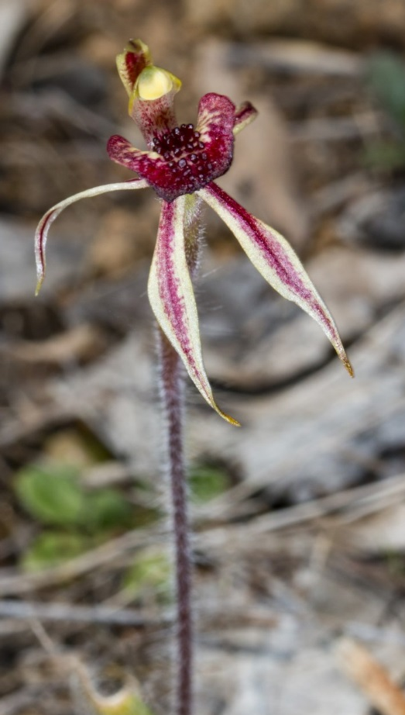
The Canberra Spider Orchid is listed as Critically Endangered in the ACT Threatened Native Species List under IUCN Criterion B and Criterion C. The factors that make it eligible include a very restricted geographic distribution that is precarious for the survival of the species; and a very low population with existing threats likely to lead to an ongoing decline in numbers, if not abated (TSSC 2005).

DESCRIPTION AND ECOLOGY
The Canberra Spider Orchid is a small terrestrial orchid that grows singly or in small groups to a height of 40 –90 mm. The flowers are solitary (rarely two), 12–20 mm in diameter and the base colour is greenish, heavily marked with red-crimson lines and suffusions (Jones and Clements 1999).
The Canberra Spider Orchid is a seasonal perennial, its leaf emerging from an underground tuber in late autumn or early winter following sufficient rainfall. Flower buds appear in late winter or early spring and plants flower from late September to mid-October. Flowers are insect pollinated by a thynnid wasp species. Plant shoots die back post-flowering and the tuber remains dormant over summer. Seeds require interactions with a mycorrhizal fungal host for germination and mature plants may also rely on such a host for supply of adequate carbon and nutrient supply (Milburn and Rouse 2004).
Canberra Spider Orchid (Derek Corrigan – Canberra Nature Map)

Distribution and Habitat
The Canberra Spider Orchid is endemic to the ACT. It is known from two main populations totalling more than 480 plants in 2014 (ACT Government 2019) in areas on the lower western slopes of Mt Ainslie and Mt Majura, in Canberra Nature Park. The species is also in the Majura Valley, on Department of Defence land, and in the Kowen Escarpment Nature Reserve.
At Ainslie–Majura, the Canberra Spider Orchid habitat are the transitional vegetation zones between Yellow Box — Red Gum Tableland Grassy Woodland (dominated by Eucalyptus blakelyi, E. melliodora and E. pauciflora) and Red Stringybark Tableland Grass/Shrub Forest (dominated by E. rossii) at an altitude of 645–745 m. Plants occur where the groundcover is grasses, forbs and low shrubs. The major population on Mt Majura grows in open areas amongst rocks where there is partial shade from the north, and in association with Allocasuarina verticillata (Milburn and Rouse 2004). It is assumed this is critical habitat for the maintenance and recovery of the species.

Threats
The Canberra Spider Orchid is likely to be highly threatened by climate change, disturbance and disease because of a very small and fragmented distribution in the ACT, likely low genetic diversity, a short flowering period, a dependence on a single sub-family of wasps for pollination and an important association with soil fungi. The most common disturbances to the habitat of the Canberra Spider Orchid are likely to be herbivore trampling, grazing, development and maintenance of infrastructures, and wildfire (ACT Government 2019).

Major Conservation Objectives
As stated in the Action Plan and National Recovery Plan (Frawley 2010a,b) the priority management objective is to preserve in perpetuity, in the wild, the known populations of the Canberra Spider Orchid. To achieve this the habitat of the Canberra Spider Orchid should be maintained throughout the ACT by allowing natural ecological processes to continue and to manage threatening processes by vigilance and prompt actions.

Conservation Issues and Proposed Management Actions
Actions (ACT Government 2019) will be undertaken to:
- protect sites where the species is known to occur in the ACT from unintended impacts
- manage the species and its habitat to maintain the potential for evolutionary development in the wild
- improve the long-term viability of populations through management of woodlands to increase habitat area and connect relict populations
- expand the range of the species in the ACT by identifying suitable habitat and establishing new populations by translocation
- improve understanding of the species’ ecology, habitat and threats
- strengthen stakeholder and community collaboration in the conservation of the species.

Other Relevant Advice, plans or Prescriptions
- ACT Draft Action Plan — Canberra Spider Orchid (ACT Government 2019)
- ACT Action Plan — Canberra Spider Orchid (Frawley 2010a)
- National Recovery Plan — Canberra Spider Orchid (Frawley 2010b)

Listing Background
The Canberra Spider Orchid (initially known as Arachnorchis actensis) was listed in the ACT as an Endangered species on 11 April 2005 in accordance with section 38 of the Nature Conservation Act 1980. At that time, the Flora and Fauna Committee (now the Scientific Committee) concluded that the assessment satisfied the following criteria:
1.2 Species is observed, estimated, inferred or suspected to be at risk of premature extinction in the ACT region in the near future, as demonstrated by:
1.2.4 Severely fragmented distribution for a species currently occurring over a small range or having a small area of occupancy within its range
1.2.6 Extremely small population.
The Canberra Spider Orchid was listed as Critically Endangered under the Environment Protection and Biodiversity Conservation Act 1999 (EPBC Act) on 6 June 2005. The Commonwealth Threatened Species Scientific Committee (TSSC) assessed the species as Critically Endangered under Criterion 2 and Criterion 3 (TSSC 2005).
Under the Nature Conservation Act 2014 the category of Critically Endangered was included on the Threatened Native Species List for the first time. In 2019, the Scientific Committee recommended the Canberra Spider Orchid be listed in the Critically Endangered category to align with the EPBC Act listing. The scientific name was also changed to Caladenia actensis to align with the EPBC Act listing as this is the original, preferred name with Arachnorchis actensis recognised as the nomenclatural synonym (CHAH 2009).

References
ACT Parks and Conservation Service 1999. Canberra Nature Park Management Plan (Environment ACT, Canberra).
ACT Government 2019. Canberra Spider Orchid Arachnorchis actensis Draft Action Plan. Environment Planning and Sustainable Development Directorate, Canberra. https://www.legislation.act.gov.au/View/ni/2019-184/current/PDF/2019-184.PDF
Backhouse, GN, Bates RJ, Brown AP and Copeland LM 2016. Checklist of the orchids of Australia including its island territories: 6, 63. Accessed 23 January 2019 from: https://biodiversity.org.au/nsl/services/rest/reference/apni/6244000
Council of Heads of Australasian Herbaria (CHAH) 2009. Australian Plant Census. Accessed 23 January 2019 from: https://biodiversity.org.au/nsl/services/rest/reference/apni/47743
Frawley K 2010a. Action Plan for the Canberra Spider Orchid (Arachnorchis actensis), ACT Government. (This Action Plan was first published as a Recovery Plan adopted under the Commonwealth EPBC Act, see below.) Accessed 23 January 2019 from: https://www.environment.act.gov.au/__data/assets/pdf_file/0003/576552/Canberra_Spider_Orchid_Action_Plan_-_Combined.pdf
Frawley K 2010b. National Recovery Plan for the Canberra Spider Orchid Arachnorchis actensis. Canberra, Australian Capital Territory: ACT Department of Territory and Municipal Services. Accessed 23 January 2019 from: http://www.environment.gov.au/biodiversity/threatened/publications/recovery/caladenia-actensis.html.
Jones DL 1988. Native Orchids of Australia (Reed Books, Frenchs Forest, NSW).
Jones DL and Clements MA 1999. Caladenia actensis (Orchidaceae), a new species from the Australian Capital Territory. The Orchadian 12(11): 522–525.
Jones DL, Clements MA, Sharma IK and Mackenzie AM 2001. A new classification of Caladenia R.Br. (Orchidaceae). The Orchadian 13(9): 389–419.
Milburn PJ and Rouse DT 2004. Nomination of Arachnorchis actensis (D.L. Jones & M.A. Clements) D.L. Jones & M.A. Clements - for consideration as an endangered species in the Australian Capital Territory under the Nature Conservation Act 1980 (A1980–20) (Unpublished, nomination to ACT Flora and Fauna Committee, Environment ACT, Canberra).
Threatened Species Scientific Committee (TSSC) 2005. Commonwealth Listing Advice on Canberra Spider-orchid (Arachnorchis actensis). Accessed 23 January 2019 from: http://www.environment.gov.au/biodiversity/threatened/species/canberra-spider-orchid.html

Further Information
Further information on the related Action Plan or other threatened species and ecological communities can be obtained from the Environment, Planning and Sustainable Development Directorate (EPSDD).
Phone: (02) 132281, EPSDD Website: http://www.environment.act.gov.au/cpr

