Australian Capital Territory

Nature Conservation (Southern Bell Frog) Conservation Advice 2019

Notifiable instrument NI2019–244
made under the
Nature Conservation Act 2014, s 90C (Conservation advice)

1 Name of instrument
This instrument is the Nature Conservation (Southern Bell Frog) Conservation Advice 2019.

2 Commencement
This instrument commences on the day after its notification day.

3 Conservation advice for the Southern Bell Frog
Schedule 1 sets out the conservation advice for the Southern Bell Frog (Litoria raniformis).

Arthur Georges
Chair, Scientific Committee
1 May 2019
Schedule 1
(see s 3)

Conservation Advice
Southern Bell Frog
Litoria raniformis

Conservation Status
The Southern Bell Frog Litoria raniformis (Keferstein, 1867) is recognised as threatened in the following jurisdictions:
International Endangered, International Union for the Conservation of Nature (IUCN).
National Vulnerable, Environment Protection and Biodiversity Conservation Act 1999
ACT Vulnerable, Nature Conservation Act 2014
NSW Endangered, Biodiversity Conservation Act 2016
VIC Threatened, Flora and Fauna Guarantee Act 1988
Endangered, Advisory List of Threatened Vertebrate Fauna in Victoria
SA Vulnerable, National Parks and Wildlife Act 1972
Tasmania Vulnerable, Threatened Species Protection Act 1995

ELIGIBILITY
The Southern Bell Frog is listed as Vulnerable in the ACT Threatened Native Species List as it is listed as Vulnerable under the Environment Protection and Biodiversity Conservation Act 1999 (Cwlth) (EPBC Act) (Department of Environment 2018). The Southern Bell Frog is listed in the IUCN Red List under IUCN Criterion A2(a)(e) as endangered because of a drastic population decline estimated to be more than 50% over the last ten years (to 2004), in part due to amphibian chytrid fungus (Hero et al. 2004).

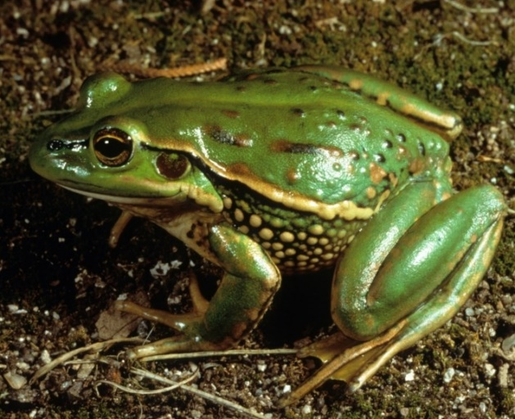
DESCRIPTION AND ECOLOGY
The Southern Bell Frog, family Hylidae, is a large frog, with females growing to at least 100 mm snout–urostyle length. Colouration varies from dull olive to bright emerald-green on the dorsum, with large irregular golden-bronze blotches. The groin and hind side of the thighs are usually bright bluish, while the lower sides and underside are off-white. The skin has numerous rounded warty projections on the back and sides (description from Barker et al. 1995 and Cogger 2000 in Clemann 2012). The male’s call is a growling, engine-like "waaa waaa waaa", heard during the breeding season (NSW Office of Environment and Heritage (OEH) 2017).
Southern Bell Frog (John Wombey – Canberra Nature Map)
Breeding occurs during the warmer months and is triggered by flooding or a significant rise in water levels. The species has been known to breed anytime from early spring through to late summer/early autumn (September to April) (OEH 2017). Tadpoles require standing water for at least 4 months for development and metamorphosis to occur but can take up to 12 months to develop. Outside the breeding season animals disperse away from the water and take shelter beneath ground debris such as fallen timber and bark, rocks, grass clumps and in deep soil cracks (OEH 2017). The species preys on a variety of invertebrates, as well as, other small frogs, including young of its own species (OEH 2017).

Distribution and Habitat
The Southern Bell Frog is endemic to south-eastern Australia, including South Australia, Victoria, Tasmania, New South Wales and the Australian Capital Territory (Clemann et al. 2012). The Southern Bell Frog was introduced to New Zealand in 1867, and is now widely distributed there (Gill and Whitaker 2001).
In NSW and the ACT, the range of the species was centred on the Murray and Murrumbidgee River valleys and their tributaries (DOE 2018). There are records of the Southern Bell Frog in the ACT from Majura in 1974 (Atlas of Living Australia (ALA) 2018) and Mt Clear in Namadgi National Park in 1980 (Canberra.naturemap.org 2018).
In terms of habitat requirements, the Southern Bell Frog is thought to be a generalist species that inhabits a wide range of environments that vary across its range. Sites frequently have a large proportion of emergent vegetation within or at the edges of still or slow-flowing water bodies such as lagoons, swamps, lakes, ponds, and farm dams (DEC 2005).

Threats
Threats to the Southern Bell Frog in the National Recovery Plan (Clemann 2012) include:
- habitat loss and degradation
- barriers to movement
- predation
- disease
- exposure to biocides.

Major Conservation Objectives
The species is considered to be locally extinct. The priority management objective in the ACT is to reduce the broad landscape threats that contributed to its local extinction. Reintroductions are not currently proposed but could be considered if broad-scale threats are managed and there is a need to re-establish wild populations in historical ranges.

Conservation Issues and Proposed Management Actions
Should the species be re-introduced into (or found in) the ACT, the following actions would be relevant (Clemann 2012):
- identify and protect important populations and prepare habitat management prescriptions at secured sites
- undertake population monitoring
- determine movement patterns
- determine historic and contemporary status of infection by the Chytrid Fungus
- determine the impact of fish predation
- test the responses to various water parameters and pollutants of all life stages
- investigate response to translocation, the creation of artificial habitats, and/or the re-creation or rehabilitation of habitat
- investigate the impact of fox and cat predation.

Other Relevant Advice, plans or Prescriptions
- National Recovery Plan — Southern Bell Frog (Clemann et al. 2012)

Listing Background
The Southern Bell Frog was initially listed as Vulnerable on 19 January 2000 under the Endangered Species Protection Act 1992 (Cwlth) and eligibility for listing carried over to the Environment Protection and Biodiversity and Conservation Act 1999 (EPBC Act) on 16 July 2000. In 2019, under the Nature Conservation Act 2014, the ACT Scientific Committee recommended that the Southern Bell Frog be listed in the Vulnerable category in the Threatened Native Species List in the ACT to align with the EPBC Act listing and be annotated as locally extinct in the ACT.

References
Atlas of Living Australia (ALA) 2018. Atlas of Living Australia. http://www.ala.org.au/
Canberra.naturemapr.org (CNM) 2018. Canberra Nature Map. https://canberra.naturemapr.org/Community/Species/3439
Clemann N and Gillespie GR 2012. National Recovery Plan for the Southern Bell Frog Litoria raniformis. State of Victoria Department of Sustainability and Environment, Melbourne. http://www.environment.gov.au/biodiversity/threatened/recovery-plans/national-recovery-plan-southern-bell-frog-litoria-raniformis
Department of the Environment 2018. Litoria raniformis in Species Profile and Threats Database. Department of the Environment, Canberra. http://www.environment.gov.au/cgi-bin/sprat/public/publicspecies.pl?taxon_id=1828
Department of Environment and Conservation (DEC) 2005. Southern Bell Frog (Litoria raniformis) Draft Recovery Plan. NSW Department of Environment and Conservation, Sydney. http://www.environment.nsw.gov.au/resources/nature/recoveryplanDraftSouthernBellFrog.pdf
Gill B and Whitaker T. 2001. New Zealand Frogs and Reptiles. 3rd Edition. David Bateman Ltd., Auckland.
Heard GW, Scroggie M and Malone B 2012. The life history and decline of the threatened Australian frog, Litoria raniformis. Austral Ecology 37: 276-284.
Hero J, Gillespie G, Lemckert F, Littlejohn M, Robertson P, Brereton R and Brown P 2004. Litoria raniformis (errata version published in 2016). The IUCN Red List of Threatened Species 2004. http://dx.doi.org/10.2305/IUCN.UK.2004.RLTS.T12152A3327485.en
Keferstein, W 1867. Ueber einige neue oder seltene Batrachier aus Australien und dem tropischen Amerika. Nachrichten von der Gesellschaft der Wissenschaften zu Göttingen 18:341–361.
Office of Environment and Heritage (OEH) 2017. Southern Bell Frog – profile. OEH NSW, Sydney. http://www.environment.nsw.gov.au/threatenedspecies/

Further Information
Further information on this or other threatened species and ecological communities can be obtained from the Environment, Planning and Sustainable Development Directorate (EPSDD).
Phone: (02) 132281, EPSDD Website: http://www.environment.act.gov.au/cpr

