Australian Capital Territory

Nature Conservation (Australian Painted Snipe) Conservation Advice 2019

Notifiable instrument NI2019–245
made under the
Nature Conservation Act 2014, s 90C (Conservation advice)

1 Name of instrument
This instrument is the Nature Conservation (Australian Painted Snipe) Conservation Advice 2019.

2 Commencement
This instrument commences on the day after its notification day.

3 Conservation advice for the Australian Painted Snipe
Schedule 1 sets out the conservation advice for the Australian Painted Snipe (Rostratula australis).

Arthur Georges
Chair, Scientific Committee
1 May 2019
Schedule 1
(see s 3)

Conservation Advice
Australian Painted Snipe
Rostratula australis

Conservation Status
The Australian Painted Snipe Rostratula australis (Gould, 1838) is recognised as threatened in the following jurisdictions:
International Endangered, International Union of Conservation of Nature (IUCN) Red List
National Endangered; Environment Protection and Biodiversity Conservation Act 1999
Endangered, Action Plan for Australian Birds 2010
ACT Endangered, Nature Conservation Act 2014
NSW Endangered, Biodiversity Conservation Act 2016
VIC Threatened, Flora and Fauna Guarantee Act 1988 (R. benghalensis (sensu lato)
Critically Endangered, Advisory List of Threatened Vertebrate Fauna 2013
QLD Vulnerable, Nature Conservation Act 1992
SA Vulnerable, National Parks and Wildlife Act 1972 (R. benghalensis (sensu lato)
NT Vulnerable, Territory Parks and Wildlife Conservation Act 2000 (R. benghalensis (sensu lato)
WA Endangered, Biodiversity Conservation Act 2016

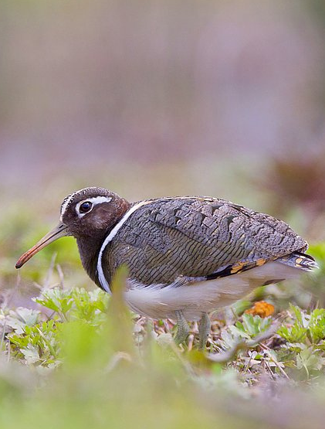
ELIGIBILITY
The Australian Painted Snipe is listed as Endangered in the ACT Threatened Native Species List under IUCN Criterion A — A2b. The factors that make it eligible for listing in the national category include a low population that is highly unlikely to exceed 2500 mature individuals and a decline (>50%) in reporting rates over the last three generations (25.8 years) which is likely to continue into the future if habitat loss is not abated (Threatened Species Scientific Committee (TSSC) 2011).

DESCRIPTION AND ECOLOGY
The Australian Painted Snipe is described as a stocky wading bird approximately 240–300 mm in length, with a wingspan of 500–540 mm and weighing 125–130 g (Birds Australia 2012).
Australian Painted Snipe (Tobias Hayashi – Canberra Birds)
It has a brown eye, white belly, bluish-green legs and long pink-orange bill darkening towards the tip (Schodde et al. 1997). The female has a chocolate-brown head with chestnut patch in the nape, a comma-shaped white marking around the eye, metallic green back and wings that are densely barred olive and black and a diagnostic white ‘harness marking’ that runs from the mantle onto the breast (D Rogers pers. comm. 2012 in DoE 2013). The male is smaller than the female and has a duller head and breast (D Rogers pers. comm. 2012 in DoE 2013); it has a mottled grey-brown head and neck, with buff stripe down the centre of the crown and through the eyes. Wings and back are barred black, buff and white, and the breast has a broad black band (Schodde et al. 1997). The juvenile is very similar to the adult male (Marchant and Higgins 1993).
The Australian Painted Snipe is a secretive nomad of Australia’s temporary inland wetlands. It usually remains among the cover of wetland vegetation while foraging. It feeds at night, probing the soft mud with its long bill as it walks, pecking at seeds and taking small invertebrates (Birdlife Australia 2018).
Breeding occurs from December to May in the north of the country and October to December in the south (Morcombe 2004). The male builds the nest, incubates the eggs (usually four) and rears the young, which hatch after 19–20 days (Morcombe 2004) and are covered in dense down (Schodde et al. 1997). The generation length of the Australian Painted Snipe is estimated to be 8.6 years (Garnett et al. 2011; BirdLife International 2016).

Distribution and Habitat
The Australian Painted Snipe is endemic to Australia and has been recorded at wetlands in all states and territories (Barrett et al. 2003; Blakers et al. 1984). The species is most common in eastern Australia where important areas for this species in the past have included the Murray-Darling Basin (particularly the Riverina of Victoria and New South Wales (NSW)), Queensland Channel Country, Fitzroy Basin of Central Queensland, south-eastern South Australia and adjacent parts of Victoria (Rogers et al. 2005).
The species is a rare visitor to the ACT. Four individuals were caught and banded when Lake Burley Griffin was filling in January 1969 (Frith in Wilson 1999). Sightings of one or two birds at Jerrabomberra Wetlands were recorded over the spring and early summer of 1972 and in December 1977 (McNaughton 1973 and 1978). One was sighted at the Fyshwick Sewage Treatment Works in January 1978 (Clark and Lenz 1978). The Australian Painted Snipe was not reported during the ACT Atlas survey (Taylor and Canberra Ornithologists Group (COG) 1992) and for many years after that.
In the spring of 2007, one bird was recorded at the Jerrabomberra Wetlands (COG 2009) and three birds arrived there in late September 2011 (COG 2013). One or two birds were reported during the spring of 2012 across several sites in Canberra (COG 2014). One bird was reported throughout the summer of 2013–2014 (COG 2015) at Jerrabomberra Wetlands. All records in the region in 2016–2017 were outside the ACT (COG 2018).
The Australian Painted Snipe lives in shallow freshwater (occasionally brackish) wetlands, both ephemeral and permanent, such as lakes, swamps, claypans, inundated or waterlogged grassland/saltmarsh, dams, rice crops, sewage farms and bore drains, generally with a good cover of grasses, rushes and reeds, low scrub, Muehlenbeckia spp. (lignum), open timber or samphire (Schodde et al. 1997; Marchant and Higgins 2003). The species is nomadic and when an area begins to dry up, becomes flooded or gets too cold the birds move away (Marchant and Higgins 2003). There is increasing evidence that the Australian Painted Snipe disperses from east to central and northern Australia for at least part of the year to exploit favourable seasonal conditions (Black et al. 2010).

Figure 1: Distribution of Australian Painted Snipe records in the ACT region – 1982–2017
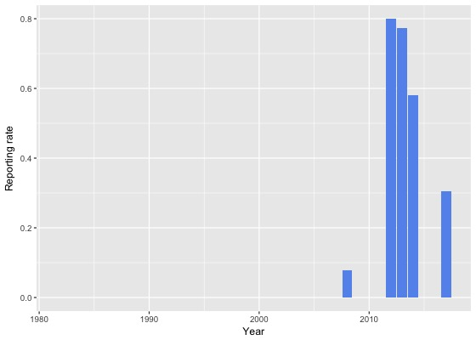
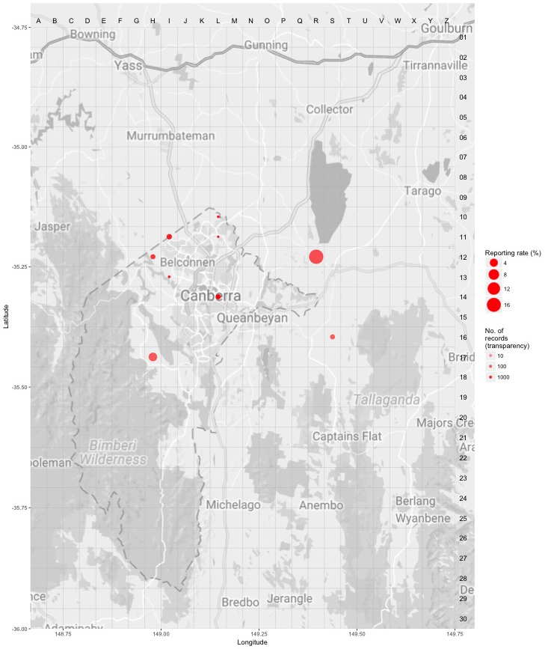
Source: Canberrabirds.org.au. (2018). Note: Reporting rate (%) is the proportion of all surveys in which the species was present. These data were collected by volunteer birdwatchers using various survey methods and, on some occasions, more than one person may have recorded bird sightings on the same day, which may skew the data.

Threats

As identified in the national Conservation Advice (DoE 2013) the main threat to the Australian Painted Snipe is the loss and degradation of wetlands, through drainage and the diversion of water for agriculture and reservoirs (Lane and Rogers 2000; Garnett et al. 2011). In NSW (OEH 2014), the threats are summarised as:
- drainage of breeding sites in wetlands (particularly in the Murray-Darling Basin)
- reduced water quality from siltation and pollution
- predation by foxes and feral cats
- use of herbicides, insecticides and other chemicals near wetlands
- grazing and associated frequent burning of wetlands
- exotic weeds and invasive native plants degrading wetland habitat
- poor understanding of the species' breeding ecology.

Major Conservation Objectives
The ACT is not regarded as a key site or as a former breeding site as individuals of the species are only infrequent visitors.

Conservation Issues and Proposed Management Actions
Some of the sites where the Australian Painted Snipe has been recorded in the ACT are protected for other species of birds facing similar threats (ACT Government 2018). Actions that could improve habitat for the species are to:
- maintain feral predator control around wetland areas
- maintain control of exotic weeds around wetland areas

Other Relevant Advice, plans or Prescriptions
- Commonwealth Listing Advice — Australian Painted Snipe (TSSC 2013)
- Commonwealth Conservation Advice — Australian Painted Snipe (DoE 2013)

Listing Background
The Australian Painted Snipe was initially listed as a Vulnerable species under the Environment Protection and Biodiversity and Conservation Act 1999 (EPBC Act) on 15 August 2003. It was transferred from the Vulnerable to the Endangered category, effective 15 May 2013 (meeting EPBC Criterion 1 (A2b)). In 2019, under the Nature Conservation Act 2014, the ACT Scientific Committee recommended the Australian Painted Snipe be listed in the Endangered category in the ACT Threatened Native Species List to align with the EPBC Act listing.
The species was listed on the List of Migratory Species and the List of Marine Species under the EPBC Act on 30 July 2000 and 4 August 2000, respectively, as Rostratula benghalensis. It was subsequently removed from the List of Migratory Species on the 30 June 2015.

References
ACT Government 2018. Action Plan for Listed Migratory Species. Environment, Planning and Sustainable Development Directorate, Australian Capital Territory, Canberra.
Barrett G, Silcocks A, Barry S, Cunningham R and Poulter R 2003. The New Atlas of Australian Birds. Royal Australasian Ornithologists Union, Hawthorn East.
Birdlife Australia 2018. Australian Painted Snipe. Birdlife.org.au. http://www.birdlife.org.au/bird-profile/australian-painted-snipe
BirdLife International. 2016. Rostratula australis. The IUCN Red List of Threatened Species 2016 http://dx.doi.org/10.2305/IUCN.UK.2016-3.RLTS.T22735692A95117342.en.
BirdLife International 2018. Species factsheet: Rostratula australis. http://datazone.birdlife.org/species/factsheet/australian-painted-snipe-rostratula-australis/text
Birds Australia (2012). Australian painted snipe Rostratula australis. http://www.birdsaustralia.com.au/our-projects/australian-painted-snipe.html
Black R, Houston W and Jaensch R 2010. Evidence of regular seasonal migration by Australian Painted Snipe Rostratula australis to the Queensland tropics in autumn and winter. Stilt 58: 1–9.
Blakers M, Davies SJJF and Reilly PN 1984. The Atlas of Australian birds. Royal Australasian Ornithologists Union. Melbourne University Press, Melbourne.
Clark GS and Lenz M 1978. Bird Report: 1 July 1977 to 30 June 1978. Canberra Bird Notes 4(3): 2–13.
COG 2009. Annual Bird Report: 1 July 2007 to 30 June 2008. Canberra Bird Notes 34(1): 1–80.
COG 2013. Annual Bird Report: 1 July 2011 to 30 June 2012. Canberra Bird Notes 38(1): 1–101.
COG 2014. Annual Bird Report: 1 July 2012 to 30 June 2013. Canberra Bird Notes 39(1): 1–106.
COG 2015. Annual Bird Report: 1 July 2013 to 30 June 2014. Canberra Bird Notes 40(1): 1–112.
Department of Environment (DoE) 2013. Approved Conservation Advice for Rostratula australis (Australian Painted Snipe). Department of Sustainability, Environment, Water, Population and Communities, Commonwealth Government, Canberra.
Garnett ST, Szabo JK and Dutson G 2011. The Action Plan for Australian Birds 2010. CSIRO Publishing, Collingwood.
Marchant S and Higgins PJ (eds) 1993. Handbook of Australian, New Zealand and Antarctic Birds. Volume 2: Raptors and Lapwings. Oxford University Press, Melbourne.
McNaughton J 1973. Listing of birds of the Fyshwick area. Canberra Bird Notes 2(6): 11–14.
McNaughton J 1978. Odd DBs – Kelly’s swamp. Canberra Bird Notes 4(3): 23.
Morcombe M 2004. Field Guide to Australian Birds (second edition). Steve Parish Publishing, Archerfield.
Office of Environment & Heritage (OEH) 2014. Australian Painted Snipe – profile. NSW Government. http://www.environment.nsw.gov.au/threatenedspeciesapp/profile.aspx?id=10734
Rogers D, Hnace I, Paton S, Tzaros C, Griffioen P, Herring M, Jaensch R, Oring L, Silcocks A and Weston M 2005. The breeding bottleneck: Breeding habitat and population decline in the Australian painted snipe. Status and Conservation of Shorebirds in the East Asian-Australasian Flyway. Proceedings of the Australasian Shorebirds Conference, 13–15 December 2003, Canberra.
Schodde R, Tidemann S and Reader's Digest Services 1997. Complete Book of Australian Birds (second edition). Reader's Digest Australia, Surry Hills.
Threatened Species Scientific Committee (TSSC) 2013. Commonwealth Listing Advice on Rostratula australis (Australian Painted Snipe). Department of Sustainability, Environment, Water, Population and Communities Commonwealth of Australia, Canberra.
Taylor M and Canberra Ornithologists Group (COG) 1992. Birds of the Australian Capital Territory – An Atlas. Canberra Ornithologist Group and National Capital Planning Authority, Canberra.
Wilson S 1999. Birds of the ACT: Two Centuries of Change. Canberra Ornithologists Group, Canberra.

Further Information
Further information on this or other threatened species and ecological communities can be obtained from the Environment, Planning and Sustainable Development Directorate (EPSDD).
Phone: (02) 132281, EPSDD Website: http://www.environment.act.gov.au/cpr

