Australian Capital Territory

**Nature Conservation (Glossy Black-cockatoo) Conservation Advice 2019**

**Notifiable instrument NI2019–248**

made under the

**Nature Conservation Act 2014, s 90C (Conservation advice)**

**1 Name of instrument**

This instrument is the *Nature Conservation (Glossy Black-cockatoo) Conservation Advice 2019*.

**2 Commencement**

This instrument commences on the day after its notification day.

**3 Conservation advice for the Glossy Black-cockatoo**

Schedule 1 sets out the conservation advice for the Glossy Black-cockatoo (*Calyptorhynchus lathami lathami*).

Arthur Georges

Chair, Scientific Committee

1 May 2019

**Schedule 1**

(see s 3)

Conservation Advice  
Glossy black-cockatoo –   
*Calyptorhynchus lathami lathami*

Conservation Status

The Glossy Black-cockatoo sub-species *Calyptorhynchus lathami lathami* (Temminck, 1807) is recognised as threatened in the following jurisdictions:

ACT **Vulnerable**, *Nature Conservation Act 2014*

NSW **Vulnerable**, *Biodiversity Conservation Act 2016*

QLD **Vulnerable**, *Nature Conservation Act 1992*

VIC **Threatened**, *Flora and Fauna Guarantee Act 1988*

ELIGIBILITY

The factors that make the Glossy Black-cockatoo eligible for listing as Vulnerable in the ACT Threatened Native Species List in the ACT are included in the Listing Background section below.

DESCRIPTION AND ECOLOGY

[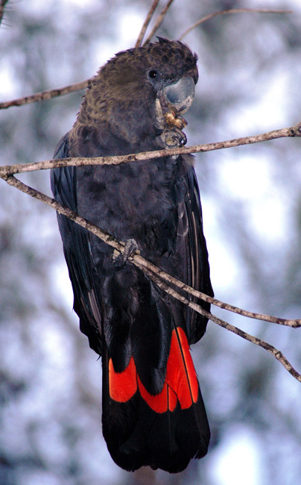](http://canberrabirds.org.au/wp-content/gallery/glossy_black-cockatoo/Black-Cockatoo_Glossy%204%20(Stuart%20Harris).jpg)The Glossy Black-cockatoo is the smallest of the black cockatoos, with an average length of 48 cm, a wingspan of 90 cm and weighing around 425 g. The adult male has a dusky blackish-brown plumage on the head, breast and belly and is dull black on the back and tail. The tail has distinctive solid bright red panels. The crest is inconspicuous and the bulbous bill, eye ring and legs are dark grey. The female is similar in appearance to the male except for irregular yellow patches around the neck and head, and orange/red tail panels. Immature birds of both sexes have fine yellow spotting on the face, shoulder and underwing, large spots or bars on the underbody and broad bars in the tail panel (Forshaw 1989; Crome and Shields 1992; Flegg and Longmore 1994; Higgins 1999; Cameron 2007).

The population of Glossy Black-cockatoos in south-eastern Australia *Calyptorhynchus lathami lathami* (which is the sub-species that occurs in the ACT) differs from the population in central eastern Queensland (*C. l. erebus*) and the isolated sub-species on Kangaroo Island in South Australia (*C. l. halmaturinus*) in the morphology of the beak and wing (Schodde et al. 1993).

[Glossy Black-cockatoo](http://canberrabirds.org.au/wp-content/gallery/glossy_black-cockatoo/Black-Cockatoo_Glossy%204%20(Stuart%20Harris).jpg) (Stuart Harris – Canberra Birds)

The Glossy Black-cockatoo is a social bird, typically observed in pairs or family groups. These small groups often aggregate to form larger feeding flocks. Diet is highly specialised, with birds feeding almost exclusively on the seeds of a range of sheoak species (Forshaw 1989; Cameron 2007). In the ACT region their food trees are largely restricted to mature age Drooping Sheoaks (*Allocasuarina verticillata*) (Holiday 2004). Feeding is concentrated in larger stands of sheoaks which reduces the need to move between trees and may offer energy benefits and reduced risk of predation (Cameron et al. 2006). The species is highly selective of both the trees and the cones they favour, often showing fidelity to particular trees in which they have foraged previously (Pepper et al. 2000).

Breeding in the NSW region occurrs from March to August and is thought to be timed with the reproduction of their local feed-tree species (Clout 1989; Crome and Shields 1992; Cameron 2007; Cameron 2009). A single egg is laid and incubated for 30 days, during which time the female usually remains on the nest and is fed by the male (Garnett et al. 1999). The nestling fledges after about 90 days, a longer nestling period than has been recorded for any other parrot (Garnett et al. 1999). The juvenile associates with its parents for at least the first year following fledging, in which time it learns to forage (Forshaw 1989; Cameron 2007).

Distribution and Habitat

The Glossy Black-cockatoo (south-eastern sub-species) is patchily distributed at low densities across south-eastern Australia from central Queensland to East Gippsland in Victoria, and inland to the southern tablelands and central-western plains of NSW, with a small population in the Riverina. Their highest densities occur east of the Great Dividing Range with a more scattered distribution inland (Forshaw 1989; Garnett 1992). It is probable that Glossy Black-cockatoos breed throughout their range. They are also occasionally recorded well beyond their usual range suggesting that the species moves between different areas when necessary (Garnett and Crowley 2000; Forshaw 2002).

Overall there has been a national decline in the sub-species and the population is possibly as low as 10,000 mature individuals (Garnett et al. 2011). In the Riverina, there has been a major decline in the population, with an estimate of no more than 40 birds (Forshaw 2002; Garnett et al. 2011).

The first published record of the Glossy Black-cockatoo in the ACT was in 1946 and the species was subsequently recorded occasionally throughout the 1970s and 1980s. The Mount Majura – Mount Ainslie complex is an important local refuge for the species (Holiday 2004). Sightings of the species in the ACT are rare, though a relatively high number of sightings were reported from the Majura Range in 2003 and 2004. The highest single count of the species recorded in the ACT was 16 birds on Majura Range in 2004 (Holiday 2004). The first record of breeding in the ACT was on Mount Majura in 2004 (Lenz et al. 2004). Reporting rates in the ACT region (Figure 1) have dropped in the past decade, with no sightings since 2016 and no breeding records since 2010–11 (COG 2018).

The Glossy Black-cockatoo nests in hollows in large eucalypts in woodland and open forests up to 1000 metres elevation. They utilise large, high, near-vertical hollows in aging or standing dead eucalypt trees and have been recorded nesting in Blakely’s Red Gum in the ACT (Scientific Committee 2018). They nest close to each other, which means they need breeding habitat with a relatively high density of suitably-sized hollows.

Mapping of vegetation communities in 2018 identified 670 ha of high quality foraging habitat of forest dominated by Drooping Sheoak (*Allocasuarina verticillata*) for Glossy Black-cockatoos in the ACT and 5,018 ha of moderate quality foraging habitat containing lower densities of Drooping Sheoak (ACT Government 2018).

**Figure 1: Distribution of Glossy Black-cockatoo records in the ACT region – 2017 and 1982–2017**

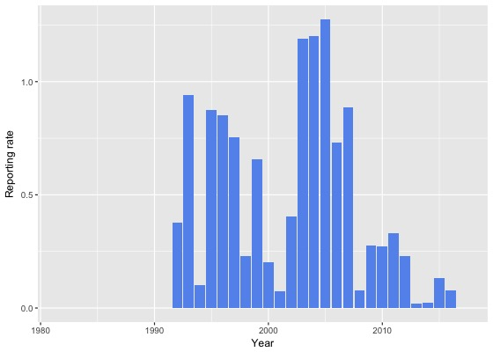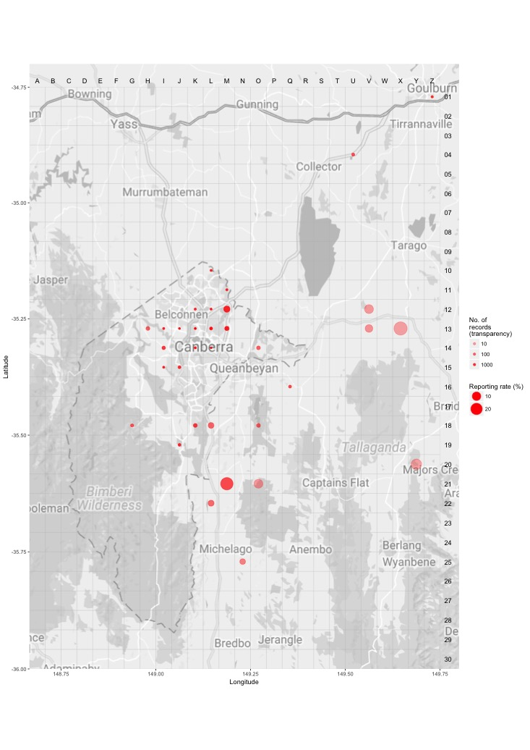

*Source: Canberrabirds.org.au (2018). Note: Reporting rate (%) is the proportion of all surveys in which the species was present. These data were collected by volunteer birdwatchers using various survey methods and on some occasions more than one person may have recorded bird sightings on the same day, which may skew the data.*

Threats

The main apparent threat to the Glossy Black-cockatoo is the degradation, loss and fragmentation of foraging and breeding habitat. In particular, the loss of canopy seed banks of feed trees by clearing or regular burning, as well as poor regeneration of these trees due to grazing, can significantly reduce available food sources. Loss of hollow-bearing nesting trees within the proximity of feed tree stands is also likely to be a significant impediment to successful breeding (Garnett and Crowley 2000; Mooney and Pedler 2005; Morgan et al. 2015).

Drooping Sheoak (*Allocasuarina verticillata*) is killed by crown fires. In the ACT, vegetation community mapping shows that 67% of all high quality foraging habitat and 82% of all moderate quality foraging habitat was burnt in the 2003 wildfires. While these areas are regenerating well, it will take a number of years (>25yrs) for the trees to reach their maximum cone-bearing potential resulting in the numbers of Glossy Black-cockatoos not expected to improve in the ACT for some years to come. Improvement focuses around core stepping stones of habitat with significant plantings of feed trees undertaken across reserves in the ACT. Ecological guidelines call for patch burning, retention of mature trees and 25 year gaps between planned fires. Protected areas of habitat are identified in the development of Bush Fire Operational Plans (ACT Government 2018).

Predation and competition for nest sites by Brush-tailed Possums (*Trichosurus vulpecula*) severely impacted breeding success of the Kangaroo Island sub-species in the past (Garnett et al. 1999; Mooney and Pedler 2005; Morgan et al. 2015), and has potential to affect birds in the ACT region. Successful protection of nesting trees from possums, in addition to restoration of habitat and provision of nest boxes, has reversed a decline in the Kangaroo Island sub-species (Mooney and Pedler 2005; Morgan et al. 2015). It is unknown to what extent competition for nest hollows from other Psittaciformes, such as Galahs, corellas and Sulphur-crested Cockatoos, may affect Glossy Black-cockatoos.

Illegal harvesting is a potential concern as there is evidence suggesting that Glossy Black-cockatoos from the Riverina district in NSW have been trapped for the illegal bird trade (OEH 2018).

The Glossy Black-cockatoo is also likely to be at risk from the effects of climate change, as the range of its main feed tree species is likely to be altered under high CO2 emission scenarios (Harris et al. 2012).

Major Conservation Objectives

The primary objective is to maintain a viable, wild population of Glossy Black-cockatoos in the ACT and region (ACT Government 2013).

Conservation Issues and Proposed Management Actions

The conservation actions detailed in the Action Plan (ACT Government 2013) and progress report (ACT Government 2018) are to:

* protect (especially mature hollow-bearing trees), manage and monitor habitat
* monitor the distribution, movement, abundance, demographics and breeding success
* maintain and enhance connectivity through plantings of Drooping Sheoak
* encourage and support the continuation and further development of community-based conservation activities
* manage hazard reduction activities in and around stands of Drooping Sheoak (at least 25 year gaps between planned burns)
* minimise nest hollow competition.

Other Relevant Advice, plans or Prescriptions

* ACT [Glossy Black-cockatoo Action Plan](https://www.environment.act.gov.au/__data/assets/pdf_file/0012/576579/Glossy_Black_AP_Final.pdf) (ACT Government 2013)
* [ACT Conservation Advice – Loss of Mature Trees](https://www.legislation.act.gov.au/View/ni/2018-536/current/PDF/2018-536.PDF) (Scientific Committee 2018)
* [ACT Woodland Conservation Strategy](http://www.environment.act.gov.au/cpr/conservation_and_ecological_communities/threatened_species_action_plans) (ACT Government 2004)
* [ACT Draft Woodland Conservation Strategy](https://www.legislation.act.gov.au/View/ni/2019-184/current/PDF/2019-184.PDF) (ACT Government 2019)
* [Glossy Black-cockatoo Conservation Guidelines](https://glossyblack.org.au/wp-content/uploads/2017/06/GBC-C-GUIDEL-published.pdf) (Glossy Black Conservancy 2010)
* Commonwealth [Conservation Advice Glossy Black-cockatoo (Kangaroo Island)](http://www.environment.gov.au/biodiversity/threatened/species/pubs/64436-conservation-advice-01042016.pdf) (TSSC 2016)

Listing Background

The Glossy Black-cockatoo was listed in the ACT as a Vulnerable species on 23 August 2010 in accordance with section 38 of the *Nature Conservation Act 1980*. The Flora and Fauna Committee (now Scientific Committee) concluded that at that time the assessment satisfied the criteria:

2.2 The species is observed, estimated, inferred or suspected to be at risk of premature extinction in the ACT region in the medium-term future, as demonstrated by:

2.2.4 Seriously fragmented distribution for a species currently occurring over a moderately small range or having a moderately small area of occupancy within its range.

References

ACT Government 2004. *Woodlands for Wildlife: ACT Lowland Woodland Conservation Strategy. Action Plan No. 27*. Environment ACT, Canberra.

ACT Government 2013. *Glossy Black-cockatoo Calyptorhynchus lathami Action Plan*. Action Plan No. 33. ACT Government, Canberra.

ACT Government 2018. Unpublished progress report – Glossy Black-cockatoo *Calyptorhynchus lathami* Action Plan No. 33. Environment Planning and Sustainable development Directorate, Canberra.

ACT Government 2019. *Draft ACT Woodland Conservation Strategy and Action Plans*. Environment Planning and Sustainable Development Directorate, Canberra.

Cameron M 2007. Cockatoos. In: *Australian Natural History Series*. CSIRO Publishing, Collingwood.

Cameron M 2009. The influence of climate on Glossy Black-cockatoo reproduction. *Pacific Conservation Biology* 15: 597–607.

Cameron M and Cunningham RB 2006. Habitat selection at multiple spatial scales by foraging Glossy Black-cockatoos. *Austral Ecology* 31: 597–607.

Canberrabirds.org.au 2018. Canberra Birds Glossy Black-cockatoo *Calyptorhynchus lathami* data sheet. Accessed 15 November 2018 from: <http://canberrabirds.org.au/wp-content/bird_data/265_Glossy%20Black-Cockatoo.html>

Clout MN 1989. Foraging Behaviour of Glossy Black-cockatoos. *Australian Wildlife Research* 16: 467–473.

COG 2018. Annual Bird Report: 1 July 2016 to 30 June 2017. *Canberra Bird Notes* 43(1): 1–110.

Crome F and Shields J 1992. *Parrots and Pigeons of Australia*. Angus and Robertson, Sydney.

Flegg J and Longmore N 1994. *Photographic Field Guide: Birds of Australia*. Reader's Digest (Australia) Pty Ltd, Sydney.

Forshaw J 2002. *Australian Parrots* (Third ed.). Alexander Editions, Robina.

Forshaw JM 1989. *Parrots of the World* (Third ed.). Landsdowne Editions, Willoughby.

Garnett S 1992. Threatened and Extinct birds of Australia. Royal Australasian Ornithologists Union (RAOU) Report 82.

Garnett ST and Crowley GM. 2000. *The Action Plan for Australian Birds*. Environment Australia, Canberra.

Garnett ST Pedler LP and Crowley GM 1999. The breeding biology of the Glossy Black-cockatoo, *Calyptorhynchus lathami*, on Kangaroo Island, South Australia. *Emu* 99: 262–79.

Garnett ST, Szabo JK and Duston G 2011. *The Action Plan for Australian Birds 2010*. CSIRO Publishing and Birds Australia, Melbourne.

Glossy Black Conservancy 2010. Glossy Black-cockatoo Conservation Guidelines for South-Eastern Queensland and Far North-Eastern New South Wales. Glossy Black Conservancy.

Harris JB, Fordham DA, Mooney PA, Pdeler LP, Araujo MB, Paton DC, Brook BW 2012. Managing the long-term persistence of a rare cockatoo under climate change. *Journal of Applied Ecology* 49(4): 785–794.

Higgins PJ 1999. *Handbook of Australian, New Zealand and Antarctic Birds* (Vol. 4 Parrots to Dollarbird). Oxford University Press, South Melbourne.

Holiday S 2004. The Glossy Black-cockatoo in the Australian Capital Territory. *Canberra Bird Notes* 29: 126–130.

Lenz M, Dabb G, Green T, Gourlay T, Holliday S, Buckley P and Oren Y 2004. First record of the Glossy Black-cockatoo breeding in the Australian Capital Territory. *Canberra Bird Notes* 29: 131–136.

Mooney PA and Pedler LP 2005. Recovery Plan for the South Australian Sub-species of the Glossy Black-cockatoo (*Calyptorhynchus lathami halmaturinus*): 2005–2010. Glossy Black-cockatoo Recovery Program. Department for Environment and Heritage, Kangaroo Island.

Morgan D, Barth M and Kinloch M 2015. The South Australian sub-species of the Glossy Black-cockatoo (*Calyptorhynchus lathami halmaturinus*) Strategic Plan 2015–2020. Natural Resources, Kangaroo Island.

NSW Office of Environment and Heritage (OEH) 2018. *Glossy Black-cockatoo – profile*. Accessed 14 November 2018 from: <https://www.environment.nsw.gov.au/threatenedSpeciesApp/profile.aspx?id=10140>

Pepper JW, Male TD and Roberts GE 2000. Foraging ecology of the South Australian Glossy Black-cockatoo (*Calyptorhynchus lathami halmaturinus*). *Austral Ecology* 25: 16–24.

Schodde R, Mason IJ and Wood JT 1993. Geographical differentiation in the Glossy Black-cockatoo *Calyptorhynchus lathami* (Temminck) and its history. *Emu* 93: 156–166.

Scientific Committee 2018. Conservation Advice – Loss of mature native trees (including hollow bearing trees) and a lack of recruitment. Environment Planning and Sustainable Development Directorate, ACT Government, Canberra.

Temminck CJ 1807. *Catalogue Systématique du Cabinet d'Ornithologie et de la Collection de Quadrumanes de Crd. Jb. Temminck*. Avec une courte description des oiseaux non-descrits suivi: d'une nôte d'oiseaux doubles et de quelques autres objets d'histoire naturelle offerts en éxchange. C. Sepp, Amsterdam.

Threatened Species Scientific Committee (TSSC) 2016. *Conservation Advice Calyptorhynchus lathami halmaturinus Glossy Black-cockatoo (Kangaroo Island)*. Department of the Environment, Canberra.

Further Information

Further information on the Action Plan or other threatened species and ecological communities can be obtained from: Environment, Planning and Sustainable Development Directorate (EPSDD).  
Phone: (02) 132281, EPSDD Website: <http://www.environment.act.gov.au/cpr>