Australian Capital Territory

Nature Conservation (Hooded Robin) Conservation Advice 2019

Notifiable instrument NI2019–249
made under the
Nature Conservation Act 2014, s 90C (Conservation advice)

1 Name of instrument
This instrument is the Nature Conservation (Hooded Robin) Conservation Advice 2019.

2 Commencement
This instrument commences on the day after its notification day.

3 Conservation advice for the Hooded Robin
Schedule 1 sets out the conservation advice for the Hooded Robin (Melanodryas cucullata cucullata).

Arthur Georges
Chair, Scientific Committee
1 May 2019
Schedule 1
(see s 3)

Conservation Advice
Hooded RObin
Melanodryas cucullata cucullata

Conservation Status
The Hooded Robin Melanodryas cucullata cucullata (Latham, 1801) is recognised as threatened in the following jurisdictions:
National Critically Endangered, Tiwi Islands sub-species – M. c. melvillensis, Environment Protection and Biodiversity Conservation Act 1999
Critically Endangered (possibly Extinct), Tiwi Islands sub-species – M. c. melvillensis, Action Plan for Australian Birds 2010
Near Threatened, Action Plan for Australian Birds 2010
ACT Vulnerable, Nature Conservation Act 2014
NSW Vulnerable, Biodiversity Conservation Act 2016
Victoria Threatened, species – Melanodryas cucullata, Flora and Fauna Guarantee Act 1988
Near Threatened, Advisory List of Threatened Vertebrate Fauna 2013
NT Critically Endangered, Tiwi Islands sub-species – M. c. melvillensis, Territory Parks and Wildlife Conservation Act 2000
SA Rare, National Parks and Wildlife Act 1972

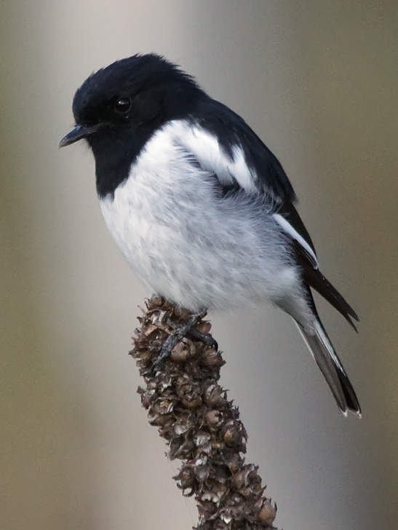
ELIGIBILITY
The factors that make the Hooded Robin eligible for listing as Vulnerable in the Threatened Native Species List in the ACT are included in the Listing Background section below.

DESCRIPTION AND ECOLOGY
Melanodryas cucullata cucullata is the sub-species of Hooded Robin resident in the ACT. It is a medium-large robin, measuring 14–17 cm in length, with a rather short slender bill and a moderately long tail which is square-tipped. Adult males are pied (black and white) with a black hood and back, white underparts, black wings, white shoulder bar and wing stripe. Females are similar to males but greyer with a brown-grey head and a dark brown wing with a white stripe. Juveniles are dark brown with off-white speckling, white markings on the upper body and white underneath (Birdlife Australia 2018).
Adult male Hooded Robin (David Cook – Canberra Birds)
Flight is short and swiftly undulating. The adult male is unmistakable but the female and young males may be confused with other species, such as the Jacky Winter (Microeca fascinans). Hooded Robins are distinguished from aesthetically similar species by their larger size, distinctive white wing bar and different 'hourglass' shaped tail markings (OEH 2017).
The Hooded Robin is a shy and largely sedentary bird. Hooded Robins are often quiet during the day, especially in the afternoon, but are one of the first birds to call in the morning, when they vigorously add their far-carrying song to the dawn chorus (Birdlife Australia 2018). The call is a series of descending, fading, mellow notes. They are never numerous, do not flock but are frequently observed in pairs or small groups. They hunt for invertebrates by ‘perch and pounce’ in grassy clearings where rocks and fallen timber litter the ground (Sullivan 1993).
Hooded Robins breed in monogamous pairs, prefer a particular breeding site and the female incubates the eggs. Pairs occupy territories of between five and fifty hectares. Small territories are defended in the breeding season (August to December) and the species occupy larger home ranges in the non-breeding season (Bell 1984; Blakers et al. 1984; Schodde and Tidemann 1986; Fitri 1993; Graham 1995). The species builds open cup nests from bark strips, leaves, grass and spiders’ web placed on stumps or in a cavity in a broken trunk or horizontal fork or branch 1–6 m above ground (Pizzey and Knight 1998). Generation length is estimated as 5.3 years (Garnett et al. 2011).

Distribution and Habitat
Four intraspecific taxa of the Hooded Robin (Melanodryas cucullata) are recognized, together distributed across most of mainland Australia: M. c. melvillensis (Tiwi Islands, NT); M. c. westralensis (south-western arid zone); M. c. picata (northern inland); and M. c. cucullata (south-eastern) (Schodde and Mason 1999; Garnett and Crowley 2000).
The south-eastern sub-species M. c. cucullata occurs from Mundubbera in Queensland, to the Spencer Gulf in South Australia, intergrading with the other sub-species through the northern Murray-Darling basin. This is the sub-species that is the breeding resident of the ACT and it has a total estimated extent of occurrence of 1.1million km² and area of occupancy of 10,000 km² (Garnett et al. 2011). The sub-species, however, is either declining or has vanished entirely from many habitat fragments and regions across its range, particularly in eucalypt-dominated woodlands and wetter areas of the south and east (Robinson 1993; Barrett et al. 1994; Paton et al. 1994; Fitri and Ford 1996; Robinson and Traill 1996; Olsen et al. 2005; Priday 2010; Ford 2011; Garnett et al. 2011).
In the ACT, small groups have been observed in grassy woodlands in the north and open areas in valleys in the south (ACT Government 1999). Taylor and Canberra Ornithologists Group (COG) (1992) stated that Hooded Robins were once common close to the city, however, local disappearances have been documented at a number of sites including Black Mountain, Campbell Park, Mt Ainslie and Tuggeranong Homestead. There were 40 active territories (or pairs) estimated in the ACT in 1991 (Graham 1995).
On Canberra Nature Map (CNM 2018) the Hooded Robin has been recorded at: Percival Hill, Mulligans Flat and Goorooyarroo in the north; Coree, Woodstock and Lower Cotter Catchment in the west; Tuggeranong, Paddys River, Tidbinbilla, Namadgi National Park, Gigerline, Booth and Tennent in the south; and in nearby NSW at Googong, Googong Foreshore, Burra, Michelago and Wallaroo.
Data analysis of COG’s woodland surveys between 1995 and 2003 at eleven key woodland sites indicated a decline in abundance of the Hooded Robin, including Mulligans Flat Nature Reserve. The species was also recorded at: the Newline quarry; the southern part of Majura Field firing range; and north of Tharwa (Cunningham 2003 in ACT Government 2004).
In a study on the largest woodland corridor in the ACT from Hall to Newline, Bounds (2006) estimated there were only four to six Hooded Robin territories in the Mulligans Flat/Goorooyarroo Nature Reserve complex of around 1500 hectares including two territories in Mulligans Flat on the eastern side of the reserve and two to three territories in Goorooyarroo, in the northern part of the reserve. It was also thought that there were only one or two territories in the Kinlyside woodlands near Hall (three records of one to two birds, 2002–2003) and possibly two to three territories in the Majura Field Range (11 records of one to five birds, 1998–2006) (N Taws, A Rowell pers comm, in Bounds 2006).
Analysis from surveys conducted between 1998 and 2005 as part of the COG Woodland Project, indicated that the Hooded Robin decreased in occupancy rate (detection rate) across the project's fourteen locations by 24% (Bounds et al. 2007). In further analyses in 2008 (Bounds et al. 2010) and 2010, the rate of Hooded Robin occupancy was too low for meaningful statistical analysis.
There have been further fluctuations and continuing declines in sightings of Hooded Robins in the ACT (COG 2018) (Figure 1 and 2). Sightings of 42 birds were recorded in 2016–2017 (82 in 2015–2016) in the ACT region with most occurring in open woodland in nearby NSW to the east of the ACT (Figure 2) (COG 2018).

Figure 1: Hooded Robin records in the ACT region – 1982–2017
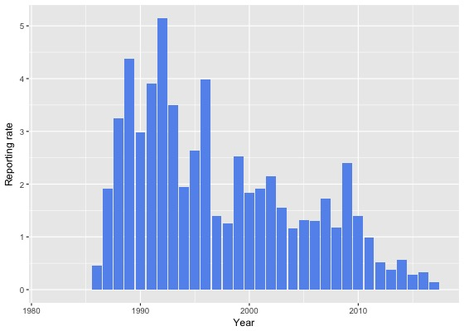
Source: Canberrabirds.org.au. (2018). Note: Reporting rate (%) is the proportion of all surveys in which the species was present. These data were collected by volunteer birdwatchers using various survey methods and, on some occasions, more than one person may have recorded bird sightings on the same day, which may skew the data.

Critical habitat features required by the Hooded Robin include:
- large trees for protective cover
- areas of grass that support insects and other invertebrates on which the species feeds
- perching sites within these grassy areas
- trees or shrubs (either standing or fallen) to provide sites for nesting (Graham 1990).
Figure 2: Hooded Robin distribution in the ACT region – 2017
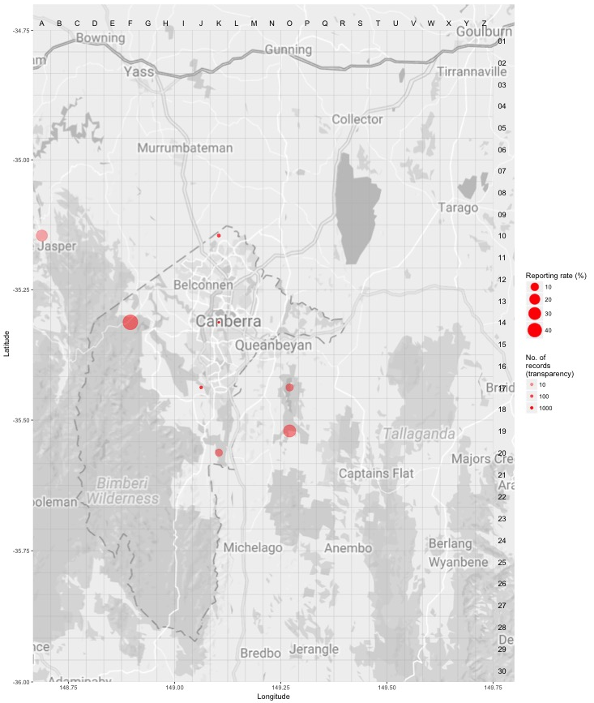Source: Canberrabirds.org.au. (2018). Note: Reporting rate (%) is the proportion of all surveys in which the species was present. These data were collected by volunteer birdwatchers using various survey methods and, on some occasions, more than one person may have recorded bird sightings on the same day, day, which may skew the data.
Hooded Robin territories usually have some patches of eucalypt regrowth. The species requires more vegetation cover in the breeding season, as nests are typically built in saplings and small trees. The results of research on the species near Armidale suggested that nesting habitat, including small patches of eucalypt regrowth, may be in shorter supply than foraging areas (Fitri 1993). The distribution of the Hooded Robin in the ACT is restricted to habitats that contain a mixture of woodland and native grassland away from urban areas (Graham 1990).
Figure 3: Hooded Robin distribution in the ACT region – 1982–2017
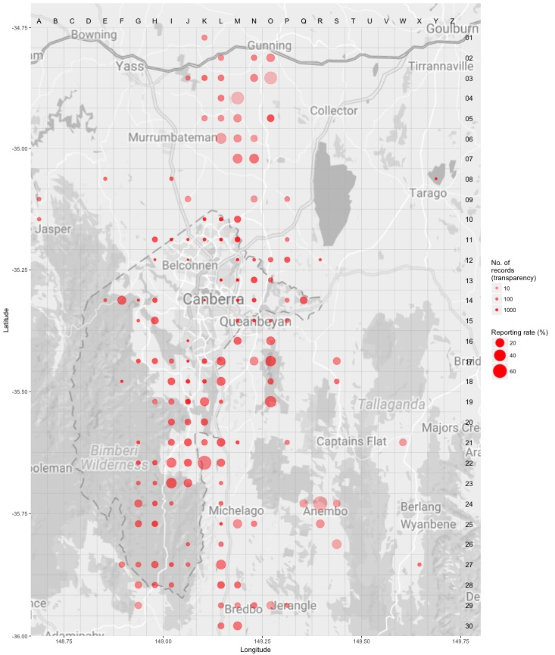Source: Canberrabirds.org.au. (2018). Note: Reporting rate (%) is the proportion of all surveys in which the species was present. These data were collected by volunteer birdwatchers using various survey methods and, on some occasions, more than one person may have recorded bird sightings on the same day, day, which may skew the data.

Threats
In common with many other threatened bird species, the principal threat to the Hooded Robin is loss of its woodland habitat. The modification of the structure of grassy woodland habitat has contributed to the decline of the Hooded Robin. The loss of perching sites essential for foraging may alone be sufficient to make otherwise suitable habitat unsuitable (Graham 1990). Therefore, the removal of timber for firewood is likely to result in local reduction of Hooded Robin numbers.
Nevertheless, nesting habitat, including small patches of eucalypt regrowth, may be in shorter supply than in foraging areas (Fitri 1993; ACT Government 1999). The species requires more vegetation cover in the breeding season as nests are typically built in saplings and small trees. High levels of nest predation leading to poor recruitment was suggested to be the likely cause of decline in Hooded Robins (Ford 2011) and it is possible that habitat degradation such as the removal of understory species and tree cover has exposed the Hooded Robin to higher rates of predation.
Threats to the Hooded Robin (ACT Government 2004) include:
- removal of fallen timber and litter and inappropriate fire regimes
- predation by feral and/or uncontrolled domestic animals (foxes, dogs and cats)
- invasion of key habitats by introduced pasture and weeds
- uncontrolled grazing by livestock
- clearing of both living and dead trees
- rural tree dieback
- inappropriate fire regimes.

Major Conservation Objectives
The primary objective in the ACT is to protect Hooded Robin habitat through limiting clearance of suitable woodland habitat and prioritising conservation management to woodland patches, particularly those that are large or have complex habitat structure.

Conservation Issues and Proposed Management Actions
The conservation actions relevant to the Hooded Robin in the ACT Lowland Woodland Conservation Strategy (ACT Government 2004) include the following:
- protect habitat
- maintain and enhance connectivity
- limit removal of live and dead timber
- reduce intensive grazing
- maintain patches of shrubs or eucalypt regrowth
- regenerate habitat
- minimise adverse effects of fire.

Other Relevant Advice, plans or Prescriptions
- ACT Woodland Conservation Strategy (ACT Government 2004)
- ACT Draft Woodland Conservation Strategy (ACT Government 2019)

Listing Background
The Hooded Robin was initially listed in the ACT as Melanodryas cucullata as a Vulnerable species on 30 May 1997 in accordance with section 38 of the Nature Conservation Act 1980.
The Flora and Fauna Committee (now Scientific Committee) concluded that at that time the assessment satisfied the criteria:
2.2 The species is observed, estimated, inferred or suspected to be at risk of premature extinction in the ACT region in the medium-term future, as demonstrated by:
2.2.1 Current serious decline in population or distribution from evidence based on:
2.2.1.1 Direct observation, including comparison of historical and current records; and
2.2.1.3 Serious decline in quality or quantity of habitat.
2.2.5 Continuing decline or serious fragmentation in population, for species with a moderately small current population.
Under the Nature Conservation ACT 2014 it is possible to list at the sub-species level where there are differentiated threats across the species range. M. c. melvillensis (Tiwi Islands) is listed as Critically Endangered in the Northern Territory. M. c. westralensis (south-western arid zone) and M. c. picata (northern inland) sub-species are not listed as threatened in their range states. Melanodryas cucullata cucullata is the only sub-species in the ACT and nearby NSW and is listed as Vulnerable in NSW, Rare in South Australia and Near Threatened in Victoria.

References
ACT Government 1999. Hooded Robin (Melanodryas cucullata): A Vulnerable Species. Action Plan No.15. Environment ACT, Canberra.
ACT Government 2004. Woodlands for Wildlife: ACT Lowland Woodland Conservation Strategy. Action Plan No. 27. Environment ACT, Canberra.
ACT Government 2019. Draft ACT Woodland Conservation Strategy and Action Plans. Environment Planning and Sustainable Development Directorate, Canberra.
Allan B 2009. The Canberra Bird Blitz 2008, Canberra Bird Notes 34(2): 111–125.
Bell HL 1984. A note on communal breeding and dispersal of young of the Hooded Robin Petroica cucullata. Emu 84: 243–244.
BirdLife Australia 2018. Hooded Robin Profile. Birdlife.org.au. Accessed 21 May 2018 from: http://www.birdlife.org.au/bird-profile/hooded-robin.
BirdLife International 2017. Melanodryas cucullata (amended version of assessment). The IUCN Red List of Threatened Species 2017. Accessed 21 May 2018 from: http://dx.doi.org/10.2305/IUCN.UK.2017-3.RLTS.T22704837A118832667.en.
Blakers M, Davies SJJF and Reilly PN 1984. The Atlas of Australian Birds. Melbourne University Press and RAOU, Melbourne.
Bounds J 2006. The status of Hooded Robins in the Hall to Newline woodland corridor. Canberra Bird Notes 31(4): 169–177.
Bounds J, Cunningham R and Taws N 2007. A statistical analysis of trends in occupancy rates of woodland birds in the ACT, December 1998 to December 2005. Canberra Bird Notes 32(2): 73–98.
Bounds J, Taws N and Cunningham R 2010. A statistical analysis of trends in occupancy rates of woodland birds in the ACT, December 1998 to December 2008: the ten-year data analysis. Canberra Bird Notes 35(3): 158–191.
Canberrabirds.org.au (2018). Hooded Robin Melanodryas cucullata data sheet. Accessed 22 August 2018 from: http://canberrabirds.org.au/wp-content/bird_data/385_Hooded%20Robin.html
Canberra.naturemapr.org (CNM) 2018. Canberra Nature Map. Accessed 22 August 2018 from: https://canberra.naturemapr.org/Community/Species/15146.
COG 2013. Bird Report – Hooded Robin Melanodryas cucullata – 1 July 1981 – 30 June 2013. Canberra Ornithologists Group, Canberra.
COG 2018. Annual Bird Report: 1 July 2016 to 30 June 2017. Canberra Bird Notes 43(1): 1–110.
Cunningham R 2003. A statistical analysis of the status and trends of woodland birds in the ACT. COG database, Canberra Ornithologists Group, Canberra.
Fitri LL 1993. Ecology and behaviour of Hooded Robins Melanodryas cucullata in the Northern Tablelands of New South Wales. Unpublished MSc thesis, University of New England, Armidale.
Fitri L and Ford HA 1996. Status, habitat and social organisation of the Hooded Robin Melandoryas cucullata in the New England Region of New South Wales. Australian Bird Watcher 17: 142–155.
Ford HA 2011. The causes of decline of birds of eucalypt woodlands: advances in our knowledge over the last 10 years. Emu 111: 1–9.
Freudenberger D 1999. Guidelines for enhancing grassy woodlands for the vegetation investment project. CSIRO Wildlife and Ecology, Canberra.
Garnett ST and Crowley GM 2000. The Action Plan for Australian Birds 2000. Environment Australia, Canberra.
Garnett ST, Szabo JK and Dutson G 2011. The Action Plan for Australian Birds. CSIRO Publishing, Collingwood, Victoria.
Graham B 1990. Habitat requirements of two pairs of Hooded Robins near Canberra – a preliminary report. Canberra Bird Notes 15(2): 22– 27.
Graham B. 1995 Hooded Robin: Bird of the year for 1991, Canberra Bird Notes 20(3): 49–58.
Latham J 1801. Supplementum Indicis, Sive Systematis Ornithologiae. G. Leigh and J. and S. Sotherby, London, 51.
Office of Environment and Heritage (OEH) 2017. Hooded Robin (south-eastern form) – Profile. Accessed 21 May 2018 from: https://www.environment.nsw.gov.au/threatenedSpeciesApp/profile.aspx?id=10519
Olsen P, Weston M, Tzaros C and Silcocks A 2005. The state of Australia’s birds 2005. Woodlands and birds. Supplement to Wingspan 15: 1–32.
Paton DC, Carpenter G and Sinclair RG 1994. A second bird atlas of the Adelaide region. Part 1: changes in the distribution of birds 1974–75 vs 1984–85. South Australian Ornithologist 31: 151–193.
Pizzey G and Knight F 1998. Field Guide to the Birds of Australia. Angus and Robertson (Harper Collins), Sydney.
Priday SD 2010. Beyond the woody remnant paradigm in conservation of woodland birds: habitat requirements of the Hooded Robin (Melanodryas cucullata cucullata). Emu 110: 118–124
Reid J 1999. Threatened and declining birds in the New South Wales sheep–wheat belt: 1. Diagnosis, characteristics and management. Consultancy report to NSW National Parks and Wildlife Service, CSIRO Sustainable Ecosystems, Canberra.
Robinson D 1993. Vale Toolern Vale: the loss of our woodland birds. Wingspan 9: 1–4.
Robinson D and Traill BJ 1996. Conserving Woodland Birds in the Wheat and Sheep Belts of Southern Australia. RAOU (Birds Australia), Melbourne.
Schodde R and Tidemann SC 1986. Complete Book of Australian Birds. Readers Digest, Sydney.
Sullivan D 1993. The breeding and non–breeding behaviour of the Hooded Robin Melanodryas cucullata in Canberra, 1990–1991. Australian Bird Watcher 15: 99–107.
Taylor M and Canberra Ornithologists Group (COG) 1992. Birds of the Australian Capital Territory – An Atlas. Canberra Ornithologist Group and National Capital Planning Authority, Canberra.

Further Information
Further information on the related Woodland Strategy or other threatened species and ecological communities can be obtained from the Environment, Planning and Sustainable Development Directorate (EPSDD). Phone: (02) 132281, EPSDD Website: http://www.environment.act.gov.au/cpr

