Australian Capital Territory

Nature Conservation (Painted Honeyeater) Conservation Advice 2019

Notifiable instrument NI2019–251
made under the
Nature Conservation Act 2014, s 90C (Conservation advice)

1 Name of instrument
This instrument is the Nature Conservation (Painted Honeyeater) Conservation Advice 2019.

2 Commencement
This instrument commences on the day after its notification day.

3 Conservation advice for the Painted Honeyeater
Schedule 1 sets out the conservation advice for the Painted Honeyeater (Grantiella picta).

Arthur Georges
Chair, Scientific Committee
1 May 2019
Schedule 1
(see s 3)

Conservation Advice
Painted Honeyeater
Grantiella picta

Conservation Status
The Painted Honeyeater Grantiella picta (Gould, 1838) is recognised as threatened in the following:
International Vulnerable, International Union of Conservation of Nature (IUCN) Red List (Birdlife International 2016)
National Vulnerable, Environment Protection and Biodiversity Conservation Act 1999
Vulnerable, Action Plan for Australian Birds 2010
ACT Vulnerable, Nature Conservation Act 2014
NSW Vulnerable, Biodiversity Conservation Act 2016
Victoria Threatened, Flora and Fauna Guarantee Act 1988
Vulnerable, Advisory List of Threatened Vertebrate Fauna 2013
QLD Vulnerable, Nature Conservation Act 1992
NT Vulnerable, Territory Parks and Wildlife Conservation Act 2000
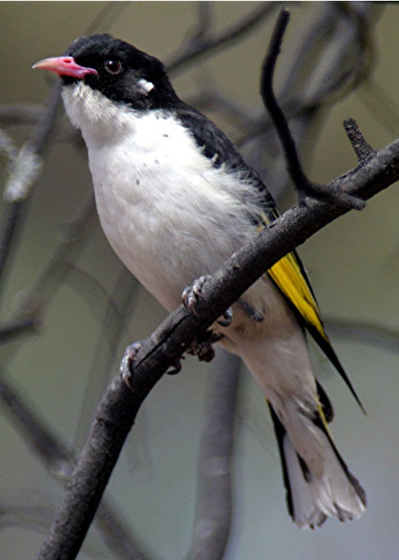
SA Rare, National Parks and Wildlife Act 1972

ELIGIBILITY
In the ACT the Painted Honeyeater is listed as Vulnerable in the Threatened Native Species List under IUCN Criterion C — C2a(ii), at the national level. The factors that make it eligible include: an estimated total national/global population <10 000, that is suspected to have declined by 20–29% over the last three generations; threats to the species’ already fragmented habitat are ongoing, suggesting the population is likely to continue to decline at a substantial rate; and its geographic distribution jeopardises its survival as 100% of mature individuals exist in one sub-population (Garnett et al. 2011; Department of the Environment (DoE) 2015).

DESCRIPTION AND ECOLOGY
The Painted Honeyeater is a small-to-medium sized honeyeater, measuring about 16 cm in length and weighing 20–25 g.
Adult male Painted Honeyeater (Geoffrey Dabb – Canberra Birds)
It has black upperparts, white underparts, black spots on its flanks and yellow edges to the flight and tail feathers. The bill is deep pink and the eye is red.
The females are smaller and browner on the back than the male, frequently with fewer streaks or spots on their breast and flanks (Higgins et al. 2001). Juveniles resemble the female. The Painted Honeyeater is the only small-to-medium honeyeater with a wholly or mostly pink bill, and the only yellow-winged honeyeater with almost wholly white underparts (marked only with sparse, fine and short black streaks) (Higgins et al. 2001).
The Painted Honeyeater often occurs singly or in pairs and less often in small flocks. It is the most specialised of Australia’s honeyeaters. Its diet mainly consists of mistletoe fruits, but also includes nectar (from flowering mistletoe, eucalypts and possibly banksias) and arthropods (Higgins et al. 2001; Garnett et al. 2011; BirdLife International 2018). Arthropods are important to the diet for nestlings and adults during the breeding season (Barea 2008a; Barea and Herrera 2009).
The Painted Honeyeater may breed in the ACT region between November and February when mistletoe fruits are most available. Nesting is in loose colonies. The species appears to prefer mistletoe as a nest substrate and selects nest sites in habitats where mistletoe prevalence and parasitism rates are high (Barea 2008b). It builds a flimsy cup nest made of plant-fibre, spiders’ webs and rootlets in the outer foliage of trees anywhere from 3 m to 20 m above the ground. Usually two to three eggs are laid in the nest and both parents incubate eggs, brood and feed young (Whitmore and Eller 1983; Schodde and Tidemann 1986; Higgins et al. 2001; Barea 2008b; Garnett et al. 2011; Barea 2012). The male bird defends the territory in a spectacular manner, flying high over the canopy and calling constantly (Eddy 1961).
Generation length is estimated at 5.8 years, with a maximum longevity in the wild estimated at 10.1 years (Garnett et al. 2011).

Distribution and Habitat
The Painted Honeyeater is sparsely distributed from south-eastern Australia to far southern Queensland, north through western Queensland to north-eastern Northern Territory. The greatest concentrations and almost all records of breeding come from south of the 26º S parallel, on inland slopes of the Great Dividing Range between the Grampians in Victoria and Roma in Queensland (Higgins et al. 2001). The species exhibits seasonal north-south movements in response to the fruiting of mistletoe, which is closely matched to its breeding season (Barea and Watson 2007). Many birds move after breeding to semi-arid regions including north-eastern South Australia, central and western Queensland, and central Northern Territory. The species is considered to have a single population given its dispersive habits (Garnett et al. 2011).
The Painted Honeyeater may visit the ACT region for short periods over late spring and summer and is described as a ‘rare breeding visitor’ to this region (Canberra Ornithologists Group (COG) 2018). There were only three published records of single birds or a pair in the Canberra region between 1951 and 2002—in woodland areas including Mt Ainslie, Captains Flat Road (NSW) and Macs Reef Road (NSW)—and two sightings at riverine locations at Casuarina Sands and Tharwa (Bounds 1994 in Bounds 2003). There was, however, an influx of Painted Honeyeaters to the ACT region in the spring-summer of 2002–2003 when the number and locations of COG sightings suggested at least 35 individuals present in the region with evidence of a few breeding. The influx was possibly due to the widespread drought affecting core habitat in western NSW and Queensland and the particularly abundant flowering and seeding of mistletoes that year in the ACT (Bounds 2003; Lenz and Dabb 2003).
Only a few reports of birds were made since 2002–2003 (Figure 1) with most sightings observed in 2013–2014 at six locations in the ACT region. Most of the 2013–2014 records were from Stony Creek Nature Reserve and comprised sightings of one to six birds (COG 2015). Sightings of single birds were recorded in 2014–2015 at Goorooyarroo Nature Reserve and Uriarra Road, no records of the Painted Honeyeater were documented in the region in 2015–2016 and only one record in 2016–2017 (COG 2016, 2017 and 2018).
Figure 1: Distribution of Painted Honeyeater records in the ACT region – 1982–2017
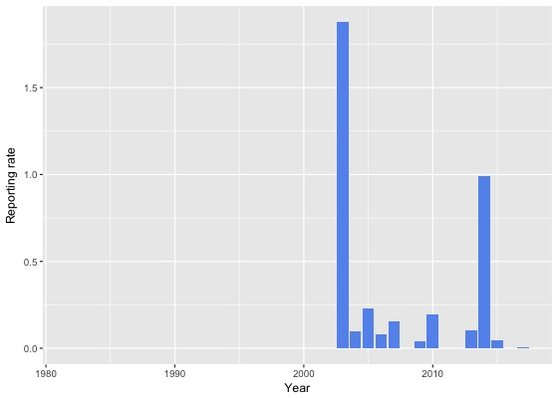
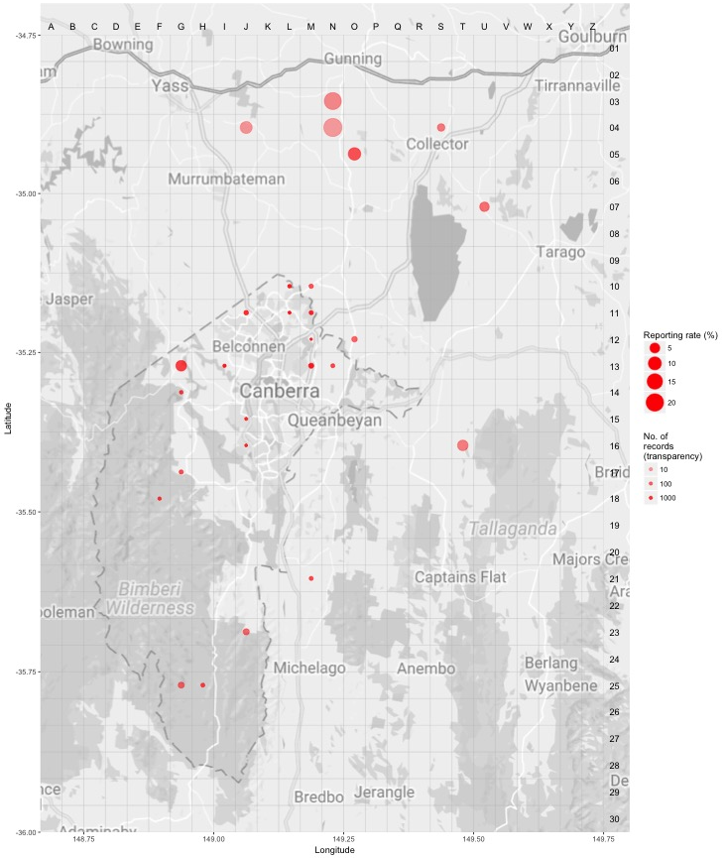
Source: Canberrabirds.org.au. (2018). Note: Reporting rate (%) is the proportion of all surveys in which the species was present. These data were collected by volunteer birdwatchers using various survey methods and on some occasions more than one person may have recorded bird sightings on the same day, which may skew the data.
In the ACT, the species has historically been associated with River Oak (Casuarina cunninghamiana) along river systems, especially the Murrumbidgee River, where River Oak is host to the Needle-leaf Mistletoe (Amyema cambagei). Wilson (1984) noted the large trees near Uriarra Crossing as a breeding area. However, since the earlier reports there have been no records of large numbers of Painted Honeyeaters associated with riverine Casuarina. The numerous sightings of Painted Honeyeaters during the dry spring-summer of 2002–2003 were from woodlands and forests away from the major river systems, including Mulligans Flat, Campbell Park, Rose Cottage Horse Paddocks, Mugga Lane, property near Callum Brae, ‘Bibaringa’ on Cotter Road, Mt Taylor, Tidbinbilla, near Hall and between Sutton and Gunning (Bounds 2003). From these records, favoured habitat was woodlands of predominately Yellow Box (Eucalyptus melliodora), Yellow Box – Blakely’s Red Gum (E. blakelyi), or Yellow Box and Blakely’s Red Gum in alliance with Red Box (E. polyanthemos) or Apple Box (E. bridgesiana), with abundant clumps of Box Mistletoe (Amyema miquelii) (Bounds 2003).
The Painted Honeyeater prefers woodlands that contain a higher number of mature trees, as these host more mistletoes and it prefers wider blocks of remnant woodland to narrower strips (Garnett et al. 2011). However, it will breed in quite narrow roadside strips if ample mistletoe fruit is available (D. Watson in litt. 2007, Barea 2008a in BirdLife International 2016).

Threats
Threats to the Painted Honeyeater identified in the Commonwealth Conservation Advice (DoE 2015) include:
- habitat loss through clearing of breeding and non-breeding habitat (Barea 2008a)
- habitat degradation by grazing of livestock, native macropods and rabbits (Oryctolagus cuniculus) (Garnett et al. 2011) and lack of recruitment
- removal of mistletoe from trees on rural land and in production forests
- competition with the aggressive Noisy Miner (Manorina melanocephala)
- nest predation by over-abundant Pied Currawongs (Strepera graculina), Pied and Grey Butcherbirds (Cracticus nigrogularis and C. torquatus), and crows and ravens (Corvidae) (K. Lindsay pers. comm. 2014 in DoE 2015; DEPI 2014).

Major Conservation Objectives
The primary conservation objectives in the Commonwealth Conservation Advice (DoE 2015) are to:
- maintain a stable population at key sites
- limit clearance of suitable habitat
- retain adequate numbers of mature trees and mistletoe across the Painted Honeyeater’s distribution.
The primary objective in the ACT is to protect Painted Honeyeater habitat through limiting clearance of suitable woodland habitat.

Conservation Issues and Proposed Management Actions
The conservation actions relevant to the Painted Honeyeater in the ACT Lowland Woodland Conservation Strategy (ACT Government 2004) include:
- maintain woodland remnants and isolated paddock trees
- limit removal of live and dead timber
- regenerate habitat
- minimise adverse effects of fire.

Other Relevant Advice, plans or Prescriptions
- Commonwealth Conservation Advice – Painted Honeyeater (DoE 2015)
- ACT Woodland Conservation Strategy (ACT Government 2004)
- ACT Draft Woodland Conservation Strategy (ACT Government 2019)
- Conservation Advice – Loss of Mature Trees (Scientific Committee 2018)

Listing Background
The Painted Honeyeater was initially listed in the ACT as a Vulnerable species on 12 January 1998 (DI1998–7) in accordance with section 38 of the Nature Conservation Act 1980.
The Flora and Fauna Committee (now Scientific Committee) concluded that the assessment satisfied the following criteria:
1.1 The species is known or suspected to occur in the ACT region and is already recognised as endangered in an authoritative international or national listing.
1.2 The species is observed, estimated, inferred or suspected to be at risk of premature extinction in the ACT region in the near future, as demonstrated by:
1.2.1 Current severe decline in population or distribution from evidence based on:
1.2.1.1 Direct observation, including comparison of historical and current records
1.2.1.3 Severe decline in quality and quantity of habitat.
1.2.6 Extremely small population.
This species was included in the Vulnerable category, under the Commonwealth Environment Protection and Biodiversity Conservation Act 1999 (EPBC Act) on 8 July 2015 following assessment by the Commonwealth Threatened Species Scientific Committee that it met the elements of IUCN Criterion C2a(ii) (DoE 2015).

References
ACT Government 1999. Painted Honeyeater (Grantiella picta): A vulnerable species. Action Plan No. 19. Environment ACT, Canberra.
ACT Government 2004. Woodlands for Wildlife: ACT Lowland Woodland Conservation Strategy. Action Plan No. 27. Environment ACT, Canberra.
ACT Government 2019. Draft ACT Woodland Conservation Strategy and Action Plans. Environment Planning and Sustainable Development Directorate, Canberra.
Barea LP 2008a. Interactions between Frugivores and their Resources: Case Studies with the Painted Honeyeater Grantiella picta. PhD Thesis, Charles Sturt University.
Barea LP 2008b. Nest-site selection by the Painted Honeyeater (Grantiella picta), a mistletoe specialist. Emu 108: 213-220.
Barea LP 2012. Habitat influences on nest-site selection by the Painted Honeyeater (Grantiella picta): do food resources matter? Emu 112: 39–45.
Barea LP and Herrera MLG 2009. Sources of protein in two semi-arid zone mistletoe specialists: Insights from stable isotopes. Austral Ecology 34: 821–828.
Barea LP and Watson DM 2007. Temporal variation in food resources determines onset of breeding in an Australian mistletoe specialist. Emu 107: 203–209.
BirdLife International 2016. Grantiella picta. The IUCN Red List of Threatened Species 2016. http://dx.doi.org/10.2305/IUCN.UK.2016-3.RLTS.T22704412A93966989.en
BirdLife International 2018. Species factsheet: Grantiella picta. http://datazone.birdlife.org/species/factsheet/painted-honeyeater-grantiella-picta/text
Bounds J 2003. Painted Honeyeater reports in the Canberra region during the 2002–03 influx. Canberra Bird Notes 28(2): 56–62.
Bounds J 2004. Painted Honeyeater reports in the Canberra region since the 2002–03 influx. Canberra Bird Notes 29(4): 143–145.
Canberra.naturemapr.org (CNM) 2018. Canberra Nature Map. https://canberra.naturemapr.org/Community/Species/15146
Canberrabirds.org.au. (2018). Painted Honeyeater Grantiella picta data sheet. http://canberrabirds.org.au/wp-content/bird_data/598_Painted%20Honeyeater.html
Canberra Ornithologists Group (COG) 2018. Painted Honeyeater – Canberra Birds. http://canberrabirds.org.au/birds/painted-honeyeater/
COG 2015. Annual Bird Report: 1 July 2013 to 30 June 2014. Canberra Bird Notes 40(1): 1–112.
COG 2016. Annual Bird Report: 1 July 2014 to 30 June 2015. Canberra Bird Notes 41(1): 1–110.
COG 2017. Annual Bird Report: 1 July 2015 to 30 June 2016. Canberra Bird Notes 42(1): 1–110.
COG 2018. Annual Bird Report: 1 July 2016 to 30 June 2017. Canberra Bird Notes 43(1): 1–110.
Department of the Environment 2015. Conservation Advice Grantiella picta (Painted Honeyeater). Department of the Environment, Commonwealth Government, Canberra.
Department of Environment and Primary Industries (DEPI) 2014. Submission in response to the listing nomination for the painted honeyeater. Flora and Fauna Guarantee Scientific Advisory Committee, Department of Environment and Primary Industries, Victoria.
Eddy RJ 1961. Twenty years of Painted Honeyeaters. Australian Bird Watcher 1: 122–128.
Garnett ST and Crowley GM 2000. The Action Plan for Australian Birds 2000. Environment Australia, Canberra.
Garnett ST, Szabo JK and Dutson G 2011. The Action Plan for Australian Birds. CSIRO Publishing, Collingwood.
Gould J 1838. A Synopsis of the Birds of Australia, and the Adjacent Islands. J Gould, London, pl.71
Higgins PJ, Peter JM and Steele WK 2001. Handbook of Australian, New Zealand and Antarctic Birds. Vol.5 Tyrant-Flycatchers to Chats. Oxford University Press, Melbourne.
Lenz M and Dabb G 2003. Breeding by Painted Honeyeaters in the Canberra region during the 2002–03 influx. Canberra Bird Notes 28(1): 1–9.
Schodde R and Tidemann SC 1986. Complete Book of Australian Birds. (2nd ed.) Reader’s Digest, Sydney.
Scientific Committee 2018. Conservation Advice – Loss of Mature Trees (including Hollow-bearing Trees) and Lack of Recruitment. ACT Government, Canberra.
Simpson K and Day N 1999. Field Guide to the Birds of Australia, 6th Edition. Penguin, Ringwood.
Whitmore MJ and Eller CM 1983. Observations at a nest of Painted Honeyeaters. Emu 83: 199–202.
Wilson SJ 1984. Painted Honeyeater, in Frith HJ (ed.) Birds in the Australian High Country (2nd Edition). Angus and Robertson, Sydney.
Wilson S 1999. Birds of the ACT: Two Centuries of Change. Canberra Ornithologists Group, Canberra.
Taylor M and Canberra Ornithologists Group (COG) 1992. Birds of the Australian Capital Territory – An Atlas. Canberra Ornithologist Group and National Capital Planning Authority, Canberra.

Further Information
Further information on the species or other threatened species and ecological communities can be obtained from the Environment, Planning and Sustainable Development Directorate (EPSDD).
Phone: (02) 132281, EPSDD Website: http://www.environment.act.gov.au/cpr

