Australian Capital Territory

Nature Conservation (Superb Parrot) Conservation Advice 2019

Notifiable instrument NI2019–254
made under the
Nature Conservation Act 2014, s 90C (Conservation advice)

1 Name of instrument
This instrument is the Nature Conservation (Superb Parrot) Conservation Advice 2019.

2 Commencement
This instrument commences on the day after its notification day.

3 Conservation advice for the Superb Parrot
Schedule 1 sets out the conservation advice for the Superb Parrot (Polytelis swainsonii).

Arthur Georges
Chair, Scientific Committee
1 May 2019
Schedule 1
(see s 3)

Conservation Advice
Superb Parrot – Polytelis swainsonii

Conservation Status
The Superb Parrot Polytelis swainsonii (Desmarest, 1826) is recognised as threatened in the following jurisdictions:
National Vulnerable, Environment Protection and Biodiversity Conservation Act 1999
ACT Vulnerable, Nature Conservation Act 2014
NSW Vulnerable, Biodiversity Conservation Act 2016
VIC Threatened, Flora and Fauna Guarantee Act 1988
Endangered, Advisory List of Threatened Vertebrate Fauna 2013

ELIGIBILITY
The Superb Parrot is listed as Vulnerable in the ACT Threatened Native Species List under IUCN Criterion A – A4(a)(c). The factors that make it eligible nationally include data indicating population reduction across a substantial portion of its range and a predicted continuing population decline caused by ongoing loss of woodland habitat and hollow bearing trees combined with climate change impacts (Threatened Species Scientific Committee (TSSC) 2016).

DESCRIPTION AND ECOLOGY
The Superb Parrot is a medium-sized (36–42 cm long; 133–157g), slender grass-green parrot with a distinctively long tail and sharply back-angled wings in flight. The male’s general plumage is brilliant green with yellow-green underparts. The forehead, throat and cheeks are yellow and there is a scarlet band across the fore-neck. The female is green, with a dull bluish-green face. Both sexes have a yellow iris and a coral red bill. Immature birds resemble the adult female, except that the iris is pale brown and young males are slightly brighter green (Forshaw and Cooper 1981). It is extremely difficult to distinguish immatures from females in the field.
Superb Parrots are usually seen in pairs or in flocks of up to 30 birds in the non-breeding season. Females leave the flocks to begin nesting, which occurs between September and December (Forshaw and Cooper 1981).
Adult Male Superb Parrot (Stuart Harris – Canberra Birds)
Loose nesting colonies of up to nine pairs are often found, and form around clusters of nest trees (Webster 1988). Pairs usually nest in separate trees, however, two or more active nests have occasionally been found in hollows in the same tree (Webster 1988). Four to six eggs are laid and incubated for about 20 days. The female remains at the nest throughout incubation and until the chicks are well developed, while the male collects food and brings it to her and her chicks (Webster 1988). Chicks are then fed by both parents until fledging at about five weeks (Forshaw and Cooper 1981).
The Superb Parrot is active mostly in the early morning and late afternoon when it feeds on the ground (on grass seeds), shrubs, understorey or in trees (Higgins 1999). Davey (1997) found that, in the ACT region, Superb Parrots rarely feed in trees, preferring to feed on the ground, particularly favouring grasses and other plants associated with Yellow Box-Red Gum Grassy Woodland. The species also eats fruits, berries, nectar flowers, and occasionally insects (Higgins 1999).

Distribution and Habitat
The Superb Parrot occurs in central and eastern inland NSW, northern ACT (Figure 1) and northern central Victoria. The species moves to northern NSW in the winter months (Webster & Ahern, 1992).
The Superb Parrot is a highly mobile species which undertakes distinct movements between breeding and non-breeding parts of its range each year, although some birds in parts of the NSW Murray-Riverina area may be present all year round (Webster and Ahern 1992). Birds utilise different habitats for different activities, and movements are believed to occur based on changes in food availability, for example, during periods of drought or the commencement of eucalypt flowering (Higgins 1999). Birds avoid crossing large open areas, preferring to move along wooded corridors when foraging locally (Baker-Gabb 2011). In the ACT region, the Yellow Box-Red Gum Grassy Woodlands form the major habitat of the species, with large Blakely’s Red Gum (Eucalyptus blakelyi) and Scribbly Gum (Eucalyptus rossii) being the main source of nesting hollows, and the woodland understorey being the main feeding habitat (Davey 1997; Rayner et al. 2015; Rayner et al. 2016).
In the ACT region, Superb Parrots are present during the breeding season (spring–summer) and are sparsely distributed in the area between Canberra, Yass, Sutton and Gundaroo (Davey, 1997), which coincides with the distribution of Yellow Box-Red Gum Grassy Woodlands.
Local historical records and results of surveys for Superb Parrots are summarised in Davey (1997) and show a decline in numbers. While reporting rates for the Superb Parrot in the ACT have been relatively high since 2010 they have begun to decline in the last few years (Figure 2). Surveys at Throsby and Spring Valley during the 2015–16 season located 12 active nests from which an estimated 43 nestlings fledged successfully (Rayner et al. 2015), however, in the following year only five active nests were located despite increased search effort – a 58% decline in nesting effort (Rayner et al. 2016). Only 13 nestlings successfully fledged in the 2016–17 season, representing a 70% decrease in breeding productivity (Rayner et al. 2016). Increased nest competition with other hollow-nesting species such as Crimson Rosellas (Platycercus elegans) and Eastern Rosellas (P. eximus) due to a delayed arrival of Superb Parrots by two weeks, combined with fewer birds arriving or staying to breed may have contributed to the observed decline in nesting effort (Rayner et al. 2016). These two recent surveys demonstrate the high temporal variability in the ACT Superb Parrot population.
Figure 1: Superb Parrot distribution in the ACT region – 2017
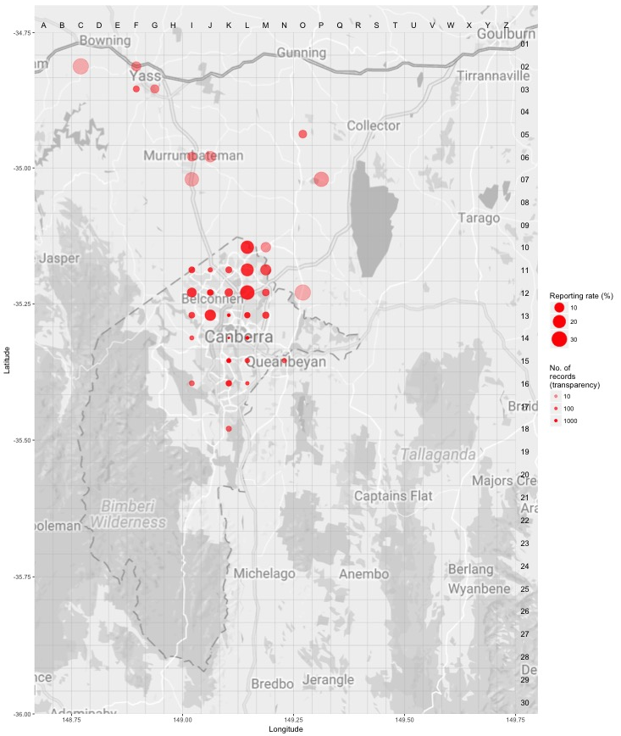
Source: Canberrabirds.org.au (2018). Note: Reporting rate (%) is the proportion of all surveys in which the species was present. These data were collected by volunteer birdwatchers using various survey methods and on some occasions more than one person may have recorded bird sightings on the same day, which may skew the data.
Figure 1: Superb Parrot distribution in the ACT region – 1982–2017
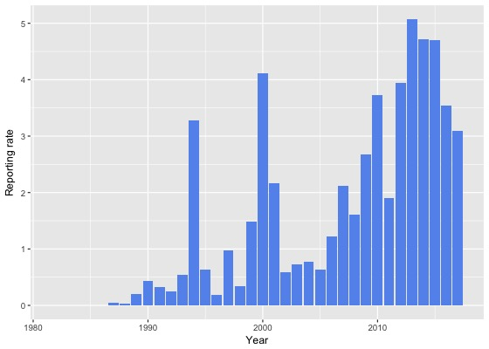
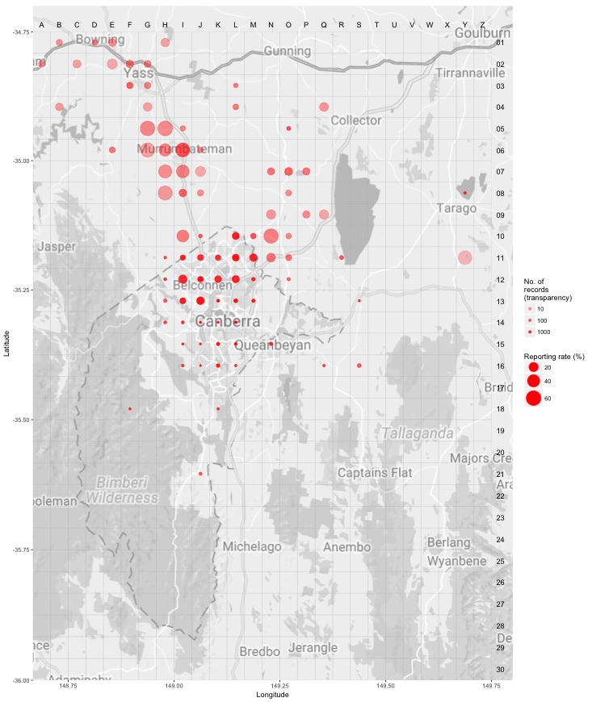 Source: Canberrabirds.org.au (2018). Note: Reporting rate (%) is the proportion of all surveys in which the species was present. These data were collected by volunteer birdwatchers using various survey methods and on some occasions more than one person may have recorded bird sightings on the same day, which may skew the data.

Threats
Ongoing habitat loss in the ACT, NSW and Victoria represents the single biggest threat to the survival of the Superb Parrot in the wild. Threats to the Superb Parrot identified in the Commonwealth Conservation Advice (TSSC 2016) include: loss and degradation of habitat; competition for resources within altered habitats; collision mortality; illegal wildlife capture and trading; Psittacine Beak and Feather Disease (PBFD); climate change.
Within the ACT, the ACT Government (2019a) has identified three key threats to maintaining a viable, stable and breeding population of Superb Parrots including:
- habitat loss
- climate change
- nest competition.

Major Conservation Objectives
The primary objective is the conservation of woodland habitats, with particular focus on protecting mature, hollow-bearing trees for nesting (TSSC 2016).

The primary objective in the ACT is to protect Superb Parrot breeding habitat through conserving Yellow Box–Red Gum Grassy Woodlands and limiting clearance of large living and dead trees.

Conservation Issues and Proposed Management Actions
The primary conservation objective in the Draft Action Plan (ACT Government 2019a) is addressed by several detailed actions under the following objectives:
- protect landscapes that support known breeding colonies
- manage open woodland to increase breeding and foraging habitat area
- manage urban landscapes to aid connectivity and promote foraging habitat.

Other Relevant Advice, plans or Prescriptions
- ACT Draft Action Plan – Superb Parrot (ACT Government 2019a)
- ACT Action Plan Superb Parrot (ACT Government 1997)
- ACT Action Plan Yellow Box/Red Gum Grassy Woodland (ACT Government 1997)
- ACT Woodland Conservation Strategy (ACT Government 2004)
- ACT Draft Woodland Conservation Strategy (ACT Government 2019b)
- National Recovery Plan for the Superb Parrot (Baker-Gabb 2011)
- Commonwealth Conservation Advice Superb Parrot (TSSC 2016)
- ACT Conservation Advice – Loss of Mature Trees (including Hollow-bearing Trees) and Lack of Recruitment (Scientific Committee 2018)

Listing Background
The Superb Parrot was initially listed as a Vulnerable species on 19 May 1997 in accordance with section 21 of the Nature Conservation Act 1980. At that time, the Flora and Fauna Committee (now Scientific Committee) concluded that the assessment satisfied the following criteria:
2.1 The species is known to occur in the ACT region and is already recognised as vulnerable in an authoritative international or national listing. (Endangered under the Commonwealth Endangered Species Protection Act 1992 (ESP Act) at the time of listing.)
2.2 The species is observed, estimated, inferred or suspected to be at risk of premature extinction in the ACT region in the medium-term future, as demonstrated by:
2.2.1 Current serious decline in population or distribution from evidence based on:
2.2.1.1 direct observation, including comparison of historical and current records;
2.2.1.3 serious decline in quality and quantity of habitat; and
2.2.1.5 serious threats from herbivores, predators, parasites, pathogens or competitors.
2.2.4 Seriously fragmented distribution for a species currently occurring over a moderately small range or having a moderately small area of occupancy within its range.
2.2.6 Small population.

The Superb Parrot was initially listed as Endangered under the Commonwealth Endangered Species Protection Act 1992 (ESP Act). The species was then transferred to the subsequent Environment Protection and Biodiversity Conservation Act 1999 (EPBC Act) on 16 July 2000 as Vulnerable following assessment of new information.

References
ACT Government 1997. Superb Parrot Polytelis swainsonii Action Plan No. 17. ACT Government, Canberra.
ACT Government 1999. Yellow Box/Red Gum Grassy Woodland: An endangered ecological community Action Plan No. 10. Environment ACT, Canberra.
ACT Government 2004. Woodlands for Wildlife: ACT Lowland Woodland Conservation Strategy Action Plan No. 27. Environment ACT, Canberra.
ACT Government 2019a. Draft Action Plan – Superb Parrot Polytelis swainsonii. Environment Planning and Sustainable Development Directorate, Canberra.
ACT Government 2019b. Draft ACT Woodland Conservation Strategy and Action Plans. Environment Planning and Sustainable Development Directorate, Canberra.
Baker-Gabb D 2011. National Recovery Plan for the Superb Parrot Polytelis swainsonii. Department of Sustainability and Environment, Melbourne.
Canberrabirds.org.au 2018. Superb Parrot Polytelis swainsonii data sheet. Accessed 14 November 2018 from: http://canberrabirds.org.au/wp-content/bird_data/277_Superb%20Parrot.html
Davey C 1997. Observations on the Superb Parrot within the Canberra district. Canberra Bird Notes, 22(1): 1–14.
Desmarest AG 1826. Perroquet. In Dictionnaire des Sciences Naturelles — dans lequel on traite méthodiquement des différens êtres de la nature, considérés soit en eux-mêmes, d'après l'état actuel de nos connoissances, soit relativement à l'utilité qu'en peuvent retirer la médecine, l'agriculture, le commerce et les arts. Suivi d'une biographie des plus célèbres naturalistes. Par plusieurs Professeurs du Jardin du Roi, et des principales Écoles de Paris. Paris: F.G. Levrault 138 pp.
Emison WB, Beardsell CM, Norman FI, Loyn RH and Bennett SC 1987. Atlas of Victorian Birds. Department of Conservation, Forests and Lands, and Royal Australasian Ornithologists Union, Melbourne.
Forshaw JM and Cooper WT 1981. Australian Parrots. Second (revised) edition. Lansdowne Editions, Melbourne.
Garnett ST and Crowley GM 2000. The Action Plan for Australian Birds 2000. Environment Australia and Birds Australia, Canberra.
Higgins PJ 1999. Handbook of Australian, New Zealand and Antarctic Birds. Oxford University Press, Melbourne.
Rayner L, Stojanovic D, Heinsohn R and Manning A 2015. Breeding ecology of the superb parrot Polytelis swainsonii in northern Canberra: Nest monitoring report. Fenner School of Environment and Society, Australian National University, Canberra.
Rayner L, Stojanovic D, Heinsohn R and Manning A 2016. Breeding ecology of the superb parrot Polytelis swainsonii in northern Canberra: Nest monitoring report. Fenner School of Environment and Society, Australian National University, Canberra.
Scientific Committee 2018. Conservation Advice — Loss of Mature Native Trees (Including Hollow-bearing Trees) and a Lack of Recruitment. Environment Planning and Sustainable Development Directorate, ACT Government Canberra.
Threatened Species Scientific Committee (TSSC) 2016. Conservation Advice Polytelis swainsonii Superb Parrot. Department of the Environment, Canberra.
Webster R 1988. The Superb Parrot — a survey of the breeding distribution and habitat requirements. Report Series No. 12. Australian National Parks and Wildlife Service, Canberra.
Webster R and Ahern L 1992. Management for conservation of the Superb Parrot (Polytelis swainsonii) in New South Wales and Victoria. NSW National Parks and Wildlife Service and Victorian Department of Conservation and Natural Resources.

Further Information
Further information on the related Action Plan or other threatened species and ecological communities can be obtained from: Environment, Planning and Sustainable Development Directorate (EPSDD)
Phone: (02) 132281, EPSDD Website: http://www.environment.act.gov.au/cpr

