Australian Capital Territory

Nature Conservation (Swift Parrot) Conservation Advice 2019

Notifiable instrument NI2019–255
made under the
Nature Conservation Act 2014, s 90C (Conservation advice)

1 Name of instrument
This instrument is the Nature Conservation (Swift Parrot) Conservation Advice 2019.

2 Commencement
This instrument commences on the day after its notification day.

3 Conservation advice for the Swift Parrot
Schedule 1 sets out the conservation advice for the Swift Parrot (Lathamus discolor).

Arthur Georges
Chair, Scientific Committee
1 May 2019
Schedule 1
(see s 3)

Conservation Advice
Swift Parrot
Lathamus discolor

Conservation Status
The Swift Parrot Lathamus discolor (Shaw, 1790) is recognised as threatened in the following jurisdictions:
International Critically Endangered, International Union of Conservation of Nature (IUCN) Red List
National Critically Endangered, Environment Protection and Biodiversity Conservation Act 1999
Endangered, Action Plan for Australian Birds 2010
ACT Critically Endangered, Nature Conservation Act 2014
NSW Endangered, Biodiversity Conservation Act 2016
VIC Threatened, Flora and Fauna Guarantee Act 1988
Endangered, Advisory List of Threatened Vertebrate Fauna 2013
TAS Endangered, Threatened Species Protection Act 1995
QLD Endangered, Nature Conservation Act 1992
SA Endangered, National Parks and Wildlife Act 1972

ELIGIBILITY
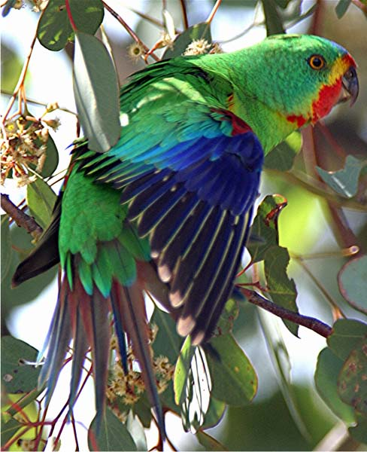
The Swift Parrot is listed as Critically Endangered in the ACT Threatened Native Species List under IUCN Criterion A — A3be. The factors that make it eligible include the likelihood it will undergo a very severe decline (approximately 87%) in population size over the next three generations (16.2 years) and the primary threat has not ceased (Threatened Species Scientific Committee (TSSC) 2016).

DESCRIPTION AND ECOLOGY
The Swift Parrot is a slim, medium-sized, nectar-eating parrot with angular pointed wings and a slender tail giving it a characteristic streamlined flight-silhouette (Higgins 1999). It is mostly bright green in colour, with dark-blue patches on the crown, a prominent red face, and chin and throat narrowly bordered with yellow. It is approximately 25 cm in length, its wingspan is 32–36 cm and it weighs approximately 65 g.
Swift Parrot (Geoffrey Dabb – Canberra Birds)
Swift Parrots are usually seen in small parties of up to 30 birds, or occasionally in larger flocks (of several hundred birds) around sources of abundant food. Swift Parrots breed in tree hollows in old-growth or other forest with suitable hollows, in relatively close proximity to the main food source, flowering Blue-gum (Eucalyptus globulus) (TSSC 2016).
Swift Parrot flocks fly quickly and with remarkable precision (Schodde and Tidemann 1986) making the species difficult to identify, unless it is in a settled feeding group. The Swift Parrot is sometimes confused with lorikeets. It is mainly an arboreal feeder, usually in the outer canopy of eucalyptus trees. Its main food on the mainland is nectar from winter flowering eucalypts, as well as on psyllids, lerps, on a range of eucalypt species including Blakely’s Red Gum (E. blakelyi) (Robinson 1994). It occasionally comes to the ground to drink and feed on seeds and fallen material (Higgins 1999).

Distribution and Habitat
The species migrates from its breeding areas in Tasmania to mainland Australia over winter, following abundances of flowering eucalypts and lerps as they occur. It is likely that groups pass through the ACT before moving west into areas of key flowering eucalypts, for example, Grey Box (E. microcarpa), White Box (E. albens) and Mugga Ironbark (E. sideroxylon) (ACT Government 1999). The rather sparse collection of records of the Swift Parrot in the ACT region is representative of the sporadic nature of the distribution of the species on the mainland during winter (ACT Government 2004).
On the mainland, the species inhabits mainly dry open eucalypt forests and woodlands, usually box-ironbark communities and also Yellow Box–Blakely’s Red Gum Grassy Woodland. Urban areas and farmland with remnant woodland are also visited (Higgins 1999). Critical local habitat features required by the Swift Parrot in the ACT include winter flowering eucalypts and eucalypts carrying lerps.
The Swift Parrot is an intermittent winter migrant to the ACT. It is likely to occur anywhere in the lower parts of the ACT region below 700 m. ACT records of the species since the 1970s are from inner Canberra suburbs, as well as Gungahlin and Hall (ACT Government 1999). In April 2000, ten birds were recorded in Namadgi National Park (Cotter Hut fire trail) feeding in E. viminalis. The species may regularly use this habitat during its northward migration (COG 2001).
There were 23 records of up to 14 birds in 2015–16 and 21 records in 2014–15 mainly from Mt Majura but with single records from Mt Ainslie, Ainslie, Mawson, Torrens and Scullin. There were only two records of one to two birds from Campbell Park in 2016–17 (COG 2018). The Swift Parrot has previously been seen in numbers in 2005, 2008, 2011 and 2015 (COG 2017) (Figure 1).

Threats
Ongoing habitat loss, particularly within the primary breeding areas in Tasmania, represents the single biggest threat to the survival of the Swift Parrot in the wild, particularly as habitat loss appears to enhance nest predation by the Sugar Glider (Petaurus breviceps) (TSSC 2016).
Threats to the Swift Parrot identified in the Commonwealth Conservation Advice (TSSC 2016) include:
- habitat loss and alteration across the mainland and Tasmanian range
- wildfire impacts
- collision mortality
- competition for resources within altered habitats
- Psittacine Beak and Feather Disease
- illegal wildlife capture and trading.
Figure 1: Distribution of Swift Parrot records in the ACT region – 1982–2017
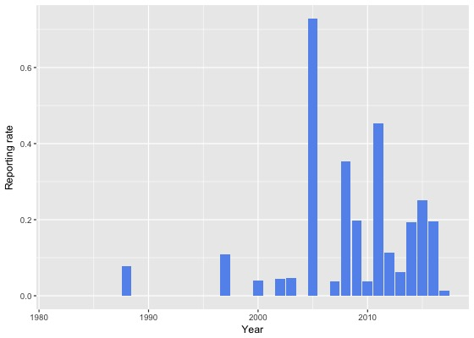
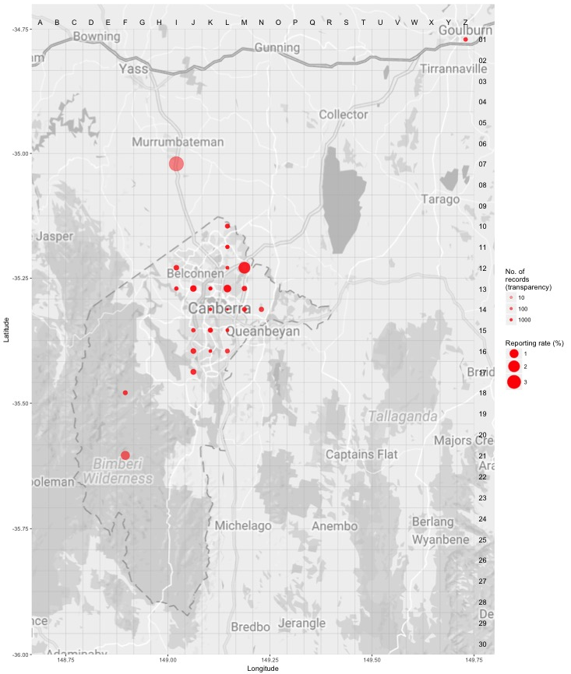
Source: Canberrabirds.org.au (2018). Note: Reporting rate (%) is the proportion of all surveys in which the species was present. These data were collected by volunteer birdwatchers using various survey methods and on some occasions more than one person may have recorded bird sightings on the same day, which may skew the data.

Major Conservation Objectives
The priority national management objective is relevant to Tasmania where the prevention of further land clearance, grazing and forestry activities in high-quality Swift Parrot summer nesting and breeding habitat is required (TSSC 2016).
The primary objective in the ACT is to protect Swift Parrot habitat through limiting clearance of woodlands that make suitable winter foraging habitat.

Conservation Issues and Proposed Management Actions
The conservation actions relevant to the Swift Parrot (ACT Government 2004) include:
- maintain woodland remnants and isolated paddock trees
- limit removal of live and dead timber
- regenerate habitat
- minimise adverse effects of fire.

Other Relevant Advice, plans or Prescriptions
- ACT Woodland Conservation Strategy (ACT Government 2004)
- ACT Draft Woodland Conservation Strategy (ACT Government 2019)
- National Recovery Plan — Swift Parrot (Saunders and Tzaros 2011)
- Commonwealth Conservation Advice — Swift Parrot (TSSC 2016)
- ACT Conservation Advice — Loss of Mature Trees (Scientific Committee 2018)

Listing Background
The Swift Parrot was initially listed in the ACT as an Endangered species on 30 May 1997 in accordance with section 38 of the Nature Conservation Act 1980. At that time, the Flora and Fauna Committee (now Scientific Committee) concluded that the assessment satisfied the following criteria:
2.1 The species is known to occur in the ACT region and is already recognised as vulnerable in an authoritative international or national listing (Vulnerable under the Commonwealth Endangered Species Protection Act 1992 (ESP Act) at the time of listing).
2.2 The species is observed, estimated, inferred or suspected to be at risk of premature extinction in the ACT region in the medium-term future, as demonstrated by:
2.2.1 Current serious decline in population or distribution from evidence based on:
2.2.1.1 direct observation, including comparison of historical and current records
2.2.1.2 serious decline in rate of reproduction or recruitment; serious increase in
mortality; serious disruption of demographic or social structure
2.2.1.3 serious decline in quality and quantity of habitat
2.2.6 Small population.
The Swift Parrot was initially listed as Vulnerable and later listed as Endangered under the Commonwealth Endangered Species Protection Act 1992 (ESP Act) and the subsequent Environment Protection and Biodiversity Conservation Act 1999 (EPBC Act) on 16 July 2000. The species was then transferred to Critically Endangered under the EPBC Act effective 5 May 2016 following assessment of new information by the Commonwealth TSSC that it meets the elements of IUCN Criterion A3(b)(e) (TSSC 2016).
Under the Nature Conservation Act 2014 the category of Critically Endangered was included in the Threatened Native Species List for the first time. In 2019, the ACT Scientific Committee recommended the Swift Parrot be listed in the Critically Endangered category of the Threatened Native Species List to align with the EPBC Act listing.

References
ACT Government 1999. Swift Parrot (Lathamus discolor): A vulnerable species. Action Plan No. 16. Environment ACT, Canberra.
ACT Government 2004. Woodlands for Wildlife: ACT Lowland Woodland Conservation Strategy. Action Plan No. 27. Environment ACT, Canberra.
ACT Government 2019. Draft ACT Woodland Conservation Strategy and Action Plans. Environment Planning and Sustainable Development Directorate, Canberra.
BirdLife International. 2016. Lathamus discolor. The IUCN Red List of Threatened Species 2016. Accessed 22 August 2018 from: http://dx.doi.org/10.2305/IUCN.UK.2016-3.RLTS.T22685219A93064101.en
Canberrabirds.org.au (2018). Swift Parrot Lathamus discolor data sheet. Accessed 22 August 2018 from: http://canberrabirds.org.au/wp-content/bird_data/309_Swift%20Parrot.html
COG 2001. Annual Bird Report: 1 July 1999 to 30 June 2000 and 1 July 2000 to 30 June 2001. Canberra Bird Notes 26(4): 105–199.
COG 2017. Annual Bird Report: 1 July 2015 to 30 June 2016. Canberra Bird Notes 42(1): 1–110.
COG 2018. Annual Bird Report: 1 July 2016 to 30 June 2017. Canberra Bird Notes 43(1): 1–110.
Heinsohn R, Webb MH, Lacy R, Terauds A, Alderman R and Stojanovic D 2015. A severe predator-induced decline predicted for endangered, migratory Swift Parrots (Lathamus discolor). Biological Conservation 186: 75–82.
Higgins PJ (ed) 1999. Handbook of Australian, New Zealand and Antarctic Birds Volume 4: Parrots to Dollarbird. Oxford University Press, Melbourne.
Robinson D 1994. Research plan for threatened woodland birds of south-eastern Australia. ARI Technical Report No. 133. Department of Conservation and Natural Resources, Victoria.
Saunders DL and Tzaros CL 2011. National Recovery Plan for the Swift Parrot Lathamus discolor. Birds Australia, Melbourne.
Schodde R and Tidemann SC 1986. Complete Book of Australian Birds. Readers Digest, Sydney.
Scientific Committee 2018. Conservation Advice – Loss of Mature Trees (including Hollow-bearing Trees) and Lack of Recruitment. ACT Government, Canberra.
Shaw G in White J 1790. Journal of a Voyage to New South Wales with Sixty-five Plates of Non-descript Animals, Birds, Lizards, Serpents, Curious Cones of Trees and other Natural Productions. J. Debrett, London, 263.
Stojanovic D, Webb M, Alderman R, Porfirio L and Heinsohn R 2014. Discovery of a novel predator reveals extreme but highly variable mortality for an endangered bird. Diversity and Distributions 20: 1200–1207.
Threatened Species Scientific Committee (TSSC) 2016. Conservation Advice Lathamus discolor (Swift Parrot). Department of Environment, Commonwealth of Australia, Canberra.
Threatened Species Section 2018. Lathamus discolor (Swift Parrot): Species Management Profile for Tasmania's Threatened Species Link. Department of Primary Industries, Parks, Water and Environment, Tasmania. Accessed 22 August 2018 from: http://www.threatenedspecieslink.tas.gov.au/Pages/Swift-Parrot.aspx

Further Information
Further information on the related Action Plan or other threatened species and ecological communities can be obtained from the Environment, Planning and Sustainable Development Directorate (EPSDD).
Phone: (02) 132281, EPSDD Website: http://www.environment.act.gov.au/cpr

