Australian Capital Territory

Nature Conservation (Varied Sittella) Conservation Advice 2019

Notifiable instrument NI2019–256
made under the
Nature Conservation Act 2014, s 90C (Conservation advice)

1 Name of instrument
This instrument is the Nature Conservation (Varied Sittella) Conservation Advice 2019.

2 Commencement
This instrument commences on the day after its notification day.

3 Conservation advice for the Varied Sittella
Schedule 1 sets out the conservation advice for the Varied Sittella (Daphoenositta chrysoptera).

Arthur Georges
Chair, Scientific Committee
1 May 2019
Schedule 1
(see s 3)

Conservation Advice
Varied Sittella
Daphoenositta chrysoptera

Conservation Status
The Varied Sittella Daphoenositta chrysoptera (Latham, 1801) is recognised as threatened in:
ACT Vulnerable, Nature Conservation Act 2014
NSW Vulnerable, Biodiversity Conservation Act 2016

ELIGIBILITY
The factors that make the Varied Sittella eligible for listing as Vulnerable in the ACT Threatened Native Species List in the ACT are included in the Listing Background section below.

DESCRIPTION AND ECOLOGY
The Varied Sittella is a small, stout bird measuring 13.5–17 cm. Females are slightly smaller than males, but both have short wings and tail. There is variation in the appearance of sittellas throughout their range with five sub-species, differing in the patterns on the head and neck, the amount of streaking and in the wing patterns (Birdlife Australia 2018). The typical appearance of the species in the ACT region includes: a sooty grey coloured head, nape and chin in both sexes, although sometimes paler on the face in males; the mantle and back are pale grey, with fine dusky streaks; and the wings are dark with a cinnamon-rufous bar, spanning both primaries and secondaries which are most conspicuous in flight.
The rump is whitish and the tail is black with a white tip. Underparts are pale and streaked rather finely with dusky brown. The bill is slightly upcurved. Juveniles are similar to adults though paler (Schodde and Mason 1999; Pizzey and Knight 1998).
Varied Sittella (David Cook – Canberra Birds)

The Varied Sitella is a climbing species usually seen in noisy flocks hopping in jerky movements up or down the outer branches of large trees. The small flocks travel between treetops with bouncing flight, and settle head-downwards on the high branches. They usually spiral down the branches, gripping with their strong feet, probing into crevices and levering away bark to reach their invertebrate prey which includes spiders, beetles, bugs and larvae (Pizzey 1980). The species is highly social, forming breeding groups of five to seven individuals and sometimes gathers into large winter flocks. In inland areas the groups are nomadic, though nearer the coast they are sedentary. The species weakly defends territories of approximately 13–20 ha (Noske, 1998).
The breeding season of the Varied Sittella in the ACT can stretch from September to February (Taylor and COG 1992) and sometimes two broods are attempted. The nest is a deep, well-camouflaged cup (often resembling a branch knot) of bark and lichen bound with cobwebs. Nests are constructed in an upright, thin (usually dead) fork, 5–20 m above ground. Members of the flock cooperate in breeding, though one female usually does most of the building and incubating.

Distribution and Habitat
The five sub-species (Birdlife Australia 2018) of Varied Sittella occupy a variety of habitats across coastal and inland Australia. They are found in most treed habitats except rainforest. Common habitat includes eucalypt forest and woodland, mallee, inland acacia, coastal scrub, farm trees, shelterbelts, roadside trees, golf courses, orchards and parks. The species has been recorded from a wide variety of woodland and forest habitat in the ACT, but is absent from the highest alpine woodlands and wettest forests (Taylor and COG 1992). In lowland habitats, where the species is more likely to be found, a preference is shown for areas with Red Stringybark (Eucalyptus macrorhyncha). The species prefers rough barked trees (Pizzey and Knight 1998; Morcombe 2000) or mature trees with hollows or dead branches (Birdlife Australia 2018) and spend up to a third of their time foraging on dead branches (Noske 1985).
Comparison of two extensive Australia-wide data sets indicated that the reporting rate for this species declined by 46% in the region over the 20 years between atlases (Birds Australia in ACT Government 2004).
Figure 1: Varied Sittella records in the ACT region – 1982–2017
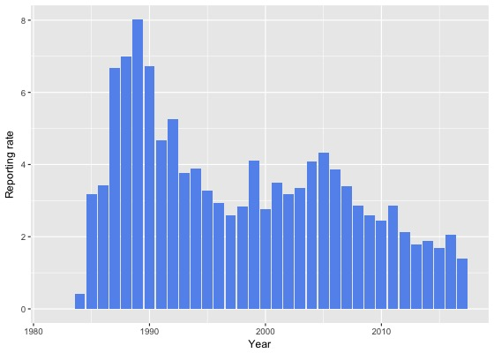
Source: Canberrabirds.org.au. (2018). Note: Reporting rate (%) is the proportion of all surveys in which the species was present. These data were collected by volunteer birdwatchers using various survey methods and on some occasions more than one person may have recorded bird sightings on the same day, which may skew the data.
When the species was first listed in 2003, it had been recorded in Aranda bushland, O'Connor and Bruce Ridges, Black Mountain, the Pinnacle Stringybark forest, Mt Ainslie – Campbell Park, Mulligans Flat, Bluett's Eucalypt forest, Naas and Orroral valleys, Shepherd's Lookout and the Murrumbidgee River Corridor (ACT Government 2004).
Figure 2: Varied Sittella distribution in the ACT region – 2017
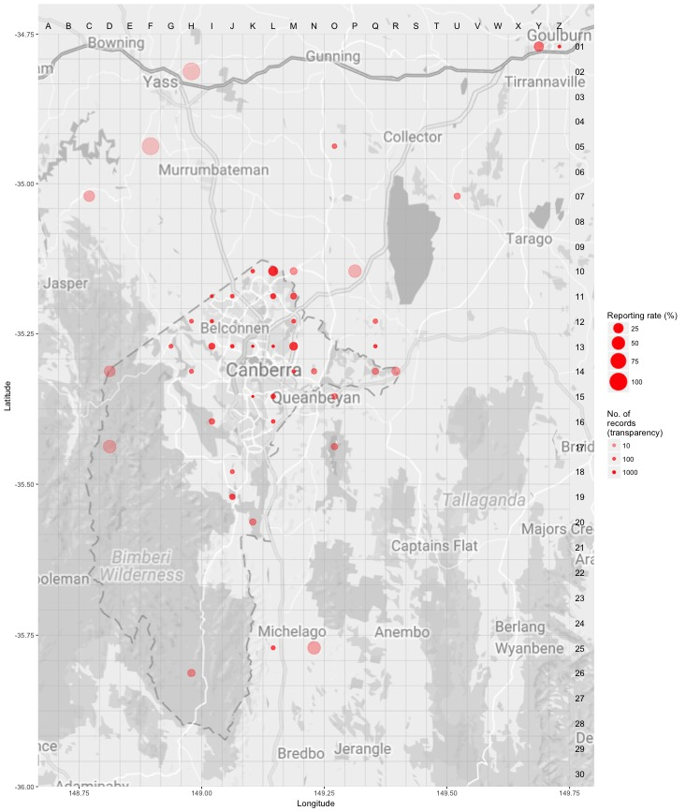Source: Canberrabirds.org.au. (2018). Note: Reporting rate (%) is the proportion of all surveys in which the species was present. These data were collected by volunteer birdwatchers using various survey methods and on some occasions more than one person may have recorded bird sightings on the same day, which may skew the data.
The reporting rate for 2016–2017 was the lowest on record in the ACT region (Figures 1 and 2). Despite the low reporting rate, high observer effort recorded 998 birds which was close to the number of individuals recorded in 2015–2016 (1,043 individuals), and many more than the ten-year average (379 individuals) and the 30-year average (254 individuals). In 2016–2017, the maximum number of birds recorded in one group was 25 (compared with 16 in 2015–2016), with seven breeding records (10 in 2015–2016) between October (in Kama Nature Reserve) and February (in Mulligans Flat) (COG 2018).
Figure 3: Varied Sittella distribution in the ACT region – 1982–2017
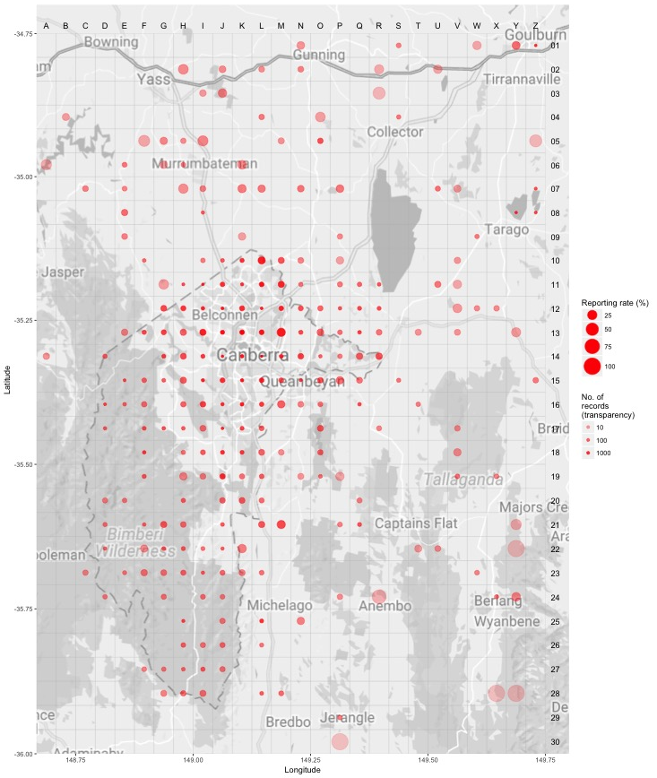Source: Canberrabirds.org.au. (2018). Note: Reporting rate (%) is the proportion of all surveys in which the species was present. These data were collected by volunteer birdwatchers using various survey methods and on some occasions more than one person may have recorded bird sightings on the same day, which may skew the data.
Critical habitat features for the Varied Sittella include:
- large living and dead trees, particularly rough barked eucalypts, which are essential for foraging, roosting and nesting sites
- relatively well-treed habitats (rather than sparsely treed habitats).
The Varied Sittella is rarely found in open areas or urban areas, suggesting that there is a minimum tree density for foraging efficiency. Woodland patches that are sparsely treed, small or lack many large trees may not provide sufficient resources to support family groups of the Varied Sittella (ACT Government 2004).

Threats
In common with many other threatened bird species, the principal threat to the Varied Sittella is a severe decline in the quality and quantity of its woodland habitat as the sedentary nature of the Varied Sittella makes cleared land a potential barrier to movement. In particular, tree clearing, small-scale clearing for fence lines and road verges, rural tree decline, loss of paddock trees and connectivity, 'tidying-up' on farms, firewood collection, overgrazing and infestation of habitat by invasive weeds result in smaller fragments, lower tree densities and fewer large trees, all of which constitute habitat degradation for the Varied Sittella. In addition, the fragmented nature of woodlands of the ACT may present barriers to movement and recolonization unless measures are taken to connect areas of viable habitat with existing populations (ACT Government 2004; OEH 2017). The Varied Sittella is also adversely affected by the dominance of Noisy Miners in woodland patches, itself a side-effect of habitat loss (OEH 2017).

Major Conservation Objectives
The primary objective in the ACT is to protect Varied Sittella habitat through limiting clearance of suitable woodland habitat and prioritising conservation management to woodland patches, particularly those that are large or have complex habitat structure.

Conservation Issues and Proposed Management Actions
The conservation actions relevant to the Varied Sittella in the ACT Lowland Woodland Conservation Strategy (ACT Government 2004) include the following:
- limit removal of live and dead timber
- regenerate habitat
- minimise adverse effects of fire.

Other Relevant Advice, plans or Prescriptions
- ACT Woodland Conservation Strategy (ACT Government 2004)
- ACT Draft Woodland Conservation Strategy (ACT Government 2019)

Listing Background
The Varied Sittella was listed in the ACT as a Vulnerable species on 8 December 2003 (DI2003–319) in accordance with section 38 of the Nature Conservation Act 1980.
The Flora and Fauna Committee (now Scientific Committee) concluded that at that time the assessment satisfied the criteria:
2.2 The species is observed, estimated, inferred or suspected to be at risk of premature extinction in the ACT region in the medium-term future, as demonstrated by:
2.2.1 Current serious decline in population or distribution from evidence based on:
2.2.1.1 Direct observation, including comparison of historical and current records.

References
ACT Government 2004. Woodlands for Wildlife: ACT Lowland Woodland Conservation Strategy. Action Plan No. 27. Environment ACT, Canberra.
ACT Government 2019. Draft ACT Woodland Conservation Strategy and Action Plans. Environment Planning and Sustainable Development Directorate, Canberra.
BirdLife Australia 2018. Varied Sittella Profile. http://www.birdlife.org.au/bird-profile/varied-sittella
BirdLife International 2016. Daphoenositta chrysoptera. The IUCN Red List of Threatened Species 2016 http://dx.doi.org/10.2305/IUCN.UK.2016-3.RLTS.T103691540A94016098.en
BirdLife International 2018. Species factsheet: Daphoenositta chrysoptera.
http://datazone.birdlife.org/species/factsheet/varied-sittella-daphoenositta-chrysoptera
Canberrabirds.org.au. (2018). Varied Sittella Daphoenositta chrysoptera data sheet. http://canberrabirds.org.au/wp-content/bird_data/549_Varied%20Sittella.html
COG 2018. Annual Bird Report: 1 July 2016 to 30 June 2017. Canberra Bird Notes 43(1): 1–110.
Latham J 1801. Supplementum Indicis, Sive Systematis Ornithologiae. G. Leigh and J. and S. Sotherby, London, xxxii.
Morcombe M 2000. Field Guide to Australian Birds. Steve Parish Publishing, Brisbane.
Noske RA 1985. Habitat use by three bark-foragers of eucalypt forests, in Keast A, Recher H, Ford H and Saunders D (eds) Birds of Eucalypt Forests and Woodlands: Ecology, Conservation and Management. Royal Australian Ornithological Union and Surrey Beatty and Sons, Chipping Norton, pp. 193–204.
Noske R 1998. Social organisation and nesting biology of the cooperatively-breeding Varied Sittella Daphoenasitta chrysoptera in North-eastern New South Wales. Emu 98: 85–96.
Office of Environment and Heritage (OEH) 2017. Varied Sittella – profile. https://www.environment.nsw.gov.au/threatenedSpeciesApp/profile.aspx?id=20135
Pizzey G 1980. A Field Guide to the Birds of Australia. Collins, Sydney.
Pizzey G and Knight F 1998. Field Guide to the Birds of Australia. Angus and Robertson (Harper Collins), Sydney.
Schodde R and Mason IJ 1999. The Directory of Australian Birds – Passerines. CSIRO Publishing, Collingwood.
Taylor M and Canberra Ornithologists Group (COG) 1992. Birds of the Australian Capital Territory – An Atlas. Canberra Ornithologist Group and National Capital Planning Authority, Canberra.

Further Information
Further information on the related Woodland Strategy or other threatened species and ecological communities can be obtained from the Environment, Planning and Sustainable Development Directorate (EPSDD). Phone: (02) 132281, EPSDD Website: http://www.environment.act.gov.au/cpr

