Australian Capital Territory

Nature Conservation (White-winged Triller) Conservation Advice 2019

Notifiable instrument NI2019–257
made under the
Nature Conservation Act 2014, s 90C (Conservation advice)

1 Name of instrument
This instrument is the Nature Conservation (White-winged Triller) Conservation Advice 2019.

2 Commencement
This instrument commences on the day after its notification day.

3 Conservation advice for the White-winged Triller
Schedule 1 sets out the conservation advice for the White-winged Triller (Lalage tricolor).

Arthur Georges
Chair, Scientific Committee
1 May 2019
Schedule 1
(see s 3)

Conservation Advice
White-winged Triller
Lalage tricolor

Conservation Status
The White-winged Triller Lalage tricolor Vieillot 1818 (formerly Lalage sueurii) is recognised as threatened in:
ACT Vulnerable, Nature Conservation Act 2014

ELIGIBILITY
The factors that make the White-winged Triller eligible for listing as Vulnerable in the ACT Threatened Native Species List in the ACT are included in the Listing Background section below.

DESCRIPTION AND ECOLOGY
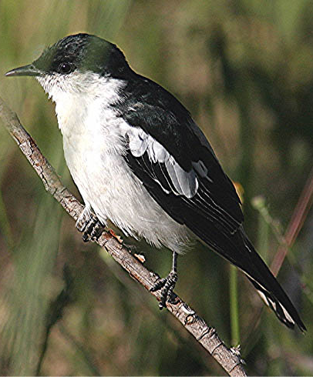
The White-winged Triller is a medium sized passerine, measuring 16–18.5 cm in length. Breeding males are glossy black on the cap to below the eye and black on the back, shoulders and wings. Plumage is white underneath, with white edges to wing-coverts forming a netted pattern on the wings. Non-breeding males are similar to females but have black flight feathers and tail. Overall, females are brownish in appearance, being pale brown above, with a dark line through the eye and slight pale eyebrow. The underparts are washed brown, with buff edges to wing feathers forming a netted pattern like the males. Immatures are similar to females (Pizzey & Knight 1998 in ACT Government 2004).
The White-winged Triller eats insects, including winged termites, ants, grasshoppers and caterpillars. Frith (1984) notes that it takes most food on or close to the ground, in shrubs or amongst fallen timber. However, it may also feed in the air (Blakers et al. 1984) and amongst blossoms (presumably on the nectar; Pizzey 1980). The feeding area may be within the breeding territory or quite often up to 1 km away.
  - Adult male White-winged Triller in breeding plumage (Geoffrey Dabb – Canberra Birds)
Birds are usually seen in pairs. Courting males fly slowly over the territory, singing, with wings and tails spread (Pizzey and Knight 1998). They have a loud canary-like trill, a series of fast notes repeated in a continuous song (Pizzey and Knight 1998). The males are particularly conspicuous during the breeding period, singing loudly and chasing other males out of nesting territories. Females can be difficult to find as they are more camouflaged (Frith 1984). The nest is a small, well-camouflaged shallow cup of grass, rootlets and spider-webs on a fork or horizontal branch of a tree (Pizzey 1980). Breeding may be semi-colonial with several pairs, although each pair has its own foraging territory (Morcombe 2000). In the Canberra region, most records of the White-winged Triller are of one or two birds.

Distribution and Habitat
The White-winged Triller is found across mainland Australia. It is resident near water in the north, nomadic and seasonally migratory through central and southern Australia and vagrant in northern Tasmania. It is also found in Indonesia and New Guinea. In the Canberra region, the species is an uncommon, breeding, summer migrant, and numbers vary from year to year. Birds begin returning from the north in August with most of the population arriving in October. The White-winged Triller is among the first of the summer migrants to leave, departing from mid-summer through to late autumn (Taylor and COG 1992).
The species inhabits eucalypt woodland, mallee, Acacia scrub and spinifex in wetter northern and drier southern regions of Australia (Blakers et al 1984). Locally, they are found in and around grassy woodland areas including Yellow Box–Red Gum, Apple Box, Candlebark, or less commonly, Snowgum woodlands.
Within the local area, records of this species have been widespread in the past (Figure 2). At the time of the original listing (2003) in the ACT, most records of the species were from Hall, Mulligans Flat, Gooroo, the Pinnacle, Campbell Park and the Gigerline–Tharwa area. Comparison of two extensive Australia-wide data sets indicated that, in the ACT region, the reporting rate for this species declined by 54% in the ACT region over the twenty years between atlases (Birds Australia in ACT Government 2004). Nationally the decline in reporting rate was 16%.
Although the number of annual records has increased significantly since the time of the original listing, the reporting rate has fluctuated markedly and was low in 2016–2017 (Figure 1) with 376 birds recorded, far fewer than the 731 in 2015–2016. This was similar to the 10-year average (418 individuals) and more than the 30-year average (202 individuals). It was recorded in every month from August (in Higgins) to February (in Callum Brae Nature Reserve). The reporting rate in 2016–2017 was 1.2% which was half that for 2015–16, and well below the ten-year average and 30-year average (both 3.5%)(Figure 3). Records came from 12% of the 2.5 minute grid cells surveyed in the ACT region (Figure 1) (14% in 2015–16). A maximum of 11 birds per sighting were recorded (18 in 2015–16), with a mean of 2.3 per sighting. There were 14 breeding records compared with 25 in 2015–16, equal to the 10-year average and more than the 30-year average (9); from November (at Campbell Park) to February (at Callum Brae Nature Reserve) (COG 2018).
Critical habitat features for the White-winged Triller include:
- large living and dead trees which are essential for perching, roosting, foraging and nesting sites
- foraging areas of grass and fallen timber that support insects and other invertebrates on which the species feeds.
Figure 1: White-winged Triller distribution in the ACT region – 2017
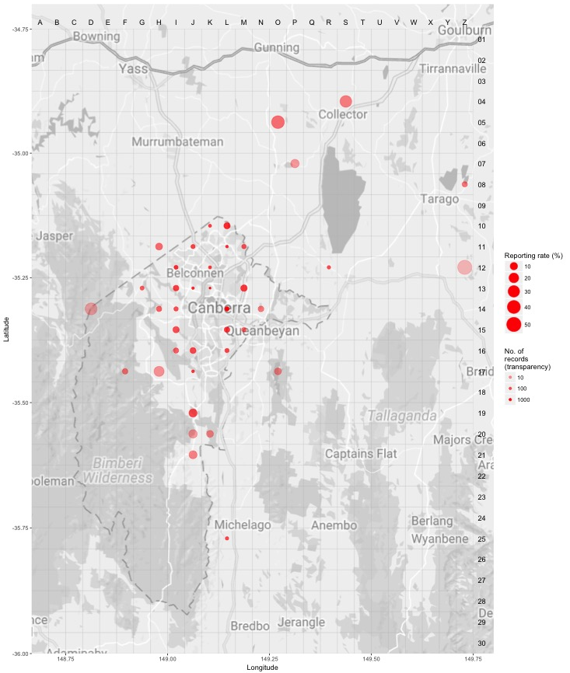Source: Canberrabirds.org.au. (2018). Note: Reporting rate (%) is the proportion of all surveys in which the species was present. These data were collected by volunteer birdwatchers using various survey methods and on some occasions more than one person may have recorded bird sightings on the same day, which may skew the data.
Figure 2: White-winged Triller distribution in the ACT region – 1982–2017
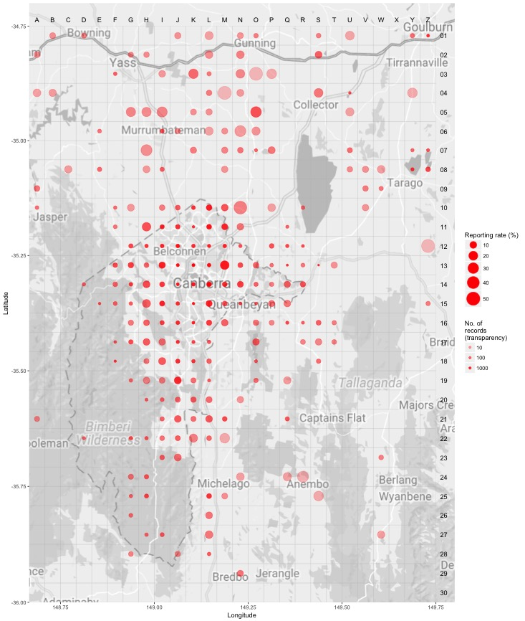Source: Canberrabirds.org.au. (2018). Note: Reporting rate (%) is the proportion of all surveys in which the species was present. These data were collected by volunteer birdwatchers using various survey methods and on some occasions more than one person may have recorded bird sightings on the same day, which may skew the data.
Figure 3: White-winged Triller records in the ACT region – 1982–2017
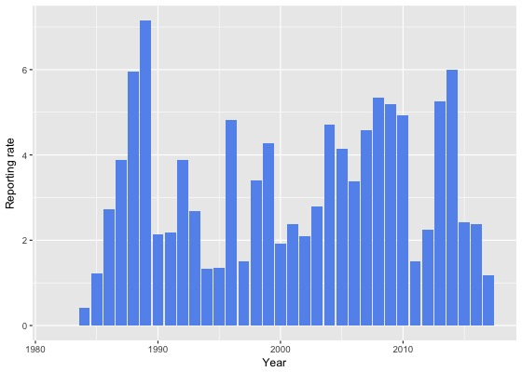
Source: Canberrabirds.org.au. (2018). Note: Reporting rate (%) is the proportion of all surveys in which the species was present. These data were collected by volunteer birdwatchers using various survey methods and on some occasions more than one person may have recorded bird sightings on the same day, which may skew the data.

Threats
In common with many other threatened bird species, the principal threat to the White-winged Triller is a severe decline in the quality and quantity of its woodland habitat. In particular, the removal of fallen timber for firewood and overgrazing have led to a loss of complexity of the ground layer and hence lower availability and quality of foraging habitat (ACT Government 2004).
Threats to the species are ongoing, particularly to its woodland habitat which continues to be cleared and degraded across its range.

Major Conservation Objectives
The primary objective in the ACT is to protect White-winged Triller habitat through limiting clearance of suitable woodland habitat and prioritising conservation management to woodland patches, particularly those that are large or have complex habitat structure.

Conservation Issues and Proposed Management Actions
The species would benefit from the retention of large mature trees and dead standing and fallen timber (ACT Government 2004).
The conservation actions relevant to the White-winged Triller in the ACT Lowland Woodland Conservation Strategy (ACT Government 2004) include the following:
- limit removal of live and dead timber
- reduce intensive grazing
- regenerate habitat
- minimise adverse effects of fire.

Other Relevant Advice, plans or Prescriptions
- ACT Woodland Conservation Strategy (ACT Government 2004)
- ACT Draft Woodland Conservation Strategy (ACT Government 2019)

Listing Background
The White-winged Triller was initially listed in the ACT as Lalage sueurii as a Vulnerable species on 8 December 2003 in accordance with section 38 of the Nature Conservation Act 1980.
The Flora and Fauna Committee (now Scientific Committee) concluded that at that time the assessment satisfied the criteria:
2.2 The species is observed, estimated, inferred or suspected to be at risk of premature extinction in the ACT region in the medium-term future, as demonstrated by:
2.2.1 Current serious decline in population or distribution from evidence based on:
2.2.1.1 Direct observation, including comparison of historical and current records.

The evidence indicated ‘a significant population decline in the ACT and region’ (ACT Government 2004). The listed scientific name of the White-winged Triller was changed from Lalage sueurii to Lalage tricolor. These species were formally considered conspecific and L.sueurii is now separated as White-shouldered Triller.

References
ACT Government 2004. Woodlands for Wildlife: ACT Lowland Woodland Conservation Strategy. Action Plan No. 27. Environment ACT, Canberra.
ACT Government 2019. Draft ACT Woodland Conservation Strategy and Action Plans. Environment Planning and Sustainable Development Directorate, Canberra.
BirdLife Australia 2018. White-winged Triller Profile Birdlife.org.au. Accessed 8 August 2018 from: http://www.birdlife.org.au/bird-profile/white-winged-triller
BirdLife International 2017. Lalage sueurii (amended version of 2017 assessment). The IUCN Red List of Threatened Species 2017. Accessed 8 August 2018 from: http://dx.doi.org/10.2305/IUCN.UK.2017-3.RLTS.T22706657A118731125.en
Blakers M, Davies SJJF and Reilly PN 1984. The Atlas of Australian Birds. Melbourne University Press and RAOU, Melbourne.
Canberrabirds.org.au. 2018. White-winged Triller Lalage tricolor data sheet. Accessed 8 August 2018 from: http://canberrabirds.org.au/wp-content/bird_data/430_White-winged%20Triller.html
COG 2018. Annual Bird Report: 1 July 2016 to 30 June 2017. Canberra Bird Notes 43: (1) 1–110.
Frith HJ (ed) 1984. Birds in the Australian High Country. (Revised edition). Angus and Robertson, Sydney.
Morcombe M 2000. Field Guide to Australian Birds. Steve Parish Publishing, Brisbane.
Pizzey G 1980. A Field Guide to the Birds of Australia. Collins, Sydney.
Pizzey G and Knight F 1998. Field Guide to the Birds of Australia. Angus and Robertson (Harper Collins), Sydney.
Taylor M and Canberra Ornithologists Group (COG) 1992. Birds of the Australian Capital Territory – An Atlas. Canberra Ornithologist Group and National Capital Planning Authority, Canberra.

Further Information
Further information on the related Woodland Strategy or other threatened species and ecological communities can be obtained from the Environment, Planning and Sustainable Development Directorate (EPSDD). Phone: (02) 132281, EPSDD Website: http://www.environment.act.gov.au/cpr

