Australian Capital Territory
Corrections Management (Allowing Electronic Devices, including Mobile Phones, into Corrections Facilities) Procedure Revocation 2019
Notifiable instrument NI2019-304
made under the
Corrections Management Act 2007, s 14 (Corrections policies and operating procedures)

1 Name of instrument
This instrument is the Corrections Management (Allowing Electronic Devices, including Mobile Phones, into Corrections Facilities) Procedure Revocation 2019.

2 Commencement
This instrument commences on the day after its notification day.
3. Revocation
This instrument revokes the Corrections Management (Allowing Electronic Devices, including Mobile Phones, into Corrections Facilities) Procedure 2013 [NI2013-583].

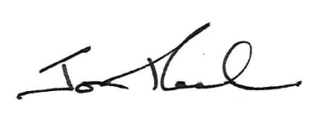

Jon Peach
Executive Director
ACT Corrective Services
16 May 2019

