Australian Capital Territory
Planning and Development (Technical Amendment—Denman Prospect) Plan Variation 2019 (No 2)

Notifiable instrument NI2019—338
Technical Amendment No 2019-07
made under the
Planning and Development Act 2007, s 89 (Making technical amendments)

- Name of instrument
This instrument is the Planning and Development (Technical Amendment—Denman Prospect) Plan Variation 2019 (No 2).
2 Commencement
This instrument commences on the day after its notification day.
3 Technical amendment
I am satisfied under section 89 (1) (a) of the Planning and Development Act 2007 (the Act) that the Denman Prospect plan variation is a technical amendment to the Territory Plan.
4 Meaning of Denman Prospect plan variation
In this instrument:
Denman Prospect plan variation means the technical amendment to the Territory Plan, variation 2019-07, in the schedule.
Note: No consultation was required in relation to the Denman Prospect plan variation under section 87 of the Act.
Kathy Cusack
Delegate of the planning and land authority
28 May 2019

Planning & Development Act 2007

Technical Amendment
to the Territory Plan
Variation 2019-07

Future urban area variation

May 2019

This page is left intentionally blank

Table of Contents

1. INTRODUCTION 3
1.1 Purpose 3
1.2 Public consultation 3
1.3 National Capital Authority 3
1.4 Process 3
1.5 Types of technical amendments under the Act 4
2. EXPLANATION 5
2.1 Territory Plan Map 5
3. TECHNICAL AMENDMENT 7
3.1 Territory Plan Map 7

This page is left intentionally blank

- INTRODUCTION
  - Purpose
This technical amendment makes the following changes to the Territory Plan:
Territory Plan Map
- The Territory Plan map is varied to remove the Future Urban Area Overlay from land in the Division of Denman Prospect, as identified in Part 2 of this document.

  - Public consultation
Under section 87 of the Planning and Development Act 2007 (the Act) this type of technical amendment is not subject to public consultation.

  - National Capital Authority
The National Capital Authority does not need to be advised of this technical amendment as per 1.2.

  - Process
This technical amendment has been prepared in accordance with section 87 and made in accordance with section 89 of the Act.

  - Types of technical amendments under the Act
The following categories of technical amendments are provided under section 87 of the Act:
- Each of the following territory plan variations is a technical amendment for which no consultation is needed before it is made under section 89:
(a) a variation (an error variation) that –
- would not adversely affect anyone’s rights if approved; and
- has as its only object the correction of a formal error in the plan;
(b) a variation to change the boundary of a zone or overlay under section 90A (Rezoning – boundary changes);
(c) a variation, other than one to which subsection (2) (d) applies, in relation to an estate development plan under section 96 (Effect of approval of estate development plan);
(d) a variation required to bring the territory plan into line with the national capital plan;
(e) a variation to omit something that is obsolete or redundant in the territory plan.
- Each of the following territory plan variations is a technical amendment for which only limited public consultation is needed under section 90:
- a variation (a code variation) that –
- would only change a code; and
- is consistent with the policy purpose and policy framework of the code; and
- is not an error variation;
- a variation to change the boundary of a zone under section 90B (Rezoning – development encroaching on adjoining territory land);
- a variation in relation to a future urban area under section 90C (Technical amendments – future urban areas);
- a variation in relation to an estate development plan under section 96 (Effect of approval of estate development plan) if it incorporates an ongoing provision that was not included in the plan under section 94 (3) (g);
- a variation to clarify the language in the territory plan if it does not change the substance of the plan;
- a variation to relocate a provision within the territory plan if the substance of the provision is not changed.
TA2019-07 has been prepared in accordance with section 87 (1) (c).

- EXPLANATION
This part of the technical amendment document explains the changes to be made to the Territory Plan.

  - Territory Plan Map
Variation to the Territory Plan

The Territory Plan map is varied to identify the zones and overlays that apply to land ceasing to be in a future urban area.

Existing Territory Plan Map

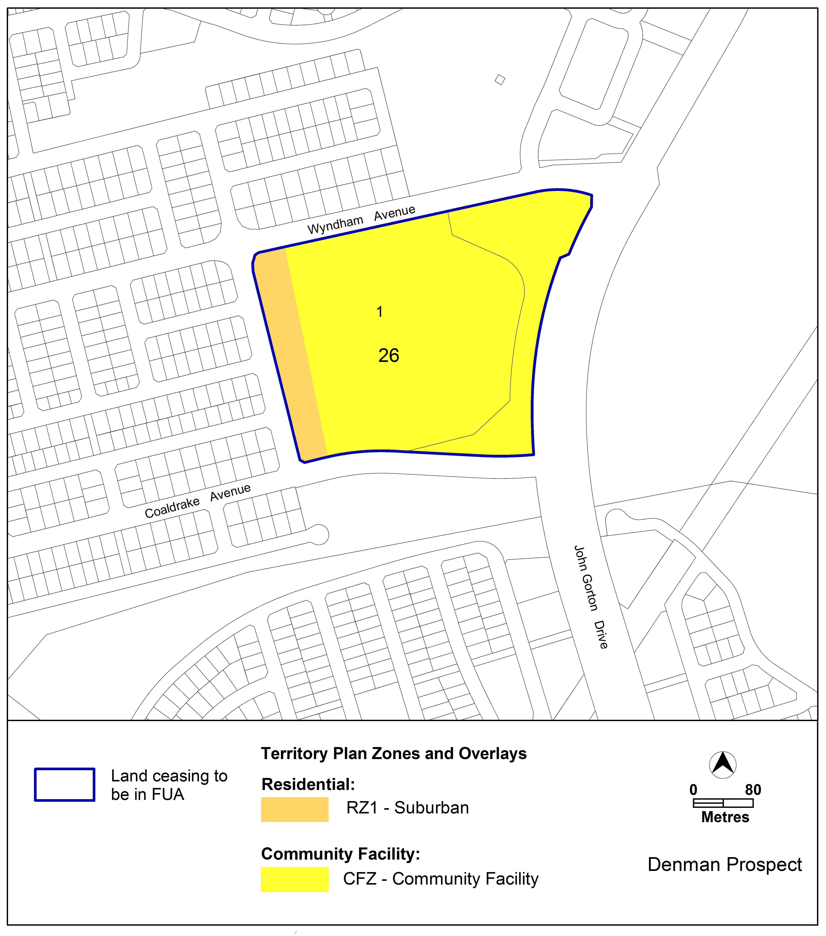

Proposed Territory Plan Map

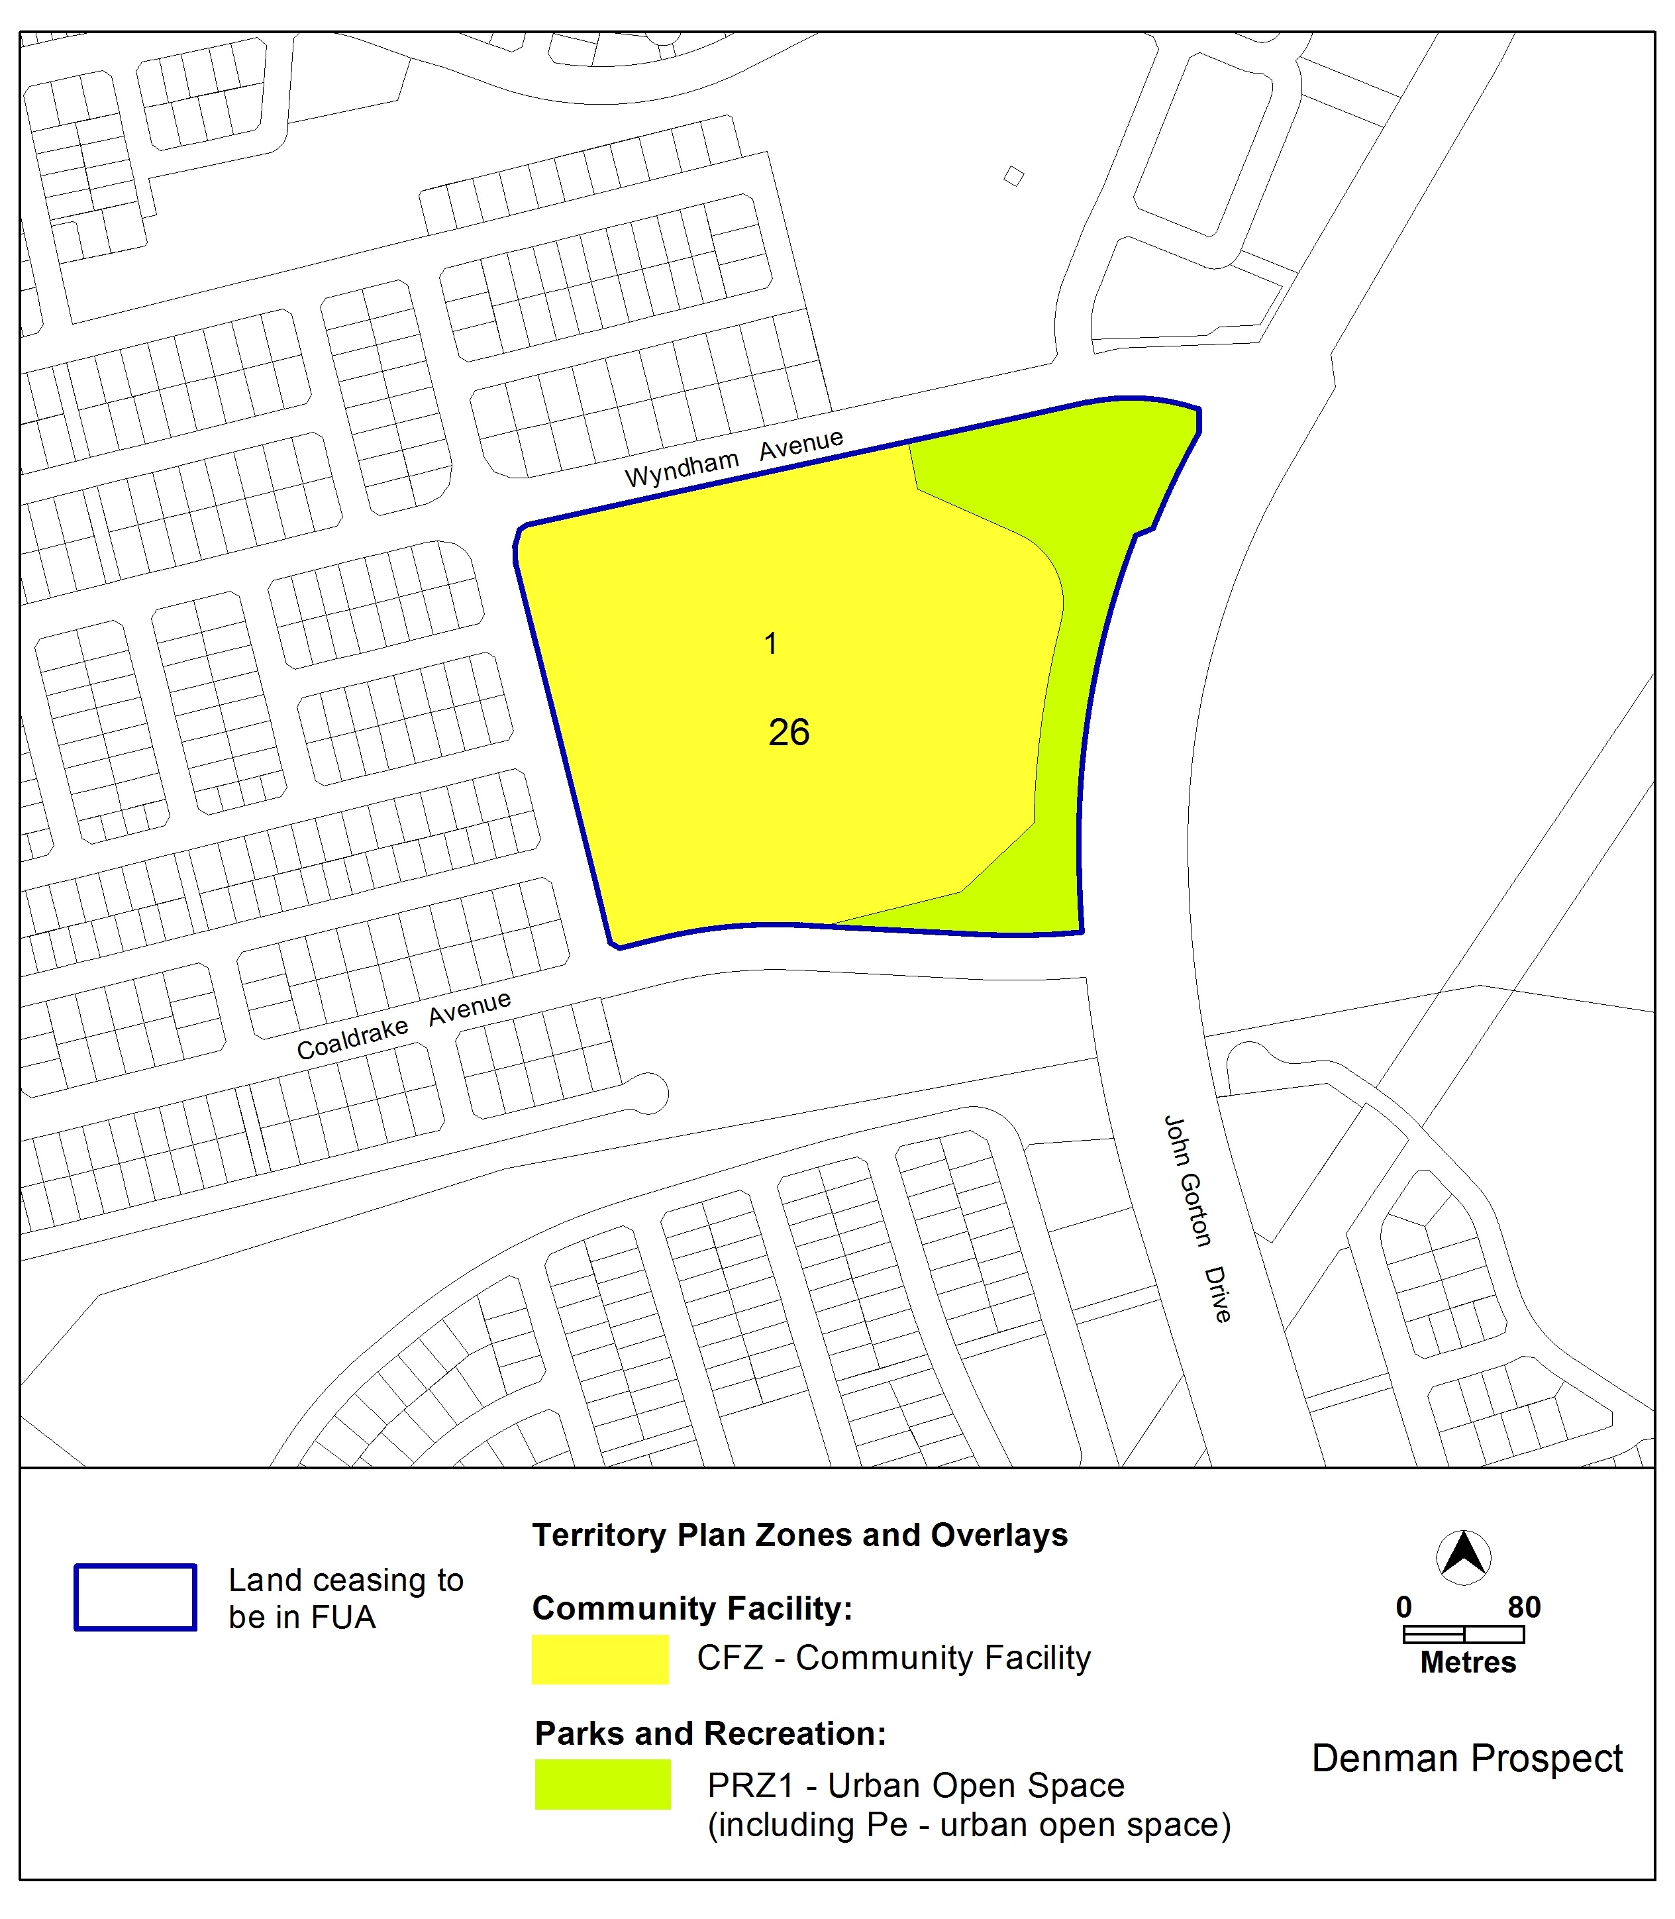

- TECHNICAL AMENDMENT
This section of the technical amendment document provides the actual instructions for implementing the changes to the Territory Plan.

  - Territory Plan Map
- Territory Plan Map

The Territory Plan map is varied as indicated below to identify the zones and overlays that apply to the land ceasing to be in a future urban area.

Interpretation service
