Australian Capital Territory
Corrections Management (Policy and Operating Procedure Development) Operating Procedure Revocation 2019
Notifiable instrument NI2019-380
made under the
Corrections Management Act 2007, s 14 (Corrections policies and operating procedures)

1 Name of instrument
This instrument is the Corrections Management (Policy and Operating Procedure Development) Operating Procedure Revocation 2019.

2 Commencement
This instrument commences on the day after its notification day.
3. Revocation
This instrument revokes the Corrections Management (Policy and Operating Procedure Development) Operating Procedure 2017 [NI2017-595].

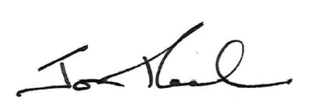
Jon Peach
Executive Director
ACT Corrective Services
14 June 2019

