Australian Capital Territory
Corrections Management (Access to the Control Room and Movement Control) Policy Revocation 2019
Notifiable instrument NI2019-428
made under the
Corrections Management Act 2007, s14 (Corrections policies and operating procedures)

1 Name of instrument
This instrument is the Corrections Management (Access to the Control Room and Movement Control) Policy Revocation 2019.
2 Commencement
This instrument commences on the day after its notification day.
3 Revocation
This policy revokes the Access to the Control Room and Movement Control Policy in the following instrument Corrections Management Policies and Operating Procedures 2017 (No 2) [NI2017-55].

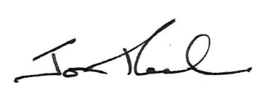
Jon Peach
Executive Director
ACT Corrective Services
24 June 2019

