Australian Capital Territory
Heritage (Decision about Provisional Registration of The Civic Square Precinct, City) Notice 2019
Notifiable instrument NI2019–611
made under the
Heritage Act 2004, s 34 (Notice of decision about provisional registration)

1 Name of instrument
This instrument is the Heritage (Decision about Provisional Registration of
The Civic Square Precinct, City) Notice 2019.
2 Decision about provisional registration
On 19 September 2019, the ACT Heritage Council (the Heritage Council) decided to provisionally register The Civic Square Precinct, Blocks 3, 18-23 and 26, Section 19, City (the Place).
3 Registration details of the Place
The registration details of the Place are in schedule 1.
4 Reasons for the decision
The Heritage Council decided to provisionally register the Place because it is satisfied on reasonable grounds that it is likely to have heritage significance as it is likely to meet one or more of the heritage significance criteria in section 10 of the Heritage Act 2004 (the Act). A detailed statement of reasons, including an assessment against the heritage significance criteria, is provided in schedule 1.
5 Date of provisional registration
The date of provisional registration is 20 September 2019 (being the day after the Heritage Council entered into the heritage register the registration details for the Place together with an indication that the registration is provisional).

6 Indication of the Heritage Council’s intention
The Heritage Council intends to decide whether to register the Place under division 6.2 of the Act during the period of provisional registration.
7 Invitation to make written comments during public consultation period
(1) The Heritage Council invites written comments about the registration of the Place. Any written comments must be made within 4 weeks after the day this notice is notified.
(2) Written comments can be provided to the Council by the following methods:
(a) mail to
The Secretary
ACT Heritage Council
GPO Box 158
CANBERRA ACT 2601
(b) email to heritage@act.gov.au
(c) via the consultation website at www.yoursay.act.gov.au.

Fiona Moore
Secretary (as delegate for)
ACT Heritage Council
19 September 2019

Schedule

(See ss 3 and 4)

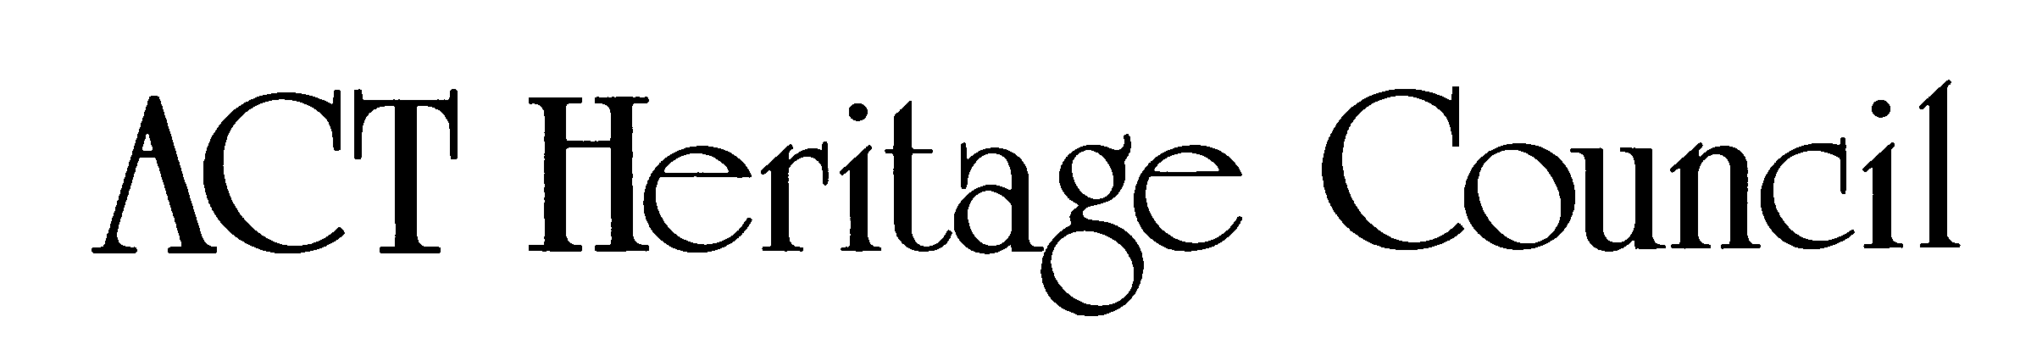
AUSTRALIAN CAPITAL TERRITORY
HERITAGE REGISTER
(Provisional Registration)

For the purposes of s. 32 of the Heritage Act 2004, a provisional entry to the heritage register has been prepared by the ACT Heritage Council for the following place:

The Civic Square Precinct

Blocks 3, 18-23 and 26 Section 19, City
DATE OF DECISION
19 September 2019
DATE OF PROVISIONAL REGISTRATION
20 September 2019 Notifiable Instrument: 2019–611
PERIOD OF EFFECT OF PROVISIONAL REGISTRATION
Start Date: 20 September 2019 End Date: 19 June 2020

Extended Period (if applicable) Start Date ________ End Date ________

Copies of the Register Entry are available for inspection at ACT Heritage. For further information please contact:

The Secretary

ACT Heritage Council

GPO Box 158

CANBERRA ACT 2601

Telephone 13 22 81

This statement refers to the location of the place as required in s. 12 (b) of the Heritage Act 2004.
LOCATION OF THE PLACE

The Civic Square Precinct, Blocks 3, 18-23 and 26 Section 19 , City.

This statement refers to the description of the place as required in s.12(c) of the Heritage Act 2004. The attributes described in this section form part of the heritage significance of the place. For the purposes of s. 12(c) of the Heritage Act 2004, the boundary of the place is at Image 1.
DESCRIPTION OF THE PLACE

The Civic Square Precinct, consisting of the following attributes (items marked with an asterisk “*” are a type of feature that should always be a part of the precinct as a planning principle; however, the current item, its current physical fabric, or current location within the Precinct are not intrinsic to the heritage significance of the place):
- The Civic Square Precinct, consisting of:
  - open space;
  - the outer square formed by the vertical sides of the buildings, taking the form of a wall enclosing the square, while maintaining easy access from all corners;
  - landscaping and amenities that are suitable for passive recreation (such as seating, lighting, shaded areas and places to gather) while maintaining a large open space suitable for large gatherings of people;
  - water features such as a pond, pool or fountain*;
  - hard paving as the predominant ground surface*;
  - lighting*; and
  - steps and a large landing looking out over the Square that can act as a podium or stage in front of the Canberra Theatre Centre*;
- Ainslie Place, consisting of:
  - landscaping and amenities that are suitable for passive recreation (such as seating, lighting, shaded areas and places to gather) and create a sense of enclosure at a human-scale including raised planter beds separating the central path from surrounding traffic as well as paths on the outer edges;
- The North and South Buildings, consisting of:
  - the form, scale and massing of each building surrounding the Square;
  - the gold gilt mosaic tiles designed by Frank Hinder to the columns on the ground level;
  - open colonnades surrounding the buildings;
  - full height glazing to the ground floor; and
  - long, low current height and repetitive facades in the stripped classical style;
- The Canberra Theatre Centre consisting of:
  - the current scale, massing and built form of the original Canberra Theatre building;
  - The scale and massing of the Canberra Theatre Centre, including the Link (building) and Playhouse, particularly noting that they do not interrupt the City Hill-Mount Ainslie axis or overshadow the Square;
- Sculptures and artwork that relate directly to The Civic Square Precinct, civic pride and community use:
  - Ethos (independently registered as a heritage object);
  - the ACT Coat of Arms above the entrance to the ACT Legislative Assembly;
  - Thespis;
  - the Canberra Times Fountain;
  - the ACT Memorial; and
  - the ACT Honour Walk;
- Artwork recognising Ngunnawal connection to the land, like Fireline*, and other contributory artworks, sculptures and installations*
- City Hill-Mount Ainslie axis within the registered boundary area as evidenced by:
  - symmetry and balance of features on either side of the axis; and
  - maintaining open space along the axis so as not to restrict views and movement along the axis.

It should also be noted that there are many other features of The Civic Square Precinct that may contribute to some degree or are neutral and not inconsistent with its heritage significance. These include, but are not limited to, the flagpoles, signage, shops within the buildings, artworks and temporary features associated with events in the Precinct.

This statement refers to the heritage significance of the place as required in s.12(d) of the Heritage Act 2004.
STATEMENT OF HERITAGE SIGNIFICANCE

The Civic Square Precinct is significant to the ACT for social and cultural values as an important central location and open space for public use, celebrations and cultural events and for expressions of democratic freedoms through protest. [criteria (a) (b) (g)]

It is also significant for its planning and design as a place that put the people ahead of built scale by providing an open contemporary and accessible space for them, and for maintaining Griffin’s spatial planning characteristics for City Hill; and for its association with the local administration of the city that has been maintained from its original Commonwealth Government inception, through to ACT self-government; and with the Precinct’s designer, Roy McGowan Simpson AO, for Yuncken Freeman, who helped shape many of the ACT’s important public spaces, as an exemplar of his design philosophy. [criteria (a) (d) (h)]

The framing of the Square is significant. It comprises the North and South Buildings designed by Yuncken Freeman in a stripped-back classical form, with ground-floor open colonnaded facades and gold-mosaic decorated columns and, to the west, the podium and Canberra Theatre Centre, with its cultural contribution to Canberra. [criterion (b)]
CONSERVATION OBJECTIVE

The guiding conservation objective is that The Civic Square Precinct shall be conserved and appropriately managed in a manner respecting its heritage significance.

The ACT Heritage Council may adopt heritage guidelines applicable to the place under s25 of the Heritage Act 2004.

For further information on guidelines applicable to the place, or for advice on proposed works or development, please contact ACT Heritage on 13 22 81.
REASON FOR PROVISIONAL REGISTRATION

The Council has assessed The Civic Square Precinct, City against the heritage significance criteria and is satisfied that the place is likely to have heritage significance when assessed against five criteria [(a), (b), (d) (g) and (h)] under s.10 of the Heritage Act 2004.
ASSESSMENT AGAINST THE HERITAGE SIGNIFICANCE CRITERIA

The Council’s assessment against the criteria specified in s.10 of the Heritage Act 2004 is as follows.

In assessing the heritage significance of The Civic Square Precinct, City, the Council considered:
- the original nomination based on its citation in the Register of the National Estate;
- the Council’s Heritage Assessment Policy (2018);
- information provided by a site inspection on 19 September 2018 by ACT Heritage; and
- the report by ACT Heritage titled, Background Information The Civic Square Precinct, September 2019, containing photographs and information on history, description, condition and integrity.

Pursuant to s.10 of the Heritage Act 2004, a place or object has heritage significance if it satisfies one or more of the following criteria. Future research may alter the findings of this assessment.
importance to the course or pattern of the ACT’s cultural or natural history;
The Council has assessed The Civic Square Precinct against criterion (a) and is satisfied that the place is likely to meet this criterion.
The Civic Square Precinct is important to the course and pattern of the ACT’s cultural history as a site for the civic administration of the city, a centre of cultural facilities, as a ‘town square’ that provides a forum for public events, performances, artwork, protest and celebration and also for the design and its implementation by the National Capital Development Authority (NCDA) (later the National Capital Development Commission (NCDC)) and the square’s planning that reinforces the spatial characteristics of Griffin’s plan as the city evolved.
The Civic Square Precinct includes a significant suite of infrastructure and buildings that form the Square, and public open space. The buildings have housed government administration since it opened in 1960, initially for the Commonwealth Department of the Interior, the ACT Advisory Council, and since self-government, the ACT Legislative Assembly.
The Square itself is an important space for holding public events and activities, including celebrations, protests and performances. The space continues to host various forms of temporary public art exhibitions. ‘Ethos’, designed by Tom Bass (1961), is a permanent sculpture prominently located within the square, representing the ‘spirit of the community’ and reflecting the philosophy of the space.
The civic role of the place in hosting cultural events and promoting culture in the ACT extends further, with the Cultural Facilities Corporation (initially, the Canberra Theatre Trust) managing the Canberra Theatre Centre, the Canberra Museum and Gallery (CMAG) and the Nolan Gallery. Additionally, the North Building houses various community-based cultural organisations.
Very little activity had occurred in the City Hill area, until the middle of the century, when the Courts Precinct and The Civic Square Precinct were constructed under the NCDC. The NCDC commissioned the development of the Precinct, which was designed by Roy McGowan Simpson, AO, of Yuncken Freemen, with the purpose of reinforcing the spatial characteristics of Griffin’s plan for Canberra for the concentration of civic and municipal administration around City Hill, with land axis links to the Capitol (now Parliament House) and a retail area (now the Russell Offices/Defence administration area).
The functions of The Civic Square Precinct fitted in with Griffin’s plan to situate the local administration in that area with the Civic Offices (now the North and South Buildings) housing the local administration branch of the Department of the Interior as well as the public library and being the location for the city square. It also reinforced Griffin’s overall planning for Canberra by maintaining his main axial lines.
As part of The Civic Square Precinct, the original Canberra Theatre Centre was designed by Yuncken Freeman in 1961 and includes an innovative early use of continuous copper roof decking.
has uncommon, rare or endangered aspects of the ACT’s cultural or natural history;
The Council has assessed The Civic Square Precinct against criterion (b) and is satisfied the place is likely to meet this criterion.
The Civic Square Precinct is planned for civic uses and includes a public square with a focus on municipal and cultural use.
The success of NCDC’s planning for the location of a civic square was dependant on developing the rest of City Hill as the civic and municipal centre that Griffin envisaged. The Civic Square Precinct is the only dedicated civic, open space in the ACT, designed to be in a central location for civic administration, community and cultural events, public celebrations and demonstrations.
The Canberra Theatre Centre frames the western side of the Square and provides a complementary function to the civic space. In Australia, it was one of the first such centres built, and the first major government-funded theatre. It was built in response to the needs of a growing community, and its opening in 1965 marked a major step forward in the cultural life of Canberra.
potential to yield important information that will contribute to an understanding of the ACT’s cultural or natural history;
The Council has assessed The Civic Square Precinct against criterion (c) and is satisfied that the place is not likely to meet this criterion.
The Civic Square Precinct does not have the potential to yield important information that will contribute to further understanding of the ACT’s cultural history. There is sufficient information available about the function, uses, design, planning and historic development of The Civic Square Precinct, therefore it is unlikely to yield additional information that would give a greater understanding of the cultural history of the ACT.
importance in demonstrating the principal characteristics of a class of cultural or natural places or objects;
The Council has assessed The Civic Square Precinct against criterion (d) and is satisfied that the place is likely to meet this criterion.
The Civic Square Precinct is important for demonstrating the principal characteristics of a civic space.
The Civic Square Precinct is used for cultural activities including concerts, markets, festivals, displays, celebrations and planned community events, as well as for public activism through demonstrations and protests. It has a variety of amenities, when taken as a whole incorporating Ainslie Place, including the Civic Library, the Canberra Museum and Gallery (CMAG), the Canberra Theatre Centre, the fountain (pool), specifically designed sculptures for the civic space, the City Hill-Mount Ainslie axis/vista, places to sit in the shade and various cafes along the edges. It is generally seen as being clean and safe.
Roy Simpson, of Yuncken Freeman and primary architect of the Square, in his AS Hook address (an address given by recipients of the Australian Institute of Architects Gold Medal) noted that the overall precinct design is more important than the individual elements within it. There was a hierarchy of importance, with the buildings subservient to the precinct and the precinct subservient to the city. Simpson’s design philosophy is evident in The Civic Square Precinct, where it has been planned around Griffin’s City Hill group and axial lines while the buildings themselves are fairly subdued, creating the open square as the focus. The changes to the Precinct have reinforced the Precinct’s role and subservience to the City even further by giving priority to movement and sightlines along Griffin’s axis.
This highlights the collective importance of the elements– the architecture, the spatial qualities and relationships and the overall aesthetic of the precinct to deliver the qualities which were envisaged by Simpson when he designed it.
importance in exhibiting particular aesthetic characteristics valued by the ACT community or a cultural group in the ACT;
The Council has assessed The Civic Square Precinct against criterion (e) and is satisfied that the place is not likely to meet this criterion.
That the aesthetic characteristics are valued by the ACT community or cultural groups in the ACT has not been tested, although this may emerge more clearly in the future.
The Square’s design emphasises the overall precinct within the greater city plan and frames the views and axial lines between City Hill and Mount Ainslie.
The Civic Square Precinct has aesthetic characteristics as a designed space for public, cultural and ceremonial activities of about 60 x 60 metres. The design demonstrates classical civic design principles within a ‘post-modern’ aesthetic. The classical layout for civic spaces involves the arrangement of significant buildings on elevated platforms or podiums.
The North and South Buildings, both administrative and community buildings, create the ‘square’, and the sequencing of the podiums that culminate in the Canberra Theatre Centre. The Civic Square Precinct also has an ascending sequence of spaces, with the highest terminating point at City Hill, the elevated podium of the Canberra Theatre Centre at the western side, with its grand staircase, providing prominence to the theatre, a place of cultural activities for the community and the City.
Originally the pool, a large rectangular element of 945m^{2,} was an integral part of the design and had an aesthetic function, providing the central focus of the square, with several fountain jets surrounded by spillage drains and a bed of uneven, polished river rocks set in concrete.
The simplicity and purity of the square’s design is complemented by its public art, with ‘Ethos’, an iconic sculpture for Canberra, symbolising the spirit of the community and celebrated since its installation in 1961. The Square is the setting of major site-specific artworks and many activities that respond to the place, its form and function.
Importance in demonstrating a high degree of creative or technical achievement for a particular period;
The Council has assessed The Civic Square Precinct against criterion (f) and is satisfied that the place is not likely to meet this criterion.
The design of the Square was in line with international urban design standards and influenced by post-war contemporary town squares. There are creative and technical achievements including the gold gilt mosaic tiles and the previous incorporation of the cooling system within the original pond designed by Tom Bass. However, The Civic Square Precinct does not demonstrate the high degree of creative or technical achievement or meet the threshold for this criterion.
has a strong or special association with the ACT community, or a cultural group in the ACT for social, cultural or spiritual reasons;
The Council has assessed The Civic Square Precinct against criterion (g) and is satisfied that the place is likely to meet this criterion.
The Civic Square Precinct has a special association with the ACT community for social and cultural reasons. The place has an enduring special association with the ACT Community.
It is an important location for celebration of sporting and other local achievements, protests, cultural events and significant social gatherings like New Year, NAIDOC Week and the Multicultural Festival.
As a designed public square that incorporates the local administration, it is a place frequently used by Canberrans to voice their concerns publicly in protest. The Cultural Facilities Corporation puts on live shows and productions at the place for the benefit of the culture of the ACT.
has a special association with the life or work of a person, or people, important to the history of the ACT.
The Council has assessed The Civic Square Precinct against criterion (h) and is satisfied that the place is likely to meet this criterion.
Roy Simpson was an accomplished architect and planner with a design philosophy of being sensitive to context rather than creating more noticeable and grandiose buildings. His contribution to the history of the ACT is evidenced by his design of The Civic Square Precinct, the Law Courts Precinct, various projects within the ANU as well as guiding its overall design for 12 years, Canberra Grammar School’s science wing, 18 houses for the Chief of Defence Service (the first NCDC commission), planning the Cotter Reserve as well as overseeing aspects of renovations to the Lodge and the Governor General’s Residence at Yarralumla. Simpson used The Civic Square Precinct as one of the three examples, along with the Melbourne Diocesan Centre and the La Trobe University master plan that exemplified his work and design philosophy in his A S Hook memorial address. He wrote the address in response to winning the RAIA Gold Medal but it was delivered posthumously by his wife Donne Simpson.
The Civic Square Precinct, including the North and South Buildings and the Canberra Theatre Centre, has maintained a strong and special association with local level administration of the ACT from the initial use by the Department of the Interior, to its current use as site for the Legislative Assembly. This association is considered to be special as there is a continuing history of the square beside these offices as a place of protest that is publicly visible and directly associated with the administration since 1988. The association is also considered to be special as the ACT administration, particularly prior to self-government when the Commonwealth could have located the department anywhere, is located at the municipal zone in Griffin’s plan.
The Civic Square Precinct is associated with the Canberra Theatre Trust (set up under the Canberra Theatre Trust Ordinance 1965, which established they would use the Canberra Theatre Centre and make it available while promoting and encouraging the development and presentation of the arts in Canberra). The Trust became the Cultural Facilities Corporation (set up under the Cultural Facilities Corporation Act 1997). The Corporation was expanded to include Canberra Historic Houses as well as CMAG and the Nolan Collection, while promoting cultural activities and collections. Their work has established the Canberra Theatre Centre as Australia’s first major theatre to be built with government funds, providing a world-class venue that continues to attract all levels of productions from local to internationally renowned companies, individual performers and concerts.
While the place has a connection with Walter Burley Griffin’s plan by reinforcing the spatial characteristics of his axial lines it is on such a broad level that he has no direct or special association with The Civic Square Precinct specifically. This association of the place to Griffin has not met the threshold for this criterion.

SITE PLAN

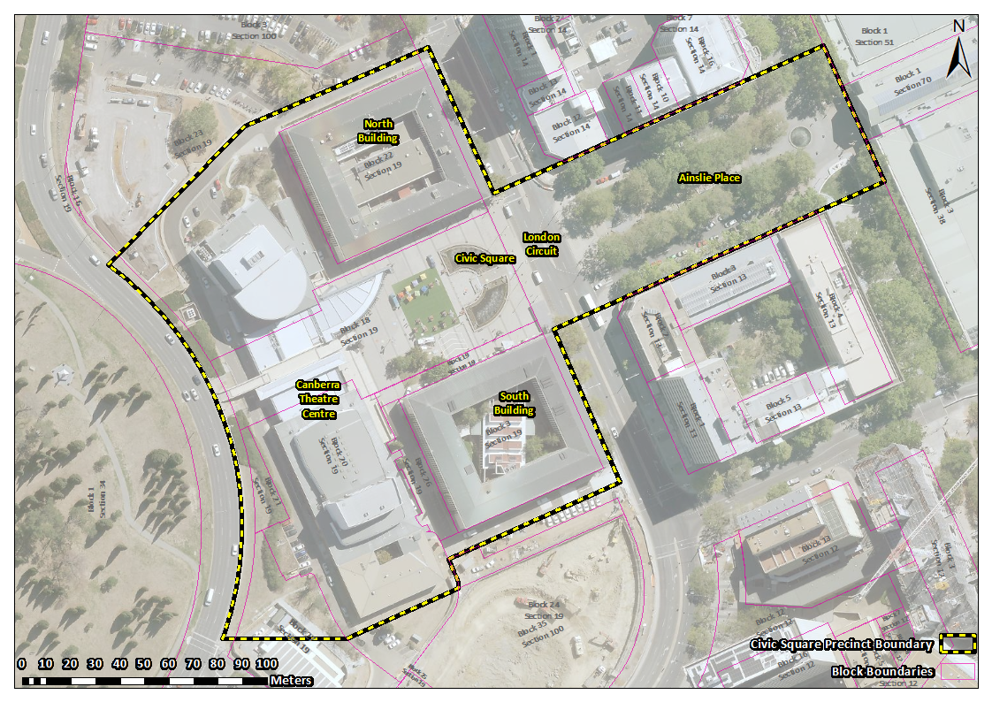
Image 1 The Civic Square Precinct site boundary

