Australian Capital Territory

**Gaming Machine Approval 2019 (No 17)**

**Notifiable instrument NI2019–672**

made under the

**Gaming Machine Act 2004, section 69 (Approval of gaming machines and peripheral equipment)**

**1 Name of instrument**

This instrument is the *Gaming Machine Approval 2019 (No* *17).*

**2 Commencement**

This instrument commences the day after the date of notification.

1. **Approval**

I approve the gaming machine(s) described in the attached Schedule to this instrument.

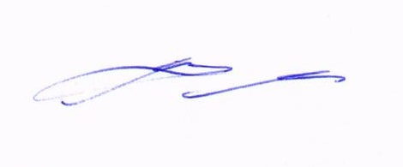

Matt Miles

Delegate

ACT Gambling and Racing Commission

15 October 2019

For further information please contact the approved supplier.

|  |  |
| --- | --- |
| Aristocrat Technologies Australia Pty Ltd | |
| Device Name | Bank Note Acceptor |
| Bank Note Acceptor Model | JCM UBA-10(AUS)-SS ID-003 |
| Application Reference Number | 01-A1883/S01 |

|  |  |
| --- | --- |
| Aristocrat Technologies Australia Pty Ltd | |
| Device Name | Bill Acceptor |
| Bill Acceptor Details 1 | |
| MEI SCN 83 Advance Un-Programmed Unit Assembly (Serial) | ATA P/N: 442155_083 |
| Bill Acceptor Details 2 | |
| MEI SC Advance SCN83 USB (GDS protocol) un-programmed Unit  Assembly | ATA P/N: 442155_283 |
| Application Reference Number | 01-A1884/S01 |