Australian Capital Territory

Nature Conservation (Tarengo Leek Orchid) Conservation Advice 2019

Notifiable instrument NI2019–711
made under the
Nature Conservation Act 2014, s 90C (Conservation advice)

1 Name of instrument
This instrument is the Nature Conservation (Tarengo Leek Orchid) Conservation Advice 2019.

2 Commencement
This instrument commences on the day after its notification day.

3 Conservation advice for Tarengo Leek Orchid
Schedule 1 sets out the conservation advice for Tarengo Leek Orchid (Prasophyllum petilum).

Arthur Georges
Chair, Scientific Committee
6 November 2019
Schedule 1
(see s 3)

Conservation Advice
Tarengo leek orchid – Prasophyllum petilum

Conservation Status
The Tarengo Leek Orchid Prasophyllum petilum D.L.Jones & R.J.Bates, is recognised as threatened in the following jurisdictions:
National Endangered, Environment Protection and Biodiversity Conservation Act 1999
ACT Endangered, Nature Conservation Act 2014
NSW Endangered, Biodiversity Conservation Act 2016

ELIGIBILITY
The factors that made the Tarengo Leek Orchid eligible for listing as Endangered in the ACT Threatened Native Species List in the ACT are included in the Listing Background section below.

DESCRIPTION AND ECOLOGY
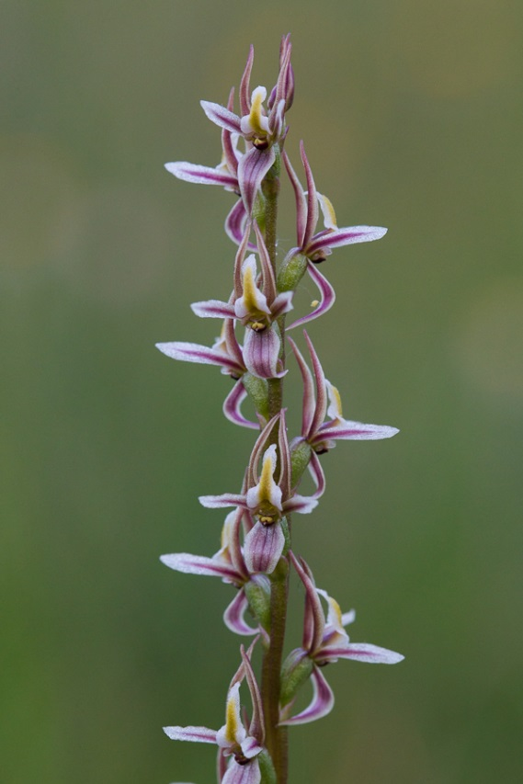
The Tarengo Leek Orchid is a slender terrestrial orchid that grows to 30 cm, with its single cylindrical leaf reaching 25 cm (Department of Environment, Climate Change and Water (NSW DECCW) 2010). The flower spike emerges from October through to November and produces 5 to 18 flowers. After flowering, small obovoid seed capsules form. The leaves and flowers are both dull green with pink tinges on the flowers, making this a very inconspicuous plant when growing among tall grasses or in small numbers (ACT Government 2019).
Given the small population size and relatively recent identification, the biology and ecology of the Tarengo Leek Orchid is poorly understood. For much of the warmer months, the plant persists as a tuber, before shooting in late autumn. An individual flowering in consecutive years is uncommon, and may contribute to the fluctuations in the population (Wilson et al. 2016). Wilson et al. (2016) found that the number of Tarengo Leek Orchids producing flowers decreased as the number of frost nights increased (particularly the number of nights at or below -4ºC). The flowers of Prasophyllum species are pollinated by insects and although reproduction is mostly by seed, daughter tubers are also produced (Jones 1988).
Tarengo Leek Orchid (Tobias Hayashi – Canberra Nature Map)

Distribution and Habitat
Known populations of the Tarengo Leek Orchid occur in grassy woodlands and grasslands of the southern tablelands and western slopes of NSW and the ACT. The largest known population is at the Tarengo Travelling Stock Reserve near Boorowa (NSW), where there is estimated to be up to 100,000 plants some years. Other populations have relatively few individuals and have been found as far north as Ilford Cemetery (Bathurst, NSW), to the south at Steve’s Travelling Stock Reserve (Delegate, NSW) and to the east at Captains Flat Cemetery (NSW DECCW 2010). Given the level of fragmentation and degradation across this region, it may be assumed that the Tarengo Leek Orchid was once more common and widespread than it is today (ACT Government 2019).
It tends to grow among native – and to a lesser extent exotic – grasses on fertile soils of low relief. Species of the genus Prasophyllum are known to prefer moister soils in depressions and swamps (Jones 1988), a tendency that appears to apply to the Tarengo Leek Orchid (ACT Government 2019).
Within the ACT, the Tarengo Leek Orchid is only known to occur at the Hall Cemetery, where the species was first properly identified in 1991. The number of flowering plants at the Hall Cemetery has fluctuated annually from 0–96 with the usual count between 30 and 52 flowering plants. This population occurs in a partially cleared area within a Yellow Box – Blakely’s Red Gum grassy woodland. The site is typical of the Tarengo Leek Orchid habitat and is dominated by Kangaroo grass (Themeda triandra) and Wallaby grasses (Rytidosperma spp.) with a high diversity of forbs (ACT Government 2019).

Threats
Threats to the Tarengo Leek Orchid in the ACT are detailed in the action plan (ACT Government 2019) and include:
- restricted range and population size
- isolation from other populations – limiting genetic diversity and increasing vulnerability to environmental change and disease
- fine-scale habitat loss as new graves are established
- Sulphur-crested Cockatoos (Cacatua galerita) feeding in spring
- competition with native and exotic species.
- cemetery grounds maintenance
- loss of vegetation structural complexity in combination with frequent and severe frosts.

Major Conservation Objective
The overall objective of the action plan (ACT Government 2019) is to preserve the Tarengo Leek Orchid in perpetuity in the wild across its natural geographic range in the ACT, including the need to maintain natural evolutionary processes.

Conservation Issues
Given that the only known ACT population of the Tarengo Leek Orchid occurs at Hall Cemetery, the Hall Cemetery Management Plan 2012 provides management actions related to operations. This relates to actions associated with mowing, weeds, eucalyptus regeneration, vehicle access, grave digging, fertiliser use, cockatoo disturbance, fire, and grazing (Conservation Research and Canberra Cemeteries 2013). A critical element in the conservation of the Tarengo Leek Orchid is the conservation of Yellow Box – Blakely’s Red Gum Grassy Woodland and Natural Temperate Grassland. The Hall Cemetery population occurs in partially modified Yellow Box – Blakely’s Red Gum Grassy Woodland. The ACT action plan expands on the required management actions (ACT Government 2019) and the Conservation Research Unit in the ACT Government oversees the management of the species by the Canberra Public Cemeteries Trust.

Other Relevant Advice, plans or Prescriptions
- National Recovery Plan for the Tarengo Leek Orchid (NSW DECCW 2010)
- ACT Draft Action Plan for the Tarengo Leek Orchid (ACT Government 2019)
- Hall Cemetery Management Plan 2012 (Conservation Research and Canberra Cemeteries 2013)
- Conservator Translocation Guidelines (ACT Government 2018)

Listing Background
The Tarengo Leek Orchid was listed in the ACT as an Endangered species on 15 April 1996 in accordance with section 21 of the Nature Conservation Act 1980. At that time, the Flora and Fauna Committee (now the Scientific Committee) concluded that the assessment satisfied the following criteria:
1.1 Species is known or suspected to occur in the ACT region and is already recognised as endangered in an authoritative international or national listing.
1.2 Species is observed, estimated, inferred or suspected to be at risk of premature extinction in the ACT region in the near future, as demonstrated by one or more of:
1.2.1 Current severe decline in population or distribution from evidence based on:
1.2.1.3 Severe decline in quality or quantity of habitat.
    - Imminent risk of severe decline in population or distribution from evidence based on:
1.2.1.4 Very high or actual or potential levels of exploitation or persecution.
1.2.3 Continuing decline or unnaturally extreme fluctuations in population, or distribution, for a species currently occurring over a small range or having a small area of occupancy within its range.
1.2.5 Continuing decline or severe fragmentation in population, for species with a small current population.
The Tarengo Leek Orchid is eligible for listing as Endangered under the Environment Protection and Biodiversity Conservation Act 1999 (EPBC Act) as, prior to the commencement of the EPBC Act, it was listed as Endangered under the Endangered Species Protection Act 1992 (Cwlth).

REferences
ACT Government 2018. Nature Conservation (Translocation of Native Flora and Fauna) Conservator Guidelines. Department of Environment, Planning and Sustainable Development, Canberra. https://www.legislation.act.gov.au/ni/2017-650/
ACT Government 2019. Draft ACT Native Woodland Conservation Strategy. Environment Planning and Sustainable Development Directorate, Canberra. https://www.legislation.act.gov.au/View/ni/2019-184/20190406-70882/PDF/2019-184.PDF
Conservation Research and Canberra Cemeteries 2013. Hall Cemetery Management Plan 2012. Environment and Sustainable Development Directorate, Canberra.
Department of Environment, Climate Change and Water (NSW DECCW) 2010. National Recovery Plan for Prasophyllum petilum, NSW Department of Environment and Climate Change and Water, Hurstville.
IUCN 2012. IUCN Red List Categories and Criteria: Version 3.1. Second edition, Gland, Switzerland: IUCN.
Jones DL 1988. Native Orchids of Australia. Reed Books, Sydney.
Wilson N, Seddon J and Baines G 2016. Factors Influencing the flowering of the Tarengo Leek Orchid (Prasophylum petilum). Technical Report 36. Environment and Planning Directorate, ACT Government, Canberra.

Further Information
Further information on the related Action Plan or other threatened species and ecological communities can be obtained from: Environment, Planning and Sustainable Development Directorate (EPSDD).
Phone: (02) 132281, EPSDD Website: http://www.environment.act.gov.au/cpr.

