Australian Capital Territory
Corrections Management (Perimeter Checks) Operating Procedure 2019
Notifiable instrument NI2019-814
made under the
Corrections Management Act 2007, s14 (Corrections policies and operating procedures), s15 (Exclusion from notified corrections policies and operating procedures)

1 Name of instrument
This instrument is the Corrections Management (Perimeter Checks) Operating Procedure 2019.

2 Commencement
This instrument commences on the day after its notification day.
3 Operating Procedure
I make this operating procedure to facilitate the effective and efficient management of correctional services.
4 Exclusion from notification
The material in this operating procedure has been excluded from notification as I believe, on reasonable grounds, that the material would be likely to disclose information that may endanger public safety or undermine justice, security or good order at a correctional centre.

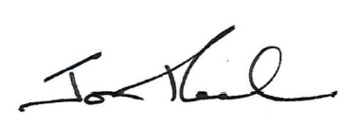

Jon Peach
Executive Director
ACT Corrective Services
12 December 2019

