Australian Capital Territory
Gaming Machine (Peripheral Equipment) Approval 2020 (No 1)
Notifiable instrument NI2020-131
made under the
Gaming Machine Act 2004, section 69 (Approval of gaming machines and peripheral equipment)

1 Name of instrument
This instrument is the Gaming Machine (Peripheral Equipment) Approval 2020 (No 1)

2 Commencement
This instrument commences the day after the date of notification.

- Approval
I approve the peripheral equipment described in the attached Schedule to this instrument.

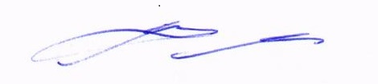
Matt Miles
Delegate
ACT Gambling and Racing Commission

9 January 2020

For further information please contact the approved supplier.

SG Gaming ANZ Pty Ltd
Subject: New Rev 7 / Rev 8 Link Progressive Jackpot Controller System
LPJS Name | Standard LPJS – Penny Pier Link
Specification Number | 35.YA005
System Details 1
System Name 1 | Rev 8 (T2E) Link Progressive Jackpot Controller System
Jackpot Theme | Penny Pier
System Details 2
System Name | Rev 7 Link Progressive Jackpot Controller System
Application Reference Number | 44-A1268/S01 & 44-A1268/S02

