Australian Capital Territory

Nature Conservation (Yellow Box – Blakely’s Red Gum Grassy Woodland) Conservation Advice 2020

Notifiable instrument NI2020–304
made under the
Nature Conservation Act 2014, s 90C (Conservation advice)

1 Name of instrument
This instrument is the Nature Conservation (Yellow Box – Blakely’s Red Gum Grassy Woodland) Conservation Advice 2020.

2 Commencement
This instrument commences on the day after its notification day.

3 Conservation advice for Yellow Box – Blakely’s Red Gum Grassy Woodland
Schedule 1 sets out the conservation advice for the Yellow Box – Blakely’s Red Gum Grassy Woodland.

Arthur Georges
Chair, Scientific Committee
22 May 2020

Schedule 1
(see s 3)

Conservation Advice
Yellow Box – Blakely’s Red Gum Grassy Woodland

ELIGIBILITY
The ACT Scientific Committee has determined that the ecological community ‘Yellow Box – Blakely’s Red Gum Grassy Woodland’ is eligible to be transferred to the Critically Endangered category in the ACT Threatened Ecological Communities List under the Nature Conservation Act 2014 (NC Act). It was initially listed in the Endangered category in 1997 (refer to the Listing Background section below). While the community has not necessarily become more threatened in the ACT since the original listing, the transfer to Critically Endangered recognises the ACT’s responsibility at the national level to preserve the nation’s largest and best connected remnants of the community.
The threatened Yellow Box – Blakely’s Red Gum Grassy Woodland in the ACT is encompassed in the ‘White Box – Yellow Box – Blakely’s Red Gum Grassy Woodland and Derived Native Grassland’ ecological community listed under the Environment Protection and Biodiversity Conservation Act 1999 (Cwth) (EPBC Act). The Australian Government listed the ‘White Box – Yellow Box – Blakely’s Red Gum Grassy Woodland and Derived Native Grassland’ ecological community as Critically Endangered under the EPBC Act on 17 May 2006 as it was found to be eligible under Criteria A3 and D3. The main reasons for this ecological community being eligible are that it has undergone a very large reduction in its historical distribution across Australia and it has experienced relatively severe (>90%) disruption of biotic processes over more than 90% of its distribution.
Listing Yellow Box – Blakely’s Red Gum Grassy Woodland as Critically Endangered: recognises that its long-term survival is under threat across Australia; aims to prevent any further decline; and promotes and assists the recovery of its biodiversity and function.
Section 90A of the NC Act allows the Minister to transfer a nationally threatened ecological community in the Threatened Ecological Communities List from one category to another category that corresponds with the EPBC category.

DESCRIPTION and Significance
Yellow Box – Blakely’s Red Gum Grassy Woodland is characterised by a discontinuous stratum of trees of medium height (10-35 m) with canopies that are separated and with 4-30% foliage cover. The community is dominated by Yellow Box (Eucalyptus melliodora) and/or Blakely’s Red Gum (Eucalyptus blakelyi); Apple Box (Eucalyptus bridgesiana) and Candlebark (Eucalyptus rubida) are the most common co-dominant trees (ACT Government 2019). A significant component is the species-rich understorey of native tussock grasses, herbs and scattered shrubs. Remnants of the community in good condition have a ground cover dominated (50% or more of the perennial species) by native grasses and forbs. The ground cover of remnants in lower condition may not be dominated by native species, yet retain a canopy of mature trees (20 or more per hectare on average) and/or support natural regeneration. Derived (secondary) grasslands develop when the tree canopy cover is removed (or suffers dieback) but a relatively diverse understorey remains intact. The size of Yellow Box – Blakely’s Red Gum Grassy Woodland remnant patches varies, but to be listed as part of the EPBC ecological community a patch must be at least 0.1 ha.
Yellow Box – Blakely’s Red Gum Grassy Woodland provides important habitat for a range of flora and fauna, including ten threatened woodland birds: Swift Parrot (Lathamus discolor), White-winged Triller (Lalage tricolor), Varied Sittella (Daphoenositta chrysoptera), Regent Honeyeater (Anthochaera phrygia), Brown Treecreeper (Climacteris picumnus), Painted Honeyeater (Grantiella picta), Superb Parrot (Polytelis swainsonii), Hooded Robin (Melanodryas cucullata), Scarlet Robin (Petroica boodang) and Glossy Black-Cockatoo (Calyptorhynchus lathami). Other threatened species include the Pink-tailed Worm-lizard (Aprasia parapulchella), Golden Sun Moth (Synemon plana) and Perunga Grasshopper (Perunga ochracea).
Threatened flora species that occur in the Yellow Box – Blakely’s Red Gum Grassy Woodland in the ACT include: Tarengo Leek Orchid (Prasophyllum petilum), Canberra Spider Orchid (Caladenia actensis), Hoary Sunray (Leucochrysum albicans var. tricolor), Small Purple Pea (Swainsona recta) and Austral Toadflax (Thesium australe).
Woodland areas that provide critical habitat for threatened species include: Mulligans Flat Nature Reserve (NR), Goorooyarroo NR, lower slopes of Mount Ainslie NR, Callum Brae NR, Kinlyside NR, Castle Hill, Tharwa, Upper Naas Valley, Newline Quarry, and Dunlop NR. Remnants of Yellow Box – Blakely’s Red Gum Grassy Woodland, including those in poorer condition, contain habitat attributes that support a diversity of fauna associated with, or dependent on, woodland ecosystems. Small patches are considered important if they retain a groundcover dominated by native species and a canopy dominated by Yellow Box or Blakely’s Red Gum, especially where mature trees are present. Maintaining and enhancing habitat features and keystone structures, including tree hollows, leaf litter, coarse woody debris, mistletoe, and bark complexity, contributes to the maintenance of biodiversity and on-going ecosystem function of Yellow Box – Blakely’s Red Gum Grassy Woodland in poorer condition (ACT Government 2019).

Distribution
In the ACT, Yellow Box – Blakely’s Red Gum Grassy Woodland persists on low-lying undulating plains in the north, and the rolling hills and valleys of the Naas Valley. Patches of Yellow Box – Blakely’s Red Gum Grassy Woodland persist at altitudes of 625 - 800 m above sea level and encompass two woodland communities described by Armstrong et al. (2013). These are: (1) Blakely’s Red Gum – Yellow Box ± White Box tall grassy woodland of the Upper South Western Slopes and western South Eastern Highlands bioregions, commonly occurring on flat, fertile soils; and (2) Yellow Box – Apple Box tall grassy woodland of the South Eastern Highlands bioregion, occurring on similar soil types as (1), but along steeper well-drained slopes (ACT Government 2019).
Aerial photography has been used to map vegetation communities in the ACT (ACT Government 2018). A number of the characteristics required to determine if areas meet the definition of the EPBC listed community (see above) are not discernible using this method (e.g. ground cover composition). Therefore, Figure 1 has been compiled to illustrate the potential distribution of Yellow Box – Blakely’s Red Gum Grassy Woodland in the ACT (21,974 ha). It incorporates woodland between 625 and 800 metres above sea level, with a canopy dominated by Yellow Box and/or Blakely’s Red Gum (and associated trees) and/or a groundcover dominated by native species. Field inspection is required to confirm the true distribution of Yellow Box – Blakely’s Red Gum Grassy Woodland within this range (ACT Government 2019).
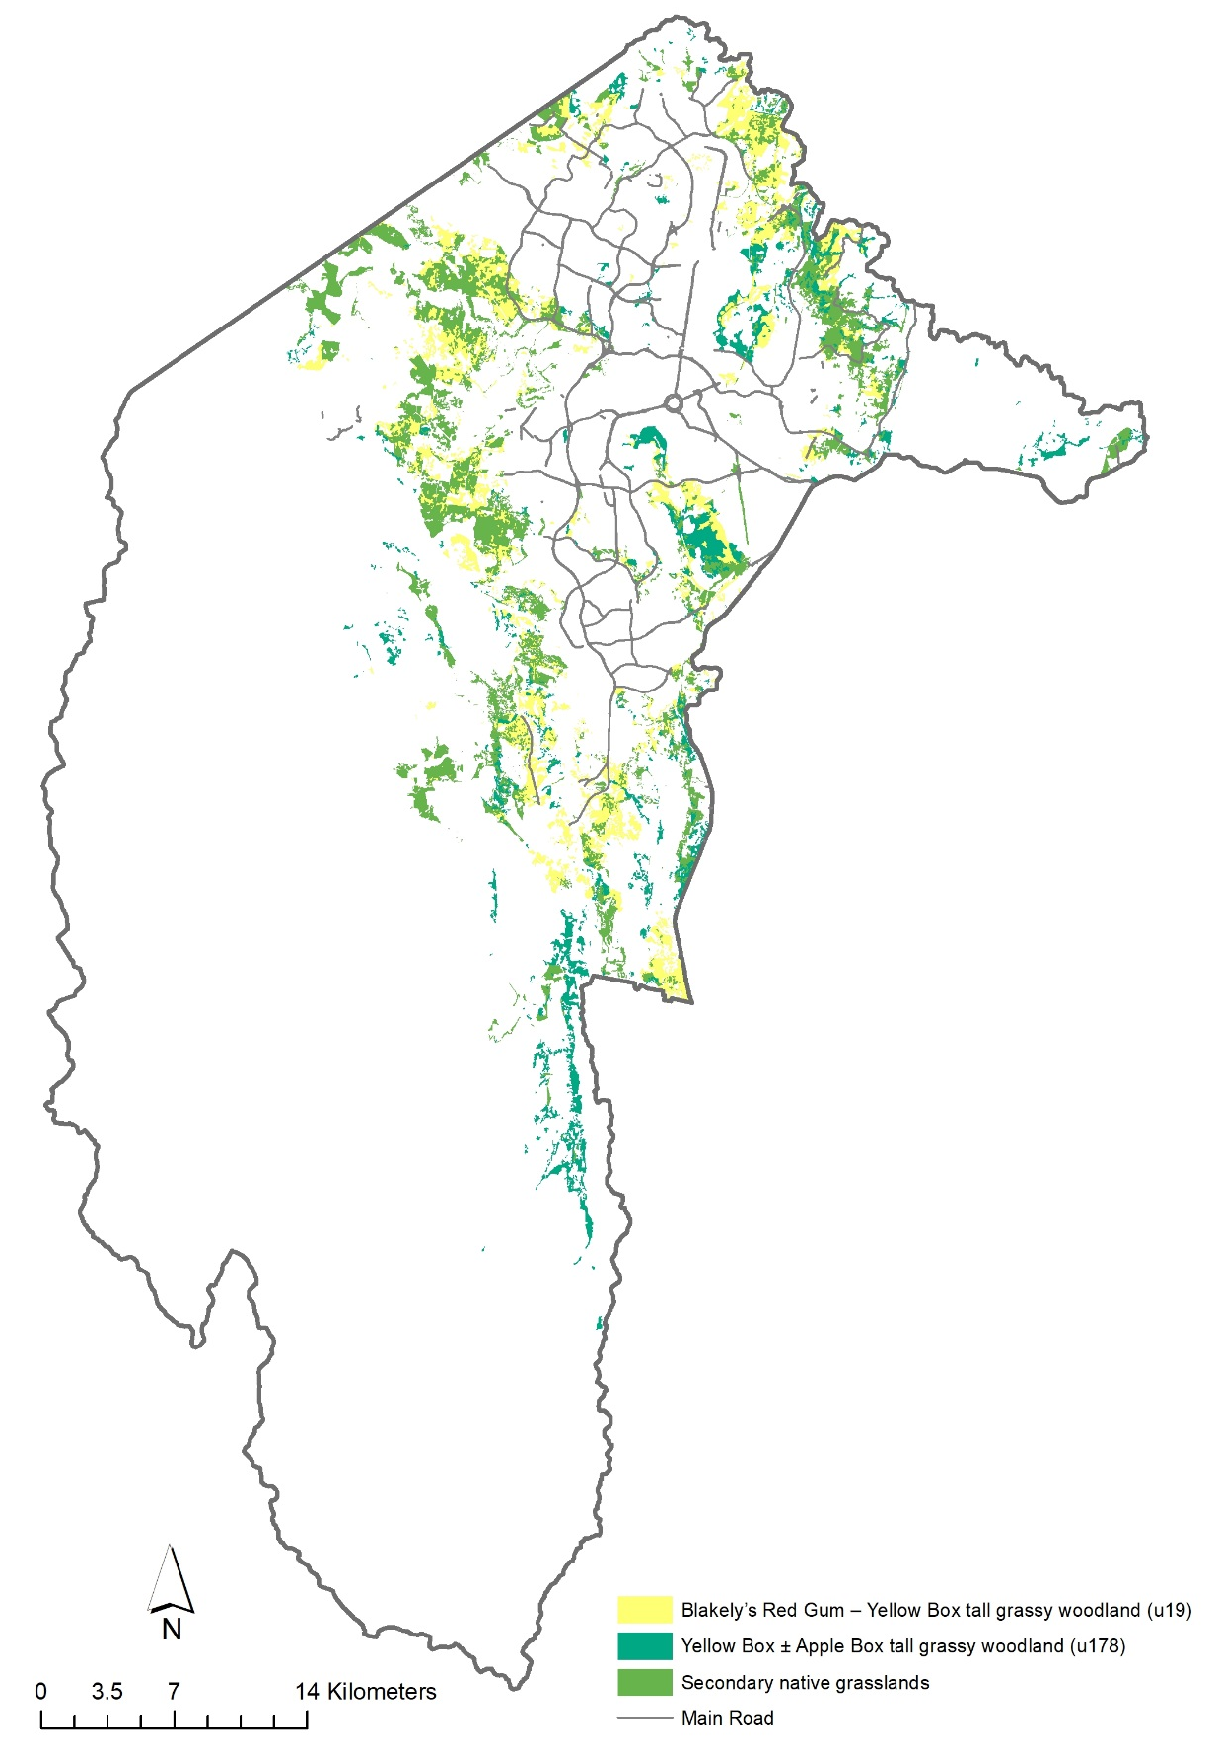
Figure 1. Potential distribution of Yellow Box-Blakely’s Red Gum Grassy Woodland. (ACT Government 2019)

Threats
Nationally, the threats to temperate woodland ecosystems include clearing, grazing, weed invasion, salinity, nutrient enrichment, deteriorating soil condition, altered fire regimes, and the effects of fragmentation and climate change (ACT Government 2019). In the ACT, the key threats to Yellow Box – Blakely’s Red Gum Grassy Woodland are:
- urbanisation
- inappropriate disturbance regimes
- invasive plants
- pest animals
- eucalypt dieback
- climate change.

Current Protection and management in the ACT
A core focus of Yellow Box – Blakely’s Red Gum Grassy Woodland management has been to ensure the community is protected in an adequate, representative and comprehensive system. The ACT contains some of the largest (> 100 ha) and best connected remnants of good quality box-gum grassy woodland in Australia (ACT Government 2004). The establishment of leasehold title and associated planning policies in the ACT discouraged the adoption of intense pasture improvement techniques that have contributed to the degradation of Yellow Box – Blakely’s Red Gum Grassy Woodland more broadly across Australia (ACT Government 2019).
The ACT Government conducts monitoring of Yellow Box – Blakely’s Red Gum Grassy Woodland to track ecological condition and better understand threats and management outcomes. Monitoring occurs at 104 sites located in box-gum woodland across the ACT, of which 75 sites are located in remnants that are classified as part of the threatened Yellow Box – Blakely’s Red Gum Grassy Woodland ecological community. Woodland monitoring focuses on trends in vegetation structure and floristic diversity to determine whether management actions are maintaining or enhancing ecological values (ACT Government 2019). Management practices that aim to maintain woodland condition have focused on reducing intense grazing pressure, controlling invasive species, and maintaining habitat for threatened species.
Evidence-based ecological restoration has been a strong focus of Yellow Box – Blakely’s Red Gum Grassy Woodland management. Improvements to the extent, condition, and connectivity of Yellow Box – Blakely’s Red Gum Grassy Woodland have been delivered through the ACT Woodland Restoration Project, Biodiversity Fund Project, and Environmental Offset restoration operations (ongoing). These projects aim to improve woodland condition and connectivity using a whole-of-landscape approach (ACT Government 2019). Restoration has primarily focused on revegetation, understorey rehabilitation, and structural enhancement.

Major conservation objectives
The overall objective is to conserve Yellow Box – Blakely’s Red Gum Grassy Woodland in perpetuity as a viable ecological community across its geographic range in the ACT (ACT Government 2019). This includes managing and restoring natural ecological and evolutionary processes within the community.
Specific objectives of the ACT Action Plan for the Yellow Box – Blakely’s Red Gum Grassy Woodland (ACT Government 2019) include:
- protect remaining areas from unintended impacts
- maintain the ecological values to promote ecosystem function and prevent biodiversity loss, including maintaining:
- understorey structural and floristic diversity
- optimal habitat for threatened species, including keystone structures
- improve the condition and ecological function by undertaking restoration
- improve understanding of ecology, restoration principles and best practice threat management
- strengthen stakeholder and community collaboration in conservation.

Other Relevant Advices, plans or Prescriptions
- ACT Native Woodlands Conservation Strategy and Action Plans (ACT Government 2019)
- Commonwealth Listing Advice – White Box – Yellow Box – Blakely's Red Gum Grassy Woodland (TSSC 2006)

Listing Background
Yellow Box – Red Gum Grassy Woodland was listed in the ACT as an Endangered ecological community on 19 May 1997 in accordance with section 21 of the Nature Conservation Act 1980. At that time, the Flora and Fauna Committee (now the Scientific Committee) concluded that the assessment satisfied the following criteria:
3.2 Community is subject to current and continuing threats or other processes likely to lead to premature extinction, as demonstrated by:
3.2.1 severe decline in distribution
3.2.2 marked alteration of composition or structure
3.2.3 community is approaching non-sustainability
3.2.4 loss or decline of species that play a major role in community function
3.2.5 small distribution causing the community to be at risk of premature extinction
3.2.6 community processes being altered to the extent that interaction between the community components will be impeded.
The criteria were met due to the following reasons:
- the area of the woodland in the ACT has been severely reduced from the original extent
- the structure and species composition of the woodland have been significantly altered
- there is widespread and severe dieback of mature trees, with a decline in numbers of saplings and younger trees
- remaining sites are threatened by urban expansion, and agricultural use, over-grazing, firewood collection, invasion by weeds, nutrient enrichment and tree dieback.
‘White Box – Yellow Box – Blakely’s Red Gum Grassy Woodland and Derived Native Grassland’ was listed as Critically Endangered under the EPBC Act in 2006 (TSSC 2006).
Under the Nature Conservation Act 2014 the category of Critically Endangered was included on the Threatened Ecological Communities List for the first time. In 2019, the Scientific Committee recommended that Yellow Box – Red Gum Grassy Woodland be transferred to the Critically Endangered category to align with the EPBC Act listing and recognise the ACT’s responsibility at the national level to preserve the nation’s largest and best connected remnants.

REFERENCES
ACT Government 2004. Woodlands for Wildlife: ACT Lowland Woodland Conservation Strategy. Action Plan No. 27. Environment ACT, Canberra.
ACT Government 2018. ACT Vegetation Map 2018. www.actmapi.act.gov.au Conservation Research, Environment, Planning and Sustainable Development Directorate. ACT Government.
ACT Government 2019. ACT Native Woodlands Conservation Strategy and Action Plans. Environment, Planning and Sustainable Development Directorate, Canberra.
Armstrong RC, Turner KD, McDougall KL, Rehwinkel R and Crooks JI 2013. Plant communities of the upper Murrumbidgee catchment in New South Wales and the Australian Capital Territory. Cunninghamia, 13(1): 125–266.
Threatened Species Scientific Committee 2006. Commonwealth Listing Advice on White Box-Yellow Box-Blakely's Red Gum Grassy Woodland and Derived Native Grassland. Department of the Environment, Canberra.

Further Information
Further information can be obtained from the Environment, Planning and Sustainable Development Directorate (EPSDD).Phone: (02) 132281, EPSDD Website: http://www.environment.act.gov.au

