Australian Capital Territory

Nature Conservation (Murray River Crayfish) Conservation Advice 2020

Notifiable instrument NI2020–352
made under the
Nature Conservation Act 2014, s 90C (Conservation advice)

- Name of instrument
This instrument is the Nature Conservation (Murray River Crayfish) Conservation Advice 2020.
- Commencement
This instrument commences on the day after its notification day.
- Conservation advice for Murray River Crayfish
Schedule 1 sets out the conservation advice for Murray River Crayfish (Euastacus armatus).

Arthur Georges
Chair, Scientific Committee
24 June 2020
Schedule 1
(see s 3)

Conservation Advice
Murray River Crayfish – Euastacus armatus

Conservation Status
The Murray River Crayfish Euastacus armatus (von Martens, 1866), is recognised as threatened in the following jurisdictions:
International Data Deficient, International Union for Conservation of Nature (IUCN) Redlist
ACT Vulnerable, Nature Conservation Act 2014
NSW Vulnerable, Fisheries Management Act 1994
Victoria Threatened, Flora and Fauna Guarantee Act 1988
Near Threatened, Advisory List of Threatened Invertebrate Fauna in Victoria

ELIGIBILITY
The factors that make the Murray River Crayfish eligible for listing as Vulnerable in the ACT Threatened Native Species List are included in the Listing Background section below.

DESCRIPTION AND ECOLOGY

The Murray River Crayfish is the second largest freshwater crayfish in the world, averaging 200 mm in length, but reportedly growing up to 500 mm (170 mm Occipital Carapace Length (OCL)) and 2.7 kg (Geddes 1990). It has large white claws, the body is generally dark green, brown or black with white spikes on the cephalon, thorax and abdomen.

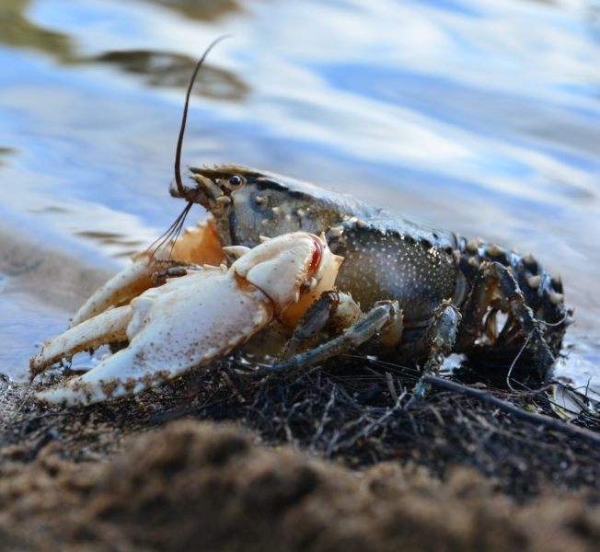
Murray River Crayfish are long-lived and may live for 30 to 50 years. Females mature at five to nine years of age (60 and 95 mm OCL) and males from four years of age. Mating occurs in May and females carry eggs under their tail from late autumn, releasing juveniles in late spring to early summer. In the ACT, egg carrying (berried) females are typically larger than 75 mm OCL (average 92 mm) (ACT Government unpublished data), though smaller berried females have been collected in sections of the upper Murrumbidgee River Catchment (Starrs et al. 2015). Fecundity appears to be correlated with female size with between 150 and 1500 eggs per female (McCormack 2012).
  - Murray River Crayfish (Mark Jekabsons – ACT Government)

Distribution and Habitat

The Murray River Crayfish is found in a wide variety of permanent rivers and large streams in the southern Murray–Darling Basin (MDB) to approximately 700 metres above sea level (Gilligan et al 2007). In the local region it is known from the Murrumbidgee River, lower Cotter River below the Cotter Dam, Tumut River, Goobragandra River and the lower Goodradigbee River (Lintermans 2002; ACT Government 2018b).

Abundance is known to decline with altitude (Raadik et al. 2001) and the ACT is at the edge of the upper altitudinal range and currently has a low abundance of the species (Ryan 2005; Gilligan et al. 2007; NSW Fisheries Scientific Committee 2013). In the ACT, region boulder/cobble substrate along with other structure such as snags may provide important cover (Fulton et al. 2010). The species prefers intermediate flow velocities, deeper pools and glides with overhanging vegetation for shading (Noble and Fulton 2016).

Threats
The major threats to the species are hypoxic blackwater events (related to infrequent floodplain inundation) in more lowland habitats (Todd et al. 2018; Whiterod et al. 2018). The main identified threats to the Murray River Crayfish in the ACT Action Plan (ACT Government 2018b) include:
- overfishing
- riparian vegetation removal
- sedimentation
- residential development
- river regulation
- reduction in water quality
- fire
- invasive species and disease
- changing climate.

Major Conservation Objective
The overall objective of the action plan (ACT Government 2018b) is to maintain in the long term, viable, wild populations of Murray River Crayfish as a component of the indigenous aquatic biological resources of the ACT and as a contribution to regional and national conservation of the species. This includes the need to maintain natural evolutionary processes and resilience.

Conservation PRIORITIES
The 2018 Action Plan for Murray River Crayfish (ACT Government 2018b) identifies actions and the following main priorities to:
- protect the species from harvest
- protect sites in the ACT where the species occurs
- manage habitat to conserve populations
- enhance the long-term viability of populations
- improve understanding of the species’ ecology, habitat and threats
- improve community awareness and support for the species and freshwater fish conservation.

Other Relevant Advice, plans or Prescriptions
- ACT Aquatic and Riparian Conservation Strategy (ACT Government 2018a)
- ACT Action Plan – Murray River Crayfish (ACT Government 2018b)
- NSW Final Determination – Murray Crayfish (NSW Fisheries Scientific Committee 2013)

Listing Background
The Murray River Crayfish was initially listed in the ACT as an Endangered species on 6 January 1997 in accordance with section 21 of the Nature Conservation Act 1980. At that time, the Flora and Fauna Committee (now the Scientific Committee) concluded that the assessment satisfied the following criteria:
2.2 species is observed, estimated, inferred or suspected to be at risk of premature extinction in the ACT region in the medium-term future as demonstrated by:
2.2.1 current serious decline in population or distribution from evidence based on:
2.2.1.1 direct observation, including comparison of historical and current records
2.2.1.3 a serious decline in quality and quantity of habitat
2.2.1.4 high actual or potential levels of exploitation or persecution.
The Murray River Crayfish is on the Commonwealth’s 2017 Finalised Priority Assessment List for assessment of threatened status at the national level which is due for completion in October 2020. This assessment will endeavour to address specific research gaps that lead to the IUCN status of Data Deficient (Alves et al. 2010).

References
ACT Government 2018a. ACT Aquatic and Riparian Conservation Strategy and Action Plans. Environment, Planning and Sustainable Development Directorate, Canberra. Available from: https://www.legislation.act.gov.au/di/2018-240/
ACT Government 2018b. Murray River Crayfish (Euastacus armatus) Action Plan. Environment, Planning and Sustainable Development Directorate, Canberra. Available from: https://www.legislation.act.gov.au/View/di/2018-240/current/PDF/2018-240.PDF
Alves N, Coughran J, Furse J and Lawler S 2010. Euastacus armatus. The IUCN Red List of Threatened Species. Accessed 20 December 2019 from: http://dx.doi.org/10.2305/IUCN.UK.2010-3.RLTS.T8136A12889370.en
Fulton C, Starrs D and Ruibal M 2010. Distribution, abundance and habitat-use of upland river populations of Murray River Crayfish (Euastacus armartus). Final Report to the ActewAGL Future Water Planning Group, Canberra.
Geddes MC 1990. The Murray. Murray–Darling Basin Commission, Canberra.
Gilligan D, Rolls R, Merrick J, Lintermans M, Duncan P and Kohen J 2007. Scoping the knowledge requirements for Murray Crayfish (Euastacus armartus). Fisheries Final Report Series. Narrandera Fisheries Centre, Narrandera.
Lintermans M 2002. Fish in the Upper Murrumbidgee Catchment: A Review of Current Knowledge. Environment ACT, Canberra.
McCormack RB 2012. A Guide to Australia's Spiny Freshwater Crayfish. CSIRO Publishing, Melbourne.
Noble M and Fulton C 2016. Habitat specialization and sensitivity to change in a threatened crayfish occupying upland streams. Aquatic Conservation: Marine and Freshwater Ecosystems 27(1): 90–102.
NSW Fisheries Scientific Committee 2013. The Murray crayfish – Euastacus armatus as a vulnerable species. Final determination. Ref No. FD53. NSW Department of Primary Industries, Crows Nest.
Raadik T, O'Connor P and Mahoney JC 2001. Fish and Decopod Crustacean Survey, Regional Forest Agreement Process, Victoria 1997–1999. Summary Report. Department of Natural Resources and Environment, Victoria.
Ryan K 2005. The home range behaviour of the Murray River Crayfish Euastacus armartus (Decapoda: Parastacidae) in the Murrumbidgee River. Australian Capital Territory. Honours thesis. (University of Canberra, Canberra.
Starrs D, Ebner B and Fulton C 2015. Ceasefire: Minimal aggression among Murray River crayfish feeding upon patches of allochthonous material. Australian Journal of Zoology 63: 115–121.
Todd CR, Whiterod N, Raymond SM, Zukowski S, Asmus M, and Todd MJ 2018. Integrating fishing and conservation in a risk framework: A stochastic population model to guide the proactive management of a threatened freshwater crayfish. Aquatic Conservation: Marine and Freshwater Ecosystems 28(4): 954–968.
Whiterod NS, Zukowski S, Asmus M, Todd CR and Gwinn DC 2018. Take the long way home: Minimal recovery in a K-selected freshwater crayfish impacted by significant population loss. Ecological indicators 89: 622–630.

Further Information
Further information on the related Action Plan or other threatened species and ecological communities can be obtained from: Environment, Planning and Sustainable Development Directorate (EPSDD).
Phone: (02) 132281, EPSDD Website: http://www.environment.act.gov.au/cpr

