Australian Capital Territory

Nature Conservation (Two-spined Blackfish) Conservation Advice 2020

Notifiable instrument NI2020–355
made under the
Nature Conservation Act 2014, s 90C (Conservation advice)

1 Name of instrument
This instrument is the Nature Conservation (Two-spined Blackfish) Conservation Advice 2020.

2 Commencement
This instrument commences on the day after its notification day.

3 Conservation advice for Two-spined Blackfish
Schedule 1 sets out the conservation advice for Two-spined Blackfish (Gadopsis bispinosus).

Arthur Georges
Chair, Scientific Committee
24 June 2020
Schedule 1
(see s 3)

Conservation Advice
Two-spined Blackfish – Gadopsis bispinosus

Conservation Status
The Two-spined Blackfish Gadopsis bispinosus Sanger, 1984, is recognised as threatened in the following jurisdictions:
International Near Threatened, International Union for Conservation of Nature (IUCN) Redlist
ACT Vulnerable, Nature Conservation Act 2014

ELIGIBILITY
The factors that make the Two-spined Blackfish eligible for listing as Vulnerable in the ACT Threatened Native Species List are included in the Listing Background section below.

DESCRIPTION AND ECOLOGY

Two-spined Blackfish is a small to medium-sized fish with a yellowish-brown to olive green back and sides, often spectacularly mottled with two to three rows of dark brown blotches (‘giraffe’ spots), running the entire body length and extending onto the dorsal, anal and caudal fins. The ventral surface is uniformly pale (cream to light grey) to the origin of the anal fin (Lintermans 2007). The recorded maximum length of the species is 325 mm total length (TL) and maximum weight of around 200 g, however, individuals larger than 240 mm TL and 50 g are uncommon (Lintermans 1998; Lintermans 2007).

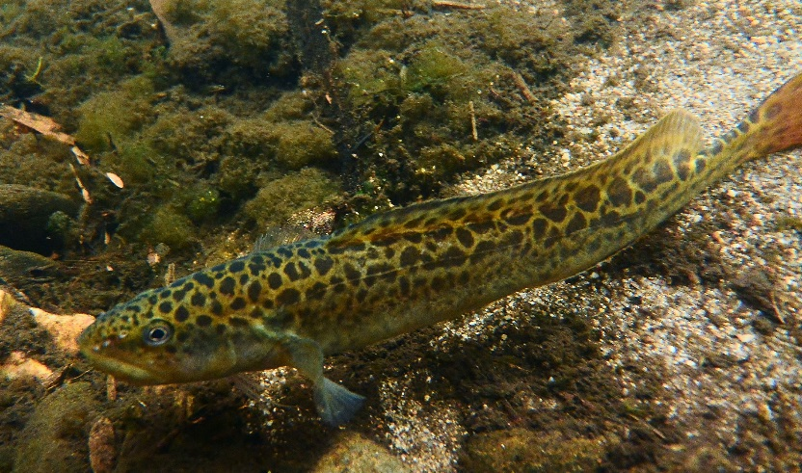
The species is largely nocturnal or crepuscular (i.e. active at dusk, dawn and night) (Ebner et al. 2009; Broadhurst et al. 2012). Their diet is characterised by a predominance of aquatic insect larvae, particularly mayflies, caddisflies and midges. Terrestrial insects also make up a significant part of the diet, indicating the importance of intact riparian vegetation communities for their associated insect fauna, which fall onto the water (Lintermans 1998). Young-of-the-year and juvenile Two-spined Blackfish eat proportionally more mayfly and midge larvae than adult fish, which consume larger items such as caddisfly larvae and terrestrial invertebrates (Lintermans 1998).
  - Two-spined Blackfish (Mark Jekabsons – ACT Government)
While movement of Two-spined Blackfish is extremely limited in rivers, with the home range of adult fish estimated at 15–23 metres, much larger movements are known in reservoirs (Lintermans 1998; Broadhurst et al. 2011) and the species is not known to undertake a spawning migration. Breeding is seasonal with egg-laying commencing in November. Fecundity is low and positively correlated with fish length. Females commence breeding in their second or third year with between 80 and 420 eggs laid (Sanger 1986, 1990; Lintermans 1998; Dennis et al. 2016) in a single egg mass. The spawning site is usually in the spaces between cobbles or boulders where the eggs are attached to the upper surface of a rock (O'Connor and Zampatti 2006). Two-spined Blackfish live for a maximum of six years with most living for less than that (Lintermans 1998; Todd et al. 2017). However, they take a comparatively long time to be free-swimming, having their larval stage attached to the egg. Generation length is calculated as 3–4 years (Lintermans et al. 2019).

Distribution and Habitat

Two-spined Blackfish are found in the cooler, upper reaches of the Murray–Darling river system in Victoria, New South Wales and the Australian Capital Territory (ACT) (Jackson et al. 1996; Lintermans 2007). In the ACT, Two-spined Blackfish are currently restricted to the Cotter River upstream of Cotter Reservoir including Bendora and Corin dams (Lintermans 2000) with the section of the river above the Corin Dam severely impacted by the 2020 bushfire.

Two-spined Blackfish are restricted to cool, clear upland or montane streams with abundant in-stream cover, usually in the form of boulders and cobble (Koehn 1990; Sanger 1990; Lintermans 1998; Lintermans 2007), as well as, upland reservoirs with suitable rocky margins (Broadhurst et al. 2012; Lintermans 2012). Two-spined Blackfish are generally found in forested catchments, where there is little sediment input to the stream from erosion or land management practices (Lintermans 1998; ACT Government 2018b).

Threats
The main identified threats in the ACT Action Plan for Two-spined Blackfish (ACT Government 2018b) include:
- habitat modification
- river regulation
- barriers to fish passage
- sedimentation
- reduction in water quality
- introduced alien species
- changing climate
- fire
- reduction in spawning habitat quality.
Sedimentation significantly impacted Two-spined Blackfish as a result of the 2020 bushfires and subsequent rainfall events.

Major Conservation Objective
The overall objective of the Action Plan for Two-spined Blackfish (ACT Government 2018b) is to maintain in the long term, viable, wild populations of Two-spined Blackfish as a component of the indigenous aquatic biological resources of the ACT and as a contribution to regional and national conservation of the species. This includes the need to maintain natural evolutionary processes and resilience.

Conservation PRIORITIES
The Action Plan for Two-spined Blackfish (ACT Government 2018b) identifies actions and the following main priorities to:
- protect sites in the ACT where the species occurs
- manage habitat to conserve populations
- enhance the long-term viability of populations
- improve understanding of the species’ ecology, habitat and threats
- improve community awareness and support for the species and freshwater fish conservation.

Other Relevant Advice, plans or Prescriptions
- ACT Aquatic and Riparian Conservation Strategy (ACT Government 2018a)
- ACT Action Plan – Two-spined Blackfish (ACT Government 2018b)
- IUCN Redlist species account – Two-spined Blackfish (Lintermans et al. 2019)

Listing Background
The Two-spined Blackfish was initially listed in the ACT as a Vulnerable species on 6 January 1997 in accordance with section 21 of the Nature Conservation Act 1980. At that time, the Flora and Fauna Committee (now the Scientific Committee) concluded that the assessment satisfied the following criteria:
2.2 species is observed, estimated, inferred or suspected to be at risk of premature extinction in the ACT region in the medium-term future as demonstrated by:
2.2.1 current serious decline in population or distribution from evidence based on:
2.2.1.1 direct observation, including comparison of historical and current records
2.2.2 imminent risk of serious decline in population or distribution from evidence based on serious threat from predators, parasites or competitors
2.2.4 seriously fragmented distribution for a species currently occurring over a moderately small range or having a moderately small area of occupancy within its range.
The most recent review of the species national conservation status found that the species meets the IUCN Criterion B – B2b(ii,iii) for Near Threatened due to a restricted distribution (area of occupancy (AOO) of 1,512 km²), with continuing declines in habitat and the AOO due to the continued release of cold-water discharges from reservoirs, sedimentation of streams from unsealed roads and loss of riparian vegetation, which impact spawning and feeding habitats (Lintermans et al. 2019). However, the Two-spined Blackfish was significantly impacted by the 2020 bushfires in south-eastern Australia, especially in the upper Cotter Catchment.

References
ACT Government 2018a. ACT Aquatic and Riparian Conservation Strategy and Action Plans. Environment, Planning and Sustainable Development Directorate, Canberra. Available from: https://www.legislation.act.gov.au/di/2018-240/
ACT Government 2018b. Two-spined Blackfish (Gadopsis bispinosus) Action Plan. Environment, Planning and Sustainable Development Directorate, Canberra. Available from: https://www.legislation.act.gov.au/View/di/2018-240/current/PDF/2018-240.PDF
Broadhurst BT, Dyer JG, Ebner BC, Thiem JD and Pridmore PA 2011. Response of Two-spined Blackfish Gadopsis bispinosus to short-term flow fluctuations in an upland Australian stream. Hydrobiologia 673(1): 63–77.
Broadhurst BT, Lintermans M, Thiem JD, Ebner BC, Wright DW and Clear RC 2012. Spatial ecology and habitat use of Two-spined Blackfish Gadopsis bispinosus in an upland reservoir. Aquatic Ecology 46(3): 297–309.
Dennis LP, Broadhurst BT and Lintermans M 2016. An accurate tool for ageing Two‐spined Blackfish for use in determining timing of spawning in upland streams in the Brindabella ranges, ACT, Australia. Ecological Management & Restoration 17(1): 70–80.
Ebner B, Clear R, Godschalx S and Beitzel M 2009. In-stream behaviour of threatened fishes and their food organisms based on remote video monitoring. Aquatic Ecology 43(2): 569–576.
Jackson PD, Koehn JD, Lintermans M and Sanger AC 1996. Family Gadopsidae: freshwater blackfishes, in Freshwater fishes of south-eastern Australia, McDowall, RM (ed.). Reed Books, Australia: 186–190.
Lintermans M 1998. The ecology of the Two-spined Blackfish Gadopsis bispinosus (Pisces: Gadopsidae). Masters thesis. Australian National University, Canberra.
Lintermans M 2007. Fishes of the Murray-Darling Basin: An introductory guide. Murray Darling Basin Authority, Canberra.
Lintermans M 2012. Managing potential impacts of reservoir enlargement on threatened Macquaria australasica and Gadopsis bispinosus in southeastern Australia. Endangered Species Research 16: (1) 1–16.
Lintermans M 2016. Conservation Status of Australian Fishes – 2016. Australian Society for Fish Biology Newsletter 46(2): 142-144. Accessed 11 December 2019 from: https://www.asfb.org.au/commitees/threatened-species-committee/
Lintermans M, Lieschke J, Koehn J, Sharley J and Tonkin Z 2019. Gadopsis bispinosus. The IUCN Red List of Threatened Species 2019. Accessed 11 December 2019 from: https://www.iucnredlist.org/species/169363/129046083
O’Connor J and Zampatti B 2006. Spawning season and site location of Gadopsis bispinosus Sanger (Pisces: Gadopsidae) in a montane stream of southeastern Australia, Transactions of the Royal Society of South Australia 130(2): 227–232.
Sanger AC 1986. The evolution and ecology of the Gadopsis marmoratus complex. PhD thesis. University of Melbourne, Victoria.
Sanger AC 1990. Aspects of the life history of the Two-spined Blackfish Gadopsis bispinosus in King Parrot Creek Victoria, Proceedings of the Royal Society of Victoria 102(2): 89–96.
Todd CR and Lintermans M, Raymond, S and Ryall J 2017. The 3 mores; does more water lead to predation and breeding habitat loss? Assessing the impacts of reservoir expansion using a population model for Two-spined Blackfish (Gadopsis bispinosus). Ecological Indicators 80: 204–214.

Further Information
Further information on the related Action Plan or other threatened species and ecological communities can be obtained from: Environment, Planning and Sustainable Development Directorate (EPSDD).
Phone: (02) 132281, EPSDD Website: http://www.environment.act.gov.au/cpr

