Australian Capital Territory
Planning and Development (Technical Amendment—Whitlam) Plan Variation 2020 (No 1)

Notifiable instrument NI2020—462
Technical Amendment No 2020-06
made under the
Planning and Development Act 2007, section 89 (Making technical amendments) and section 96 (Effect of approval of estate development plan)

- Name of instrument
This instrument is the Planning and Development (Technical Amendment—Whitlam) Plan Variation 2020 (No 1).
2 Commencement
This instrument commences on the day after its notification day.
3 Technical amendment
I am satisfied under section 89(1)(a) of the Planning and Development Act 2007 (the Act) that the Whitlam plan variation is a technical amendment to the Territory Plan.
4 Meaning of Whitlam plan variation
In this instrument:
Whitlam plan variation means the technical amendment to the Territory Plan, variation 2020-06, in the schedule.
Note: No consultation was required in relation to the Whitlam plan variation under section 87 of the Act.
Lesley Cameron
Delegate of the planning and land authority
24 July 2020

Planning & Development Act 2007

Technical Amendment
to the Territory Plan
Variation 2020-06

Future urban area variation and introduction of the Whitlam Precinct Map and Code

July 2020

This page is left intentionally blank

Table of Contents
1. INTRODUCTION 3
1.1 Purpose 3
1.2 Public consultation 3
1.3 National Capital Authority 3
1.4 Process 3
1.5 Types of technical amendments under the Act 4
2. EXPLANATION 5
2.1 Territory Plan Map 5
2.2 Whitlam Precinct Map and Code 7
3. TECHNICAL AMENDMENT 7
3.1 Territory Plan Map 8
3.2 Whitlam Precinct Map and Code 9

This page is left intentionally blank

- INTRODUCTION
  - Purpose
This technical amendment makes the following changes to the Territory Plan:
Territory Plan Map
- The Territory Plan map is varied to remove the future urban area overlay from land in the Division of Whitlam, as identified in Part 2 of this document.
Whitlam Precinct Map and Code
- The Whitlam Precinct Map and Code is introduced to include ongoing provisions, as described in Part 2 of this document.

  - Public consultation
Under section 87(1)(c) of the Planning and Development Act 2007 (the Act) this type of technical amendment is not subject to public consultation.

  - National Capital Authority
The National Capital Authority does not need to be advised of this technical amendment as per 1.2.

  - Process
This technical amendment has been prepared in accordance with section 87 and made in accordance with section 89 of the Act.
  - Types of technical amendments under the Act
The following categories of technical amendments are provided under section 87 of the Act:
- Each of the following territory plan variations is a technical amendment for which no consultation is needed before it is made under section 89:
(a) a variation (an error variation) that –
- would not adversely affect anyone’s rights if approved; and
- has as its only object the correction of a formal error in the plan;
(b) a variation to change the boundary of a zone or overlay under section 90A (Rezoning – boundary changes);
(c) a variation, other than one to which subsection (2)(d) applies, in relation to an estate development plan under section 96 (Effect of approval of estate development plan);
(d) a variation required to bring the territory plan into line with the national capital plan;
(e) a variation to omit something that is obsolete or redundant in the territory plan.
- Each of the following territory plan variations is a technical amendment for which only limited public consultation is needed under section 90:
- a variation (a code variation) that –
- would only change a code; and
- is consistent with the policy purpose and policy framework of the code; and
- is not an error variation;
- a variation to change the boundary of a zone under section 90B (Rezoning – development encroaching on adjoining territory land);
- a variation in relation to a future urban area under section 90C (Technical amendments – future urban areas);
- a variation in relation to an estate development plan under section 96 (Effect of approval of estate development plan) if it incorporates an ongoing provision that was not included in the plan under
section 94(3)(g);
- a variation to clarify the language in the territory plan if it does not change the substance of the plan;
- a variation to relocate a provision within the territory plan if the substance of the provision is not changed.
TA2020-06 has been prepared in accordance with section 87(1)(c).
- EXPLANATION
This part of the technical amendment document explains the changes to be made to the Territory Plan.
  - Territory Plan Map
Variation to the Territory Plan
The Territory Plan map is varied to identify the zones and overlays that apply to land ceasing to be in a future urban area.

Existing Territory Plan Map
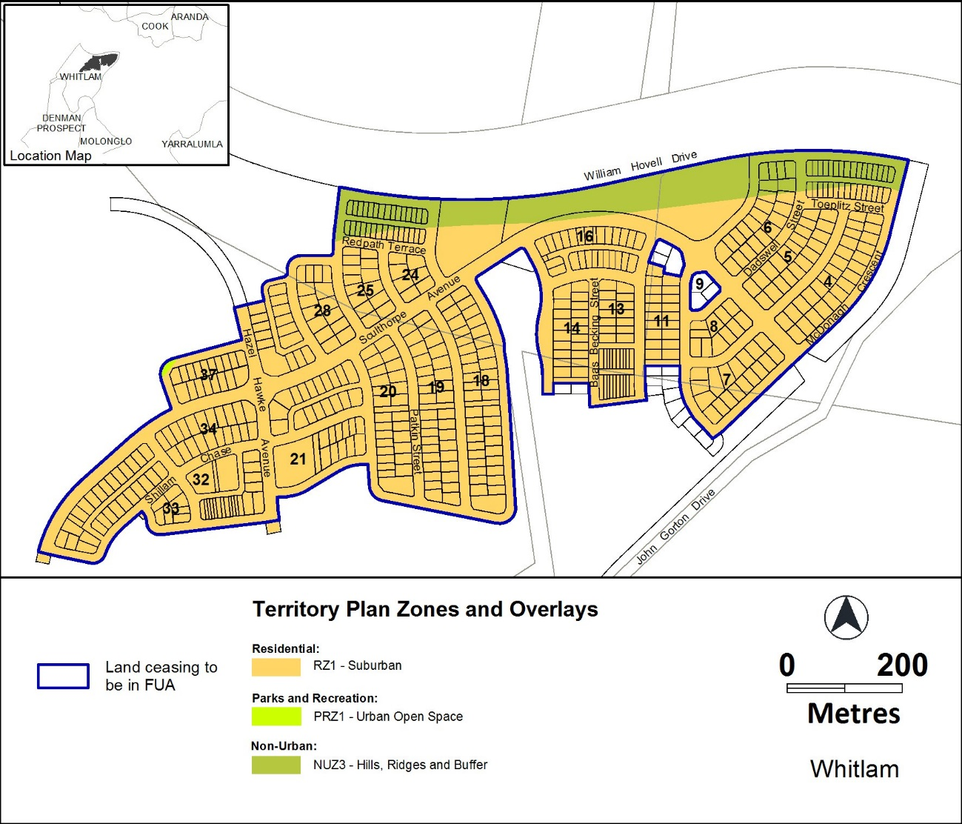

Proposed Territory Plan Map
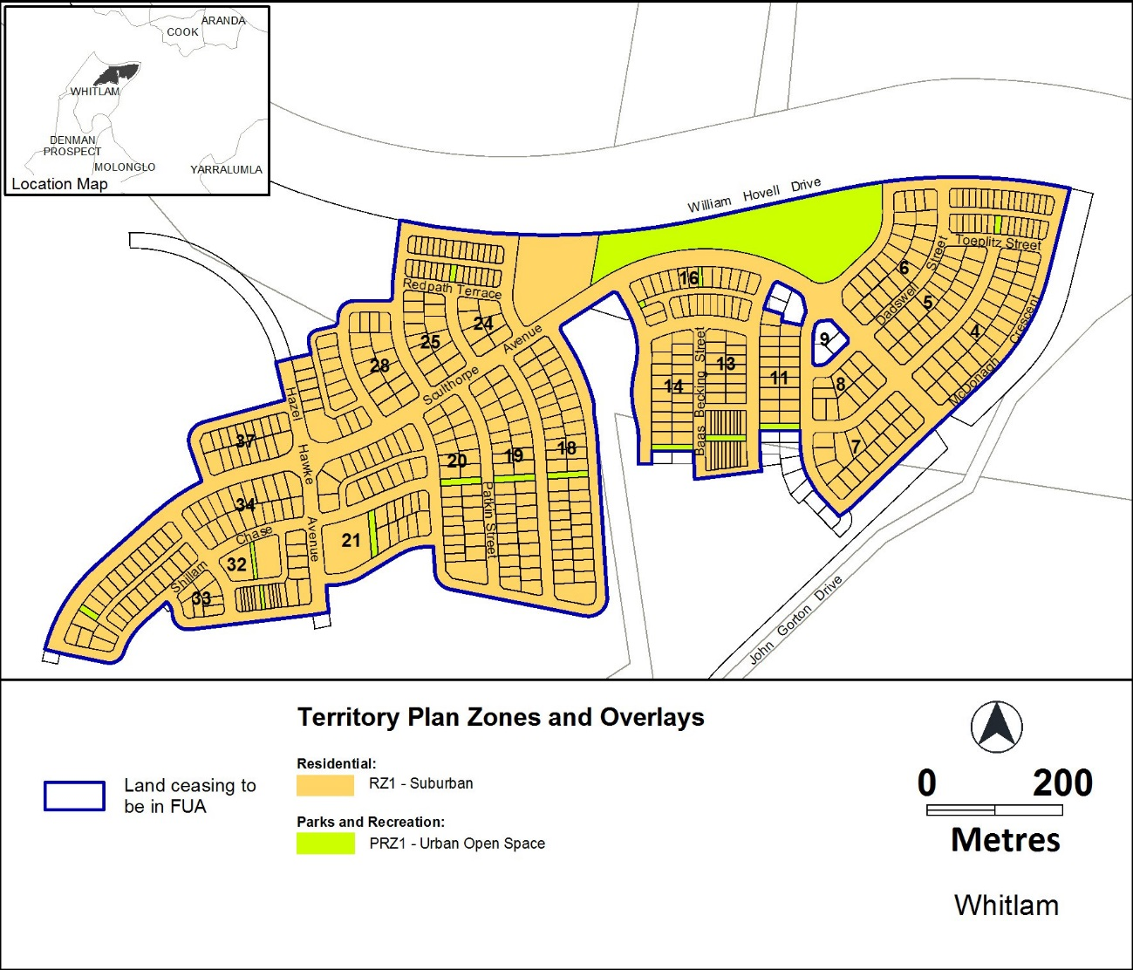
  - Whitlam Precinct Map and Code
Introduction of the Whitlam Precinct Map and Code
The Whitlam Precinct Map and Code is introduced to incorporate rules and criteria and ongoing block specific provisions that are consistent with the approved estate development plan.

- TECHNICAL AMENDMENT
This section of the technical amendment document provides the actual instructions for implementing the changes to the Territory Plan.
  - Territory Plan Map
- Territory Plan Map
The Territory Plan map is varied as indicated below to identify the zones and overlays that apply to the land ceasing to be in a future urban area.

  - Whitlam Precinct Map and Code
- Whitlam Precinct Map and Code
Insert Whitlam Precinct Map and Code into the Territory Plan at Appendix A.

Whitlam Precinct Map and Code

This page is intentionally blank.

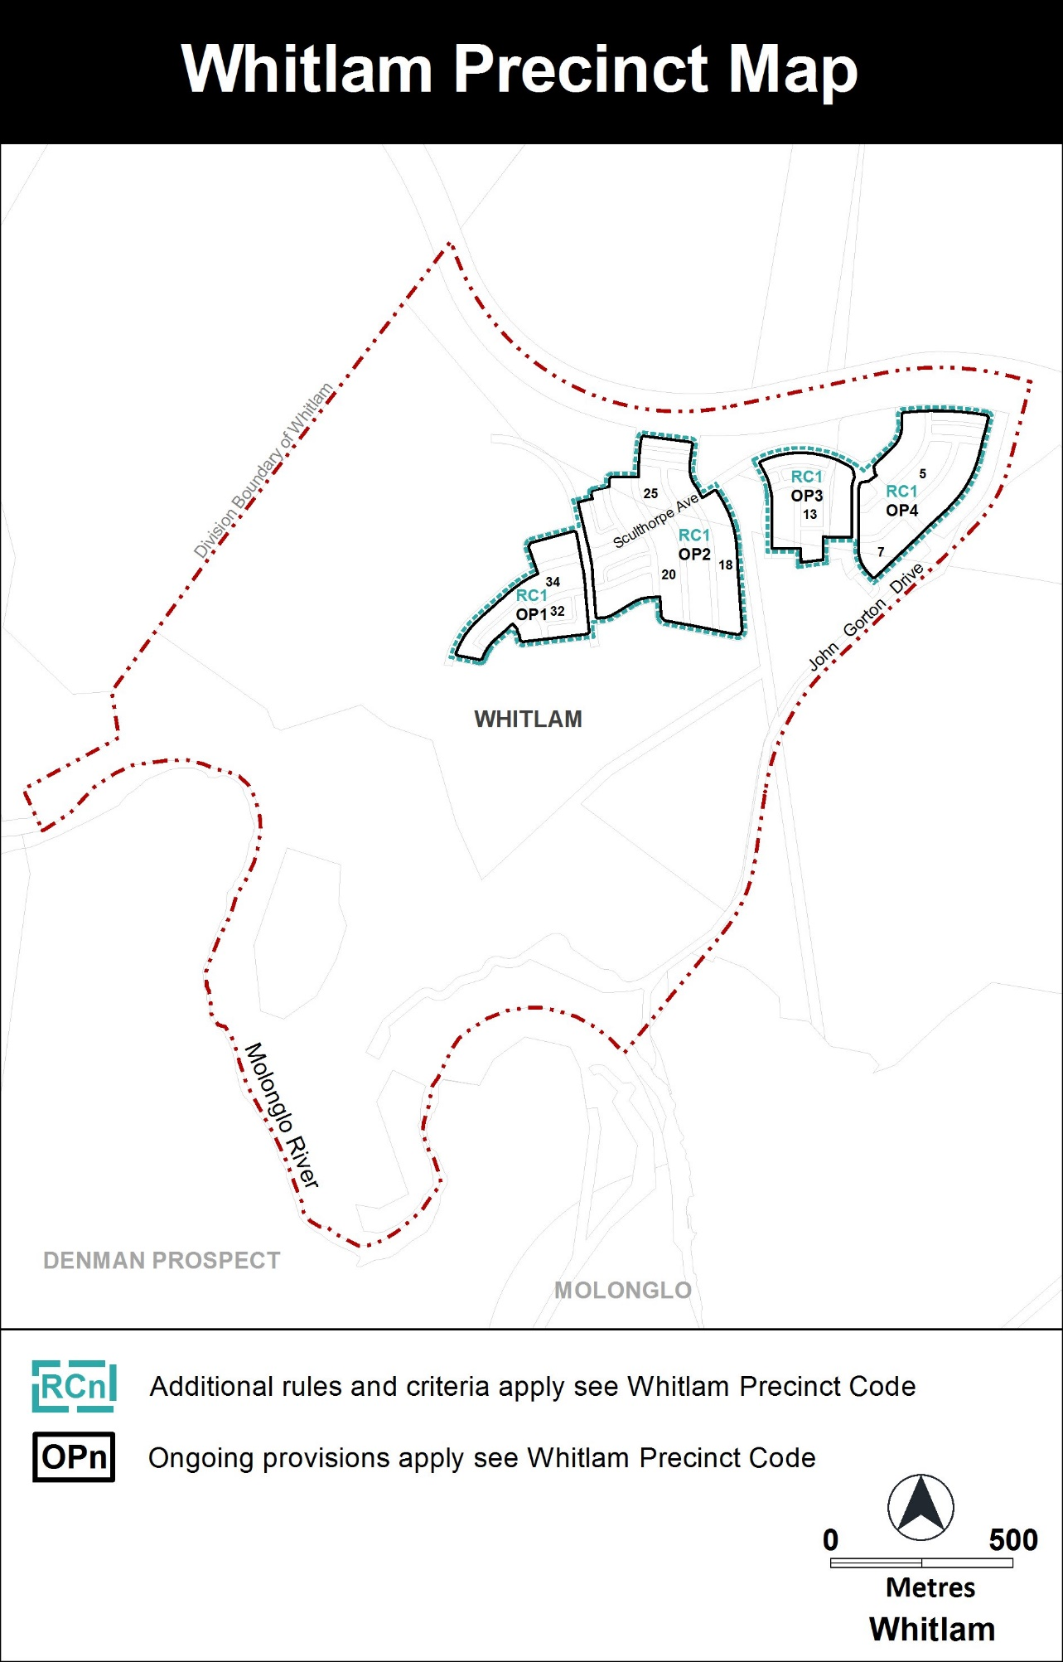
Whitlam Precinct Code

Contents
Introduction 3
Additional rules and criteria 5
RC1 – Whitlam Residential 5
Element 1: Building and site controls 5
1.1 Courtyard walls 5
1.2 Vehicular access 5
1.3 Minimum number of storeys 5
1.4 Setbacks 6
Element 2: Amenity 6
2.1 Acoustic protection –front wall height 6
Other ongoing provisions 12
OP1 – Whitlam residential area 12
OP2 – Whitlam residential area 13
OP3 – Whitlam residential area 14
OP4 – Whitlam residential area 15

FIGURES
Diagram 1 Elevation Of Courtyard Wall 7
Figure 1 Whitlam Residential Area 1 8
Figure 2 Whitlam Residential Area 2 9
Figure 3 Whitlam Residential Area 3 10
Figure 4 Whitlam Residential Area 4 11
Figure 5 Whitlam Residential Area Ongoing Provisions 12
Figure 6 Whitlam Residential Area Ongoing Provisions 13
Figure 7 Whitlam Residential Area Ongoing Provisions 14
Figure 8 Whitlam Residential Area Ongoing Provisions 15

Introduction
Name
The name of this code is the Whitlam Precinct Code.
Application
The code applies to the Division of Whitlam.
Purpose
This code provides additional planning, design and environmental controls for specific areas or blocks and may also contain references to provisions in other codes.
In conjunction with other relevant codes it will be used by the Authority to assess development applications and offer guidance to intending applicants in designing development proposals and preparing development applications.
Structure
This code contains additional rules and/or criteria for particular blocks or parcels identified as areas RCn on the precinct map, to be read in conjunction with the relevant development code. It may also contain sub-parts.
Each element has one or more rules and, unless the respective rule is mandatory, each rule has an associated criterion. Rules provide quantitative, or definitive, controls. By contrast, criteria are chiefly qualitative in nature.
In some instances rules are mandatory. Such rules are accompanied by the words “This is a mandatory requirement. There is no applicable criterion.” Non-compliance with a mandatory rule will result in the refusal of the development application. Conversely, the words “There is no applicable rule” are found where a criterion only is applicable.
Code hierarchy
Under the Planning and Development Act 2007, where more than one type of code applies to a development, the order of precedence if there is inconsistency of provisions between codes is: precinct code, development code and general code.
If more than one precinct code applies to the site, the most recent precinct code takes precedence to the extent of any inconsistency.
Definitions
Defined terms, references to legislation and other documents are italicised.
Definitions of terms used in this code are listed in part 13 of the Territory Plan or, for terms applicable only to this code, associated with the respective rule.

Acronyms
EPA ACT Environment Protection Authority
ESA ACT Emergency Services Agency
EPSDD ACT Environment, Planning and Sustainable Development Directorate
NCA National Capital Authority
P&D Act Planning and Development Act 2007
TCCS ACT Transport Canberra and City Services

Additional rules and criteria
This part applies to blocks and parcels identified in the Whitlam Precinct Map (RCn). It should be read in conjunction with the relevant zone development code and related codes.
RC1 – Whitlam Residential
This part applies to blocks and parcels identified in area RC1 shown on the Whitlam Precinct Map.
Element 1: Building and site controls
Rules | Criteria
1.1 Courtyard walls
R1  This rule applies to blocks or parcels in locations identified in Figures 1, 2, 3, and 4.  Courtyard wall to a maximum height of 1.5m constructed of rendered brick, block or stonework in combination with feature panels that include openings not less than 25% of the surface area, and setback 600mm from the front boundary to incorporate landscaping.  The length of the wall is to extend along the boundary and terminate 5 metres from the corner boundary adjoining a road.  Note: See Diagram 1 for examples of courtyard wall. | This is a mandatory requirement. There is no applicable criterion.
1.2 Vehicular access
R2  This rule applies to blocks or parcels in locations identified in Figures 1, 2, 3, and 4.  Vehicular access is not permitted to or from blocks where indicated. | This is a mandatory requirement. There is no applicable criterion.
1.3 Minimum number of storeys
R3  This rule applies to blocks or parcels in locations identified in Figure 4.  Minimum number of storeys is 2. | This is a mandatory requirement. There is no applicable criterion.
1.4 Setbacks
R4  This rule applies to blocks or parcels in locations identified in Figures 1 and 3.  Minimum boundary setbacks to lower floor level and/or upper floor level are nominated. | This is a mandatory requirement. There is no applicable criterion.
R5  This rule applies to blocks or parcels in locations identified in Figures 1, 2, 3 and 4.  The northern boundary of section 11 blocks 13 and 17 are considered side setbacks for the purposes of this rule.  Side setbacks are minimum 3m and 1.5m for garages. | This is a mandatory requirement. There is no applicable criterion.
Element 2: Amenity
2.1 Acoustic protection – front wall height
R6  This rule applies to blocks or parcels in locations identified in Figures 2, 3, and 4.  Dwelling walls facing the front boundary are to achieve a minimum wall height within the primary building zone, of 6 metres above datum ground level.  Note: The purpose of this rule is to provide acoustic protection measures for the estate. | This is a mandatory requirement. There is no applicable criterion.

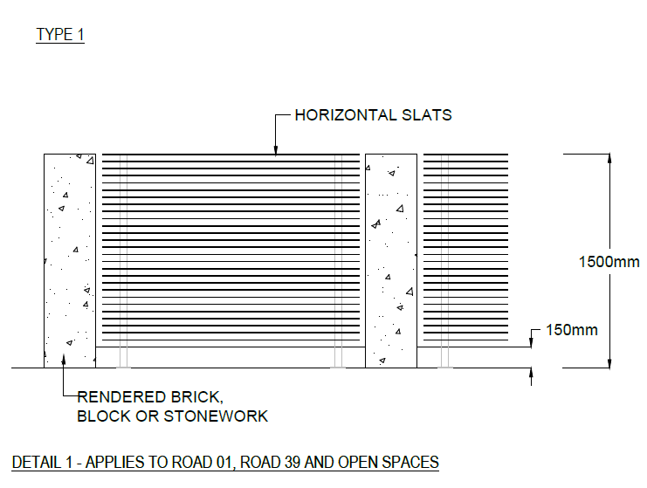

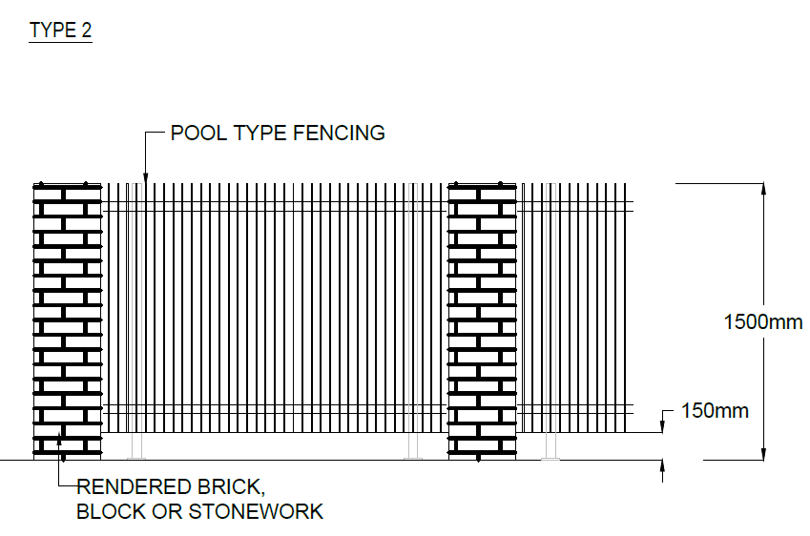
Diagram 1 Elevation of courtyard wall
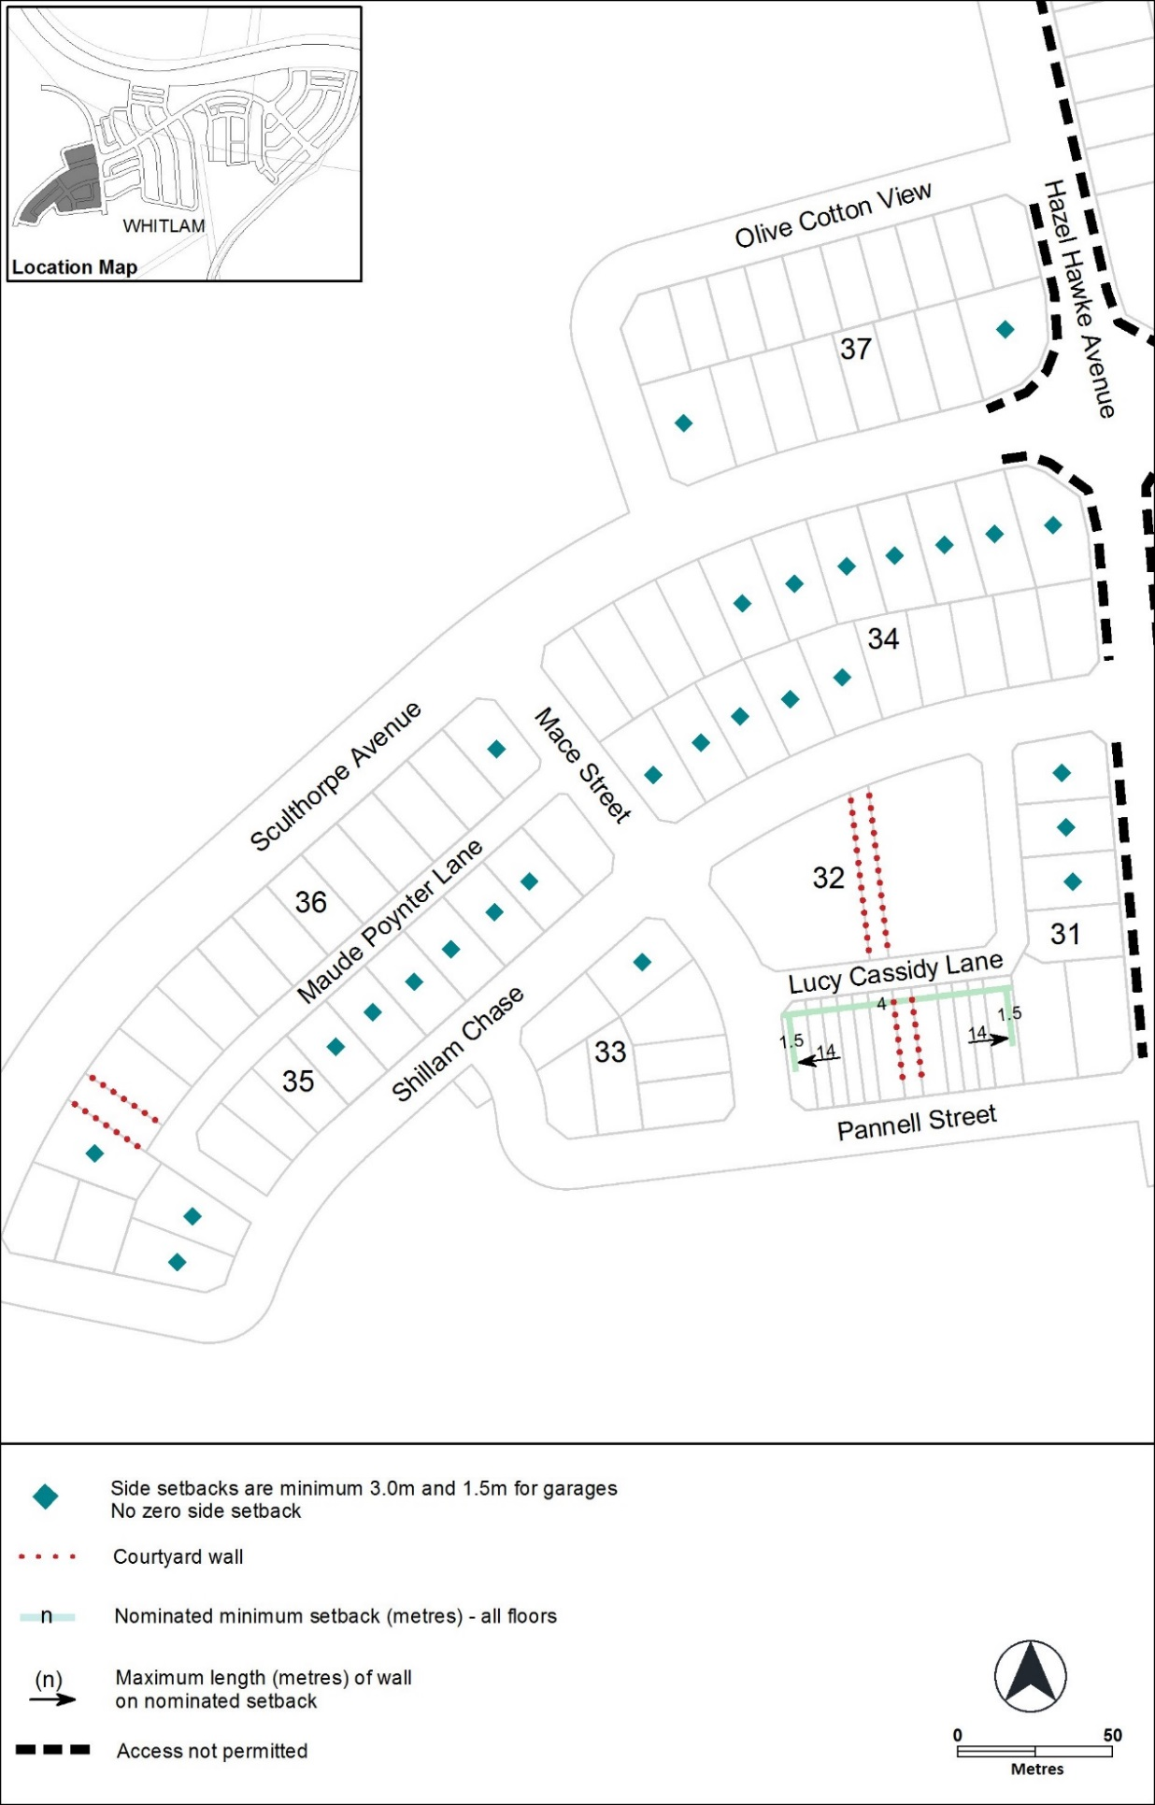
Figure 1 Whitlam residential area 1
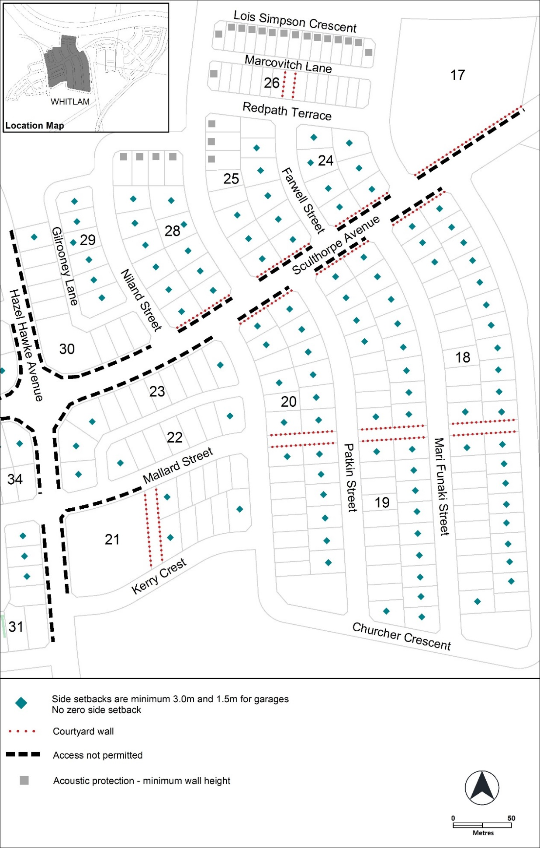
Figure 2 Whitlam residential area 2
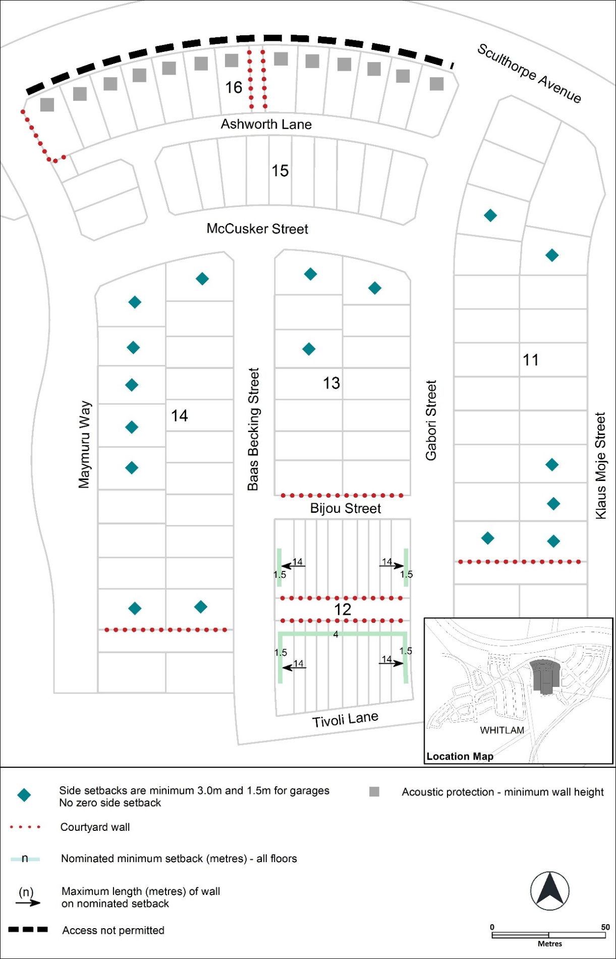
Figure 3 Whitlam residential area 3
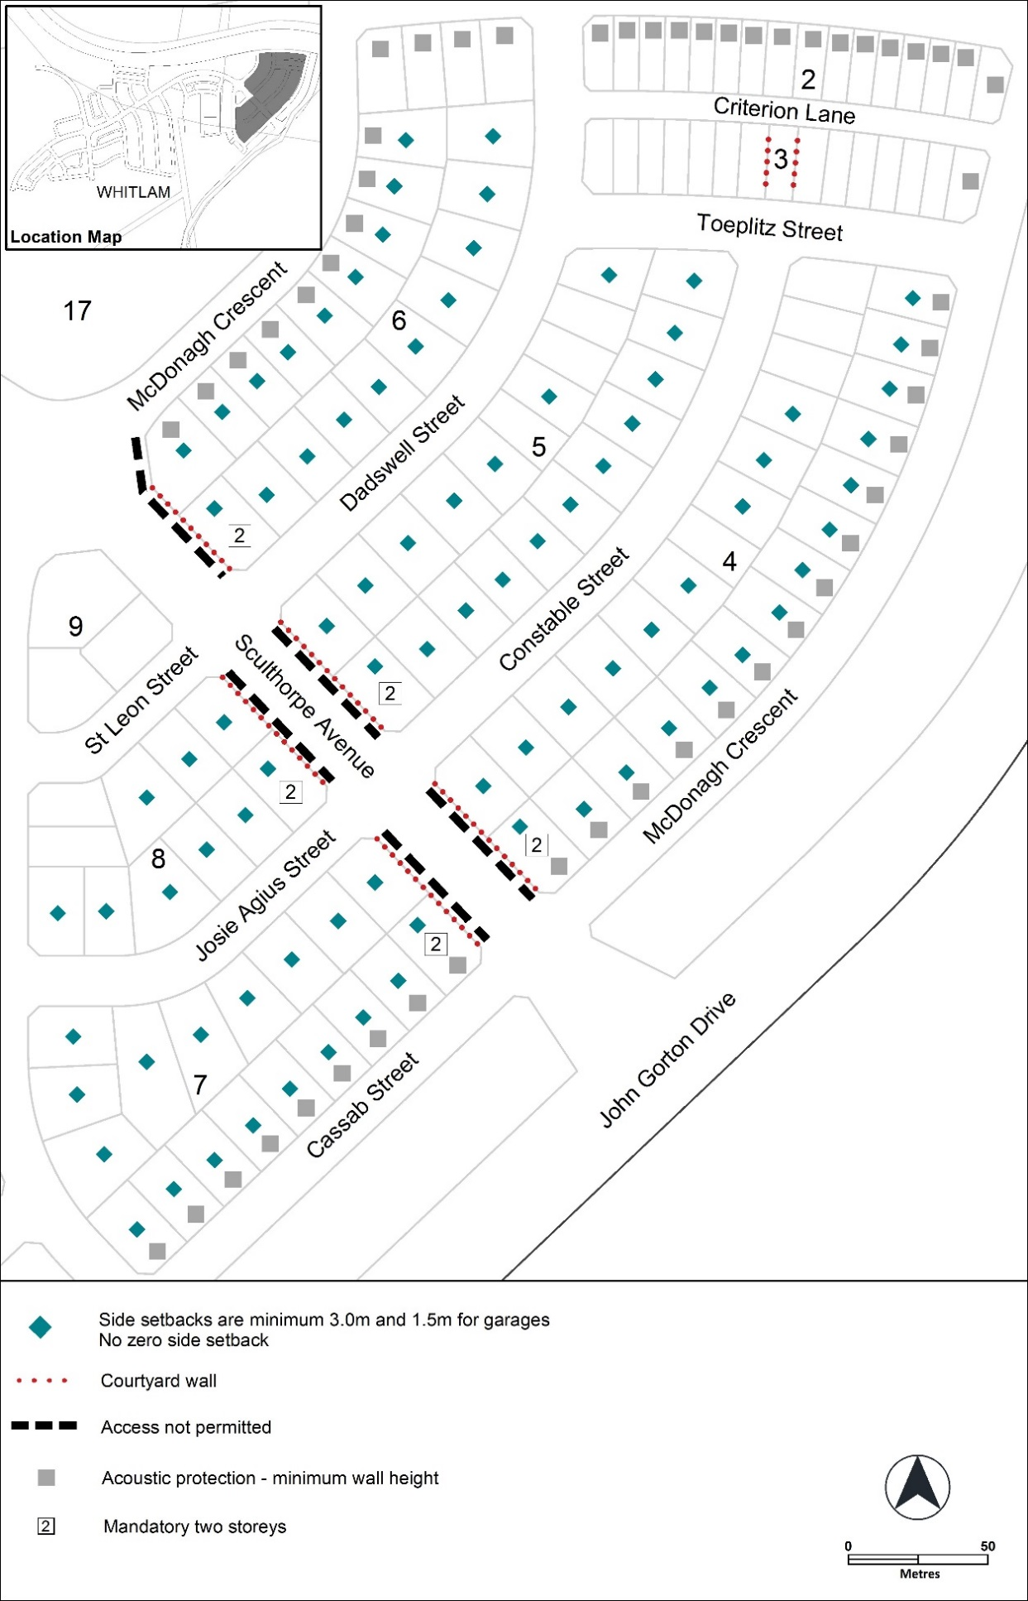
Figure 4 Whitlam residential area 4
Other ongoing provisions
This part applies to blocks and parcels identified as ongoing provisions (OPn) in the Whitlam Precinct Map. It should be read in conjunction with the relevant zone development code and related codes.
OP1 – Whitlam residential area
This part applies to blocks and parcels identified in area OP1 shown on the Whitlam Precinct Map.

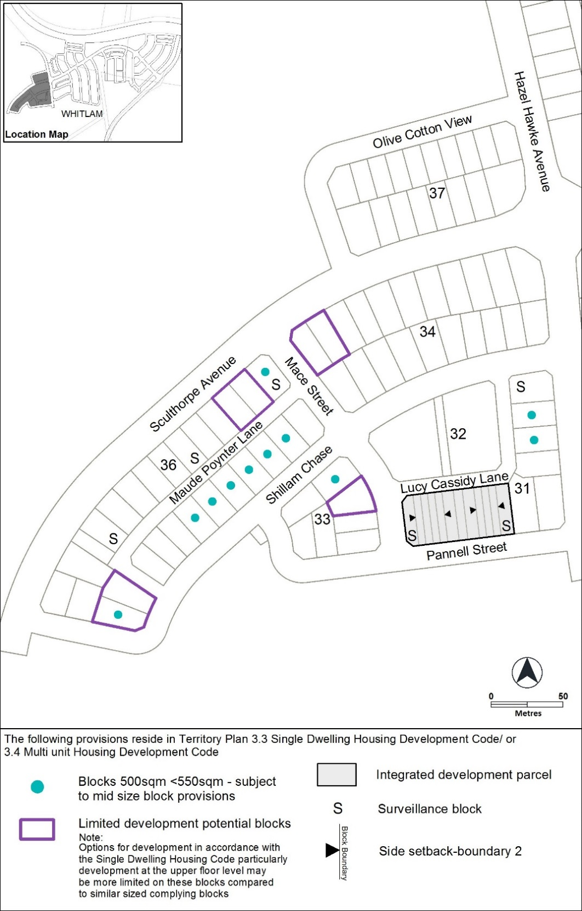
Figure 5 Whitlam residential area ongoing provisions
OP2 – Whitlam residential area
This part applies to blocks and parcels identified in area OP2 shown on the Whitlam Precinct Map.

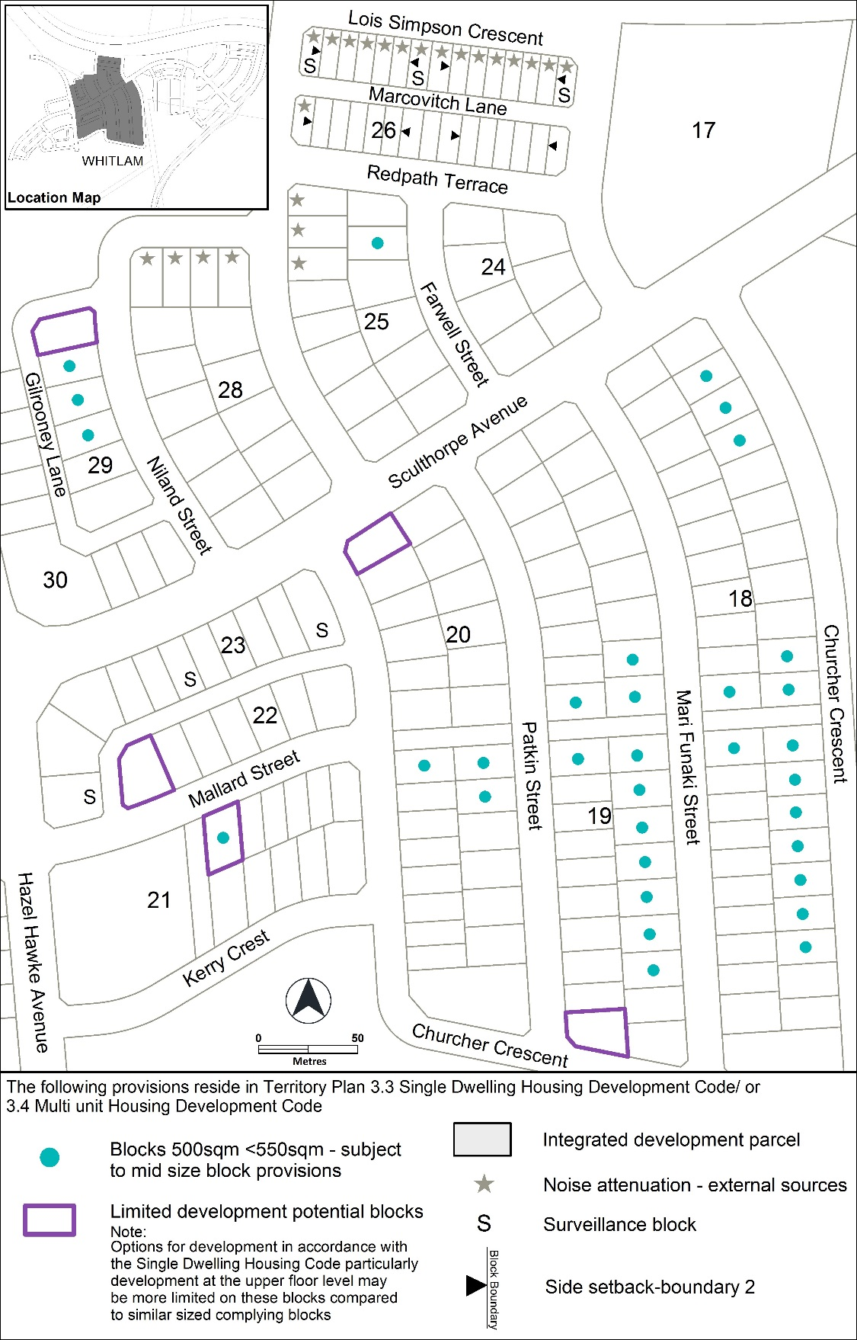
Figure 6 Whitlam residential area ongoing provisions
OP3 – Whitlam residential area
This part applies to blocks and parcels identified in area OP3 shown on the Whitlam Precinct Map.

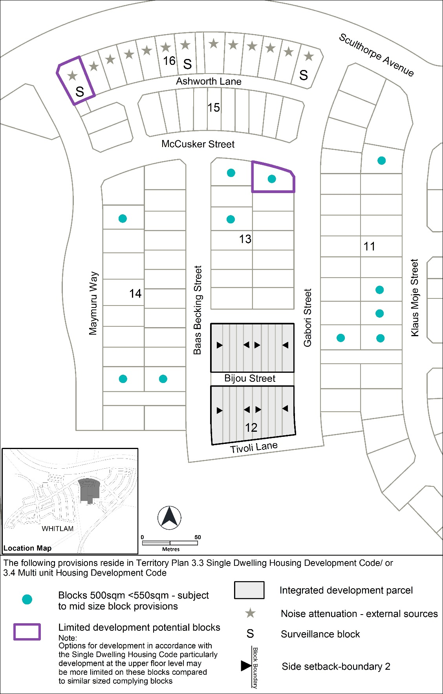
Figure 7 Whitlam residential area ongoing provisions
OP4 – Whitlam residential area
This part applies to blocks and parcels identified in area OP4 shown on the Whitlam Precinct Map.

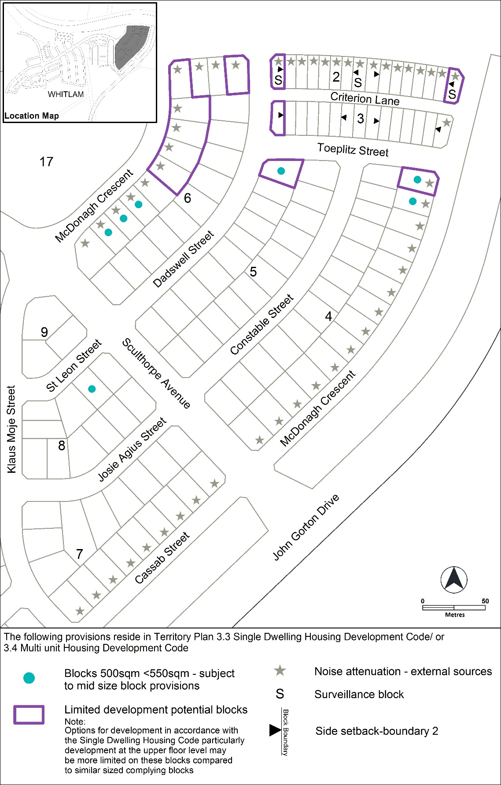
Figure 8 Whitlam residential area ongoing provisions

