Australian Capital Territory
Planning and Development (Draft Variation No 377) Consultation Notice 2020
Notifiable instrument NI2020-489
made under the
Planning and Development Act 2007, s 63 (Public consultation—notification) and s 64 (Public consultation—notice of interim effect etc)

- Name of instrument
This instrument is the Planning and Development (Draft Variation No 377) Consultation Notice 2020.

- Draft variation to the Territory Plan
The planning and land authority (the Authority) has prepared a draft plan variation 377 – Dairy Road Fyshwick: Rezoning from Industrial IZ1 General Industrial Zone to Commercial CZ3 Services Zone and Non-Urban NUZ3 Hills Ridges and Buffer Zone and changes to the Fyshwick Precinct Map and Code (the draft variation) to vary the Territory Plan. The draft variation proposes to rezone Blocks 11 and 12 Section 38 Fyshwick from Industrial IZ1 General Industrial Zone to Commercial CZ3 Services Zone and make changes to the Fyshwick Precinct Map and Code to introduce specific controls and provisions for the site, known as Dairy Road. The draft variation also proposes to rezone part of Block 14 Section 38 Fyshwick from IZ1 Zone to Non-Urban NUZ3 Hills Ridges and Buffer Zone.
- Documents available for public inspection
(1) The Authority gives notice that the following documents are available for public inspection and purchase:
(a) the draft variation; and
(b) the background papers relating to the draft variation.
(2) Copies of the documents mentioned in section 3 (1) are available for inspection and purchase at the Access Canberra Shopfront in Dickson, Monday to Friday (except public holidays) between 8:30am and 4:30pm for the period commencing on the day this notice commences and ending on 25 September 2020 (the consultation period).
(3) Copies of the documents mentioned in section 3 (1) are also available for inspection during the consultation period online at
https://www.planning.act.gov.au/tools-resources/plans-registers/plans/territory-plan/draft_variations_to_the_territory_plan

- Invitation to give written comments
(1) The Authority invites written comments about the draft variation during the consultation period. Comments should include reference to the draft variation and be addressed to the Territory Plan Section of the Environment, Planning and Sustainable Development Directorate (EPSDD). Please also provide your name and contact details to assist in the assessment of the comments provided and to enable the Authority to contact you in relation to your comments, if required.
(2) Written comments should be provided to the Authority by:
(a) email to terrplan@act.gov.au; or
(b) mail to Territory Plan Section, EPSDD, GPO Box 158, Canberra, ACT 2601; or
(c) hand delivery to Access Canberra Shopfront, Dickson.
Note All personal information will be managed in accordance with the Information Privacy Act 2014 and the EPSDD Information Privacy Policy which are available through the EPSDD website.
- Public inspection of written comments
(1) Copies of written comments about the draft variation given in response to the invitation in section 4, or otherwise, or received from the National Capital Authority will be available (unless exempted) for public inspection for a period of at least 15 working days starting 10 working days after the day the consultation period ends, at Access Canberra Shopfront, Dickson, Monday to Friday (except public holidays) between 8:30am and 4:30pm and may be published on the EPSDD website at www.planning.act.gov.au.
(2) You may apply under section 411 of the Planning and Development Act 2007 (the Act) for part of your consultation comments to be excluded from being made available to the public. A request for exclusion under this section must be in writing, clearly identifying what you are seeking to exclude and how the request satisfies the exclusion criteria. Please note that your name and contact details and other personal information will not be made public unless you request otherwise.
- Effect of the draft variation
Section 65 of the Act applies to the draft variation for the area shown in the figure below. This means that the Territory, the Executive, a Minister or a territory authority must not, during the defined period, do or approve the doing of anything that would be inconsistent with the Territory Plan if it were varied in accordance with the draft variation.
Note Defined period, for a draft variation—see the Planning and Development Act 2007, section 65 (3).

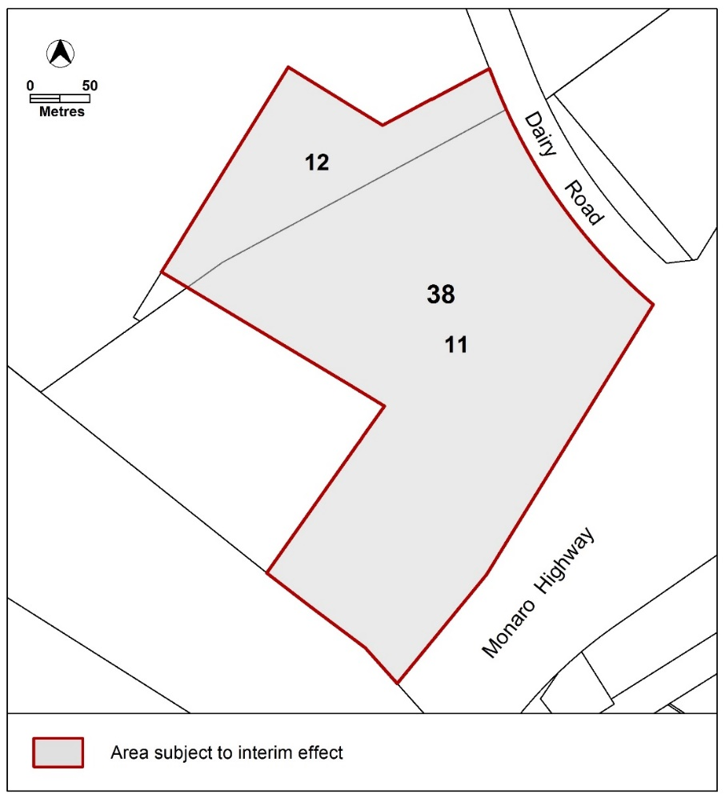
- Obtaining further information
Further information about the draft variation can be obtained through email correspondence with the Territory Plan Section, EPSDD, at terrplan@act.gov.au. A reference to the draft variation should be included in any email.
- Dictionary
In this instrument:
draft plan variation No 377 – Dairy Road Fyshwick: Rezoning from Industrial IZ1 General Industrial Zone to Commercial CZ3 Services Zone and Non-Urban NUZ3 Hills Ridges and Buffer Zone and changes to the Fyshwick Precinct Map and Code means the draft plan variation in Schedule 1.

Lesley Cameron
Delegate of the planning and land authority
13 August 2020

Planning and Development Act 2007

Draft
Variation to the
Territory Plan
377

Dairy Road Fyshwick:
Rezoning from Industrial IZ1 General Industrial Zone to Commercial CZ3 Services Zone and Non-Urban NUZ3 Hills Ridges and Buffer Zone and changes to the Fyshwick Precinct Map and Code

August 2020

Draft variation for public consultation prepared
under s60 of the Planning and Development Act 2007

This page is intentionally blank.

Contents

1. INTRODUCTION 1
1.1 Summary of the Proposal 1
1.2 Outline of the process 1
1.3 This document 2
1.4 Public Consultation 2
2. EXPLANATORY STATEMENT 4
2.1 Background 4
2.2 Site Description 5
2.3 Current Territory Plan Provisions 7
2.4 Proposed Changes 8
2.4.1 Proposed Changes to the Territory Plan Map 8
2.4.2 Proposed Changes to Territory Plan 9
2.5 Reasons for the Proposed Draft Variation 9
2.6 Planning Context 10
2.6.1 National Capital Plan 10
2.6.2 ACT Planning Framework 11
2.7 Interim Effect 15
2.8 Consultation with Government Agencies 17
3. DRAFT VARIATION 22
3.1 Variation to the Territory Plan 22

This page is intentionally blank.

- INTRODUCTION
  - Summary of the Proposal
The draft variation proposes rezoning Blocks 11 and 12 Section 38 Fyshwick from Industrial IZ1 General Industrial Zone to Commercial CZ3 Services Zone and making changes to the Fyshwick Precinct Map and Code to introduce specific controls and provisions for the site, known as Dairy Road.
The draft variation also proposes rezoning part of Block 14 Section 38 Fyshwick from the Industrial IZ1 zone to Non-Urban NUZ3 Hills Ridges and Buffer Zone to confirm the use of this land as an open natural landscape buffer between the Dairy Road site and the Jerrabomberra Wetlands Nature Reserve.

  - Outline of the process
The Commonwealth’s Australian Capital Territory (Planning and Land Management) Act 1988 allows for the Legislative Assembly to make laws to establish a Territory Planning Authority and for that Authority to prepare and administer a Territory Plan. The Planning and Development Act 2007 (the Act) establishes the planning and land authority as the Authority that prepares and administers the Territory Plan, including continually reviewing and proposing amendments as necessary. The functions of the planning and land authority are administered by the Environment, Planning and Sustainable Development Directorate (EPSDD). The Director-General of EPSDD is the planning and land authority.
The Territory Plan is comprised of a written statement and a map. The written statement contains a number of parts, namely governance; strategic directions; zones (including objectives and development tables and zone or centre development codes); precinct codes; general codes; overlays; definitions; structure plans, concept plans and development codes for future urban areas.
The Territory Plan Map graphically represents the applicable land use zones (under the categories of residential, commercial, industrial, community facility, urban parks and recreation, transport and services and nonurban), precincts and overlays. The zone, precinct and overlay requirements are detailed in the Territory Plan.
Draft variations to the Territory Plan are prepared in accordance with the Act. Following the release of the draft variation under section 63 of the Act, submissions from the public are invited. At the conclusion of the consultation period the EPSDD (planning and land authority) submits a report on consultation and a recommended final variation to the Minister responsible for planning for referral to the Legislative Assembly standing committee responsible for planning. The Minister must consider the findings of the committee before deciding whether to approve the draft variation. If the Minister approves the variation, the variation and associated documents will be tabled in the Legislative Assembly. Unless disallowed by the Legislative Assembly within five sitting days, the variation commences on a day nominated by the Minister.

  - This document
This document contains the background information in relation to the proposed variation. It comprises the following parts
Part 1 This Introduction
Part 2 An Explanatory Statement, which gives reasons for the proposed variation and describes its effect
Part 3 The Draft Variation, which details the precise changes to the Territory Plan that are proposed
  - Public Consultation
Written comments about the draft variation are invited from the public by 25 September 2020.
Comments should include reference to the draft variation and be addressed to the Territory Plan Section, EPSDD. Please also provide your name and contact details to assist in the assessment of the comments provided, and to enable EPSDD to contact you in relation to your comments, if required. Your personal information will be managed in accordance with the Information Privacy Act 2014 and the EPSDD Information Privacy Policy, which is available for viewing on EPSDD’s website.
Comments can be:
- emailed to terrplan@act.gov.au
- mailed to Territory Plan Section, GPO Box 158, Canberra, ACT 2601
- delivered to the Access Canberra Customer Service Centre at 480 Northbourne Avenue, Dickson
Copies of written comments received with respect to the draft variation will be made available for public inspection for no less than 15 working days starting 10 working days after the closing date for comment. The comments will be available at the Access Canberra customer service centre in Dickson and will be published on EPSDD’s website. Comments made available will not include personal contact details unless you request otherwise.
A request may be made for parts of a submission to be excluded under section 411 or 412 of the Planning and Development Act 2007. A request for exclusion under these sections must be in writing, clearly identifying what parts of your submission you are seeking to exclude and how the request satisfies the exclusion criteria.

Further Information
The draft variation and background documents are available online at www.act.gov.au/draftvariations until the closing date for written comments.
Printed copies of the draft variation (this document) and background documents are available for inspection and purchase at the Access Canberra Customer Service Centre, 16 Challis Street, Dickson, Monday to Friday (except public holidays) between 8:30am and 4:30pm. Please call 6207 1923 to arrange a copy for purchase.

- EXPLANATORY STATEMENT
  - Background
2.1.1 Blocks 11 and 12 Section 38 Fyshwick (Dairy Road site)
The site is currently zoned Industrial IZ1 General Industrial Zone. The proposal is to rezone the site to Commercial CZ3 Services Zone to allow for a mix of uses, including commercial, light industrial, residential, creative and cultural uses.
The site is located at the western extent of the industrial suburb of Fyshwick, and due to its position (see section 2.2 Site Description), the location of proposed uses on the site is intended to respond to the particular constraints posed by adjacent land uses and activities.
The interface of those parts of the site adjacent to surrounding roads and the major public utility installations (Fyshwick Sewerage Treatment Plant and the high pressure gas pipeline in the Monaro Highway road reserve) will be managed by the provision of defined exclusion areas within the site where certain uses are restricted, or where specific mitigation measures are required. The residential component, comprising a diversity of housing and accommodation types, will be protected from adverse impacts by only being permitted in the south west part of the site.
The Jerrabomberra Wetlands Nature Reserve to the west is one of the most valuable wetland habitat areas in the ACT, and of national and international importance. The Jerrabomberra Wetlands are part of Canberra Nature Park nature reserve system. Any potential impacts on the wetlands will be mitigated by restrictions on the intensity and nature of development adjoining the wetlands, specific Water Sensitive Urban Design (WSUD) measures and landscaping requirements.
Block 11 Section 38 Fyshwick is also subject to a Main Avenues and Approach Routes (MAAR) overlay in the National Capital Plan, and as such will require a Development Control Plan (DCP) to be approved by the National Capital Authority providing for the specific planning and urban design objectives for the Dairy Road site’s location adjacent to a MAAR.

2.2.1 Part of Block 14 Section 38 Fyshwick
The draft variation also proposes rezoning part of Block 14 Section 38 Fyshwick, which is unleased land adjacent to the Dairy Road site to the west, from IZ1 to Non-Urban NUZ3 Hills Ridges and Buffer Zone.
Block 14 Section 38 Fyshwick is registered on the ACT Heritage Register as part of the ‘Jerrabomberra Wetlands’, which is of heritage significance for the occurrence of paleochannels and wildlife habitation areas. Although the part of Block 14 which is proposed to be rezoned is not included in the nature reserve, it is considered to function as part of the wetlands.
The proposed rezoning to Non-Urban NUZ3 Hills Ridges and Buffer Zone will confirm the use of this land as an open natural landscape buffer between the Dairy Road site and the Jerrabomberra Wetlands Nature Reserve.

  - Site Description
The Dairy Road site is identified as Blocks 11 and 12, Section 38, Fyshwick. It is currently zoned Industrial IZ1 General Industrial Zone and located on the western edge of the industrial suburb of Fyshwick, about five kilometres from Canberra City and three kilometres from the Canberra International Airport.
It is bordered by the Monaro Highway to the east, Dairy Road and the Fyshwick Sewerage Treatment Plant to the north, the Jerrabomberra Wetlands Nature Reserve to the west and the Canberra-Sydney railway corridor to the south. The site currently contains surface car parking and several industrial and warehouse buildings, some of which have been repurposed to accommodate a variety of uses and businesses and indoor recreation activities.

Figure 1 Location Plan

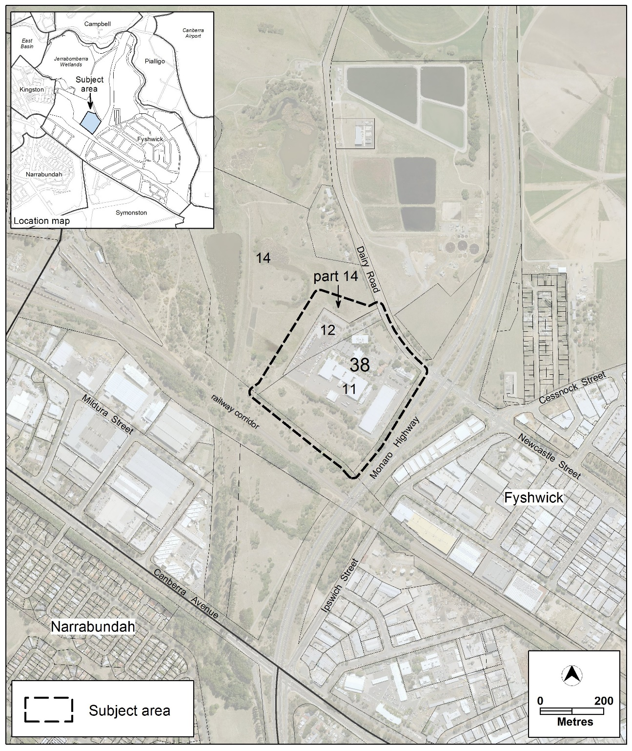

  - Current Territory Plan Provisions
The Territory Plan map zone for the area subject to this variation is shown in Figure 2.

Figure 2 Existing Territory Plan Zones Map
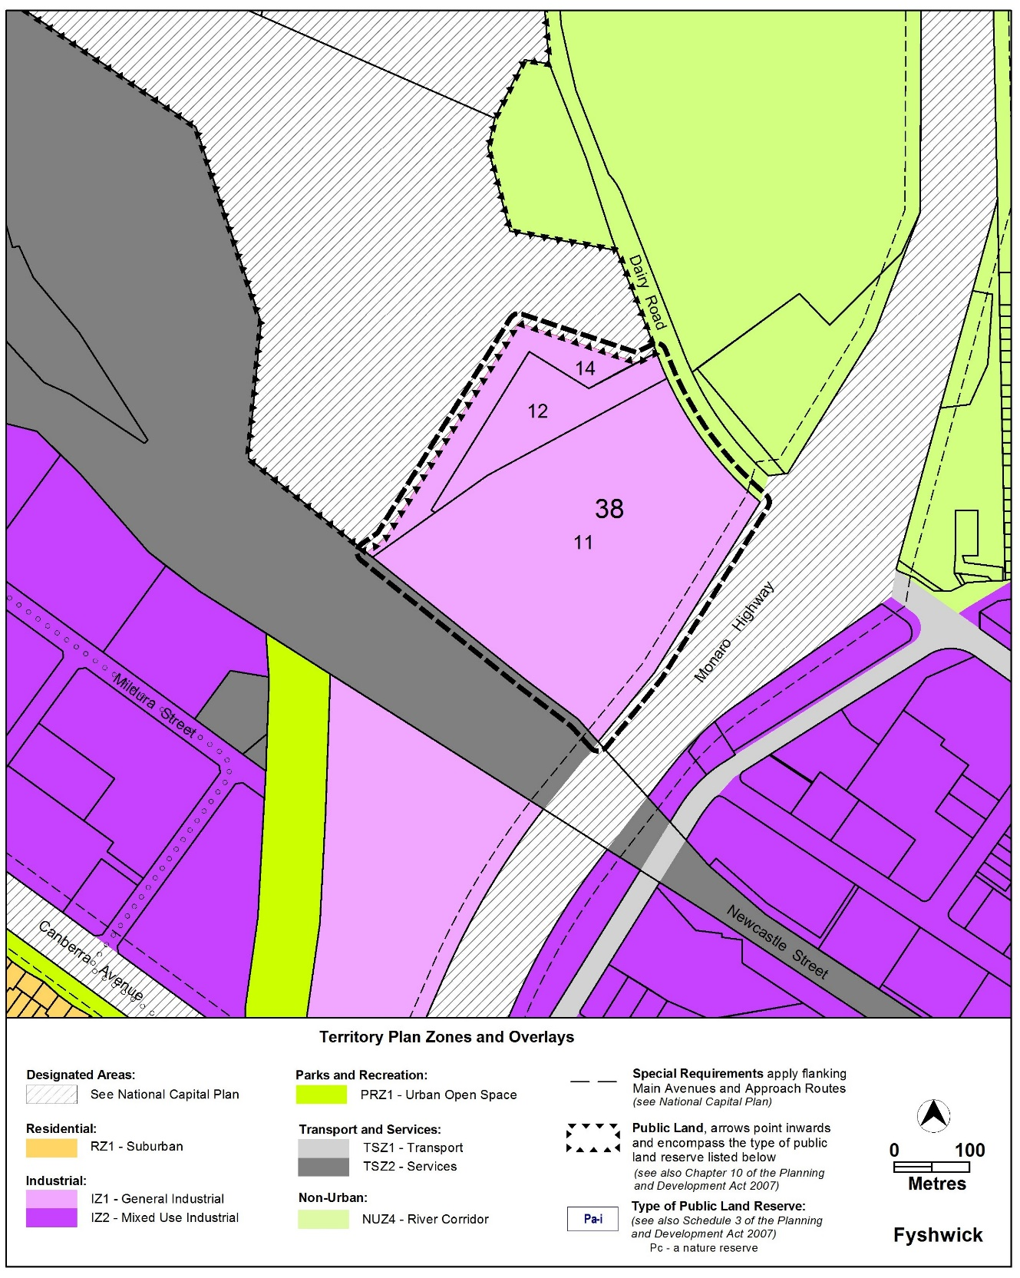
  - Proposed Changes
    - Proposed Changes to the Territory Plan Map
The proposed changes to the Territory Plan map are indicated in Figure 3 and at Part 3 of this document and are detailed as follows:
- rezone Blocks 11 and 12 Section 38 Fyshwick from Industrial IZ1 General Industrial Zone to Commercial CZ3 Services Zone
- rezone part Block 14 Section 38 Fyshwick from IZ1 to Non-Urban NUZ3 Hills Ridges and Buffer Zone
Figure 3 Proposed Territory Plan Zones Map
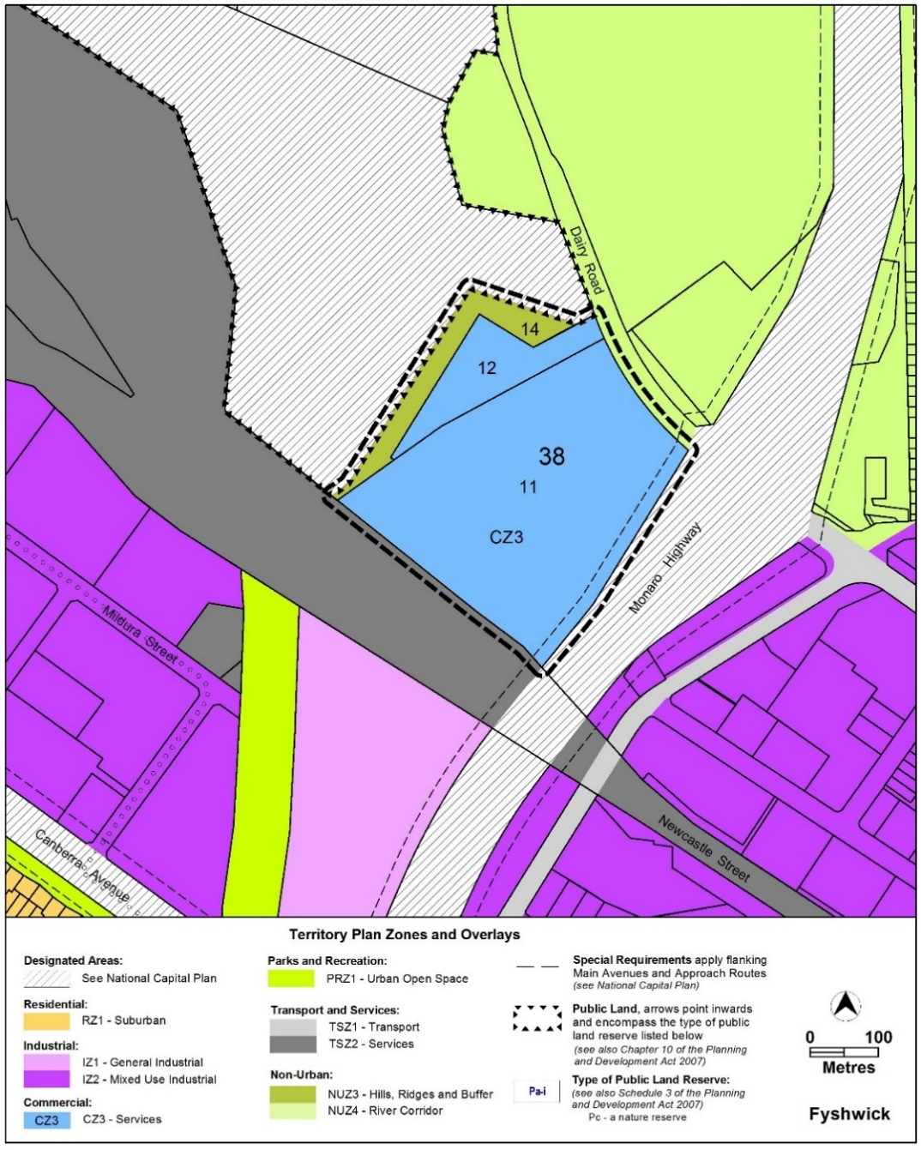
The draft variation map indicates the proposed zone boundaries as accurately as possible but may be subject to adjustments following detailed surveys.
    - Proposed Changes to Territory Plan
The specific controls for managing the matters of road noise, gas safety, sewer odour, proximity to the Jerrabomberra Wetlands and scale of development are proposed to be incorporated into the Fyshwick Precinct Map and Code. These provisions include:
- additional prohibited development and additional merit track development for blocks and parcels shown in the Dairy Road Precinct Map
- restrictions on sensitive uses and certain uses that result in higher concentrations of people (e.g. stadium) within a 205m buffer zone in response to the high pressure gas main and requirement for a Safety Management Study (SMS) to be completed for all developments, regardless of use in accordance with Australian Standard AS2885 prior to development application approval
- restrictions on sensitive uses in the north‐eastern portion of the site in response to sewer odour modelling outcomes
- location of residential development (maximum 1300 dwellings) in the south-western part of the site
- building heights limited to a maximum of 4 storeys adjacent to the Jerrabomberra Wetlands (western boundary of the site) and a maximum of 8 storeys across the remainder of the site
- consideration of environmental provisions to manage the interface with the Jerrabomberra Wetlands (light spill, WSUD, landscaping, cat containment)
- introduction of gross floor area limits for shop, supermarket, office
- requirements to mitigate traffic noise from the Monaro Highway which is a major arterial road carrying high traffic volumes
- provisions for the continuation of existing uses (and continuing tenants) such as ‘defence installation’ and ‘scientific research establishment’
  - Reasons for the Proposed Draft Variation
The reasons for the draft variation are as follows:
- The proximity of the site in West Fyshwick provides opportunities for its transition from an industrial area to a mixed-use industrial and commercial precinct
- The site is considered appropriate for the range of uses permitted in the Commercial CZ3 Services Zone
- The CZ3 Zone permits more suitable uses adjoining the interface with the Jerrabomberra Wetlands Nature Reserve than the potentially noxious uses permitted in an industrial zone
- The site is located adjacent to a major arterial road (Monaro Highway) providing good vehicular access to and from the site to various destinations such as the airport and city centre
- The site is in close proximity to one of the largest employment locations in Canberra (Fyshwick industrial area) and will provide future residents with access to nearby employment opportunities
- The proposed residential development component will provide a diversity of future housing and accommodation types including affordable housing schemes
- The Dairy Road site is located immediately adjacent to the East Lake urban renewal study area. The proposed rezoning and subsequent development on the site will contribute to achieving a mixed-density, mixed-use urban renewal precinct that integrates with the Fyshwick industrial/commercial uses, Kingston Foreshore, the Jerrabomberra Wetlands, interstate passenger rail service and the wider Inner South Canberra community.
- Rezoning part of Block 14 Section 38 Fyshwick from the Industrial IZ1 zone to the Non-Urban NUZ3 Hills Ridges and Buffer zone will confirm the use of the land between the Dairy Road site and the Jerrabomberra Wetlands as an open natural landscape buffer.
  - Planning Context
    - National Capital Plan
The Australian Capital Territory (Planning and Land Management) Act 1988 established the National Capital Authority (NCA) with two of its functions being to prepare and administer a National Capital Plan (NCP) and to keep the NCP under constant review and to propose amendments to it when necessary.
The NCP, which was published in the Commonwealth Gazette on 21 January 1990 is required to ensure that Canberra and the Territory are planned and developed in accordance with their national significance. The Planning and Land Management Act 1988 also requires that the Territory Plan is not inconsistent with the NCP.

    - ACT Planning Framework
Statement of Strategic Directions
The Statement of Strategic Directions sets out the principles for giving effect to the main objective of the Territory Plan as required by the Planning and Development Act 2007. The proposal is consistent with the Territory Plan’s statement of strategic directions in terms of environmental, economic and social sustainability and spatial planning and urban design principles, in particular:
1.1 Planning processes and decisions will be focused on the combined achievement of economic vitality, community wellbeing, and environmental quality. Broad community involvement will be a key element in the pursuit of sustainable development, as will complementary regional strategies and agreements.
The proposed rezoning to the Commercial CZ3 Services Zone will support a mixed-use development which will provide for a diverse range of uses and employment opportunities fostering economic vitality, promote community wellbeing and have a focus on environmental quality. Community involvement is a significant part of all stages of the process, from the conception of the proposal (the planning report requires community engagement), through to the draft variation process (community consultation is a statutory requirement under the Planning and Development Act 2007) and then the subsequent estate development plan development application which is publicly notified for community feedback.

1.5 Planning policies will seek to ensure the efficient use of all resources and to reduce consumption of non-renewable resources. Waste minimisation, reuse and recycling will be encouraged, whilst energy-rating and conservation measures will be applied wherever appropriate, particularly in transport, subdivision planning, and building design and construction.
The proponent is committed to achieving and, where possible, bettering the current ACT standards in the key areas of energy and water consumption, energy ratings, water sensitive urban design and reuse and recycling of materials.
A range of principles and guidelines will be further developed through the estate development plan and deed of agreement phases to achieve environmental sustainability at Dairy Road. Some of the potential principles and guidelines which the proponent has committed to addressing as part of on-going design and development include:
- Achieving zero carbon emissions
- Developing targets to reduce CO₂ emissions during construction and operation
- Retaining and reusing existing buildings where possible (e.g. studio spaces, workshops, offices, residences)
- Achieving zero waste
- Reusing existing buildings either by adapting to a new use or reusing materials and minimising waste
- Investigating efficient building techniques that minimise waste
- Developing real targets such as reducing household and business waste, increasing recycled proportions for households (compared to the average Australian household) and increasing proportion of reuse of existing buildings and infrastructure.

1.9 Urban expansion will be contained in order to minimise impacts on valuable natural and rural areas
The proposed development is within the existing urban footprint, thereby minimising impacts on valuable natural and rural areas.

1.12 Planning policies will facilitate the widest possible range of commercial, retail, industrial, rural, tourism, and other forms of economic activity in order to promote new investment and a more diversified economy, to underpin employment growth, and to respond to changing economic opportunities.
The proposed rezoning will support a mixed-use development providing for a diversity of employment opportunities and a range of uses including industrial, commercial, cultural, creative and recreation, and a managed approach to future residential occupation.

1.21 Provision of affordable, adaptable and special-needs housing will be promoted throughout the city, as well as modification or redevelopment of existing stock to meet emerging social needs.
The proponent intends to provide affordable housing as part of a managed approach to future residential occupation as well as a range of housing options to encourage a diversity of residents. The proponent also intends to target a 10% affordable housing component at Dairy Road using a range of mechanisms for example: pricing, partnerships with community housing providers and/or build to rent.

1.24 All new developments and re-developments will be planned with appropriate and segregated network facilities for pedestrians and cyclists; provision for accessible public transport; a legible and permeable hierarchy of roads; conveniently located commercial and community facilities; and a network of open spaces.
The subsequent estate development plan will be required to provide a detailed plan of facilities for pedestrians and cyclists, provision for bus stops, road layout, access to commercial and community facilities for future residents, and sufficient open space provision.

2.2 Future residential settlement will be accommodated through development of greenfields areas, subject to detailed feasibility and suitability studies; some expansion of existing towns; and appropriate use of suitable vacant or underdeveloped sites.
The ACT Planning Strategy 2018 identifies areas for urban intensification and envisages up to 70 percent of new housing being built within the existing urban footprint. The proposal meets the objective of the appropriate use of suitable vacant and underdeveloped sites for accommodating future residential settlement.

2.14 Policies and procedures to promote high quality, creative design of development, urban spaces and landscape settings will be applied throughout the Territory, and innovation encouraged, in keeping with the spirit of the National Capital as an exemplar of best practice. Particular care will be taken to ensure high-amenity, quality design outcomes within residential areas, heritage areas, major centres and activity nodes, and along principal approach routes. The relationship between the public and private realms will also be emphasised in terms of the design quality of precincts and shared spaces, including spaces around buildings, as well as that of individual developments.
This will be achieved through particular emphasis on high quality urban design outcomes that will be further supported through adherence with the objectives of National Capital Authority’s Development Control Plan for the site.

2.16 Retention of Canberra’s unique landscape setting, including the integration of natural and cultural elements that create its ‘garden city’ and ‘bush capital’ qualities, will be accorded the highest priority. Special attention will be given to safeguarding visual amenity, protecting vegetation and other important features within the established urban landscape, and ensuring the high quality of environmental design in new developments or redevelopment.
The rezoning of part of Block 14 Section 38 Fyshwick from the Industrial IZ1 zone to the Non-Urban NUZ3 Hills Ridges and Buffer zone will confirm the use of the land between the Dairy Road site and the Jerrabomberra Wetlands as an open natural landscape buffer. The NUZ3 zone prohibits urban development and other high impact activities. The change of zoning will assist in safeguarding the visual amenity, protecting the fauna and flora and other important features of the Jerrabomberra Wetlands, a significant ecological feature within the urban landscape.

ACT Planning Strategy 2018
The ACT Planning Strategy 2018 identifies five themes for Canberra: a compact and efficient city, diverse, sustainable and resilient, liveable, and accessible. The aim is to progress a vision of Canberra as a sustainable, competitive and equitable city that respects Canberra as a city in the landscape and the national capital, whilst being responsive to the future and resilient to change.
The consideration of the draft variation for this site is particularly guided by the compact and efficient city and diverse Canberra themes and related strategic directions, in particular:
Compact and efficient city: Strategic Direction 1.1 – Support sustainable urban growth by working towards delivering up to 70% of new housing within our existing urban footprint, and by concentrating development in areas located close to the city centre, town and group centres and along key transit corridors.
Diverse Canberra: Strategic Direction 2.4 – recognise and protect existing industrial areas and service trades areas as important elements of a diverse economy.

Compact and efficient: Urban intensification and mixed-use precincts
- As part of delivering a compact and efficient city, the ACT Planning Strategy 2018 identifies urban intensification localities catering for increased density in appropriate places such as around town and group centres and along major transport corridors, which are areas of high accessibility.
- Urban intensification is seen as a gradual transition through the introduction of higher density built form, commercial and employment activities, community, recreation and cultural spaces and a wide variety of land uses. The Dairy Road proposal is illustrating this transitional change from low density industrial uses to a mixed-use precinct providing a broad range of employment and investment opportunities.
- The Dairy Road site is located adjacent to a major arterial road (Monaro Highway). Increased density is envisaged in the ACT Planning Strategy along major transport routes.
- The longer term intention for the site is to develop the south-western part for medium to higher density residential use, which is in keeping with the 70 percent of new housing to be built within the existing urban footprint.
Diverse: Likely impact on the ACT’s employment lands generally and industrial land supply specifically:
- The ACT Planning Strategy 2018 recognises Fyshwick as one of the ACT’s key employment locations. A key strategic direction is to recognise and protect the role and function of existing industrial and employment areas as important elements of the ACT’s economy. This reflects the National Capital Plan’s employment location policies and the identification of Fyshwick Industrial Area as a ‘Defined Activity Centre’ in the National Capital Plan.
- Industrial areas are increasingly under pressure due to the interest in the conversion of land to other uses and due to conflicts than can arise between industrial use and nearby sensitive uses.
- Notwithstanding concerns about the potential loss of traditionally zoned industrial land, there are advantages to the rezoning of the Dairy Road site to enable the development of a mixed-use industrial and commercial employment precinct to support a range of innovative light industrial, creative and cultural uses.

  - Interim Effect
Section 65 of the Planning and Development Act 2007 applies to the draft variation for the area shown in Figure 4. This means that the provisions of DV377 for the area shown in Figure 4 have interim effect, and apply to development applications lodged on or after the notification day of this instrument.
During the period of interim effect the ACT Government must not do or approve anything that would be inconsistent with the Territory Plan as if it were amended by the draft variation. Where there is an inconsistency between provisions in the current Territory Plan and provisions in the draft variation, then the draft variation takes precedence for the extent of the inconsistency.
Interim effect will end on the day the earliest of the following happens:
- the day the public availability notice under section 70 for the draft variation being recommended to the Minister is notified in accordance with the Legislation Act
- the day the draft variation, or the corresponding variation, is withdrawn under section 68 (1)(b) or section 76 (3)(b)(v)
- 1 year after the date of the consultation notice.
Figure 4 Area subject to interim effect
  - Consultation with Government Agencies
The EPSDD is required to, in preparing a draft variation under section 61(b) consult with each of the following in relation to the proposed draft variation:
- the National Capital Authority
- the Conservator of Flora and Fauna
- the Environment Protection Authority
- the Heritage Council
- the Land Custodian, if the draft variation would, if made, be likely to affect unleased land or leased public land – each custodian for the land likely to be affected

National Capital Authority
The National Capital Authority provided the following comments on 5 August 2020
“The National Capital Authority (NCA) has no objection to the proposed land use change of the site, from IZ1 to CZ3 and NUZ3. The site is within Urban Areas under the National Capital Plan (the Plan) and the proposed zonings are not inconsistent with this land use category.
The Dairy Road site is adjacent to the Monaro Highway, an Approach Route under the Plan. Special Requirements apply and a Development Control Plan (DCP) is required to be prepared to guide development. The NCA has commenced preparation of a DCP and will continue to liaise with EPSDD officers as this work progresses. Further discussion is critical to ensure that there are no inconsistencies between the DCP and final TPV.
It would be useful to understand whether EPSDD has considered the inclusion of design quality criteria in the draft variation. A key issue for the NCA is the landscape and architectural quality of development, particularly as the site presents to Designated Areas (both the Monaro Highway Approach Route and the Jerrabomberra Wetlands). The NCA will include design quality provisions in the DCP, however there may be merit in including such criteria consistently across the planning framework for the site.”
Response
The comments are noted and EPSDD agrees that further discussion with the NCA is critical to make sure there are no inconsistencies between the DCP and final variation.
As the NCA will include the provisions for design quality criteria in the DCP, it is not considered necessary to duplicate these in the draft variation. Some duplication will most likely result (such as building heights), however it is expected that there will be no inconsistencies between the DCP and the Territory Plan.
Conservator of Flora and Fauna
The Conservator of Flora and Fauna made the following comments on
29 July 2020:
“In accordance with Section 61(b) of the Planning and Development Act 2007 I advise that I have examined Draft Variation No 377, Dairy Road, Fyshwick, that proposes the rezoning of Blocks 11 and 12, Section 38, Fyshwick from Industrial IZ1 General Industrial Zone to Commercial CZ3 Services Zone, the rezoning of part Block 14 Section 38 Fyshwick from IZ1 to Non-Urban NUZ3 Hills Ridges and Buffer Zone, and other relevant changes to the Fyshwick Precinct Map and Code.
The proposed changes will allow residential and mixed commercial/industrial uses adjacent to and upstream of Jerrabomberra Wetlands Nature Reserve (JWNR). These wetlands are listed as an important Australian wetland (Environment Australia 2001. A Directory of Important Wetlands in Australia - Third Edition). In terms of the diversity of wetland habitat, the abundance and diversity of wetland birds supported and the habitat they provide to threatened and migratory species, the wetlands are one of the most significant of the ACT region.
There are a number of potential impacts from the proposal on the JWNR. While some of these have been addressed satisfactorily in the Planning Report, there are several issues which require further consideration.
Visual impacts and amenity
The medium and high-density residential development proposed by DV377 (four storey residential development adjacent to the wetlands and eight storey residential development on blocks behind that) will have a detrimental visual impact on the wildlife and amenity of the JWNR. Visual impacts on the wetlands will need to be considered in a more detailed environmental impact assessment before the Draft Variation is supported. Consideration should be given to a reduction in building heights to 2 storeys adjacent to the wetlands and an incremented step back in building heights to a six storeys maximum for the residential development.
Cumulative impacts of development
The cumulative impacts of the proposed Dairy Road resident development and that of the future East Lake development will need to be considered. Potentially between 4,000 and10,000 additional people could be living or working immediately adjacent to the wetlands in the future.
This has the potential to cause an unacceptable burden on the JWNR to provide for some of the recreational needs of future residents. This increased usage may compromise the function of the JWNR, in particular as a refuge for migratory and
other bird species. Adequate areas within the development to cater for the active recreational needs of future residents is required to be demonstrated. These recreational areas will not be located adjacent to the wetlands.
Impacts on the wetlands reserve
Whilst it may be within the existing urban footprint, the Draft Variation does not adequately address potential impacts on the adjacent JWNR. A full investigation of environmental impacts on the wetlands is required prior to the variation.
Consideration should also be given to including a provision that the proponent is required to make a financial contribution to upgrade facilities within the JWNR. The contribution could be used for: low key facilities such as pedestrian paths; upgrading habitat for water birds; improving stormwater controls; providing infrastructure such as boardwalks and bird hides; landscaping within the wetlands; or for general maintenance infrastructure within the wetlands.
Environmental provisions for the JWNR interface management: (light spill, Water Sensitive Urban Design, landscaping, cat containment) also need to consider noise controls, visual impacts, invasive weeds and fire management. The environmental provisions should also require that no utility infrastructure associated with the development is constructed within the JWNR boundary and that no overhead lines are constructed adjacent to the wetlands to minimise impacts on reserve values.
Hydrological impacts
Further information on and consideration of asset protection requirements in addition to potential hydrological impacts must be provided as it is yet to be demonstrated that no adverse environmental impacts will eventuate within the wetlands as a result of the proposed changes and development.
Landscape and visual buffer
The proposed rezoning of part Block 14 Section 38 Fyshwick from IZ1 to Non-urban NUZ3 Hills Ridges and Buffer Zone is supported. To minimise visual impacts of the proposed Dairy Road development on the JWNR, the proposal will need to include dense landscaping/planting in this buffer zone.”
Response
Noted.

Visual impacts and amenity
The precinct code limits building heights to a maximum of 4 storeys adjacent to the wetlands. A provision has also been included in the precinct code that any lighting within 50 metres of the site boundary adjacent to the wetlands will require a lighting plan to demonstrate how light spill will be contained so as not to adversely affect the reserve.
Cumulative impacts of development
The Estate Development Plan will be required to demonstrate how appropriate and adequate access to the reserve is provided, and how visitation into the reserve will be controlled, with the increase in residential population on the site. The EDP will need to provide for adequate recreational areas and open public space on the site to alleviate pressure on the wetlands as a recreational destination.
Impacts on the wetlands reserve
The Conservator has advised that discussions will be held with the proponent about potential future arrangements with the Wetlands Trust to build resilience in the conservation and land management operations and visitor experiences within the Jerrabomberra Wetlands Nature Reserve.
The Estate Development Plan includes controls that need to be addressed to make sure any impacts on the wetlands reserve are avoided. A Lighting Plan is required for any development within 50 metres of the site boundary adjacent to the wetlands. The EDP will also need to demonstrate that no utility infrastructure associated with the development is constructed within the JWNR boundary and that no overhead lines are constructed adjacent to the wetlands in order to minimise impacts on reserve values.
Visual impacts will be considered by the NCA’s Development Control Plan (DCP) which covers the whole site, including the interface with the reserve, as the Jerrabomberra Wetlands are located in Designated Land. The DCP will address building design and landscaping for the interface with the Monaro Highway and wetlands. Invasive weeds and fire management will be addressed through provisions for landscape plans and bushfire considerations in the precinct code.
Hydrological impacts
A provision has been included in the precinct code requiring a hydrological assessment to be undertaken to demonstrate that there will be no adverse hydrological impacts on the Jerrabomberra Wetlands as a result of development on the site.

Landscape and visual buffer
Parks and Conservation Services currently manage that part of Block 14 Section 38 Fyshwick as a buffer, and will continue to do so once the zone is changed to confirm this land use over that parcel of land.

Environment Protection Authority
The Environment Protection Authority provided the following comments on
22 July 2020:
“The Authority has reviewed the Draft Dairy Road Planning Report dated July 2020 by Molonglo (Planning Report) to inform Draft Variation 377 to the Territory Plan for Blocks 11 & 12 Section 38 Fyshwick (the Site). The proposal is to rezone the Site from its current Industrial IZ1 General Industry Zone to Commercial CZ3 Services Zone (CZ3) and make changes to the Fyshwick Precinct Map and Code (Code) to introduce specific controls and provisions for the Site to allow for a range of future developments including the provision of multi-unit housing, non-retail commercial uses, mixed use (retail, cafes, restaurants etc) and some community facilities and services.
The Site is located in the Fyshwick Industrial Estate (Estate) zoned General Industrial and is located between the Fyshwick sewerage treatment plant (STP) to the north and industrially zoned land to the west, south and east.
The Planning Report and previously provided supporting documentation have failed to demonstrate to the satisfaction of the Authority that the Site is suitable for residential and other sensitive uses and have not adequately addressed the impacts on the surrounding on-Site and off-site existing and permitted uses should Draft Variation 377 proceed.
Specifically, the Authority is not satisfied that the following environmental concerns have been adequately addressed:
- land contamination;
- current land use compatibility issues, both internal and external to the Site; and
- potential land use compatibility issues and impacts from the surrounding Estate including: noise, odour and other pollutants.

The Authority provides the following comments on Draft Variation 377.
Land contamination
Comment:
The Site has not been adequately assessed from a contamination perspective to determine if it is suitable for the proposed and permitted uses.
The ACT Government's Strategic Plan Contaminated Sites Management, 1995 specifically requires that potentially contaminated land be investigated at the earliest stages of the planning process to ensure a site is suitable for the proposed development.
Advice:
An environmental assessment of the Site in accordance with endorsed guidelines must be undertaken by a suitably qualified environmental consultant to determine whether past activities have impacted the Site from a contamination perspective and to determine if the Site is suitable for the proposed and permitted uses. This assessment must include a review of all prior contaminated land assessments undertaken at the Site.
The findings of the assessment and remedial works must be independently audited by an Authority approved contaminated land auditor and the findings of the audit into the suitability of the Site for its proposed uses endorsed by the Authority prior to the Territory Plan being varied.
This assessment must be conducted in accordance with the requirements of the ACT Government’s Contaminated Sites Environment Protection Policy December 2017 and associated guidelines to ensure that adverse impacts of contaminated land on the environment and human health are appropriately assessed and managed.
Notwithstanding the land contamination issues, the Authority has concerns about the following on-Site and off-site impacts.
Land Use Compatibility Issues
Comment
Noise and air emission impacts including odour have not been adequately assessed to determine if the Site is suitable for the proposed and permitted uses.
Specific environmental issues which have not been addressed on the Site are noise and odour impacts from the existing industrial uses which include a coffee roaster, brewery, distillery and chocolatier. The Acoustic Report gives no consideration of noise from the existing industry at the Site. It is worth noting the Acoustic Report has not considered noise from the adjacent rail line or internal roads which may have an impact on some of the uses.
Air Quality
Advice
An air quality assessment, in accordance with the ACT Government’s Separation Distance Guidelines for Air Emissions, November 2017 (the Guidelines), needs to be undertaken to demonstrate that the existing industrial uses will not have adverse impacts on existing and proposed sensitive uses. The Guidelines provide recommended separation distances between various emission sources and sensitive land uses. The recommended separation distances aim to ensure the incompatible land uses are located in a way that minimise the impacts of odour and polluting air emissions. They do not however prohibit lesser separation distances provided an air quality assessment can demonstrate the impacts are within the adopted air quality standards and can be appropriately managed. They also assist in the siting of new developments to ensure that industrial activities in appropriate zones, such as the existing Estate, and surrounding industrial uses are protected from encroachment by residential and other sensitive land uses that would have a negative effect on the viability of industry.
Specific comments on Rule 7.2 in relation to odour.
It would be preferable if Rule 11 required an air quality assessment if the uses proposed on the Site are within the recommended separation distance detailed in the Guidelines. This would ensure impacts from emissions sources both within the Site and from the surrounding industrial uses is appropriately assessed. If management is required, this would form part of the air quality assessment. It would also be important that appropriate institutional controls are implemented to ensure compliance with any recommended management measure through the development application and approval process.
Noise
Advice
An acoustic assessment of noise impacts from the adjacent rail line, internal roads, Estate and existing industry on the Site needs to be undertaken to determine if the Site is suitable for the proposed uses. This assessment should be conducted in accordance with the January 2010 Noise Environment Protection Policy and the Guidelines for the preparation of Noise Management Plans for development applications to ensure that legislative requirements including the need to prevent or minimise environmental harm and to demonstrate how environmental noise pollution will be managed for the Site and any developments on the Site.
The principles include that the acoustic environmental values secured through noise standards should protect the health and wellbeing of the community and the individual and that regulatory controls should enable economically desirable or socially acceptable activities to take place provided that all reasonable steps consistent with the expectations of the overall community will be taken to minimise noise from such activities.
The factors to be considered when preparing the acoustic assessment include:
- that residential development must meet the ‘design sound level ranges’ recommended for residential buildings of AS/NZS 2107 and commercial accommodation developments should meet AS/NZS 2107 for sleeping areas; and
- noise from all permitted uses identified as being noisy, regardless of whether the noisy permitted use is utilised, must be attenuated at the building design stage or measures that allow the attenuation to be incorporated in the future should a permitted use be activated.
It is noted that changing the zoning of the Site to CZ3 would result in the noise standard for the Site under the current Environment Protection Regulation 2005 (Regulation) changing from the industrial noise standard (for Zone A) which is appropriate for the uses on the Site and surrounding industrial uses to the residential noise standard (for Zone G) which would not be appropriate for the existing uses on the Site and surrounding industrial land uses.
Specific comments on Rule 7.1 and 7.3 Noise Attenuation are that the Regulation is based on the Territory Plan zonings where CZ3 zones support the City and Town Centres. The Regulation would require amendment to specifically identify this Site as Zone B as all CZ3 zones are within the City or Town Centre precincts in the Territory Plan. Two possible solutions are: change CZ3 to zone B (where not in the City or Town Centre) or to be consistent with the structure of the Regulation in recognising noise impacts from adjacent land uses (in this case surrounded by Industrial) include CZ3 to zone F which means it would take on Industrial noise standards being the highest adjoining noise zone.
The advantage here is the residences would be constructed to mitigate higher levels which would assist with higher noise levels on the Site from existing and permitted used and from surrounding industrial land uses.
The Authority provides the following general advice on the enforceability of the proposed rules in the Code. The proposed rules fail to indicate how compliance is enforced, in particular, that construction of the buildings including the proposed dwellings, is to the standard/s specified in the Code.”
Response
Noted. The following responses are provided on the matters of land contamination and land use compatibility including air quality and noise issues.
Land contamination:
A requirement for a contamination study has been inserted into the precinct code as a mandatory rule. The environmental assessment must be endorsed by the Environment Protection Authority prior to development or a change in use.
The proponent has advised that they are in the process of completing a contamination assessment and Site Audit Statement for the whole site to determine the suitability of the site for the proposed and permitted uses.
Land Use Compatibility Issues
The precinct code includes provisions for requiring noise and air emission impacts including odour to be addressed prior to development being undertaken on the site. The acoustic assessment and noise management plan will be required to address noise from the existing industry at the Site, noise from industrial uses external to the Site, and noise from the adjacent rail corridor.
Air Quality:
A provision requiring an air quality assessment to be undertaken to demonstrate that the existing industrial uses will not have adverse impacts on existing and proposed sensitive uses has been included in the precinct code.
The air quality assessment will need to make sure that impacts from emissions sources both within the Site and from the surrounding industrial uses is appropriately assessed in accordance with the EPA’s applicable guidelines at the time and endorsed by the EPA.
Noise:
The acoustic assessment and noise management plan will be required to address noise from the existing industry at the Site, noise from industrial uses external to the Site, and noise from the adjacent rail corridor.
It is considered that amending the Environment Protection Regulation 2005 to add CZ3 zones (where not located in city or town centres) to Zone F under Schedule 2 in the Regulation is the preferable option. This can be done concurrently with the draft variation process.

Heritage Council
The Heritage Council provided the following comments on 21 July 2020
“Pursuant to Part 10 of the Heritage Act 2004, the ACT Heritage Council advises that:
The proposed Territory Plan Variation is unlikely to diminish the heritage significance of the places subject to conditions set out below.
Background:
On 10 July 2020, the ACT Heritage Council (the Council) received the Draft Territory Plan Variation for Blocks 11 and 12 Section 38, and part of Block 14 Section 38, Fyshwick (‘DV377’). DV377 proposes:
- The rezoning of Blocks 11 and 12 Section 38 Fyshwick to Commercial CZ3 Services Zone, to allow for a mix of uses, including commercial, light industrial, residential, creative and cultural uses;
- The rezoning of part of Block 14 Section 38 Fyshwick to Non-Urban NUZ3 Hills Ridges and Buffer Zone, to formalise the status of this land as a landscape buffer between the Dairy Road site and the Jerrabomberra Wetlands Nature Reserve; and
- Related changes to the Fyshwick Precinct Map and Code for the blocks.
Blocks 11 and 12 Section 38 Fyshwick do not contain any registered or recorded heritage places or objects, and due to previous development, unrecorded heritage places or objects are unlikely to occur.
Block 14 Section 38 Fyshwick is registered on the ACT Heritage Register as part of the ‘Jerrabomberra Wetlands’, which is of heritage significance for the occurrence of paleochannels and wildlife habitation areas.
DV377 recognises the valuable habitat of the Jerrabomberra Wetlands, and sets out measures adopted to mitigate any future development impacts, including restrictions on the intensity and nature of development adjoining the wetlands, specific Water Sensitive Urban Design measures and landscaping requirements.
Advice:
Following review of DV377, the Council advises that the proposed Territory Plan Variation is unlikely to result in detrimental heritage impacts subject to the following heritage conditions:
- Future development of Blocks 11 and 12 Section 38 Fyshwick is to include management measures to ensure that bird and wildlife habitation areas within Jerrabomberra Wetlands are not adversely affected; and
- Future development of Blocks 11 and 12 Section 38 Fyshwick is to include an ‘Unanticipated Discovery Protocol’, to describe how any future heritage discoveries would be managed in accordance with Heritage Act 2004 provisions.”
Response
A provision has been included in the precinct code to require the ecological values of the wetlands, including flora and fauna, are protected from any adverse impacts as a result of development on the Dairy Road site.
No listed Aboriginal places or objects have been identified as occurring within the Dairy Road site. However, should the Proponent discover an unregistered Aboriginal place or object during site development and construction it will be reported as required under Section 51 of the ACT Heritage Act 2004. This will be managed via the inclusion of an Unanticipated Discovery Protocol which will form part of the construction management plans.

Land Custodian EPSDD Parks and Conservation Service – for Block 14 Section 38 Fyshwick
The land custodian provided the following comments on 6 August 2020:
“PCS has no objection to the proposed rezoning of 14/38 Fyshwick”

Response
Noted.
Parks and Conservation Service has been managing much of this land as a buffer already and the change of zone to NUZ3 will confirm this area as an open natural landscape buffer between the wetlands and the Dairy Road development.

- DRAFT VARIATION
  - Variation to the Territory Plan
The Territory Plan is varied in all the following ways:

Variation to the Territory Plan Map
- Territory Plan Map - Fyshwick

Substitute
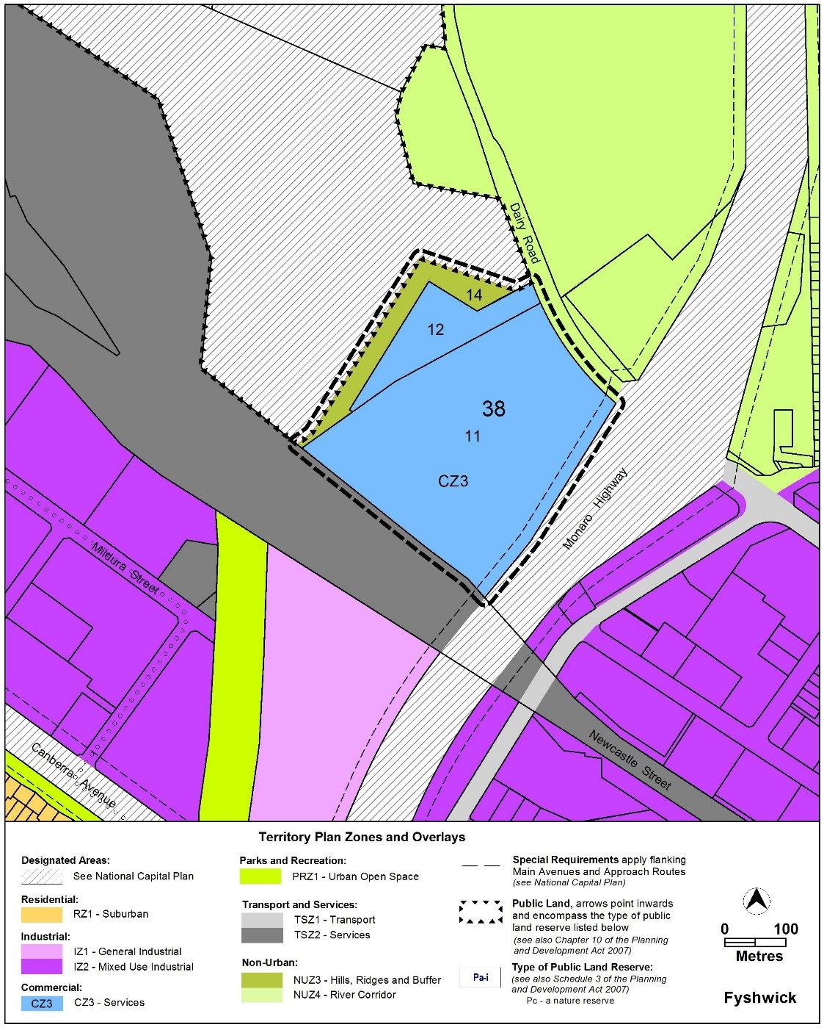

Variation to the Fyshwick Precinct Map and Code
- Fyshwick Precinct Map

Substitute

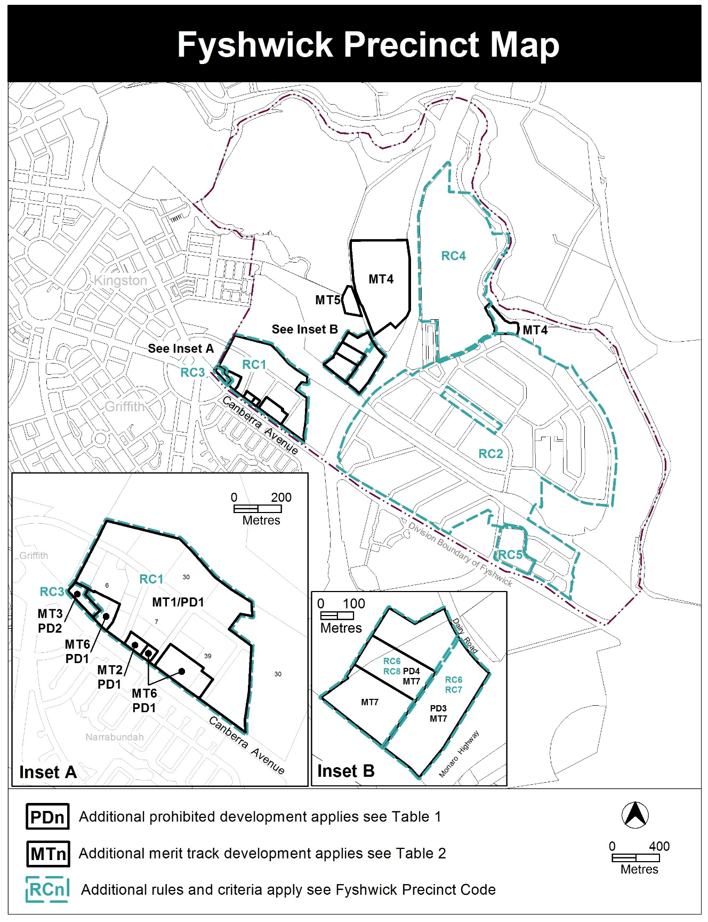
- Fyshwick Precinct Code; Table 1 – Additional prohibited development

Insert PD3 and PD4 into Table 1 after PD2:
Additional prohibited development
Suburb precinct map label | Zone | Development
PD3 | CZ3 | child care centre  COMMERCIAL ACCOMMODATION USE  hospital  RESIDENTIAL USE
PD4 | CZ3 | RESIDENTIAL USE  COMMERCIAL ACCOMMODATION USE

- Fyshwick Precinct Code; Table 2 – Additional merit track development

Insert after MT6 in Table 2:
Additional merit track development that may be approved subject to assessment
Suburb precinct map label | Zone | Development
MT7 | CZ3 | defence installation  scientific research establishment

- Fyshwick Precinct Code; Additional rules and criteria

Insert after RC5 – Block 8 Section 48 Fyshwick:

RC6 - Dairy Road mixed use area
This part applies to any proposed residential development on the blocks and parcels identified in the area RC6 shown on the Fyshwick Precinct Map.

Element 7: Residential Amenity
Rules | Criteria
7.1 Noise attenuation - external sources
R9  This rule applies in addition to R67 of the Multi Unit Housing Development Code and R42 of the Single Dwelling Housing Development Code which require mitigation of noise from road traffic, rail and regulated sources.  For residential development all dwellings shall be constructed to comply with the relevant sections of AS/NZS 2107:2016 - Acoustics – Recommended design sound levels and reverberation times for building interiors (the relevant satisfactory recommended interior design sound level).  Compliance with this rule is demonstrated by an acoustic assessment and noise management plan, prepared by a member of the Australian Acoustical Society with experience in the assessment of rail traffic noise, and endorsed by the ACT Government entity responsible for transport planning. | This is a mandatory requirement. There is no  applicable criterion
R10  Development complies with a noise management plan prepared by a suitably qualified person and endorsed by the Environment Protection Authority (EPA).  The noise management plan will detail the proposed design, siting and construction methods that will be employed to ensure compliance with the Noise Zone Standard as detailed in the Environment Protection Regulation 2005, based on the estimated noise levels when the facility is in use.  Note: A condition of development approval may be imposed to ensure compliance with the endorsed noise management plan. | This is a mandatory requirement. There is no  applicable criterion.
7.2 Air quality assessment
R11  Prior to any residential development being proposed for the site, an air quality assessment must be undertaken to demonstrate that the existing industrial uses both within and external to the site will not have adverse impacts on existing and proposed sensitive uses.  The air quality assessment will need to demonstrate that impacts from emissions sources both within the site and from the surrounding industrial uses is appropriately assessed in accordance with the Environment Protection Authority’s applicable guidelines at the time and endorsed by the Environment Protection Authority. | This is a mandatory requirement. There is no  applicable criterion.
7.3 Noise and odour – internal sources
R12  Where subdivision (including unit titling) of parcels is proposed, noise and odour management plans are prepared by a suitably qualified person and endorsed by the Environment Protection Authority.  The plans will demonstrate how the development addresses noise and odour emissions from within the site and how the impacts are mitigated for sensitive uses on and adjoining the site. | This is a mandatory requirement. There is no  applicable criterion.
Element 8: Use
Rules | Criteria
8.1 Restrictions on use
R13  The maximum gross floor area for a supermarket or a shop selling food is 300m² | This is a mandatory requirement. There is no applicable criterion.
R14  The maximum gross floor area for an office on any tenancy is 2000m². | This is a mandatory requirement. There is no applicable criterion.
R15  The maximum gross floor area for all NON RETAIL COMMERCIAL USE is 40,000m² | This is a mandatory requirement. There is no applicable criterion.
R16  This rule applies to Area A in Figure 1:  The maximum number of storeys is 4 | This is a mandatory requirement. There is no applicable criterion.
R17  This rule applies to Area B in Figure 1:  The maximum number of storeys is 8. | This is a mandatory requirement. There is no applicable criterion.
R18  The maximum number of dwellings is 1300. | This is a mandatory requirement. There is no applicable criterion.
R19  Educational establishment is only permitted where it is for technical and vocational training. | This is a mandatory requirement. There is no applicable criterion.
R20  Stadium or arena is not permitted.  Note: Stadium, arena fall under the definition of outdoor recreation facility | This is a mandatory requirement. There is no applicable criterion.
R21  Agriculture is only permitted where it is for horticulture and apiaries | This is a mandatory requirement. There is no applicable criterion.
8.2 Contamination
R22  An environmental assessment into the site’s suitability from a contamination perspective must be undertaken in accordance with the ACT Contaminated Sites Environment Protection Policy and be endorsed by the Environment Protection Authority prior to development or a change in use. This rule does not apply if the Environment Protection Authority has provided written advice that the site has been assessed for contamination to its satisfaction. | This is a mandatory requirement. There is no applicable criterion.

Element 9: Environment
Rules | Criteria
9.1 Environment Protection
R23  The Estate Development Plan (EDP) must address all of the following to avoid adverse ecological impacts on the Jerrabomberra Wetlands:  - Stormwater runoff and water sensitive urban design measures  - Landscaping to be in accordance with a landscape master plan to complement the existing species and prevent the spread of invasive species. The vegetation adjacent to the site boundary with the wetlands must be a combination of mid-layer shrubs and advanced stock tree planting to provide visual screening of the site from the wetlands. The species are to be chosen to have minimal impact on the wetlands and to avoid any exotic species entering the reserve.  - Bushfire containment measures including but not limited to an edge road and asset protection zone  - Lighting to be designed to avoid light spill into the reserve  - Location of infrastructure including roads, footpaths, utilities, etc  - Public realm considerations including  - the location and provision of pedestrian access into the wetlands is to be suitable and capable of dealing with the expected increase in patronage as a result of the future residential population on the site  - provision and location of suitable open space and recreational facilities on the site to ease pressure on the wetlands as a recreational destination  - no utility infrastructure associated with the development is constructed within the reserve boundary and no overhead lines are constructed adjacent to the wetlands.  The above measures in the EDP must be endorsed by the Conservator of Flora and Flora. | This is a mandatory requirement. There is no applicable criterion.
9.2 Sustainability
There is no applicable rule | C24  Development demonstrates that there is no net gain of urban heat as measured on the 2017 urban heat map.  Compliance with this criterion is demonstrated in a microclimate assessment report by a qualified professional which gives consideration of mitigating measures including:  - low thermal mass building materials and building colours.  - inclusion of canopy trees to achieve an overall minimum of 30% shade of the precinct.  - use of permeable surfaces.  - use of water features.  This criterion does not apply to a development application for the change of use of an existing building or structure.  Note 1: the 2017 urban heat map is available on ACTmapi via the following link: http://www.actmapi.act.gov.au
9.3 Cat containment
R25  The provisions of the Domestic Animals Act relating to cat containment apply. | This is a mandatory requirement. There is no applicable criterion.

RC7 - Gas pipeline impact area
This part applies to blocks and parcels identified in the area RC7 shown on the Fyshwick Precinct Map.

Element 9: Use
Rules | Criteria
9.1 Safety management study (SMS)
R26  This rule applies to the gas pipeline impact area shown in Figure 2.  Development complies with a Safety Management Study plan prepared by an experienced SMS facilitator who has been approved by a senior officer within the licensed gas utility provider and endorsed by the ACT Government’s Technical Regulator.  The plan will detail an assessment against the safety management study process and location classifications in accordance with Australian Standard AS2885.1 Pipelines – gas and liquid petroleum.  Note: a senior officer within the licensed gas utility provider needs to be a principal engineer, a senior pipeline engineer or the gas network manager. | This is a mandatory requirement. There is no applicable criterion.

RC8 – Jerrabomberra Wetlands interface
This part applies to blocks and parcels identified in the area RC8 shown on the Fyshwick Precinct Map.

Element 10: Use
Rules | Criteria
10.1 Environment
R27  This rule does not apply to any Estate Development Plan Development Application.  Any development within 50 metres of the site boundary adjacent to the Jerrabomberra Wetlands must have a light spill assessment demonstrating that there will be no adverse impacts from lighting on the adjacent wetlands.  The light spill assessment must be prepared by a suitably qualified professional and must be to the satisfaction of the Conservator of Flora and Fauna. | This is a mandatory requirement. There is no applicable criterion.
R28  This rule does not apply to any Estate Development Plan Development Application.  A hydrological assessment is to be provided to demonstrate that there will be no adverse hydrological impacts on the Jerrabomberra Wetlands as a result of development on the site.  The assessment must be prepared by a suitably qualified hydrological professional and endorsed by the Conservator of Flora and Fauna. | This is a mandatory requirement. There is no applicable criterion.
R29  This rule does not apply to any Estate Development Plan Development Application.  Water Sensitive Urban Design (WSUD) measures shall be implemented in accordance with a WSUD assessment demonstrating that there are no adverse impacts on the Jerrabomberra Wetlands and be endorsed by the Conservator of Flora and Fauna. | This is a mandatory requirement. There is no applicable criterion.
R30  This rule does not apply to any Estate Development Plan Development Application.  A landscape plan for the site shall be prepared demonstrating that the species used are appropriately chosen and managed to remove any risk of introduction of incompatible species to the Jerrabomberra Wetlands.  The vegetation adjacent to the site boundary with the wetlands must be a combination of mid-layer shrubs and advanced stock tree planting to provide visual screening of the site from the wetlands. The species are to be chosen to have minimal impact on the wetlands and to avoid any exotic species entering the reserve.  The landscape plan is endorsed by the Conservator of Flora and Fauna. | This is a mandatory requirement. There is no applicable criterion.

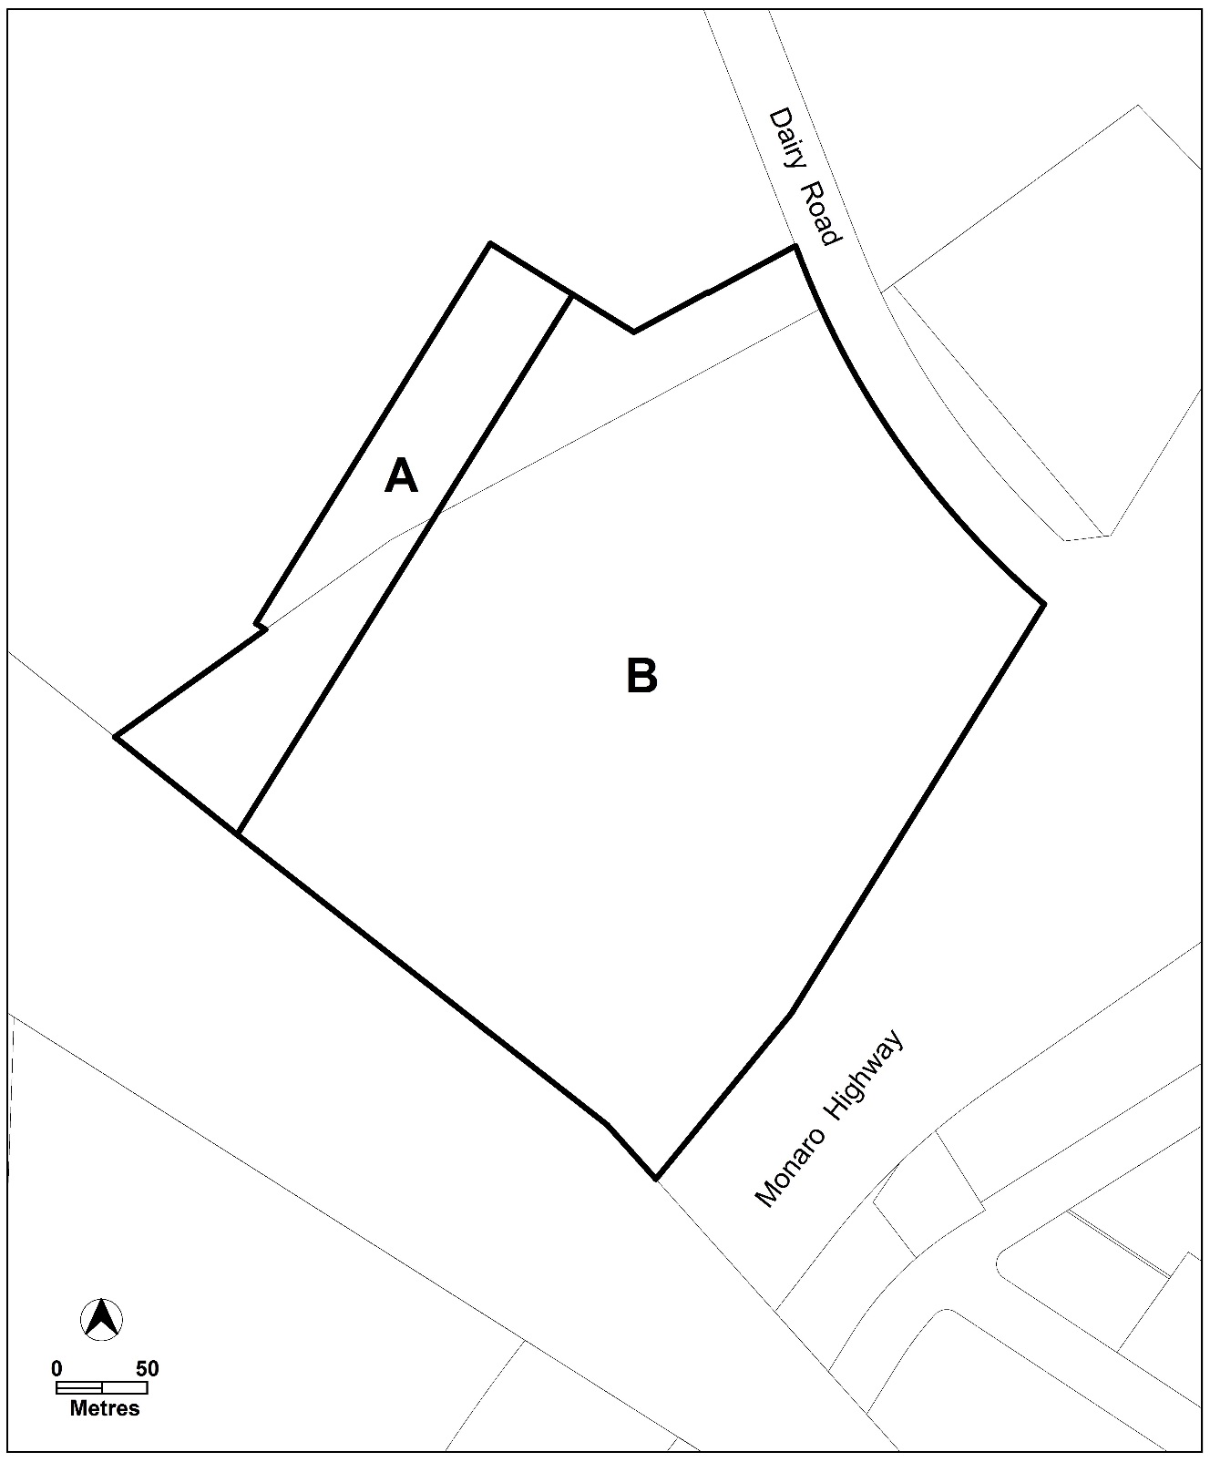
Figure 1 Building heights

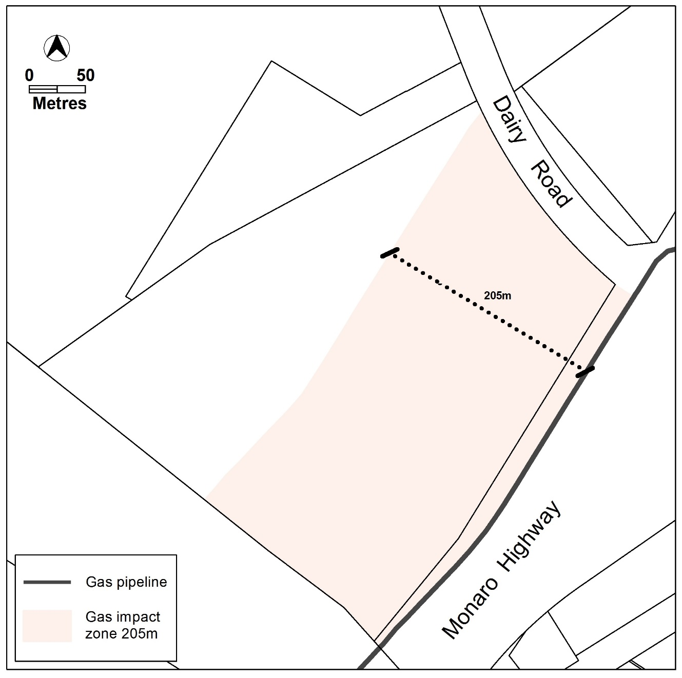
Figure 2 Gas pipeline impact area

Interpretation service
