Australian Capital Territory

Nature Conservation (Perunga Grasshopper) Conservation Advice 2020

Notifiable instrument NI2020–567
made under the
Nature Conservation Act 2014, s 90C (Conservation advice)

1 Name of instrument
This instrument is the Nature Conservation (Perunga Grasshopper) Conservation Advice 2020.

2 Commencement
This instrument commences on the day after its notification day.

3 Conservation advice for Perguna Grasshopper
Schedule 1 sets out the conservation advice for Perunga Grasshopper (Perunga ochracea).

Arthur Georges
Chair, Scientific Committee
4 September 2020
Schedule 1
(see s 3)

Conservation Advice
Perunga grasshopper – Perunga ochracea

Conservation Status
The Perunga Grasshopper Perunga ochracea Sjöstedt, 1921, is recognised as threatened in the following jurisdictions:
ACT Endangered, Nature Conservation Act 2014

ELIGIBILITY
The factors that make the Perunga Grasshopper eligible for listing as Endangered in the ACT Threatened Native Species List are included in the Listing Background section below.

DESCRIPTION AND ECOLOGY
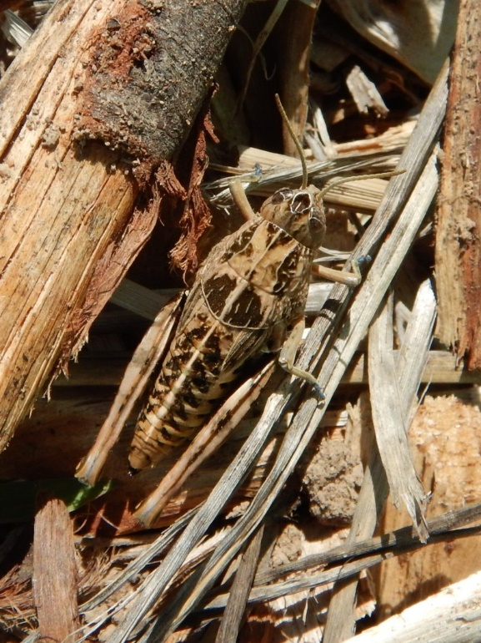
The Perunga Grasshopper is a small, flightless acridid grasshopper, characterised by a whitish dorsal streak extending from the keeled pronotum to the tip of the abdomen and a broad pale ‘X’ on the pronotum (Rentz et al. 2003). Adult females range in length from 26–35 mm and adult males from 15–20 mm. A range of colours is possible in adults, with colour morphs ranging between tan, grey-brown, or dull to bright green. The proportion of each colour morph can vary from year to year with a tendency toward grey-brown in dry years and greenish in wet years (R Lewis pers. comm. in ACT Government 1999).
There is little information on the diet of the Perunga Grasshopper. Other grasshoppers in the same subfamily (Catantopinae) have a mixed diet of grasses and forbs, with preference for forbs, while other subfamilies on a similar diet show a preference for grasses. The species has a suspected dietary relationship with native forbs (pers. comm. B. Howland), notably Chrysocephalum spp. (Rentz 1996). The Perunga Grasshopper appears to prefer grasslands composed of native species (ACT Government 2017a). The only other member of the genus, Perunga sp. 1, feeds widely, including upon Capeweed (Arctotheca calendula), Wild Geranium (Erodium spp.) and Common Everlasting (Chrysocephalum apiculatum) (P. Birks pers. comm. in ACT Government 1999).

  - Perunga Grasshopper (Cath Busby – Canberra Nature Map)
Although no work has been undertaken to identify predators of the Perunga Grasshopper, parasitic wasps, Scelio spp. in south-eastern Australia have been shown to regulate some populations of other acridid grasshoppers (Baker et al. 1996). Other predators of the Perunga Grasshopper may include birds and the local Wolf Spiders (specifically, Lycosa godeffroyi), which are known to eat other large ACT grassland grasshoppers (A. Rowell, pers. obs.).
The Perunga Grasshopper has a life cycle of one year, although, unusually for an ACT grasshopper species, it overwinters as nymphs rather than as eggs. Adults have been recorded between late October and mid-February (Australian National Insect Collection (ANIC) specimens). Very few nymphs have been recorded, so little is known about their appearance, behaviour, or habitat requirements compared to those of the adult.

Distribution and Habitat
The observed range of the Perunga Grasshopper stretches 180 km east–west and 150 km north–south and includes Murrumbateman, Gundaroo, the ACT and Bungendore. The actual area occupied within much of this range is likely to be low because habitat alteration and fragmentation have reduced or destroyed populations. The full extent of the range of the Perunga Grasshopper is unknown. This is, in part, due to a lack of current data. Previous ACT Government work (ACT Government 1999, ACT Government 2017a) indicates populations in Gungahlin (Mulanggari, Gungaderra, Crace, Mulligans Flat and Goorooyaroo nature reserves), Lower Molonglo Nature Reserve, Red Hill Nature Reserve, Murrumbidgee River Corridor), the Majura Valley, Lawson Grasslands, and near the junction of the Gudgenby and Naas rivers. Former collection sites in Reid, Calwell, Gordon,O’Malley and Weetangera have since been developed for housing (ACT Government 2017a). In addition to the limited available site location data, the grasshopper is difficult to see unless first disturbed. When disturbed, the adult appears to actively seek shelter, jumping once or twice before burying itself into a grass tussock. It is a powerful jumper, covering distances of a metre or more (Rentz 2003).
The Perunga Grasshopper is found in areas of Critically Endangered Natural Temperate Grassland (Stephens 1998) with some ACT Government collection records suggesting that the species sometimes occurs in open woodland areas with a grassy understorey, including the Critically Endangered Yellow Box–Blakley’s Red Gum Grassy Woodland community.
The reliance on these grasslands is likely to be for both food and shelter. Field observations suggest that the Perunga Grasshopper uses grass tussocks as shelter spaces, although the species has been recorded in heavily grazed habitats, where the availability of dense grass tussocks was low (Stephens 1998, ACT Government 2013). Stephens (1998) reported that in these latter instances they were found in or near grass tussocks, suggesting a dependence on tussocks for habitat.

Threats
The Perunga Grasshopper is known only from areas of Natural Temperate Grassland, a Critically Endangered ecological community under the Nature Conservation Act 2014 (NC Act). The main threats provided in the ACT Action Plan for the species (ACT Government 2017a) include:
- habitat loss of Natural Temperate Grassland
- habitat degradation of native plant species through inappropriate management strategies that reduce grassland structure or allow colonisation of native grasslands by exotic plant species
- habitat fragmentation compounded by the flightless nature of adults that restricts movement between fragments and recolonisation
- inappropriate large-scale autumn/winter fire regimes that may endanger nymphs
- climate change effects combined with the species’ limited mobility makes it less able to adapt by moving to accommodate habitat change.

Major Conservation Objective
The overall conservation objective of the Action Plan for this species (ACT Government 2017) is to maintain in the long term, viable, wild populations of the Perunga Grasshopper as a component of the indigenous biological resources of the ACT and region.

Conservation Priorities
The long-term conservation of the Perunga Grasshopper depends on protecting its native grassland and grassy woodland habitat. Conservation priorities include to:
- conserve important ACT populations
- manage the species and its habitat to preserve sufficient genetic diversity to promote population resilience in the wild, particularly through mowing or grazing, removal of weeds, patch burning and creation of a diverse habitat structure
- enhance the long-term viability of populations through management of adjacent grassland to increase habitat area and connect populations
- provide offset areas, with management plans, for areas subject to urban development
- continue extensive survey, monitoring and research
- understand the habitat requirements of the species (in terms of food plants, and required vegetation structure)
- collaborate with research institutions and non-government organisations and encourage citizen science and volunteers to increase knowledge of the species, its distribution, population status, biology and habitat needs.

Other Relevant Advice, plans or Prescriptions
- ACT Action Plan – Perunga Grasshopper (ACT Government 2017a)
- ACT Native Grassland Conservation Strategy (ACT Government 2017b)

Listing Background
The Perunga Grasshopper was listed in the ACT as a Vulnerable species on 30 May 1997 in accordance with section 21 of the Nature Conservation Act 1980. At that time, the Flora and Fauna Committee (now the Scientific Committee) concluded that the assessment satisfied the following criterion:
2.2 Species is observed, estimated, inferred or suspected to be at risk of premature extinction in the ACT region in the medium-term future, as demonstrated by the following:
2.2.1 Current serious decline in distribution, from evidence based on:
2.2.1.1 direct observation, including comparison of historical and current records
2.2.1.3 a serious decline in quality and quantity of habitat
2.2.4 Seriously fragmented distribution for a species currently occurring over a moderately small range or having a moderately small area of occupancy within its range.
The Flora and Fauna Committee assessed that this species met the above criteria for listing as Vulnerable for the following reasons:
- the Perunga Grasshopper was fairly common in specific areas in the ACT until the late 1970s, when some of these areas were lost to urban development
- there was a serious decline in the quality and quantity of the habitat of the species throughout its range, including the ACT, and the area of occupancy is probably now extremely small
- destruction and alteration of habitat seriously fragmented the species' distribution, therefore, resulting in little possibility of recolonisation after local extinctions due to the flightless nature of adults.

References
ACT Government 1997. Natural Temperate Grassland: An endangered ecological community. Action Plan No. 1. Environment ACT, Canberra.
ACT Government 1999. Perunga Grasshopper (Perunga ochracea): A vulnerable species. Action Plan No. 21. Environment ACT, Canberra.
ACT Government 2017a. Action Plan Perunga Grasshopper Perunga ochracea. Environment, Planning and Sustainable Development Directorate, Canberra.
ACT Government 2017b. ACT Native Grassland Conservation Strategy and Action Plans. Environment, Planning and Sustainable Development Directorate, Canberra.
Baker GL, Dysart RJ and Pigott RG 1996. Parasitism of grasshopper and locust eggs (Orthoptera: Acrididae) by Scelio species (Hymenoptera: Scelionidae) in southern Australia. Australian Journal of Zoology 44: 427–43.
Rentz DCF 1996. Grasshopper country: the abundant orthopteroid insects of Australia. University of NSW Press, Sydney.
Rentz DCF, Lewis RC, Su YN and Upton MS (eds) 2003. A Guide to Australian Grasshoppers and Locusts. Natural History Publications, Borneo.
Rowell A 2015. The vulnerable Perunga Grasshopper at Canberra Airport, 2003 to 2014. Report to Canberra Airport, Canberra.
Stephens CJ 1998. Grasshopper (Orthoptera: Acrididae) assemblages in natural temperate grasslands of differing native plant diversities. Honours thesis. Department of Botany & Zoology, Australian National University, Canberra.

Further Information
Further information on the related Action Plan or other threatened species and ecological communities can be obtained from: Environment, Planning and Sustainable Development Directorate (EPSDD).
Phone: (02) 132281, EPSDD Website: http://www.environment.act.gov.au/cpr

