Australian Capital Territory
Planning and Development (Draft Variation No 374) Consultation Notice 2020
Notifiable instrument NI2020—583
made under the
Planning and Development Act 2007, s 63 (Public consultation—notification)

- Name of instrument
This instrument is the Planning and Development (Draft Variation No 374) Consultation Notice 2020.

- Draft variation to the Territory Plan
The planning and land authority (the Authority) has prepared a draft plan variation No 374 – Kaleen Indoor Sports Club (the draft variation) to vary the Territory Plan. The draft variation will rezone Kaleen section 89 block 4 from Parks and Recreation PRZ2 – Restricted Access Recreation (PRZ2) to Commercial CZ5 - Mixed Use (CZ5) to allow for the introduction of medium density residential development on the site.
The Kaleen Precinct Map and Code will be amended to allow the club to continue to operate in a CZ5 zone and to make sure indoor sporting facilities are retained on this site into the future.

- Documents available for public inspection
(1) The Authority gives notice that the following documents are available for public inspection and purchase:
(a) the draft variation; and
(b) the background papers relating to the draft variation.
(2) Copies of the documents mentioned in section 3 (1) are available for inspection and purchase at Access Canberra Shopfront, Dickson, Monday to Friday (except public holidays) between 9:00am and 4:00pm for the period commencing on the day this notice commences and ending on 23 October 2020 (the consultation period).
(3) Copies of the documents mentioned in section 3 (1) are also available for inspection during the consultation period online at
https://www.act.gov.au/draftvariations

- Invitation to give written comments
(1) The Authority invites written comments about the draft variation during the consultation period. Comments should include reference to the draft variation and be addressed to the Territory Plan Section of the Environment, Planning and Sustainable Development Directorate (EPSDD). Please also provide your name and contact details to assist in the assessment of the comments provided and to enable the Authority to contact you in relation to your comments, if required.
(2) Written comments should be provided to the Authority by:
(a) email to terrplan@act.gov.au; or
(b) mail to Territory Plan Section, EPSDD, GPO Box 158, Canberra, ACT 2601; or
(c) hand delivery to Access Canberra Shopfront, Dickson.
Note All personal information will be managed in accordance with the Information Privacy Act 2014 and the EPSDD Information Privacy Policy which are available through the EPSDD website.

- Public inspection of written comments
(1) Copies of written comments about the draft variation given in response to the invitation in section 5, or otherwise, or received from the National Capital Authority will be available (unless exempted) for public inspection for a period of at least 15 working days starting 10 working days after the day the consultation period ends, at Access Canberra Shopfront, Dickson, Monday to Friday (except public holidays) between 9:00am and 4:00pm and may be published on the EPSDD website at www.planning.act.gov.au.
(2) You may apply under section 411 of the Planning and Development Act 2007 (the Act) for part of your consultation comments to be excluded from being made available to the public. A request for exclusion under this section must be in writing, clearly identifying what you are seeking to exclude and how the request satisfies the exclusion criteria. Please note that your name and contact details and other personal information will not be made public unless you request otherwise.

- Effect of the draft variation
Section 65 of the Act does not apply in relation to the draft variation and therefore it does not have interim effect as a result of notification of this instrument. Where a draft variation does not have interim effect, the current Territory Plan will continue to apply.
- Obtaining further information
Further information about the draft variation can be obtained through email correspondence with the Territory Plan Section, EPSDD, at terrplan@act.gov.au. A reference to the draft variation should be included in any email.

- Dictionary
In this instrument:
draft plan variation No 374 – Kaleen Sports Club means the draft plan variation in the schedule.

Lesley Cameron
Delegate of the planning and land authority
8 September 2020

Planning and Development Act 2007

Draft
Variation to the
Territory Plan
374

Kaleen Indoor Sports Club
Kaleen section 89 block 4
Zone change and amendments to the Kaleen Precinct Map and Code

September 2020

Draft variation for public consultation prepared
under s60 of the Planning and Development Act 2007

This page is intentionally blank.

Contents

1. INTRODUCTION 1
1.1 Summary of the Proposal 1
1.2 Outline of the process 1
1.3 This document 3
1.4 Public Consultation 3
2. EXPLANATORY STATEMENT 5
2.1 Background 5
2.2 Site Description 5
2.3 Current Territory Plan Provisions 7
2.4 Proposed Changes 8
2.4.1 Proposed Changes to the Territory Plan Map 8
2.4.2 Proposed Changes to Territory Plan 8
2.4.3 Minor correction to Territory Plan 8
Reasons for the Proposed Draft Variation 9
2.5 Planning Context 9
2.5.1 National Capital Plan 9
2.5.2 ACT Planning Framework 10
2.6 Interim Effect 11
2.7 Consultation with Government Agencies 11
3. DRAFT VARIATION 15
3.1 Variation to the Territory Plan 15

This page is intentionally blank.

- INTRODUCTION
  - Summary of the Proposal
The draft variation proposes to rezone Kaleen section 89 block 4 from Parks and Recreation PRZ2 Restricted Access Recreation (PRZ2) zone to Commercial CZ5 Mixed Use (CZ5) zone to enable residential development on the site.
The Kaleen Precinct Map and Code will be amended to allow the existing licenced club to continue to operate in the proposed CZ5 zone and to enable indoor recreational facilities to be retained on this site into the future.

  - Outline of the process
The Commonwealth’s Australian Capital Territory (Planning and Land Management) Act 1988 allows for the Legislative Assembly to make laws to establish a Territory Planning Authority and for that Authority to prepare and administer a Territory Plan. The Planning and Development Act 2007 (the Act) establishes the planning and land authority as the Authority that prepares and administers the Territory Plan, including continually reviewing and proposing amendments as necessary. The functions of the planning and land authority are administered by the Environment, Planning and Sustainable Development Directorate (EPSDD). The Director-General of EPSDD is the planning and land authority.
The Territory Plan is comprised of a written statement and a map. The written statement contains a number of parts, namely governance; strategic directions; zones (including objectives and development tables and zone or centre development codes); precinct codes; general codes; overlays; definitions; structure plans, concept plans and development codes for future urban areas.
The Territory Plan Map graphically represents the applicable land use zones (under the categories of residential, commercial, industrial, community facility, urban parks and recreation, transport and services and nonurban), precincts and overlays. The zone, precinct and overlay requirements are detailed in the Territory Plan.
Draft variations to the Territory Plan are prepared in accordance with the Act. Following the release of the draft variation under section 63 of the Act, submissions from the public are invited. At the conclusion of the consultation period the EPSDD (planning and land authority) submits a report on consultation and a recommended final variation to the Minister responsible for planning for referral to the Legislative Assembly standing committee responsible for planning. The Minister must consider the findings of the committee before deciding whether to approve the draft variation. If the Minister approves the variation, the variation and associated documents will be tabled in the Legislative Assembly. Unless disallowed by the Legislative Assembly within five sitting days, the variation commences on a day nominated by the Minister.

  - This document
This document contains the background information in relation to the proposed variation. It comprises the following parts:
Part 1 This Introduction
Part 2 An Explanatory Statement, which gives reasons for the proposed variation and describes its effect
Part 3 The Draft Variation, which details the precise changes to the Territory Plan that are proposed
  - Public Consultation
Written comments about the draft variation are invited from the public by 23 October 2020.
Comments should include reference to the draft variation and be addressed to the Territory Plan Section, EPSDD. Please also provide your name and contact details to assist in the assessment of the comments provided, and to enable EPSDD to contact you in relation to your comments, if required. Your personal information will be managed in accordance with the Information Privacy Act 2014 and the EPSDD Information Privacy Policy, which is available for viewing on EPSDD’s website.
Comments can be:
- emailed to terrplan@act.gov.au
- mailed to Territory Plan Section, GPO Box 158, Canberra, ACT 2601
- delivered to the Access Canberra Customer Service Centre at 480 Northbourne Ave, Dickson
Copies of written comments received with respect to the draft variation will be made available for public inspection for no less than 15 working days starting 10 working days after the closing date for comment. The comments will be available at the Access Canberra customer service centre in Dickson and may be published on EPSDD’s website. Comments made available will not include personal contact details unless you request otherwise.
A request may be made for parts of a submission to be excluded under section 411 or 412 of the Planning and Development Act 2007. A request for exclusion under these sections must be in writing, clearly identifying what parts of your submission you are seeking to exclude and how the request satisfies the exclusion criteria.

Further Information
The draft variation and background document are available online at www.act.gov.au/draftvariations until the closing date for written comments.
Printed copies of the draft variation (this document) and background document are available for inspection and purchase at the Access Canberra Customer Service Centre, 480 Northbourne Ave, Dickson, Monday to Friday (except public holidays) between 9:00am and 4:00pm. Please call 6207 1923 to arrange a copy for purchase.

- EXPLANATORY STATEMENT
  - Background
An existing indoor sports facility and licensed club operate at Kaleen section 89 block 4. The building, which contains a gym, including a boxing gym and courts for indoor soccer, netball, cricket, volleyball and dodgeball is nearing the end of its useful life and is in need of redevelopment to continue to meet the needs of the community.
The draft variation would allow the redevelopment of the indoor sports facility and club and the introduction of residential development.
The current Parks and Recreation PRZ2 Restricted Access Recreation zone does not allow for residential use. It is proposed to rezone the site to Commercial CZ5 Mixed Use, which allows recreational, commercial and residential uses.
The CZ5 zoning does not allow a club, therefore it is proposed to introduce controls into the Kaleen Precinct Map and Code to allow a commercial licenced club to operate. In addition, the Kaleen Precinct Map and Code will introduce controls that restrict building heights, introduce site specific setbacks, respond to potential noise and contamination issues and require indoor sports facilities to be provided into the future.
  - Site Description
The subject site at Kaleen section 89 block 4 is within the District of Belconnen.
The site is accessed from Georgina Crescent, Kaleen, and is located directly opposite the car park which services the Kaleen group centre. The site is rectangular in shape, and slopes to the south and south west with a fall of about 6 metres. It is approximately 7,575 square metres in size and is currently zoned PRZ2 Restricted Access Recreation.
The block is bounded by the St Mark Coptic Orthodox Church on Community Facility zoned land to the north, a walkway and stormwater channel on PRZ1 Urban Open Space zoned land to the west, single residential blocks on RZ2 Suburban Core zoned land to the south and the Kaleen group centre on Commercial CZ1 Core zoned land to the east.
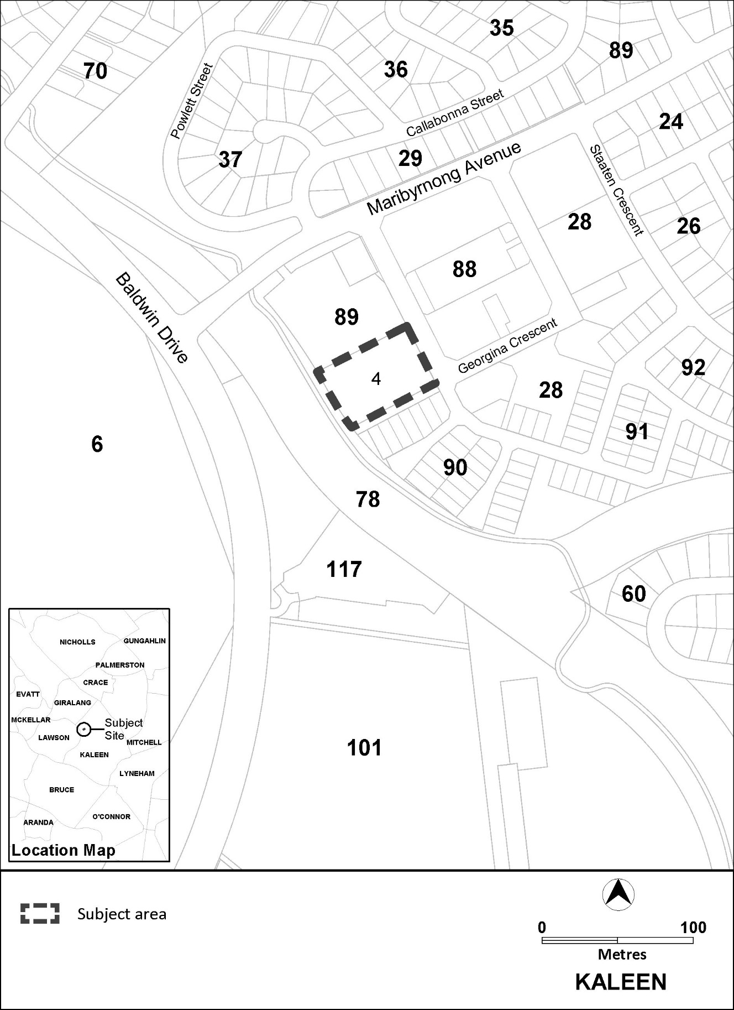
Figure 1: Location map

  - Current Territory Plan Provisions
The Territory Plan map for the area subject to this variation is shown in Figure 2. The subject site is currently zoned Parks and Recreation PRZ2 Restricted Access Recreation.
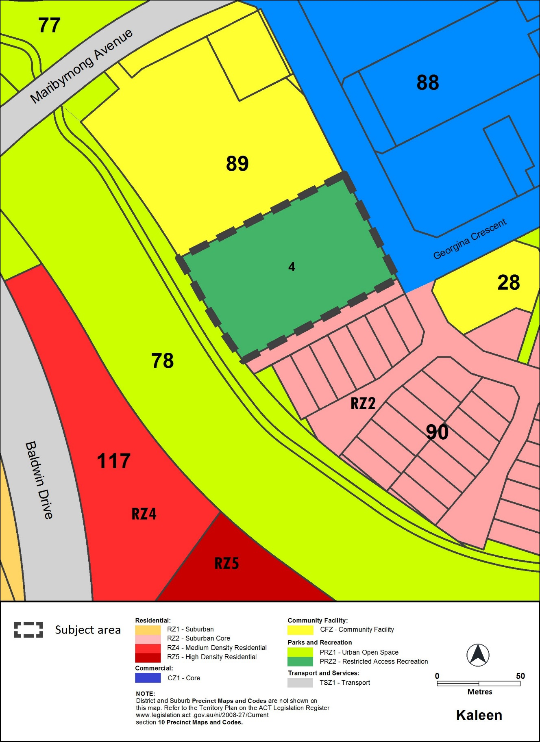 Figure 2: Territory Plan Zones Map
  - Proposed Changes
    - Proposed Changes to the Territory Plan Map
The proposed change to the Territory Plan map is indicated at Part 3 of this document and is detailed as follows:
- Rezone the block from Parks and Recreation PRZ2 Restricted Access Recreation zone to Commercial CZ5 Mixed Use zone
    - Proposed Changes to Territory Plan
It is proposed to amend the Kaleen Precinct Map and Code by introducing:
- ‘club’ as an additional merit track development
- a provision to guarantee an indoor recreation facility of 1,400m² is retained into the future
- provisions requiring:
  - a noise management plan
  - an environmental assessment consistent with the ACT Contaminated Sites Environment Protection Policy for endorsement by the Environment Protection Authority
- maximum building height limits of:
  - 2 storeys and 8.5 metres for 15 metres into the site along Georgina Crescent and the southern boundary
  - 4 storeys and 15.5 metres for the remainder of the site
- boundary setback controls:
  - 6 metres at the front of the site along Georgina Crescent
  - 3 metres to other site boundaries
    - Minor correction to Territory Plan
It is proposed to amend the Kaleen Precinct Map and Code by:
- deleting unnecessary text ‘C3’ from the Kaleen precinct code under 3.1 building height criteria column, which is not required as the corresponding rule R5 is a mandatory requirement

Reasons for the Proposed Draft Variation
The reasons for the draft variation are as follows:
- the site:
  - is appropriate for the range of uses proposed
  - is well located and close to existing services in the Kaleen group centre
  - has good access to public transport and active travel linkages
- supports housing diversity and choice within the existing urban footprint by introducing medium density residential development in close proximity to the Kaleen group centre and within the existing urban footprint
- enables the existing indoor recreation facility and club to be redeveloped and upgraded, enhancing the longevity and financial viability of the sports club into the future
- supports the continued viability of the Kaleen group centre
- building height and setback requirements address interface, bulk, scale and solar access to the existing neighbouring residential development to the south and the retail centre to the east

  - Planning Context
    - National Capital Plan
The Australian Capital Territory (Planning and Land Management) Act 1988 established the National Capital Authority (NCA) with two of its functions being to prepare and administer a National Capital Plan (NCP) and to keep the NCP under constant review and to propose amendments to it when necessary.
The NCP, which was published in the Commonwealth Gazette on 21 January 1990 is required to ensure that Canberra and the Territory are planned and developed in accordance with their national significance. The Planning and Land Management Act 1988 also requires that the Territory Plan is not inconsistent with the NCP.

    - ACT Planning Framework
Statement of Strategic Directions
The Statement of Strategic Directions sets out the principles for giving effect to the main objective of the Territory Plan as required by the Planning and Development Act 2007. The proposal is consistent with the Territory Plan’s statement of strategic directions in terms of environmental, economic and social sustainability and spatial planning and urban design principles.
1.18A Development is planned to promote active living through the following six principles:
a) providing connectivity between uses and activity nodes
b) preserving open space
c) encouraging mixed land use and density
d) ensuring public places are safe and attractive for all
e) providing supportive infrastructure that encourages regular physical activity
f) ensuring environments promote social inclusion, and are equitable and where practicable are accessible by all.

Redeveloping the indoor recreation facility and club and introducing residential development on the site addresses principles c) and e) by encouraging mixed land use and density and providing a facility that encourages regular physical activity.
2.5 A wide range of housing types will be permitted in identified residential areas close to commercial centres and some major transport routes to increase choice; maximise opportunities for affordable housing; and secure some intensification of development consistent with maintaining residential amenity. Outside of these areas, planning policies will protect the typically low density, garden city character of Canberra’s suburban areas.
The proposal will provide additional residential development and diversify housing choices when compared to the neighbouring, predominantly single residential housing development in the RZ2 Suburban Core zone, consistent with the above principle. Allowing housing intensification in this area also supports the above principle because it is close to the Kaleen group centre, which is serviced by public transport and will encourage active travel, increase the viability of the centre and maintain the housing amenity of surrounding areas.

ACT Planning Strategy 2018
The introduction of medium density housing close to Kaleen Group Centre is consistent with the ACT Planning Strategy 2018 in meeting the following principles:
  - Support sustainable urban growth by working towards delivering up to 70% of new housing within our existing urban footprint, and by concentrating development in areas located close to the city centre, town and group centres and along key transit corridors, and
4.4 Deliver housing that is diverse and affordable to support a liveable city.

  - Interim Effect
Section 65 of the Planning and Development Act 2007 does not apply in relation to the draft variation, so it does not have interim effect. The current Territory Plan will continue to apply while the variation remains in draft form.

  - Consultation with Government Agencies
The EPSDD is required to, in preparing a draft variation under section 61(b), consult with each of the following in relation to the proposed draft variation:
- the National Capital Authority
- the Conservator of Flora and Fauna
- the Environment Protection Authority
- the Heritage Council

National Capital Authority
The National Capital Authority (NCA) provided the following comments on 2 September 2020
Thank you for the referral for Draft Variation 374, Kaleen Indoor Sports Centre. The NCA has no objections to the proposed draft variation. The National Capital Plan (the Plan) identifies the site as ‘Urban Areas’ under the ‘General Policy Plan – Metropolitan Canberra’, and the proposed land use and variations are not inconsistent with the Plan.
Response
Noted
Conservator of Flora and Fauna
The Conservator of Flora and Fauna made the following comments on 3 September 2020

Thank you for the opportunity to comment on this Draft Variation.
There are no ecological concerns apparent for this variation therefore no comment.

Response
Noted

Environment Protection Authority
The EPA provided the following comments on 3 September 2020
Thank you for the opportunity to review and provide comments on the draft Territory Plan Variation DV374 to change the zoning of block 4 section 89 Kaleen (the Site) from PRZ2 Restricted Access Recreation (PRZ2) zone to Commercial CZ5 Mixed Use (CZ5) zone to allow for the introduction of residential development on the site. It is noted a provision is included to require an indoor recreation facility of 1,400m2 is retained on the site.
The Authority provides the following comments on Draft Variation 374.
Contamination
Comment
The Site has not been adequately assessed from a contamination perspective to determine if it is suitable for all the proposed uses.
The ACT Government's Strategic Plan Contaminated Sites Management, 1995 specifically requires that potentially contaminated land be investigated at the earliest stages of the planning process to ensure a site is suitable for the proposed development.
Advice
An environmental assessment of the Site in accordance with endorsed guidelines must be undertaken by a suitably qualified environmental consultant to determine whether past activities have impacted the Site from a contamination perspective and to determine if the Site is suitable for the proposed and permitted uses. This assessment must include a review of all prior contaminated land assessments undertaken at the Site.

The findings of the assessment and remedial works must be independently audited by an Authority approved contaminated land auditor and the findings of the audit into the suitability of the Site for its proposed uses endorsed by the Authority prior to the Territory Plan being varied.
This assessment must be conducted in accordance with the requirements of the ACT Government’s Contaminated Sites Environment Protection Policy December 2017 and associated guidelines to ensure that adverse impacts of contaminated land on the environment and human health are appropriately assessed and managed.
Noise
Comment
Indoor recreation facilities are associated with noise complaints when they are in close proximity to residential dwellings. The developer should be made aware the potential for noise compatibility issues and the requirements for acoustic assessment and a Noise Management Plan at the Development Application stage. To avoid impacts to activities conducted in the indoor recreation facility it is recommended careful consideration be given to the proximity and siting of the facility to residential dwellings.
Advice
The proposed TV variation will change the noise zone from the current zone E and zone F which will reduce the permitted noise level on the Site. Under Schedule 2 of the Environment Protection Regulation 2005, the current permitted noise levels are 50dB(A) /40dB(A) and the new permitted levels will be reduced by 5dB(A) at night time only to 35dB(A).
An acoustic assessment of noise impacts from the existing uses on the Site such as the indoor recreation facility, will need to be undertaken at the Development Application stage to determine if the Site is suitable for the proposed uses, especially residential. This assessment should be conducted in accordance with the January 2010 Noise Environment Protection Policy and the Guidelines for the preparation of Noise Management Plans for development applications to ensure that legislative requirements including the need to prevent or minimise environmental harm and to demonstrate how environmental noise pollution will be managed for the Site and any developments on the Site.
The factors to be considered when preparing the acoustic assessment include:
• that residential development must meet the ‘design sound level ranges’ recommended for residential buildings of AS/NZS 2107 and commercial accommodation developments should meet AS/NZS 2107 for sleeping areas; and
• noise from all permitted uses identified as being noisy, regardless of whether the noisy permitted use is utilised, must be attenuated at the building design stage or measures that allow the attenuation to be incorporated in the future should a permitted use be activated.

Response
Noted. The following responses are provided on the matters of contamination and noise.
Contamination:
A requirement for a contamination assessment has been inserted into the precinct code as a mandatory rule. The environmental assessment must be endorsed by the Environment Protection Authority prior to construction or a change in use.
Noise:
A requirement for a noise management plan has been inserted into the precinct code as a mandatory rule. A condition of development approval may be imposed at development application stage to ensure compliance with the endorsed noise management plan.

Heritage Council
The Heritage Council provided the following comments on 4 September 2020
On 1 September 2020, a draft Territory Plan Variation (DV374 – Kaleen Indoor Sports Centre) for Block 4 Section 89 Kaleen was referred to the ACT Heritage Council (the Council) for entity advice.
DV374 proposes to rezone the subject area from PRZ22 Restricted Access Recreation to CZ5 Mixed Use Development; to allow for the redevelopment of the existing Sports Club Kaleen.
The Council provided prior advice on 11 January 2018 which supported a draft Planning Report in relation to this proposal. This noted that the subject block does not contain any registered or recorded heritage places or objects, and that the proposed redevelopment of the block is unlikely to result in detrimental heritage impacts
In this context, the Council does not object to DV374, and does not identify any additional heritage assessment or management requirements.
Response
Noted
- DRAFT VARIATION
  - Variation to the Territory Plan
The Territory Plan is varied in all of the following ways:

Variation to the Territory Plan Map
Substitute

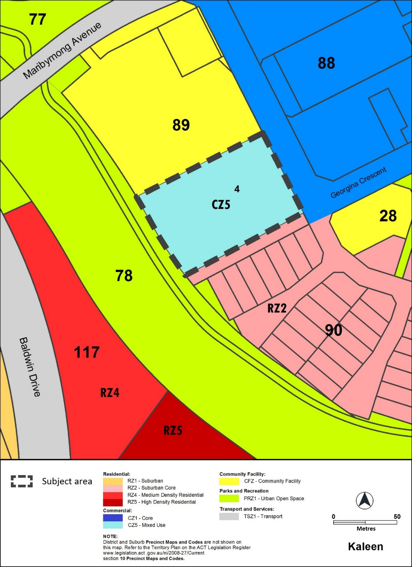

Variation to the Kaleen Precinct Map and Code
- Kaleen Precinct Map
Substitute
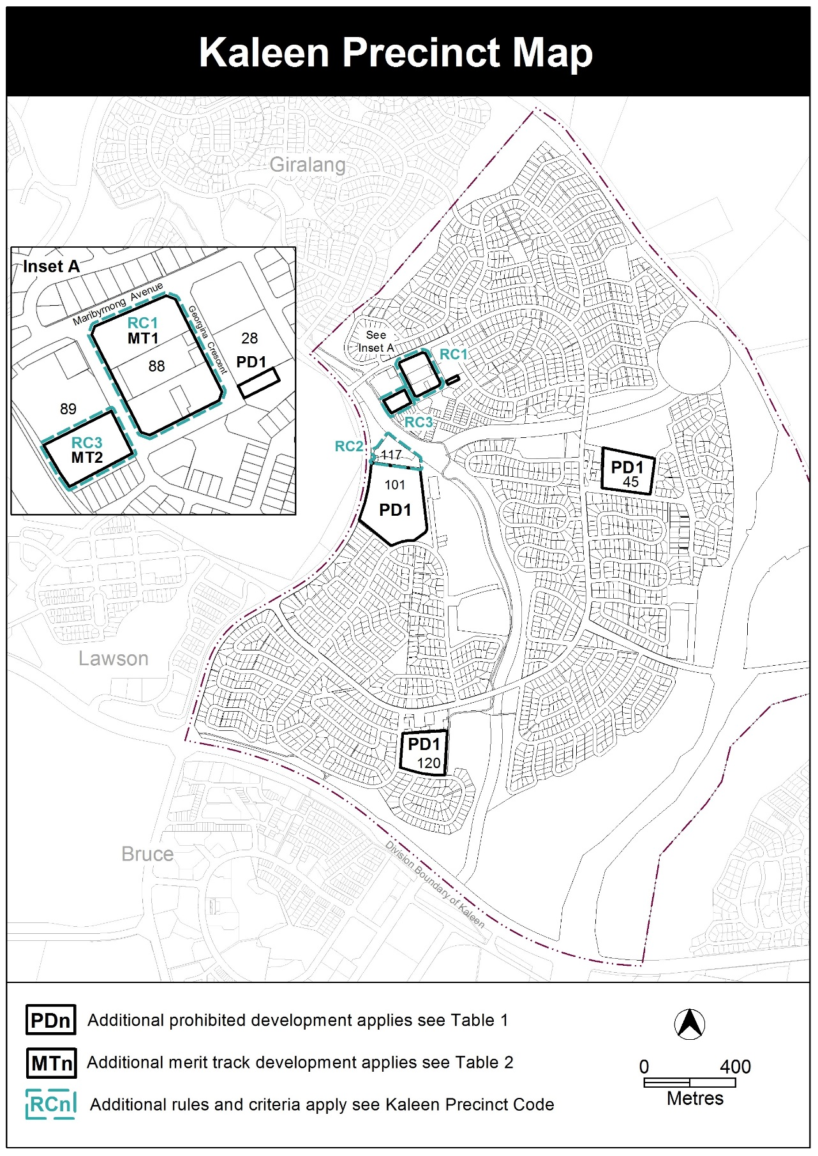
- Assessment Tracks, Table 2 – Additional merit track development, new item MT2
Insert
MT2 | CZ5 | club

- Additional rules and criteria, RC2 – RZ5 zone additional provisions, Element 3: Buildings, 3.1 Building height, Criterion C3
Delete
C3
- Kaleen Precinct Code; Additional rules and criteria
Insert After Rule R5

RC3 – CZ5 zone additional provisions
This part applies to any proposed development on the blocks and parcels identified in the area RC3 shown on the Kaleen Precinct Map.
Element 4: Use
Rules | Criteria
4.1 Indoor recreation facility
R6  The block identified in the area RC3 provides for an indoor recreation facility with a minimum gross floor area of 1400m² that is available for use by members of the public. The required 1400m² does not include a fitness centre or associated amenities. | This is a mandatory requirement. There is no applicable criterion.
4.2 Noise attenuation
R7  Development complies with a noise management plan prepared by a suitably qualified person and endorsed by the Environment Protection Authority (EPA).  The noise management plan will detail the proposed design, siting and construction methods that will be employed to ensure compliance with the Noise Zone Standard as detailed in the Environment Protection Regulation 2005, based on the estimated noise levels when the facility is in use.  Note: A condition of development approval may be imposed to ensure compliance with the endorsed noise management plan. | This is a mandatory requirement. There is no applicable criterion.
4.3 Contamination
R8  An environmental assessment into the site’s suitability from a contamination perspective must be undertaken in accordance with the ACT Contaminated Sites Environment Protection Policy and be endorsed by the Environment Protection Authority prior to construction or a change in use. This rule does not apply if the Environment Protection Authority has provided written advice that the site has been assessed for contamination to its satisfaction. | This is a mandatory requirement. There is no applicable criterion

Element 5: Building and site controls
Rules | Criteria
5.1 Building heights
R9  This rule applies to areas identified in Figure 3.  The maximum number of storeys and height of building identified in Figure 3 is:  - in area ‘A’ 2 storeys and 8.5m  - in area ‘B’ 4 storeys and 15.5m.  For this rule the building height excludes all of the following:  - roof top plant  - lift overruns  - antennas  - photovoltaic panels  - air conditioning units  - chimneys, flues and vents  Excluded items are setback from the building facade of the floor immediately below a minimum distance of 3 metres. | This is a mandatory requirement. There is no applicable criterion.
5.2 Setbacks
R10  Development is setback as identified in Figure 3 and complies with all of the following:  - setback to frontage along Georgina Crescent is a minimum of 6m  - all other boundary setbacks are 3m. | This is a mandatory requirement. There is no applicable criterion.

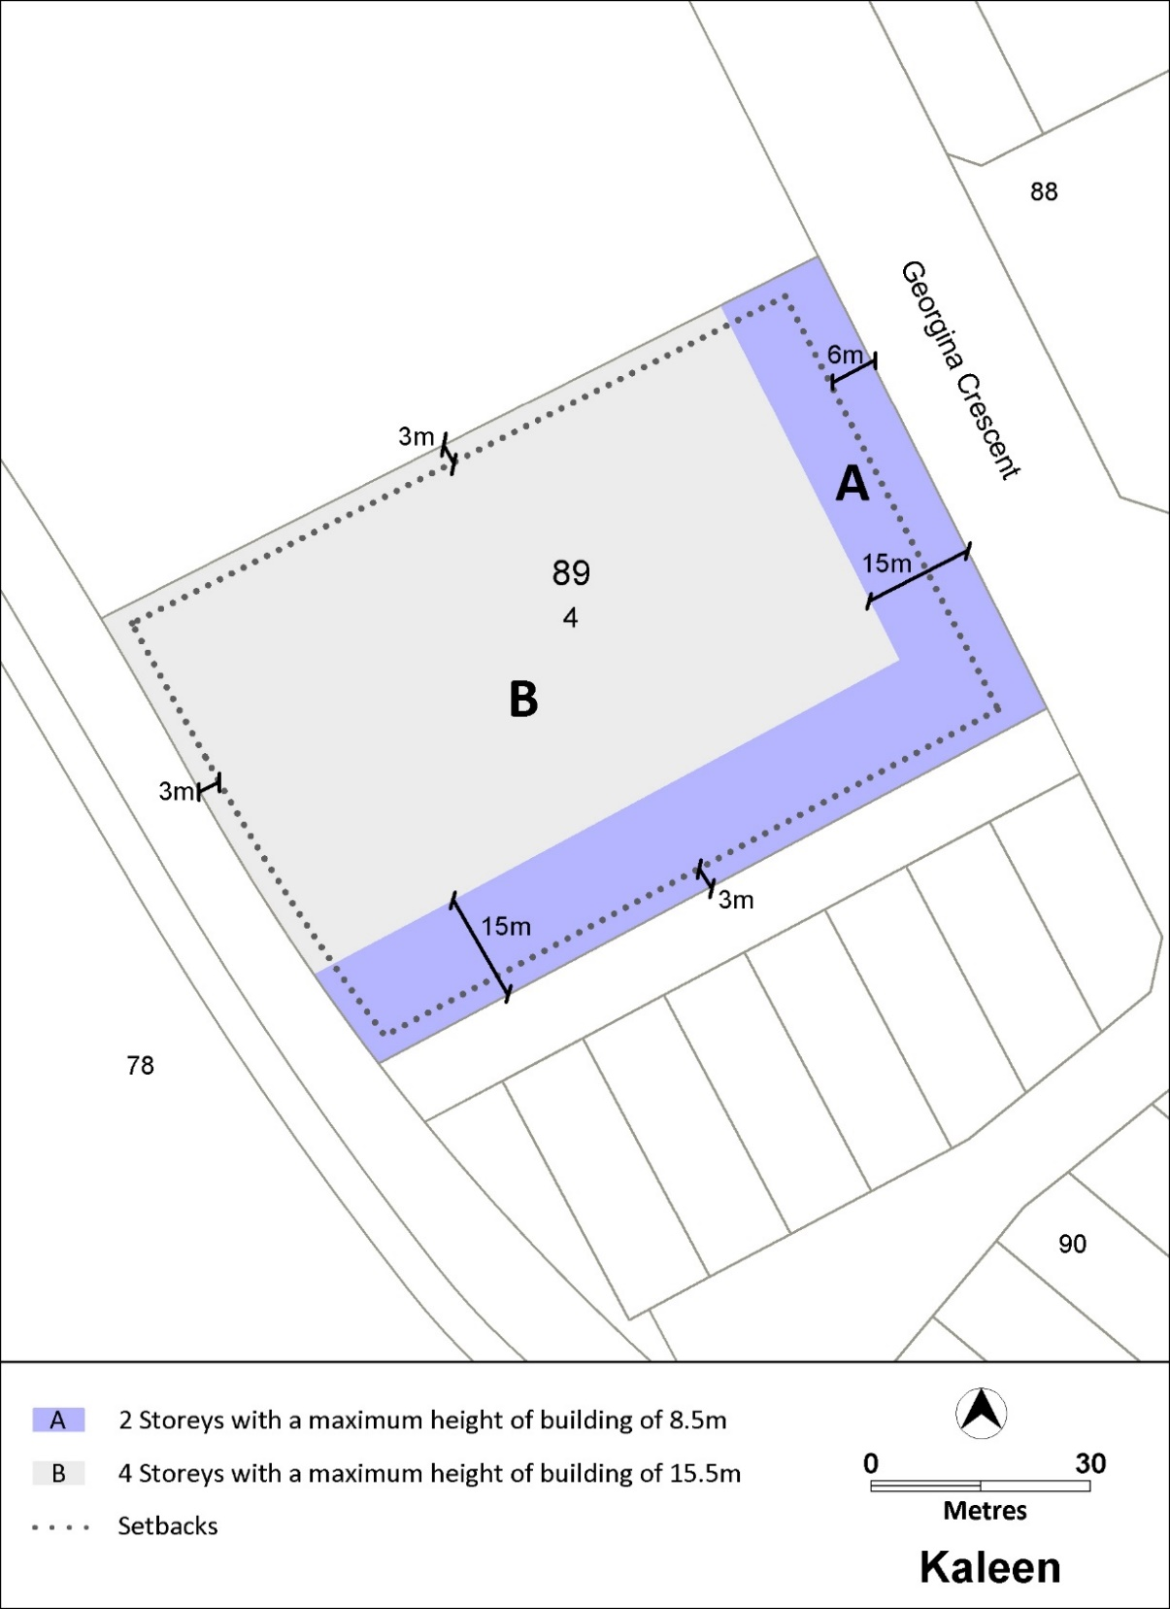
Figure 3: Building heights and boundary setbacks

Interpretation service
