Australian Capital Territory
Corrections Management (International Transfer of Prisoners) Policy 2020
Notifiable instrument NI2020-649
made under the
Corrections Management Act 2007, s14 (Corrections policies and operating procedures)

1 Name of instrument
This instrument is the Corrections Management (International Transfer of Prisoners) Policy 2020.

2 Commencement
This instrument commences on the day after its notification day.
3 Policy
I make this policy to facilitate the effective and efficient management of correctional services.

Jon Peach
Commissioner
ACT Corrective Services
28 September 2020

INTERNATIONAL TRANSFER OF PRISONERS
policy no. C18

Contents
ACT Corrective services
1 PURPOSE 4
2 SCOPE 4
3 DEFINITIONS 4
4 PRINCIPLES 4
5 Process for applications for transfer to Australia 6
6 Process for applications for transfer from Australia 6
7 Commonwealth Warrant to Transfer 7
8 Commonwealth Directions 7
9 Physical Transfer Arrangements 7
10 Escort Officers 8
11 Admission and Discharge 9
12 RELATED DOCUMENTS AND FORMS 9

PURPOSE
The purpose of the International Transfer of Prisoners (ITP) Scheme is to promote the successful rehabilitation and reintegration into the community of the detainee, while preserving the sentence imposed by the sentencing country as far as possible. The ITP Scheme contributes to community safety by ensuring that detainee convictions are recorded in their own country and their reintroduction into their own community is appropriately supported, monitored and supervised.

This policy provides instructions for the international transfer of prisoners to the ACT.

SCOPE
This policy applies to all correctional centres in the ACT.

Where required, the Deputy Commissioner Custodial Operations will establish operational
procedures under this policy.

DEFINITIONS
International Transfer of Prisoners
Refers to when a prisoner is transferred under the International Transfer of Prisoners Act
1997 (Cth) (ITP Act) and the International Transfer of Prisoners Scheme.
Escort Officer
Means the person appointed by the Deputy Commissioner Custodial Operations as
specified in the warrant authorising the transfer of the prisoner under the ITP Act to
conduct the physical escort.
Prisoner
Means a detainee who is serving a sentence of imprisonment and includes:
- a mentally impaired detainee; and
- a detainee who has been released on parole.

PRINCIPLES
  - Information on the International Transfer of Prisoner Scheme is provided to any detainee that informs ACT Corrective Services (ACTCS) that they are a foreign national and are from one of the participating countries (ITP statement policy and Participating Countries list).
  - Inquiries about International transfer are referred to the International Transfer of Prisoners Unit at the Australian Attorney-General’s Department using the following email address itp@ag.gov.au
  - The Australian Attorney-General’s Department manages applications and appropriate consents to transfer a prisoner.
  - Information and reports are provided as requested by the Australian
Attorney-General’s Department about the prisoner and registered victim related matters.
  - The Attorney-General provides a Commonwealth Warrant to transfer a prisoner and directions for sentence enforcement upon transfer.
  - ACTCS will coordinate the physical transfer once the Commonwealth Warrant for transfer is received.
  - Information on the process including application forms for the International Transfer of prisoner can be found at the Australian Attorney-General’s Department website.

Process for applications for transfer to Australia
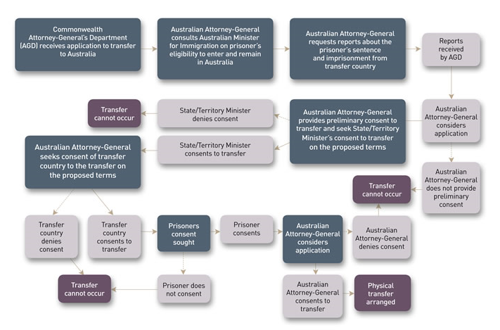

Process for applications for transfer from Australia
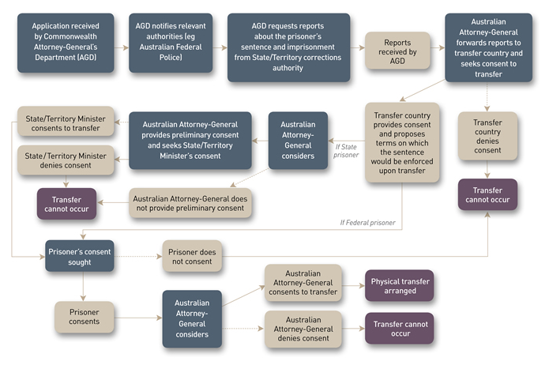

Commonwealth Warrant to Transfer
  - The Australian Attorney-General must provide a warrant for transfer (Form 8). The warrant authorises the transfer of the detainee to or from Australia to complete serving the sentence in accordance with the terms agreed in the ITP Act.
  - A warrant for transfer to or from Australia must:
- specify the name and date of birth of the prisoner to be transferred;
- specify the transfer country to which the prisoner is to be transferred;
- state that the following written consents to the transfer have been given:
  - consent from the prisoner or their representative; and
  - appropriate Ministerial consent.

Commonwealth Directions
  - The Attorney-General will make directions on how a sentence made by an international sentencing authority will be enforced upon the transfer of the prisoner to Australia.

Physical Transfer Arrangements
  - The Deputy Commissioner Custodial Operations will appoint an officer to coordinate the escort.
  - The appointed officer will:
- coordinate the physical transfer as per the International Escort package checklist (Annex A – International Escort Package);
- negotiate a transfer date and preferred flights with the transfer country;
- confirm the prisoner’s passport details including the passport number and expiry date;
- book and confirm flights, accommodation, transfers, and organise travel insurance. Group seating at the rear of the plane is to be confirmed with the airline;
- arrange for uplift approval from the airline;
- conduct a security risk assessment and draft an operational/ implementation plan. Liaison is to occur between ACTCS and the transfer country regarding the agreed operational/ implementation plan with consideration to prisoner alerts; and
- check the smart traveller website for alerts relevant to the transfer country.
  - Escort officers will complete a travel approval form and request travel allowances.
  - Ministerial approval is required for travel arrangements and costs.
  - The appointed officer will notify the following areas in writing:
- Intelligence and Integrity Unit;
- AFP Intelligence Unit;
- AFP Airport Operations;
- Canberra Airport group;
- International Transfer of Prisoners Unit;
- The Department of Home Affairs (Immigration);
- Consular Operations and Emergency Centre;
- JACS Security Advisor; and
- others as required.
  - The transfer country is to be advised of luggage restrictions and searching procedures.
  - A Surrender of Prisoner Form is to be completed on handover of the detainee. The Form must be signed by an escorting officer from both the receiving and transferring countries. The Form must be accompanied by the warrant to transfer.
  - A preliminary staff briefing is to be conducted six (6) weeks prior to the escort date and a final briefing in the days leading up to the escort date. A debrief with a focus on opportunities for improvement is to be conducted once the escort is complete.
  - The Senior Director, Sentence Management and the Senior Director, Programs and Reintegration, are to be advised of the sentence details and any information in relation to parole eligibility and release planning.

Escort Officers
  - The Deputy Commissioner Custodial Operations will determine the number of escort officers required and appoint escorting staff with consideration to risks.
  - Escorting staff will always carry identification and an agency mobile phone with international roaming activated during the escort.
  - Escort officers will attend scheduled briefings and debriefings.
  - Escort officers must be eligible to apply for an Australian Official passport for travel on government business. Official passports will be kept by ACTCS.
  - Escorting officers will not wear uniform on escort unless otherwise directed by the Deputy Commissioner Custodial Operations.

Admission and Discharge
  - An electronic file is to be created for the prisoner. Transfer documentation and any documents received from the transfer country are to be uploaded to the prisoner’s electronic record system.
  - The prisoner will be admitted into the correctional centre (Admissions Policy, Induction Policy).
  - If the prisoner is transferring out of Australia they must be discharged in accordance with the Discharge Policy.
  - The Director, Sentence Administration Section, is responsible for ensuring sentence information is verified and correctly recorded.

RELATED DOCUMENTS AND FORMS
- A – Escorts – Air Transport Operating Procedure
- B – Annex A – International Escort Package
- C – Form 8 Commonwealth Warrant to transfer to Australia
- D – Direction for Transfer
- E – Travel approval form
- F – Notice of proposed movement of a person in custody form
- G – Security Risk assessment
- H – Sponsored passport application

Jon Peach
Commissioner
ACT Corrective Services
28 September 2020

Document details
Criteria | Details
Document title: | Corrections Management (International Transfer of Prisoners) Policy 2020
Document owner/approver: | Commissioner, ACT Corrective Services
Date effective: | The day after the approval date
Review date: | Three years after the approval date
Compliance with law: | This policy reflects the requirements of the Corrections Management (Policy Framework) Policy 2020
Responsible officer: | Director, Sentence Administration Section

Version Control
Version no. | Date | Description | Author
V1 | May-20 | First Issued | J West

