Australian Capital Territory

Work Health and Safety (Office of the Work Health and Safety Commissioner) Strategic Plan 2020-2024*

Notifiable instrument NI2020-680
made under the
Work Health and Safety Act 2011, section 2.38 (Strategic Plan)

- Name of instrument
This instrument is the Work Health and Safety (Office of the Work Health and Safety Commissioner) Strategic Plan 2020-2024.

- Commencement
This instrument commences on the day after notification.

- Notification
I make the Strategic Plan 2020-2024 as set out in Schedule 1.

Jacqueline Agius
Work Health and Safety Commissioner
1 October 2020

Schedule 1: Strategic Plan 2020 - 2024

Strategic plan

2020 - 2024

Contents
WORK HEALTH AND SAFETY COMMISSIONER’S MESSAGE 5
WORKSAFE ACT 6
OVERVIEW 6
VISION AND VALUES 6
NATIONAL CONTEXT 7
OUR CONTEXT 8
STRATEGIES 9
STRATEGIC ENFORCEMENT PRIORITIES 10
CREATING AN EXEMPLARY REGULATOR 10
Performance criteria 11

WORK HEALTH AND SAFETY COMMISSIONER’S MESSAGE
On 30 April 2020, I was appointed by the Minister for Employment and Workplace Safety to the role of Work Health and Safety (WHS) Commissioner and became the Territory’s work health and safety regulator.
As the WHS Commissioner, I am required to act independently. I will be adopting a firm and consistent approach to compliance monitoring and enforcement, aligned with WorkSafe ACT’s Compliance and Enforcement Policy 2020 –- 2024. WorkSafe ACT’s compliance and enforcement activities will be evidence based and informed by consultation and engagement with key stakeholders, including industry and employee representatives.
This Strategic Plan sets-out the strategic focus areas for the regulator over the coming four years. Based on the Australian Work Health and Safety Strategy 2012-2022 (the Australian Strategy), WorkSafe ACT’s strategies underpinning our activities are:
- Ensuring fair and firm enforcement against non-compliance;
- Minimising physical and psychological harm and improving WHS practice and culture;
- Engaging with stakeholders to better understand and respond to current and emerging WHS issues; and
- Creating an exemplary regulator.
In setting the strategic priorities for WorkSafe ACT, I have sought input and feedback widely across government, industry, unions and non-government organisations to ensure we have adopted a balanced and appropriately focused approach. In addition, I have consulted with the Minister for Employment and Workplace Safety and the WHS Council. While WorkSafe ACT is accountable for achieving its outcomes, all stakeholders share responsibility for supporting the overall success of this Strategic Plan and in achieving improved outcomes for the Territory’s workers.
I am cognisant of the complexities facing our community across the Territory and Australia, particularly during 2020, and the impact these economic, environmental, physical and social challenges have had and will continue to have on our workplaces. While developed in a time of considerable change and in an environment in which it is difficult to anticipate the future, these strategic settings are intended to be durable and sufficiently high-level to remain appropriate until 2024.
Looking ahead over these coming four years, I am confident WorkSafe ACT will demonstrate its effectiveness in delivering against our vision through the achievement of the strategies described in this Strategic Plan.

Jacqueline Agius
Work Health and Safety Commissioner

WORKSAFE ACT

OVERVIEW
The Office of the WHS Commissioner, known as WorkSafe ACT consists of the WHS Commissioner and staff of the office. The functions of WorkSafe ACT are set out in the Work Health and Safety Act (2011) (WHS Act) and include promoting an understanding and acceptance of, and compliance with the WHS Act; and researching and developing educational and other programs for the purpose of promoting WHS. In addition, WorkSafe ACT is required to provide advice to the Minister on matters relevant to WHS and wellbeing.
The principle objective of the WHS Act is to provide for a balanced and nationally consistent framework to secure the health and safety of workers and workplaces. WorkSafe ACT is also responsible for ensuring compliance with other legislation including the Workers’ Compensation Act 1951 (ACT), Dangerous Substances Act 2004 (ACT) and Dangerous Goods (Road Transport Act) 2009 (ACT).
In 2018, the ACT Government engaged the Nous Group to undertake a review of the ACT’s work health and safety compliance and enforcement arrangements. The Independent review made 27 recommendations to enable WorkSafe ACT to be an effective and efficient WHS regulator in the future. The recommendations cover governance, capability, systems, and compliance and enforcement.
The commencement of the WHS Amendment Act on 30 April 2020 saw the introduction of the WHS Commissioner as the Regulator, and the Office of the Work Health and Safety Commissioner as an independent authority. The resulting governance structure has addressed a number of recommendations from the 2018 review.

VISION AND VALUES

WorkSafe ACT’s vision is aligned with the Australian WHS Strategy 2012-2022 (the Australian Strategy), with strategic priorities focussed on ensuring all workers in the Territory have healthy, safe and productive working lives, regardless of their status or employment arrangements.

NATIONAL CONTEXT
Australia has a highly diverse workforce, with over 12 million persons employed in a range of sectors. As of the beginning of 2019, the top five employing industries are health care and social assistance; retail trade; construction; professional, scientific and technical services; and education and training. This is a significant change from 30 years ago, when manufacturing was the largest employing industry.

Figure 1: Department of Education, Skills and Employment.
While there continue to be workplace injuries and fatalities, the overall picture of Australian work health and safety is positive and has improved over the ten years for which Safe Work Australia set national WHS targets. The Australian Work Health and Safety Strategy 2012-2022 aimed to reduce:
- worker fatalities by 20%;
- the incidence rate of claims resulting in one or more weeks off (serious injuries) by 30%; and
- the incidence rate of claims for musculoskeletal disorders resulting in one or more weeks off by 30%.
According to the 2017 review, Australia is on track to meet all of those targets.
Source: Safe Work Australia, ‘Midterm review of the Australian Work Health and Safety Strategy.’

OUR CONTEXT
The ACT’s workforce is significantly different to the national context, with several of the highest risk national industries not significantly represented in the ACT. For instance, there is less and lower-risk agriculture and manufacturing industry representation and no mining industry in the Territory. Further, the proportion of small to medium sized employers is greater than the national average.
Source: Worksafe Act, Workplace Work Health and Safety Visits, Notices issued and fines in 2019/20 FY
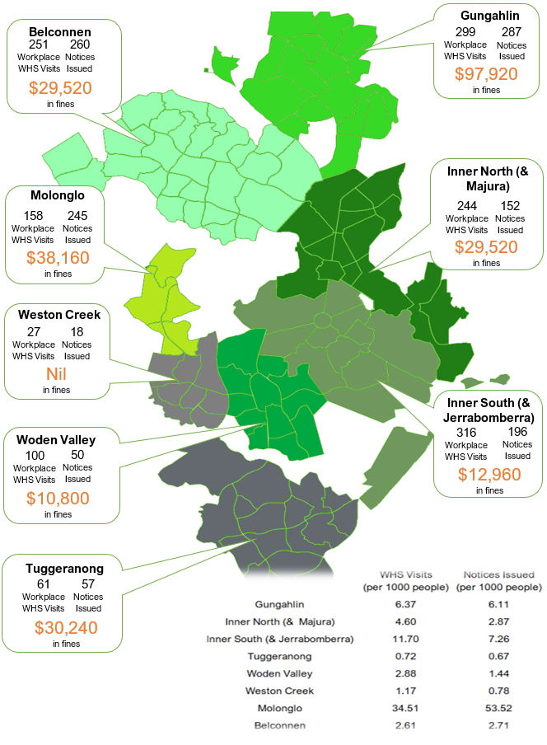
In 2019, the ACT employed 228,200 people, an increase of 7.8% since November 2013. This figure is projected to grow by a further 5.7% in the next three years to 2023. The top three largest employing sectors are: Public Administration and Safety; Health Care and Social Assistance; and Professional, Scientific and Technical Services. The ACT has the most highly educated workforce in Australia, with 77% of workers holding post-school qualifications.

WHO WE WORK WITH
Due to the nature of our role as an independent regulator of WHS, we have a wide range of stakeholders.

STRATEGIES
Within this context, over the 2020-2024 period WorkSafe ACT has four high-level strategies that will underpin our activities and help us achieve our outcomes, they are:
- Ensuring fair and firm enforcement against non-compliance;
- Minimising physical and psychological harm and improving WHS practice and culture;
- Engaging with stakeholders to better understand and respond to current and emerging WHS issues; and
- Creating an exemplary regulator.
The activities WorkSafe ACT will undertake each year to support these strategies are outlined in its Statement of Operational Intent, prepared annually in response to the Minister’s Statement of Expectations. These documents are notifiable instruments and are available on the WorkSafe Act website.

STRATEGIC ENFORCEMENT PRIORITIES
As described in WorkSafe ACT’s Compliance and Enforcement Policy 2020-2024, WorkSafe ACT uses a combination of inputs in determining its strategic enforcement priorities. This includes data analysis; emerging trends; community, industry and union consultation. WorkSafe ACT is guided by the Australian Strategy to frame our strategic enforcement priorities. To ensure we work collaboratively WorkSafe ACT also engages with other WHS regulators. Industries, mechanisms and substances that present a significant risk of injury or illness to workers are prioritised.

CREATING AN EXEMPLARY REGULATOR
Critical to the creation of an exemplary regulator is the implementation of fundamental change recommended in the 2018 Independent Review – these changes include regulatory and corporate governance reform; re-development and programmed review of standard operating procedures; development and implementation of an automated case management system; and organisational capability development.
The establishment of the Office of the WHS Commissioner as an independent statutory ACT Government authority requires it to meet a range of statutory obligations in regard to corporate governance, including risk and audit; financial management and annual reporting.
WorkSafe ACT is committed to a positive workplace culture through the active application of the principles of the Respect, Equity and Diversity Framework as well as the ACT Public Sector Employee Values and Signature Behaviours.

Performance criteria
WorkSafe ACT’s performance will be measured against the Accountability Indicators included in WorkSafe’s annual Budget Statements and in the WorkSafe ACT’s Annual Report. The Australian Strategy sets out three national targets to be achieved during the life of the Australian Strategy (ie 2012 to 2022).
WorkSafe ACT’s targets showing the jurisdiction’s performance against WHS outcomes align with the Australian Strategy targets and will be reviewed if these targets are changed:
- A reduction in the number of worker fatalities due to injury of at least 20%;
- A reduction in the incidence rate of claims resulting in one or more weeks off work of at least 30%; and
- A reduction in the incidence rate of claims for musculoskeletal disorders resulting in one or more weeks off work of at least 30%.
The performance of the ACT is reported in the Comparative Performance Monitoring Report produced by Safe Work Australia and published annually on its website.

Above n 1, p 13.
‘Australian Jobs 2019’, Australian Government Department of Education, Skills and Employment, 14 May 2019 https://docs.employment.gov.au/system/files/doc/other/australianjobs2019.pdf

