Australian Capital Territory
Planning and Development (Draft Variation No 377) Public Availability Notice 2020

Notifiable instrument NI2020—811
made under the
Planning and Development Act 2007, s 70 (Public notice of documents given to Minister) and s 71 (Public availability notice—notice of interim effect etc)

- Name of instrument
This instrument is the Planning and Development (Draft Variation No 377) Public Availability Notice 2020.
- Commencement
This instrument commences on the day after its notification day.
- Documents available for public inspection
  - The planning and land authority (the Authority) gives notice that the following documents are available for public inspection:
    - Draft Plan Variation to the Territory Plan No 377 (the draft variation);
    - the background papers relating to the draft variation;
    - a written report setting out the issues raised in any consultation comments about the draft variation;
    - a written report about the Authority’s consultation with the public, the National Capital Authority (NCA), the Conservator of Flora and Fauna, the Environment Protection Authority, the Heritage Council; and the land custodian – EPSDD Parks and Conservation Service; and
    - a copy of any written document given to the Minister by the NCA in relation to the draft variation.
Note The documents mentioned above:
(a) have been given to the Minister for approval under s 69 (2) of the Act; and
(b) can also be viewed online at: www.act.gov.au/recommendedvariations.
  - Printed copies of the documents mentioned in section 3 (1) are available for inspection at Access Canberra, Land, Planning and Building Services Shopfront, 8 Darling Street, Mitchell, Monday to Friday (except public holidays) for a period of 6 months ending on the day this instrument expires.
- Effect of the draft plan variation
Section 72 of the Planning and Development Act 2007 applies to the draft variation for the area shown in the below figure. This means that the Territory, the Executive, a Minister or a territory authority must not, during the defined period, do or approve the doing of anything that would be inconsistent with the Territory Plan if it were varied in accordance with the draft variation.
Note Defined period, for a draft variation—see the Planning and Development Act 2007, s 72 (3).
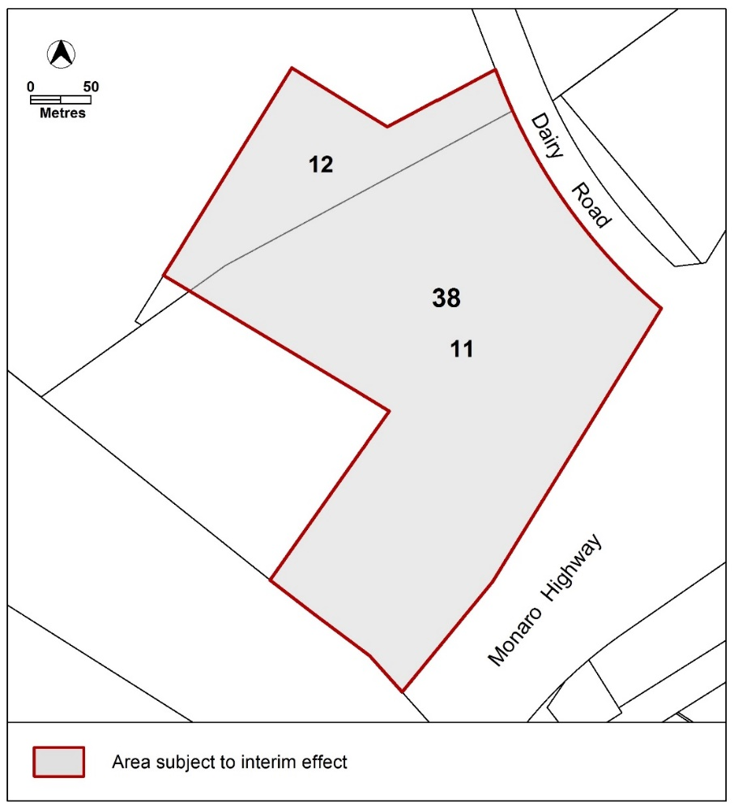
- Obtaining further information
Further information about the draft variation can be obtained through email correspondence with the Territory Plan Section of the Environment, Planning and Sustainable Development Directorate at Terrplan@act.gov.au. A reference to the draft variation should be included in any email.

Lesley Cameron
Delegate of the planning and land authority
18 December 2020

