Australian Capital Territory
Planning and Development (Technical Amendment—Strathnairn) Plan Variation 2020 (No 5)

Notifiable instrument NI2020—813
Technical Amendment No 2020-13
made under the
Planning and Development Act 2007, section 89 (Making technical amendments)

- Name of instrument
This instrument is the Planning and Development (Technical Amendment—Strathnairn) Plan Variation 2020 (No 5).
2 Commencement
This instrument commences on the day after its notification day.
3 Technical amendment
I am satisfied under section 89 (1) (a) of the Planning and Development Act 2007 (the Act) that the Strathnairn plan variation is a technical amendment to the Territory Plan.
4 Dictionary
In this instrument:
Strathnairn plan variation means the technical amendment to the Territory Plan, variation 2020-13, in the schedule.
Note: No consultation was required in relation to the Strathnairn plan variation under section 87 of the Act.
Lesley Cameron
Delegate of the planning and land authority
18 December 2020

Planning & Development Act 2007

Technical Amendment
to the Territory Plan
Variation 2020-13

Changes to the
Strathnairn Precinct Map and Code

December 2020

This page is left intentionally blank

Table of Contents

1. INTRODUCTION 1
1.1 Purpose 1
1.2 Public consultation 1
1.3 National Capital Authority 1
1.4 Process 1
1.5 Types of technical amendments under the Act 2
2. EXPLANATION 3
2.1 Background 3
2.2 Strathnairn Precinct Map and Code 3
3. TECHNICAL AMENDMENT 8
3.1 Strathnairn Precinct Map and Code 8

- INTRODUCTION
  - Purpose
This technical amendment makes the following changes to the Territory Plan:
Strathnairn Precinct Map and Code
- Replaces Figures 10 and 11.

  - Public consultation
Under section 87 of the Planning and Development Act 2007 (the Act) this type of technical amendment is not subject to public consultation.

  - National Capital Authority
The National Capital Authority does not need to be advised of this technical amendment as per 1.2.

  - Process
This technical amendment has been prepared in accordance with section 87 and made in accordance with section 89 of the Act.

  - Types of technical amendments under the Act
The following categories of technical amendments are provided under section 87 of the Act:
- Each of the following territory plan variations is a technical amendment for which no consultation is needed before it is made under section 89:
(a) a variation (an error variation) that –
- would not adversely affect anyone’s rights if approved; and
- has as its only object the correction of a formal error in the plan;
(b) a variation to change the boundary of a zone or overlay under section 90A (Rezoning – boundary changes);
(c) a variation, other than one to which subsection (2)(d) applies, in relation to an estate development plan under section 96 (Effect of approval of estate development plan);
(d) a variation required to bring the territory plan into line with the national capital plan;
(e) a variation to omit something that is obsolete or redundant in the territory plan.
- Each of the following territory plan variations is a technical amendment for which only limited public consultation is needed under section 90:
- a variation (a code variation) that –
- would only change a code; and
- is consistent with the policy purpose and policy framework of the code; and
- is not an error variation;
- a variation to change the boundary of a zone under section 90B (Rezoning – development encroaching on adjoining territory land);
- a variation in relation to a future urban area under section 90C (Technical amendments – future urban areas);
- a variation in relation to an estate development plan under section 96 (Effect of approval of estate development plan) if it incorporates an ongoing provision that was not included in the plan under
section 94(3)(g);
- a variation to clarify the language in the territory plan if it does not change the substance of the plan;
- a variation to relocate a provision within the territory plan if the substance of the provision is not changed.

TA2020-13 has been prepared in accordance with section 87 (1) (a) of the Act.

- EXPLANATION

  - Background
This part of the technical amendment document explains the changes to be made to the Territory Plan, the reasons for the change, and a statement of compliance against the relevant section of the Act.

  - Strathnairn Precinct Map and Code
Changes to Figures 10 and 11 were made in technical amendment TA2020-05. The Strathnairn Precinct Map and Code was subsequently replaced in technical amendment TA2020-09, but the former Figures 10 and 11 were inadvertently included.
This technical amendment replaces Figures 10 and 11 in Strathnairn Precinct Map and Code with the revised figures in TA2020-05.

Compliance with the Planning and Development Act 2007
Section | Statement
s87(1)(a)  (a) a variation (an error variation) that—  (i) would not adversely affect anyone’s rights if approved; and  (ii) has as its only object the correction of a formal error in the plan; | Compliant.  The change corrects a formal error in the Strathnairn Precinct Map and Code by replacing outdated Figures 10 and 11.

Current Figure 10 in the Strathnairn Precinct Map and Code

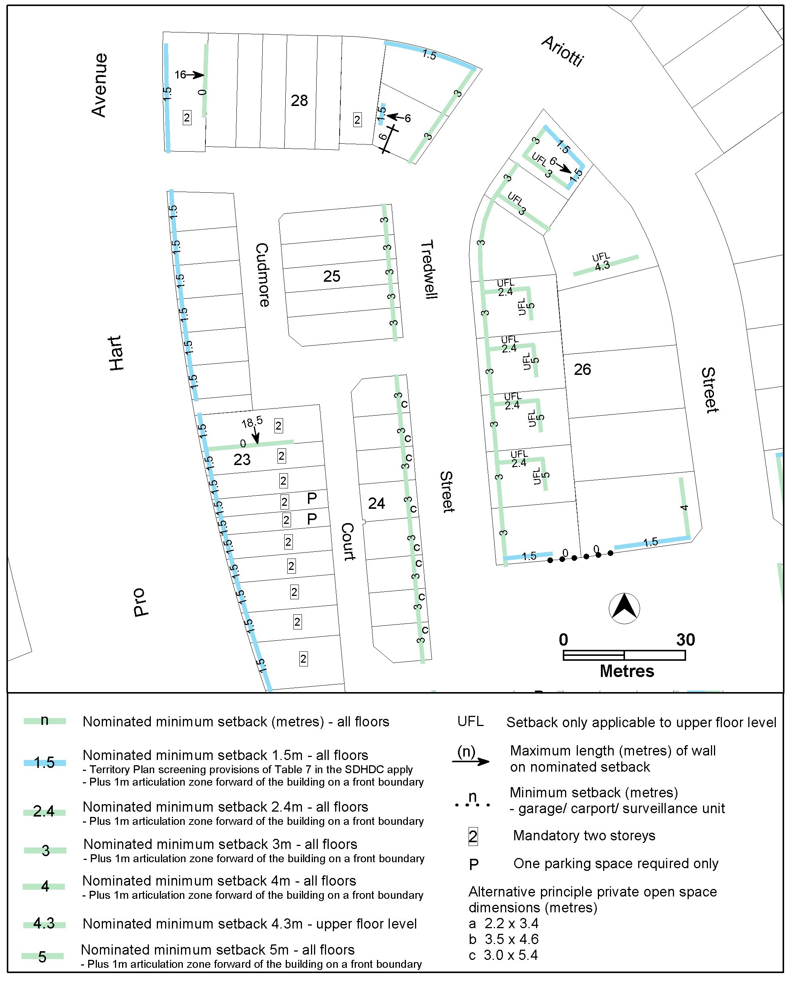

Proposed Figure 10 in the Strathnairn Precinct Map and Code

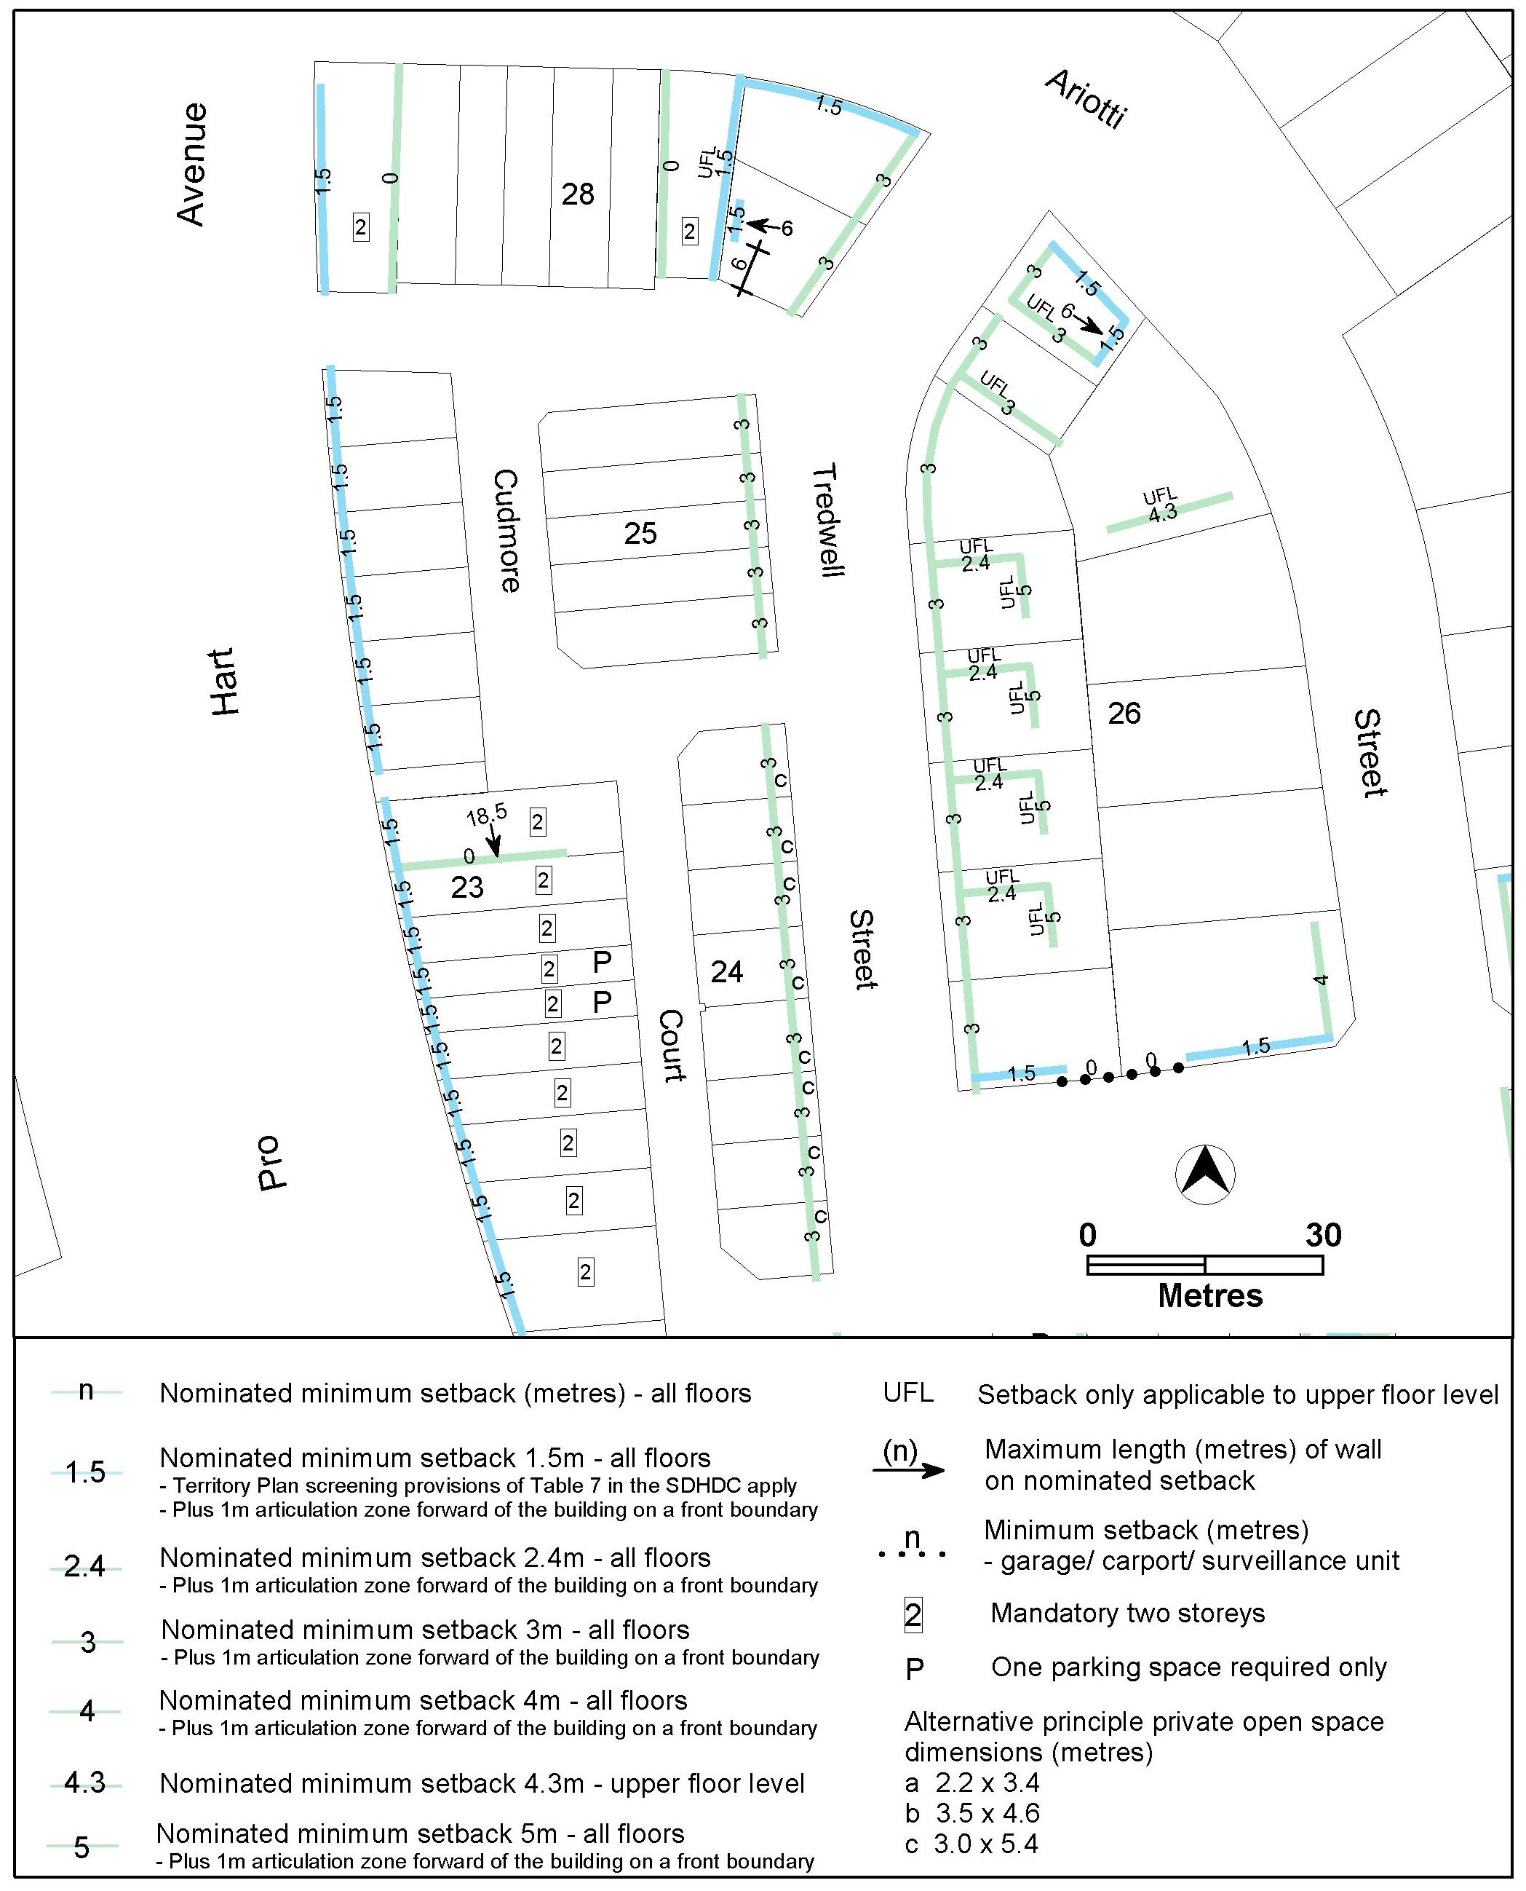

Current Figure 11 in the Strathnairn Precinct Map and Code

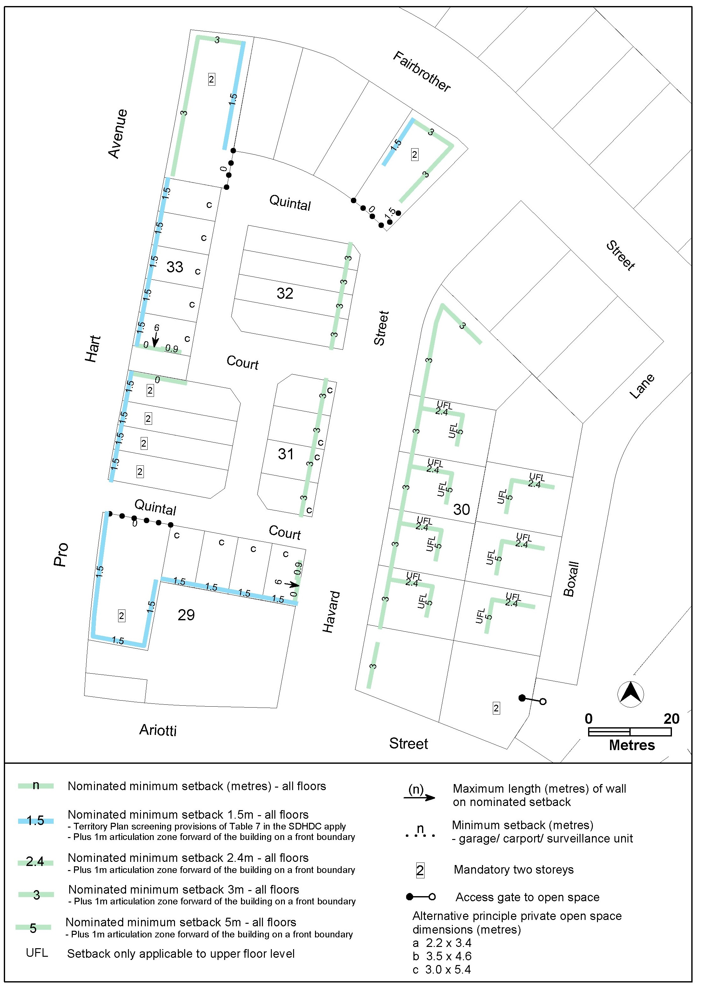

Proposed Figure 11 in the Strathnairn Precinct Map and Code

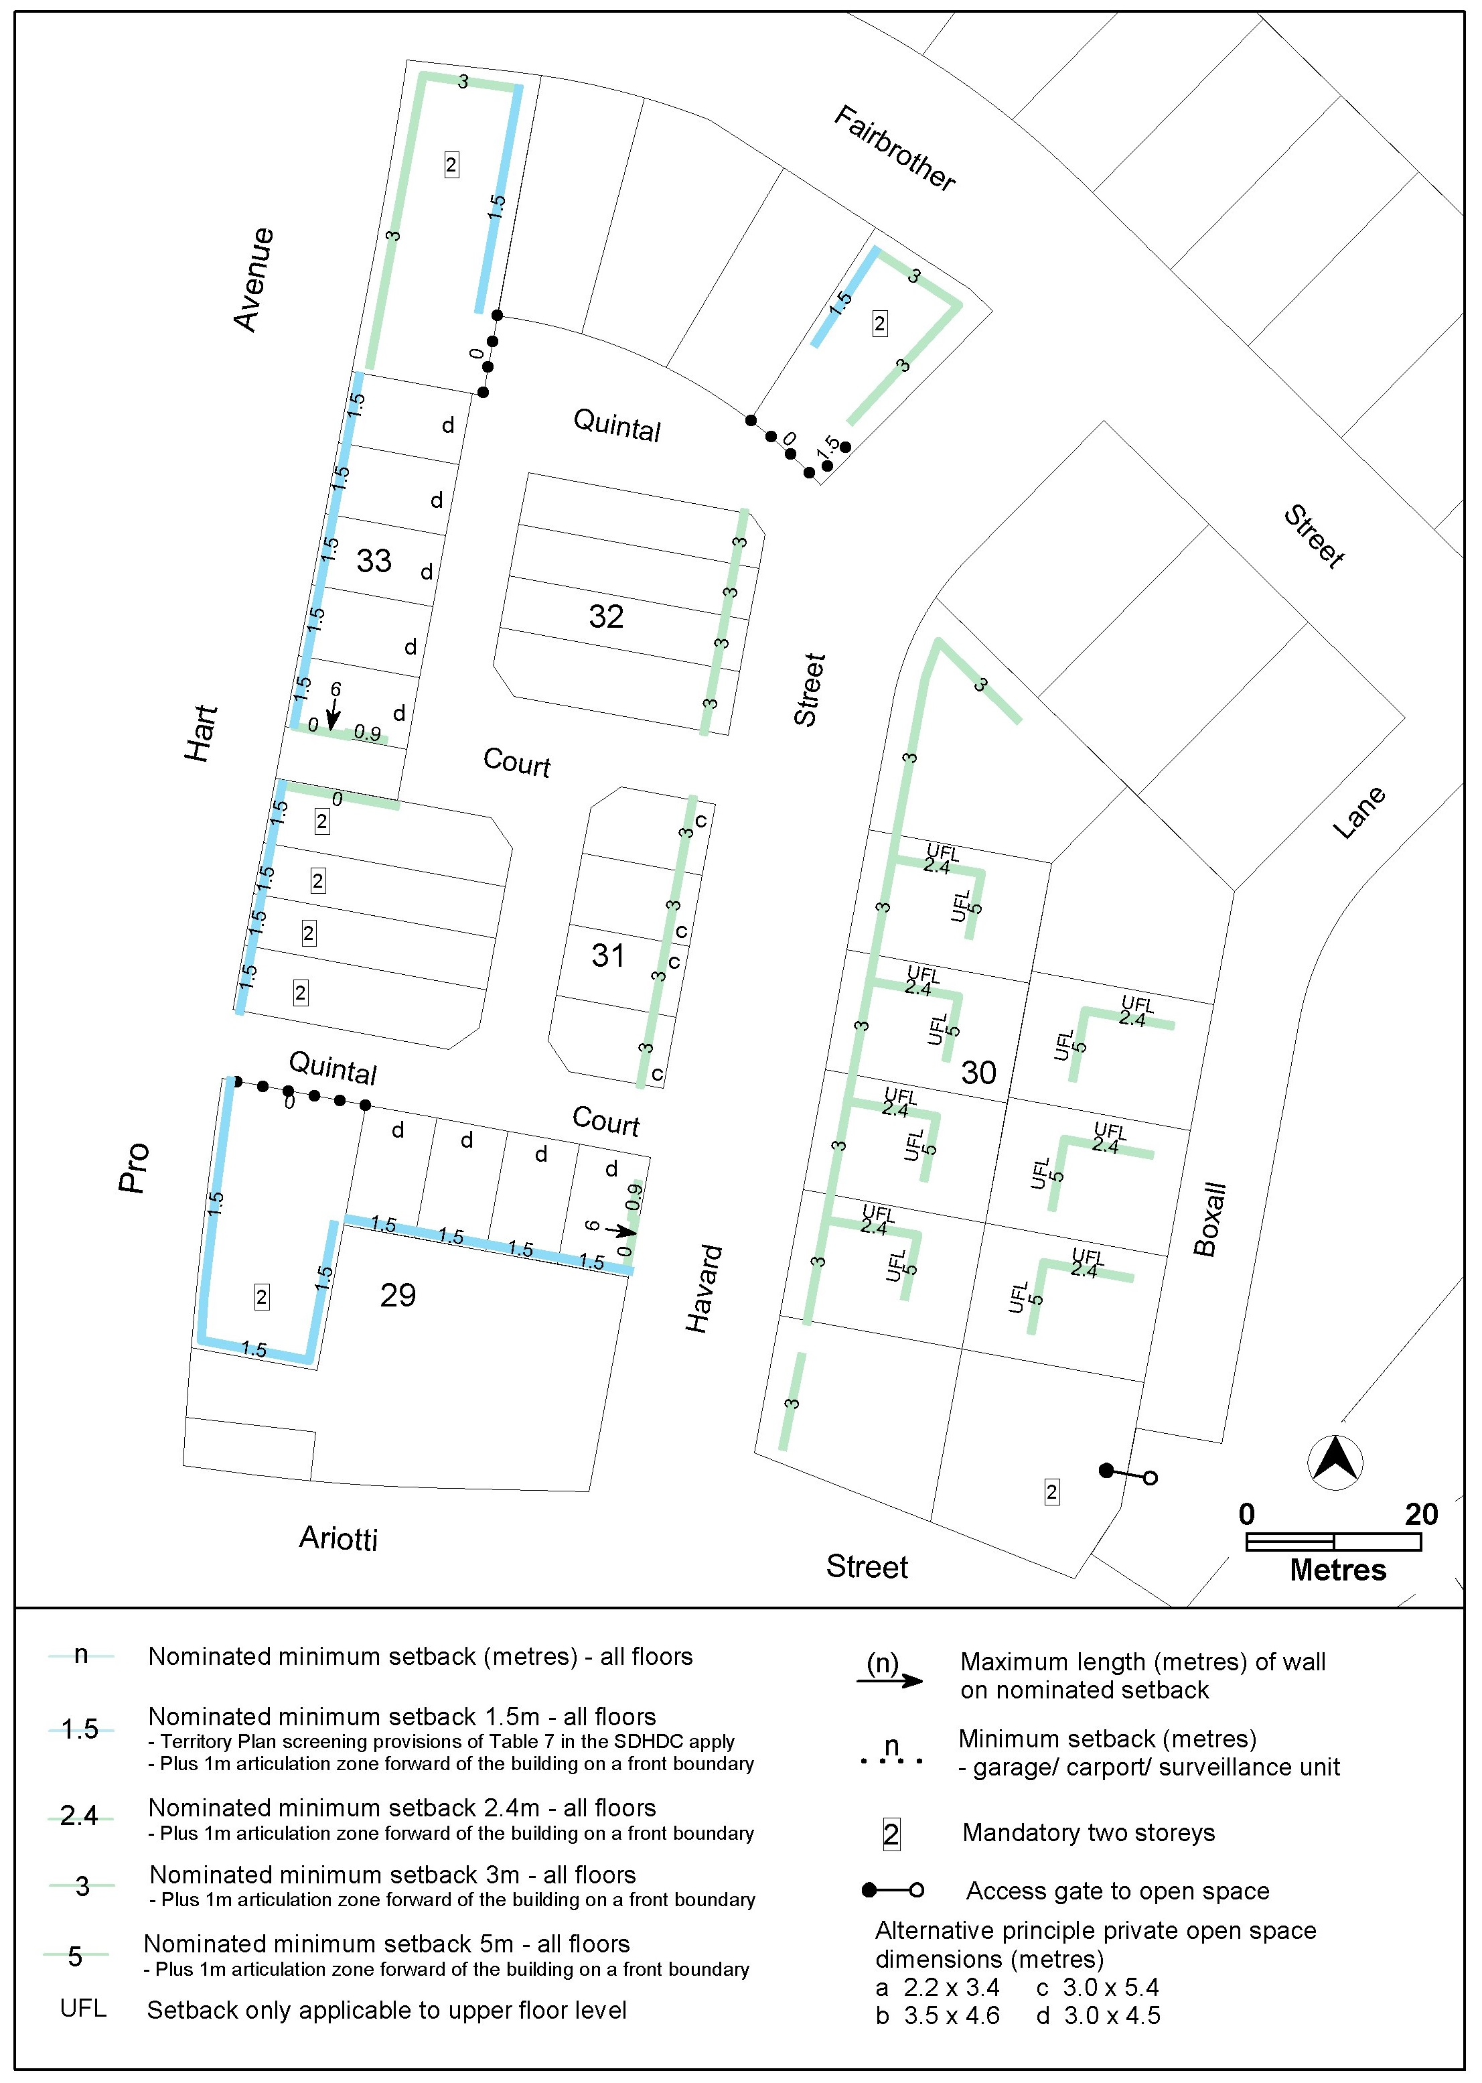

- TECHNICAL AMENDMENT
This section of the technical amendment document provides the actual instructions for implementing the changes to the Territory Plan.

  - Strathnairn Precinct Map and Code
- Additional rules and criteria, RC1 – Residential area, Figure 10 Strathnairn residential area 6

Substitute

Figure 10 Strathnairn residential area 6
- Additional rules and criteria, RC1 – Residential area, Figure 11 Strathnairn residential area 7

Substitute

Figure 11 Strathnairn residential area 7

Interpretation service
