Australian Capital Territory
Planning and Development (Plan Variation No 367) Approval 2020

Notifiable instrument NI2020-83
made under the
Planning and Development Act 2007, section 76 (Minister’s powers in relation to draft plan variations)

1 Name of instrument
This instrument is the Planning and Development (Plan Variation No 367) Approval 2020.

2 Approval of draft plan variation
(1) I approve under section 76 (2) (a) of the Planning and Development Act 2007 the draft plan variation No 367 to the Territory Plan.
(2) In this section:
Draft plan variation No 367 to the Territory Plan means the draft plan variation in the schedule.

Mick Gentleman MLA
Minister for Planning and Land Management
03/02/2020

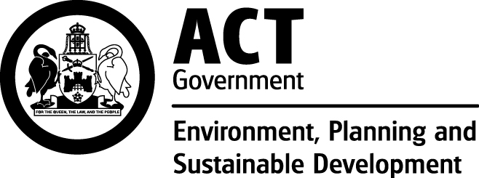

Planning and Development Act 2007

Draft
Variation to the
Territory Plan
No 367

Common Ground
Dickson section 72 block 25
Zone change and amendments to the Dickson precinct map and code

February 2020

Final variation prepared under s76 of the
Planning and Development Act 2007

This page is intentionally blank.

Contents

1. EXPLANATORY STATEMENT 1
1.1 Background 1
1.2 Summary of the proposal 1
1.3 The National Capital Plan 1
1.4 Current Territory Plan Provisions 2
1.5 Changes to the Territory Plan 3
1.6 Consultation on the Draft Variation 3
1.7 Revisions to the draft variation recommended to the Minister 4
2. DRAFT VARIATION 6
2.1 Variation to the Territory Plan 6

This page is intentionally blank.

- EXPLANATORY STATEMENT
  - Background
The Environment Planning and Sustainable Development Directorate engaged with the community during 2018 about the revitalisation of Section 72 Dickson. This included specific reference to a second Common Ground being developed on Block 25. The community expressed a strong desire to see more community facilities in Section 72 and were generally supportive of some community and private housing to complement these uses.
Common Ground is a housing initiative focused on providing quality tenant outcomes for people at risk of, or experiencing, chronic homelessness and low-income tenants.
Canberra’s first Common Ground was built in Gungahlin and comprises 40 one-bedroom unit dwellings. Common Ground Dickson will comprise approximately 40 units with a mix of one, two and three bedroom dwellings. Fifty per cent of the total dwellings will be for supportive housing. The remaining dwellings will be for community housing comprising affordable rental that will be managed by a community housing provider.
Variation 367 (V367) rezones the subject site to community facility zone, reinforcing the community benefit of the proposed Common Ground development, along with amendments to the Dickson precinct map and code to allow uses that are associated with the proposed development.
  - Summary of the proposal
V367 makes the following changes to the Territory Plan:
- rezones block 25 section 72 Dickson from commercial CZ6 leisure and accommodation zone to CFZ community facility zone; and
- introduces provisions for built form including location, heights, and setbacks, and introduces definitions of community housing and social enterprise, into the Dickson Precinct Map and Code.
  - The National Capital Plan
The Australian Capital Territory (Planning and Land Management) Act 1988 established the National Capital Authority (NCA) with two of its functions being to prepare and administer a National Capital Plan (the Plan) and to keep the NCP under constant review and to propose amendments to it when necessary.
The Plan, which was published in the Commonwealth Gazette on 21 January 1990, is required to ensure Canberra and the Territory are planned and developed in accordance with their national significance. The Australian Capital Territory (Planning and Land Management) Act 1988 also requires that the Territory Plan is not inconsistent with the Plan. The area covered by this draft variation is within urban areas identified in the Plan.

  - Current Territory Plan Provisions
The Territory Plan map for the area subject to this draft variation is shown in Figure 2.
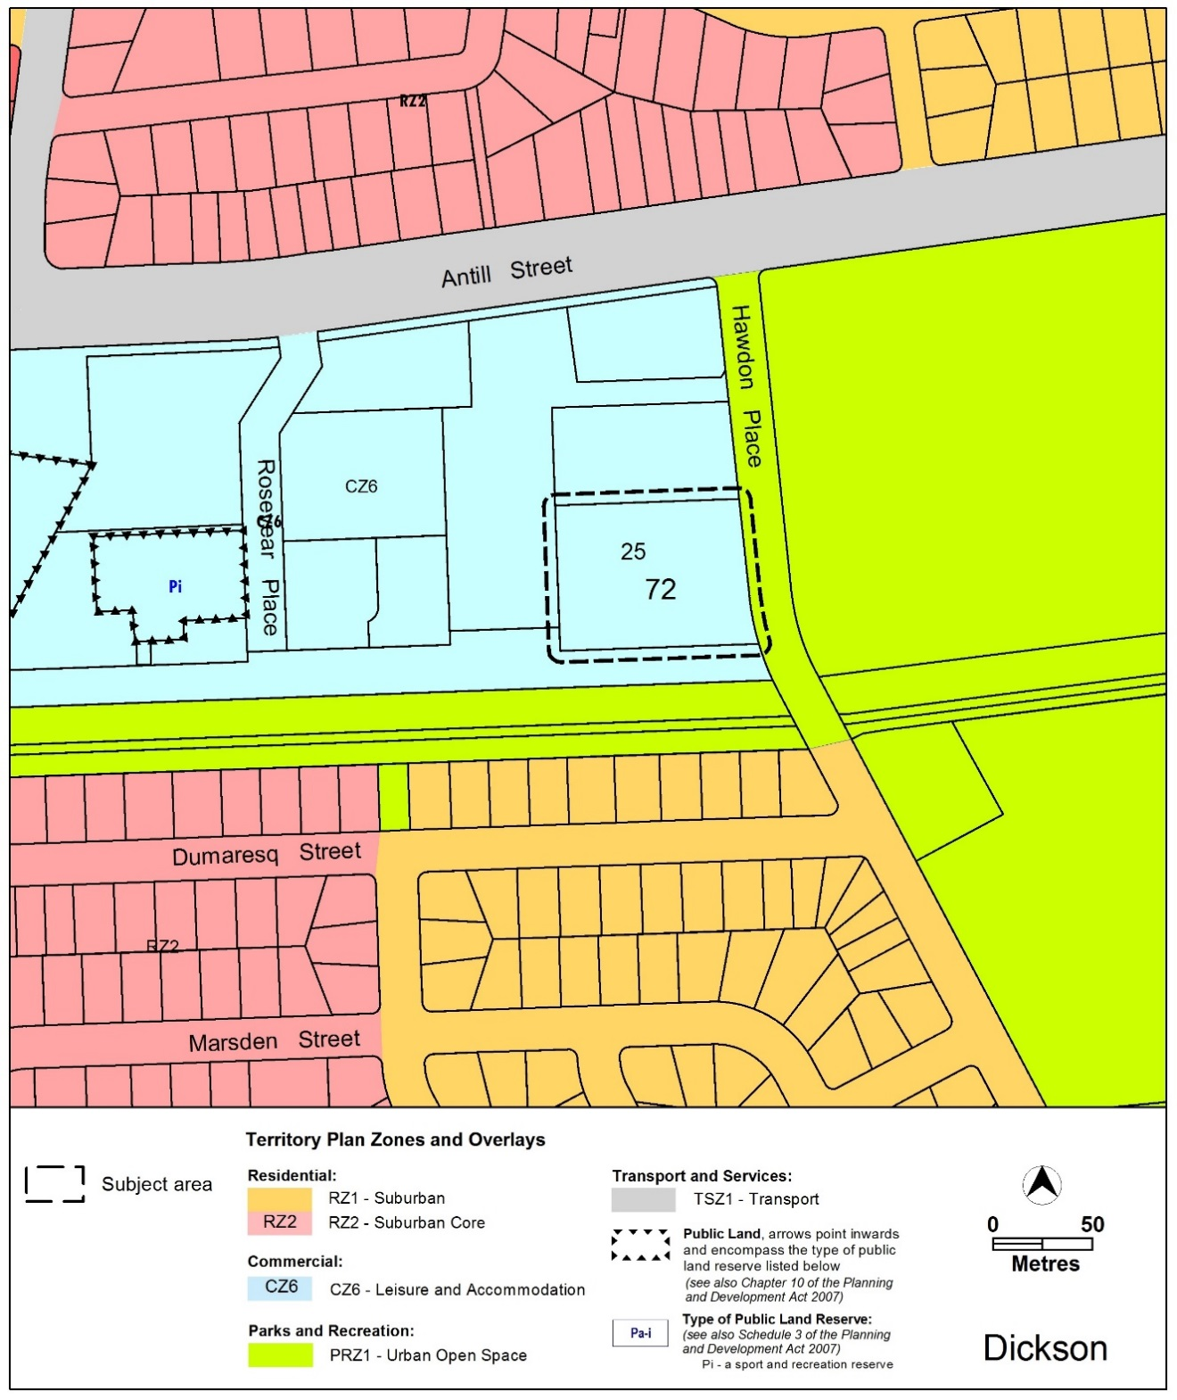
Figure 2: Territory Plan Zones Map
  - Changes to the Territory Plan
Detailed changes to the Territory Plan are noted in section 2 of this document.
  - Consultation on the Draft Variation
The draft variation was released for public comment between 13 September 2019 and 1 November 2019. A consultation notice under section 63 of the Planning and Development Act 2007 (P&D Act) was published on the ACT Legislation Register on 13 September 2019.
Consultation resulted in 50 written submissions on the draft variation. Comments related to the following:
Issue | Number of submissions
Support for the development of Common Ground | 10
Problems with consultation on the pre-development application and the draft variation process | 6
Inappropriate location for proposed development | 5
Building heights are too high | 12
Holistic planning for section 72 should be undertaken prior to the draft variation proceeding | 11
Possible loss of trees | 48
Negative impacts of construction | 6
Possible site contamination | 4
Building design and eventual quality of construction is questionable | 5
Risk of site being flooded | 16
Lack of heritage recognition | 7
Inadequate provisions for car parking | 10
Roads and traffic implications | 16
Scale of development and consequent visual impact and overshadowing | 10
Need to comply with environment policies | 6
Need for an environmental impact statement | 3
The proposed Dickson precinct code contains an error and there is a lack of clarity on building heights and setbacks | 2
The above issues were considered and are detailed in a report on consultation which is available at www.act.gov.au/recommendedvariations. Some changes were made as a result of consultation. The Minister responsible for planning, considered the outcomes of consultation prior to approval of this variation.

  - Revisions to the draft variation recommended to the Minister
The following changes were made following public consultation:
- Figure 4 in the proposed Dickson precinct code has been amended to:
  - clarify the location of the six storey building element
  - clarify the location of building setbacks
  - remove the proposed road reserve to the southern boundary
  - include a 13m setback to the southern boundary
  - graphically display the 0m setback to the western boundary.
- Rule R30 has been amended to include reference to Figure 4 and include a 13 metre setback from the southern property boundary, which may include a driveway.
- Rules R33 and R34 and criteria C35 and C37 have been added to:
  - make sure that appropriate access is provided for future development within section 72 to the west of the site
  - allow for an active transport connection to the south of the site while protecting the health of existing trees in the Dickson channel corridor.
- Rule R36 has been introduced to only allow subdivision if it is for the creation of a road or public access way.
- The definition of social enterprise was amended to clarify that it can also be for profit as long as its primary purpose is for social benefit as follows:
Original:
  - Social enterprise is a commercial organisation that exists to create social rather than economic benefit which may include employment and skills development for on-site residents.
Revised:
  - Social enterprise is a commercial organisation that exists to create social benefit as its primary purpose and may or may not be for profit and which may include employment and skills development for on-site residents.
- The sentence in the criterion field of the proposed Dickson precinct code has been corrected to: ‘This is a mandatory requirement. There is no applicable criterion.’

- DRAFT VARIATION
  - Variation to the Territory Plan
The Territory Plan is varied in all of the following ways:

Variation to the Territory Plan Map
Substitute
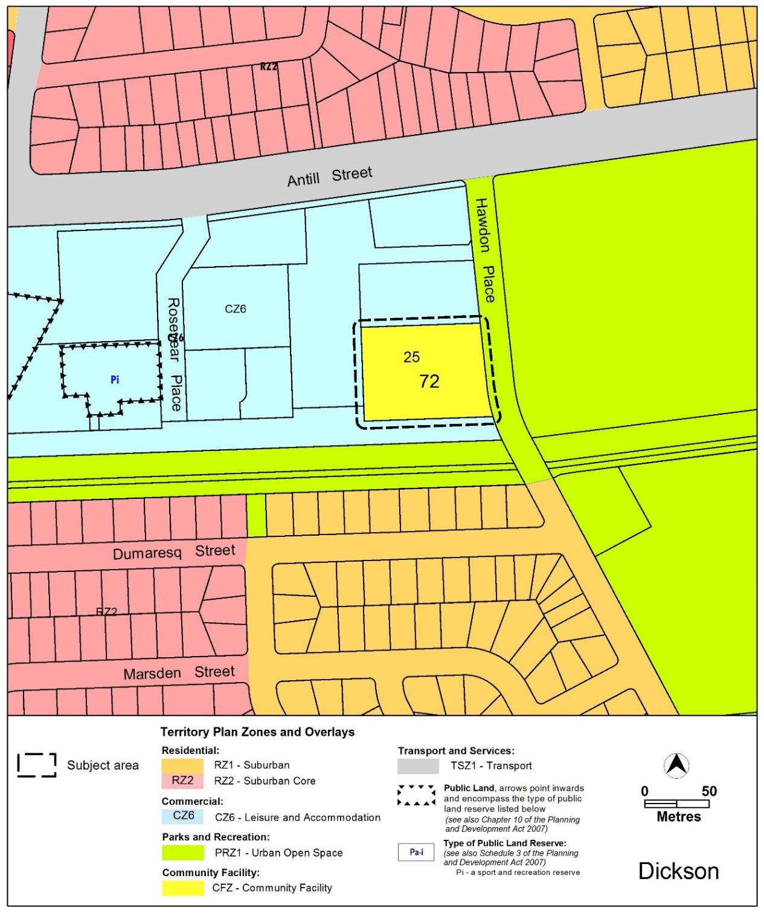

Variation to the Territory Plan Written Statement
- Dickson Precinct Map and Code

Substitute

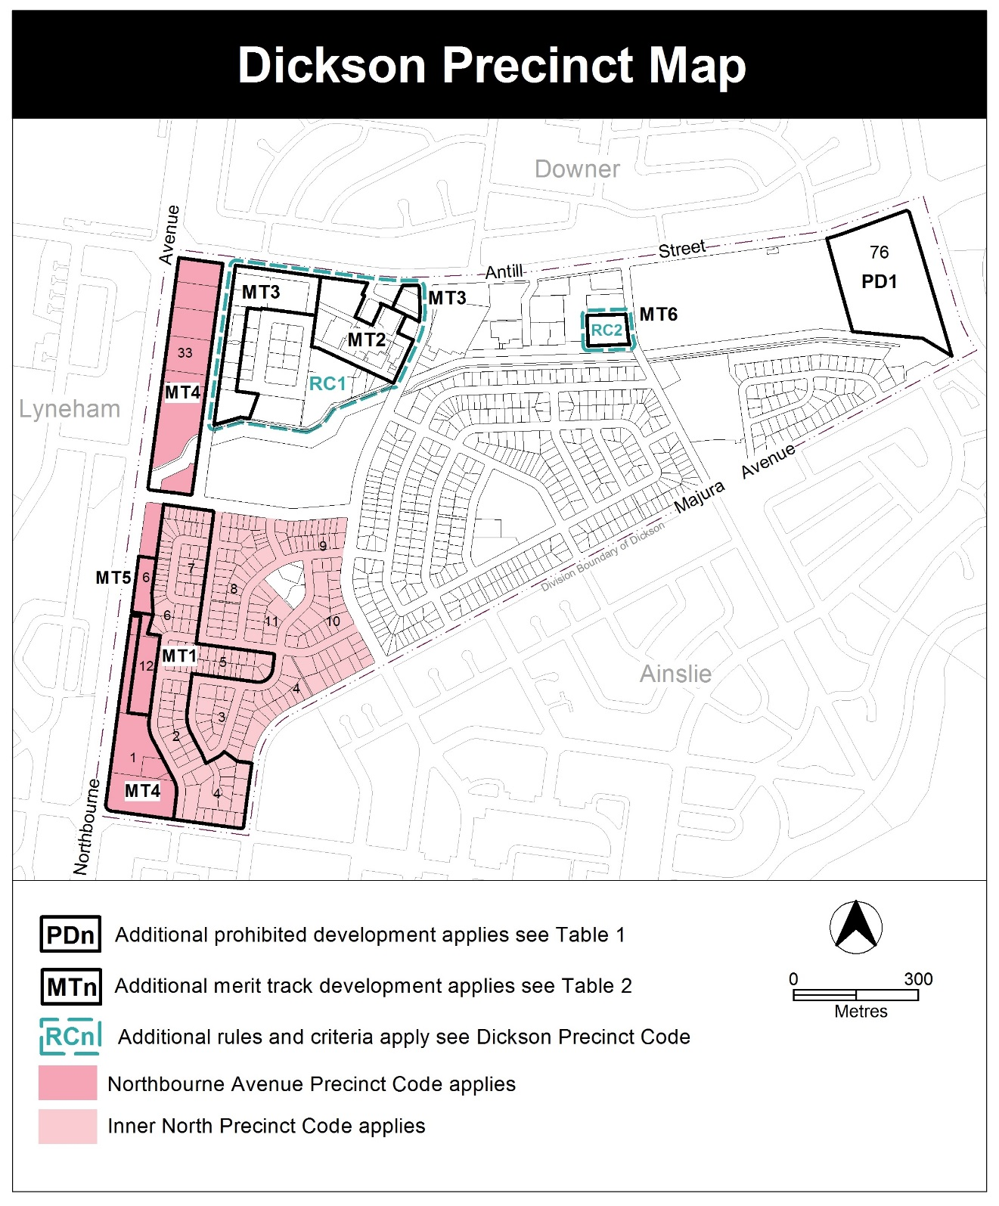

- Assessment tracks, Table 2 – Additional merit track development
Add

Suburb precinct map label | Zone | Development
MT6 | CFZ | craft workshop  community housing  pedestrian plaza  social enterprise

- Introduction, Definitions
Substitute second paragraph with:

Definitions of terms used in this code are listed in part 13 of the Territory Plan or, for terms applicable only to this code listed below.

Community housing means the use of land for affordable residential rental which is managed by a community housing provider.

Social enterprise is a commercial organisation that exists to create social benefit as its primary purpose and may or may not be for profit and which may include employment and skills development for on-site residents.

- Additional rules and criteria, RC1 – Dickson Group Centre, Element 4: Entity (Government Agency) endorsement
Insert after Rule R28

RC2 – Common Ground
This part applies to blocks and parcels identified in area RC2 shown on the Dickson Precinct Map.
Element 5: Buildings
Rules | Criteria
5.1 Building heights
R29  This rule applies to Area A shown in Figure 4.  The maximum height of building is 23m (6 storeys).  Building height measurement includes all of the following:  - roof top plant  - lift overruns  - antennas  - photovoltaic panels  - air conditioning units  - chimneys, flues and vents.  Note: 4 storeys is permitted on the remainder of the site in accordance with the Community Facility Zone Development Code. | This is a mandatory requirement. There is no applicable criterion.
5.2 Setbacks
R30  Development is setback as shown in Figure 4 and complies with all of the following:  - setback to frontage along Hawdon Place is a minimum of 3m  - setback from the southern boundary is a minimum of 13m and may include a driveway within this setback  - setback on western boundary is a minimum of 0m  - setback fronting proposed road reserve on the northern boundary is a minimum of 3m. | This is a mandatory requirement. There is no applicable criterion.
5.3 Community housing
R31  Community housing is a maximum of 50% of the total dwellings provided. | This is a mandatory requirement. There is no applicable criterion.
R32  Community housing complies with the Multi Unit Housing Development Code. | This is a mandatory requirement. There is no applicable criterion.
5.4 Roads and access
R33  The road design within the road reservation shown in Figure 4 to the north of the site meets all of the following:  - endorsed by TCCS  - 13m minimum road reservation width  - enable access through the site to facilitate future development of section 72 to the west of the site.  Note:  TCCS will endorse the plan if it complies with the relevant TCCS standards. TCCS may endorse departures. | This is a mandatory requirement. There is no applicable criterion.
R34  A public access way to facilitate active travel in an east-west direction along the southern boundary of the site is to be located within the 13m setback area, as shown in Figure 4. | This is a mandatory requirement. There is no applicable criterion.
Rules | Criteria
There is no applicable rule. | C35  The public access way to the south of the site within the 13m setback complies with all of the following:  - reasonable functionality  - reasonable safety  - does not compromise the health existing trees to the south of the site  - provision for pedestrians and landscaping  - provision of adequate wayfinding signage.
5.4 Subdivision
R36  Subdivision is only permitted if it is for the following purposes:  - maintaining public access to the south of the site within the 13m setback  - the creation of a proposed road as shown in Figure 4. | This is a mandatory requirement. There is no applicable criterion.
There is no applicable rule. | C37  The Subdivision of the site is consistent with the proposed road reserve boundary shown on Figure 4.

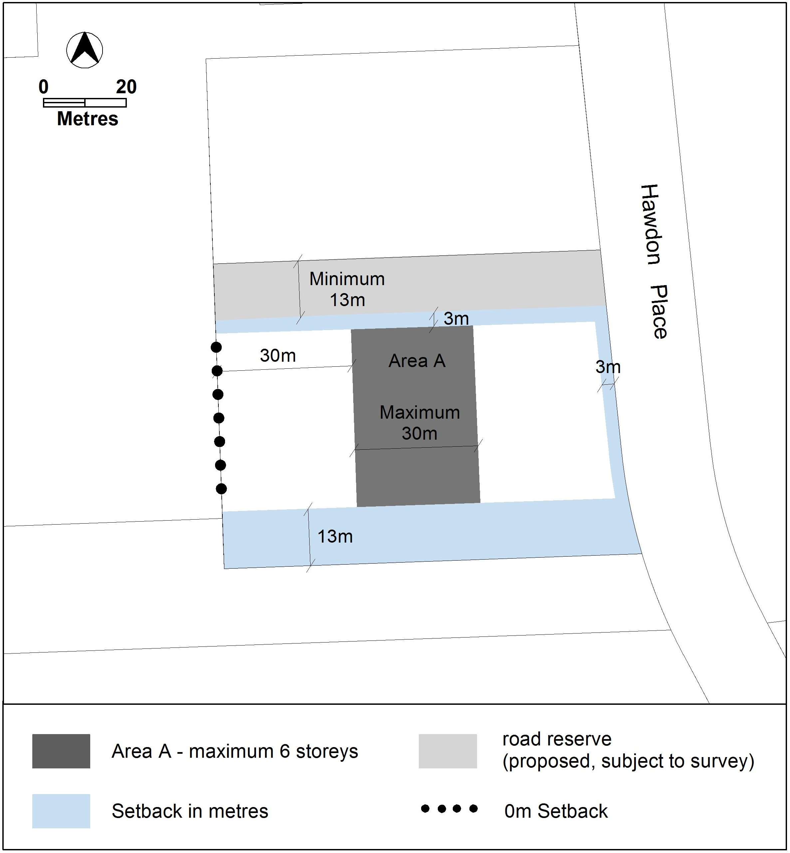 Figure 4: Building setbacks and height limit

Interpretation service
