Australian Capital Territory
Heritage (Decision about Registration of
Cinema Center, City) Notice 2021
Notifiable instrument NI2021—211
made under the
Heritage Act 2004, s 40 (Decision about registration)

1 Name of instrument
This instrument is the Heritage (Decision about Registration of Cinema Center, City) Notice 2021.
2 Decision about registration
On 1 April 2021, the ACT Heritage Council (the Heritage Council) decided to register Cinema Center, Block 21 and part surrounding road and sidewalk verge, Section 35, City (the Place).
3 Registration details of the Place
The registration details of the Place are in the schedule.
4 Reasons for the decision
The Heritage Council is satisfied on reasonable grounds that the Place has heritage significance as it meets one or more of the heritage significance criteria in section 10 of the Heritage Act 2004. A detailed statement of reasons including an assessment against the heritage significance criteria is provided in the schedule.
5 Date registration takes effect
The registration of the Place takes effect on the day after this notice is notified.

6 Revocation
The Heritage (Decision about Provisional Registration of Cinema Center, City)
Notice 2020 (NI2020—720) is revoked.

Edwina Jans
A/g Secretary (as delegate for)
ACT Heritage Council
1 April 2021

Schedule

(See sections 3 and 4)

AUSTRALIAN CAPITAL TERRITORY
HERITAGE REGISTER
(Registration)

For the purposes of s40 of the Heritage Act 2004, an entry to the heritage register has been prepared by the
ACT Heritage Council for the following place:

Cinema Center

Block 21 and part surrounding road and sidewalk verge, Section 35, City
DATE OF REGISTRATION
1 April 2021 Notifiable Instrument: 2021–

Copies of the Register Entry are available for inspection at ACT Heritage. For further information please contact:

The Secretary

ACT Heritage Council

GPO Box 158

CANBERRA ACT 2601

Telephone 13 22 81

This statement refers to the location of the place as required in s12(b) of the Heritage Act 2004.
LOCATION OF THE PLACE

Cinema Center, Block 21 and part surrounding road and sidewalk verge, Section 35, City.

This statement refers to the description of the place as required in s12(c) of the Heritage Act 2004. The attributes described in this section form part of the heritage significance of the place. For the purposes of s12(c) of the Heritage Act 2004, the boundary of the place is at Image 1.
DESCRIPTION OF THE PLACE

Cinema Center consisting of the following attributes:
- The original free standing mixed-use commercial building, including:
  - The asymmetrical form of geometric shaped components;
  - roof-top plant tower with sloping fin wall;
  - the original form of the balconies cantilevering over the public footpath/verge, noting that along the Bunda Street frontage the two lower balconies extend vertically at their ends in asymmetrical geometric shapes;
  - recessed entry way and deep ground floor awning, characteristic of cinema entrances in the mid-20th century, including original welded metal panelling to awning soffit;
  - four storeys of retail and office space;
  - open plan basement with mezzanine level as a single open space reflecting the past use as a cinema and the achievement of the Vierendeel truss that allows the large span;
  - the three concrete and steel Vierendeel trusses at the ground floor supporting the floors above, and allowing for a free span basement below; and
  - The original metal letter and logo ‘Cinema Center’ signage on the northern elevation of the building.

This statement refers to the heritage significance of the place as required in s12(d) of the Heritage Act 2004.
STATEMENT OF HERITAGE SIGNIFICANCE

Cinema Center has made an important contribution to cultural life in the ACT during the mid to late 20th century. The cinema venue, Center Cinema, in the basement of the building (Center Cinema) operated as an independent cinema for 38 years, providing high quality and culturally diverse entertainment for the burgeoning Canberra population. The place has a strong association with the development of cinema entertainment and attendance as a cultural activity in the ACT, being influential in the establishment of an independent cinema industry in the ACT thanks largely to the special association of the place with Dr Darrell Killen whose partnership with Dr Enrico Taglietti AO led to several other commissions to expand the ACT’s cultural life. There is a further special association between the place and Enrico Taglietti, as it remains as one of his culturally influential private, commercial commissions. [Criteria (a), (h)]

Cinema Center is an early, possibly the first, example of the use of Vierendeel trusses to achieve a large free span basement in Australia. Architect Enrico Taglietti and structural engineer Keith Sellick, developed an innovative design solution where a cinema space could be located underground to free the upper floors for the remaining programme and maximise commercial viability of the complex. The design solution demonstrates creative and technical achievement in its use of three concrete and steel Vierendeel trusses, with a depth of over 4m, to achieve a free span basement space required for the cinema and a functional ground floor layout. [Criterion (f)]
CONSERVATION OBJECTIVE

The guiding conservation objective is that Cinema Center shall be conserved and appropriately managed in a manner respecting its heritage significance.

The ACT Heritage Council may adopt heritage guidelines applicable to the place under s25 of the Heritage Act 2004.

For further information on guidelines applicable to the place, or for advice on proposed works or development, please contact ACT Heritage on 13 22 81.
REASON FOR REGISTRATION

The Council has assessed the Cinema Center, City against the heritage significance criteria and is satisfied that the place has heritage significance when assessed against three criteria [a, f and h] under s10 of the Heritage Act 2004.
ASSESSMENT AGAINST THE HERITAGE SIGNIFICANCE CRITERIA

The Council’s assessment against the criteria specified in s10 of the Heritage Act 2004 is as follows.

In assessing the heritage significance of Cinema Center, City, the Council considered:
- the original nomination and documentary evidence supplied by the nominator;
- the Council’s Heritage Assessment Policy (March 2018);
- information provided by a site inspection of the openly accessible public areas of the building on 26 June 2019 by ACT Heritage;
- the report by ACT Heritage titled, Background Information Cinema Center, April 2021, containing photographs and information on history, description, condition and integrity;
- information and comments received during the public consultation period under s37 of the Act on the provisional registration of Cinema Center.

Pursuant to s10 of the Heritage Act, a place or object has heritage significance if it satisfies one or more of the following criteria. Future research may alter the findings of this assessment.
importance to the course or pattern of the ACT’s cultural or natural history;
The Council has assessed Cinema Center against criterion (a) and is satisfied that the place meets this criterion.

Built in 1965 to accommodate restaurants, retail, a gallery, offices and an independent cinema, Cinema Center was a distinctively modern cultural hub and well-known meeting place in the City. The purpose built cinema (Center Cinema) located in the building’s basement, art gallery on the first floor, and variety of retail and dining options provided at the ground floor level of the building, provided a cosmopolitan entertainment experience, previously unavailable in Canberra at the time.

Cinema Center has a strong association with the development of cinema entertainment and attendance as a cultural activity in the ACT. Showing high quality International films sourced directly from Hollywood, Europe, and later films from Hong Kong and Taiwan and local cinema, not otherwise available in Canberra; the building enriched cultural life in the ACT.

With government support stimulating growth of an Australian national film industry in the 1960s and 70s, Cinema Center provided a platform for the ‘renaissance’ of Australian film to reach Canberra audiences. The cinema was the venue for film premieres attended by a cross section of Canberra society, including world premieres of independent Australian films ‘Journey Out of Darkness’ in 1967, and ‘We of the Never Never’ in 1982. These premieres were widely publicised and reviewed in Australian media and established Cinema Center as a prominent cultural venue in the ACT.

Cinema Center was influential in the development of an independent cinema industry in the ACT. Its commercial success led directly to development of the Boulevard Red and Blue Cinemas (later Electric Shadows) in 1973, an independent cinema which followed a similar business model with a focus on quality films.

The cinema auditorium, box office, showings signage and projection room are no longer extant. However, the building name, ‘Cinema Center’ signage, recessed front entry, and deep ground floor awning characterise mid twentieth century cinema buildings, and serve as a visual reminder of important role of the Cinema Center in the cultural life of the ACT. Additionally, several items from the Cinema Center have been preserved as part of the Canberra Museum and Gallery collection, including selected programs, signage and seating as being representative items of an important part of the Canberra’s cultural history.
has uncommon, rare or endangered aspects of the ACT’s cultural or natural history;
The Council has assessed Cinema Center against criterion (b) and is satisfied that the place does not meet this criterion.

Cinema Center is not considered to be rare in the context of the ACT. The cinema auditorium at Cinema Center was the fourth purpose built cinema space in the ACT. Although, the three purpose built cinemas constructed prior to Cinema Center (Capitol Theatre Manuka, Civic Theatre Braddon and Starlight Drive-in Watson) have been demolished, a number of purpose built cinemas have since been constructed and remain extant with higher integrity than Cinema Center. Dr Taglietti also designed the Sundown Drive-in in Narrabundah (designed 1968, built 1969), which has many elements, like the main kiosk/projection booth/admin building, still intact, but its conversion into a caravan park and motel has altered the landscape and other drive-in features such as the screen, parking bays and speaker stands.
potential to yield important information that will contribute to an understanding of the ACT’s cultural or natural history;
The Council has assessed Cinema Center against criterion (c) and is satisfied that the place does not meet this criterion.

Cinema Center does not contain substantial new physical evidence of archaeological or other research interest. Detailed study of the Verindeel trusses supporting the upper levels of the building may yield information about structural efficiency of this design solution, of interest to structural engineers. However, this information is likely to replicate or confirm evidence provided by existing published resources.
importance in demonstrating the principal characteristics of a class of cultural or natural places or objects;
The Council has assessed Cinema Center against criterion (d) and is satisfied that the place does not meet this criterion.

Cinema Center is not a representative example of a class of cultural or natural places or objects. Designed by architect Enrico Taglietti, Cinema Center is an example of a commercial building exhibiting some characteristics of the Late Twentieth-Century Organic architectural style. The extant free asymmetric massing, complex geometries and horizontal roof planes are characteristic of the architectural style. While unsympathetic modifications to the exterior have affected other key characteristics of the style, including horizontally boarded fascia, horizontally boarded balustrade and expressed timber that have been painted over or replaced; these are mostly cosmetic changes that could easily be reinstated to original, so the integrity of the place has not been lost.
importance in exhibiting particular aesthetic characteristics valued by the ACT community or a cultural group in the ACT;
The Council has assessed Cinema Center against criterion (e) and is satisfied that the place does not meet this criterion.

When constructed, the Cinema Center was celebrated as a place with evocative aesthetic qualities. The building’s distinctive silhouette, with deep cantilevered balconies wrapped around a bold asymmetrical form, and cavernous recessed entry drawing visitors into its interior, distinguished the Cinema Center in the Bunda Street streetscape. Reviews from the time describe the building as luxurious and modern, with a sense of grandeur created by the large lobby space, grand staircase and first floor rotunda in the interior. However, the interior of the building has since been modified to such an extent that the interior no longer displays aesthetic characteristics that are likely to evoke a strong human response.

The exterior of the building retains its distinctive silhouette and dramatic architectural form. These qualities are common to Enrico Taglietti’s architecture and are widely appreciated by members of the architectural profession (represented by the Australian Institute of Architects) and those in the ACT community who appreciate late 20th century architecture.

The exterior of Cinema Center displays aesthetic characteristics that are appreciated by professional architectural bodies and interest groups. That these characteristics are valued by the greater ACT community or cultural groups in the ACT has not been tested, although this may emerge more clearly in the future.
importance in demonstrating a high degree of creative or technical achievement for a particular period;
The Council has assessed Cinema Center against criterion (f) and is satisfied that the place meets this criterion.

The basement design of Cinema Center demonstrates an innovative architectural and structural solution to overcome the difficulties of a demanding brief for a mixed use complex of shops, offices and a cinema on a small site with height restrictions. Architect Enrico Taglietti and structural engineer Keith Sellick developed a particularly appropriate design solution where a cinema space could be located underground to free the upper floors for the remaining programme and maximise commercial viability of the complex. The design solution is innovative in its use of three concrete and steel Vierendeel trusses, with a depth of over 4m, to achieve a free span basement space required for the cinema.

Cinema Center is an early, possibly the first, example of the use of Vierendeel trusses to achieve a large free span basement in Australia. This structural solution had been applied to bridge and factory roof construction in Australia and internationally in commercial and institutional buildings. However, no other local examples of use of the Vierendeel trusses to create a free span basement have been found. Basement cinemas previously constructed in Australia were constrained by the limitations of steel beam and column construction. The structural solution at Cinema Center allowed for a larger open space to meet international modern cinema standards and a commercially viable ground floor.

The Vierendeel trusses supporting the upper floors of the building remain intact, the basement level a free span space and the building structurally dependent upon the innovative design solution to function as a viable commercial premises. The physical evidence at Cinema Center continues to demonstrate a high level of creative and technical achievement.
has a strong or special association with the ACT community, or a cultural group in the ACT for social, cultural or spiritual reasons;
The Council has assessed Cinema Center against criterion (g) and is satisfied that the place does not meet this criterion.

Cinema Center was a popular entertainment venue and many people in the ACT are likely to have fond memories of the place. However, there is insufficient evidence before the Council at this time to suggest that Cinema Center is highly valued by the ACT community.
has a special association with the life or work of a person, or people, important to the history of the ACT.
The Council has assessed Cinema Center against criterion (h) and is satisfied that the place meets this criterion.

Architect Dr Enrico Taglietti AO played a significant role in Canberra’s cultural history, being one of the most critically acclaimed architects to practice in the Capital. In the design of Cinema Center, Taglietti, drew upon design schema from previous projects including the Sant-Erasmo theatre in Milan, and stylistic expressions developed for the Town House Motels (Young and Wagga Wagga).
His first commissions in Canberra included commercial buildings that were associated with a distinct, entrepreneurial phase of the city’s development in terms of tourism, hospitality and services. The buildings represented (and were recognised for) the broadening image of the city as an innovative cultural centre. The first of these, the Town House Motel (1961) included a restaurant annex (‘Noahs’) and sculptural elements (by Clement Meadmore) that exemplified these transitions. Other such commissions included the Captain James Cook Hotel (Narrabundah, 1970) and the ACMA Convention Centre (Barton, 1967).

The two hotels have been demolished; the convention centre much modified. While Taglietti’s contribution to government-commissioned architecture has been recognised in heritage listings, his private and commercial commissions have not. Given its place as one of the most substantial of these commissions, the Cinema Center has a special association with Taglietti. It is emblematic of his role in the entrepreneurial commitment to and cultural synthesis of the national capital in a major formative period of its development.

On 26 January 2020, Dr Taglietti was posthumously awarded an Officer of the Order of Australia for distinguished service to architecture, particularly in the Australian Capital Territory, to education, and to professional organisations.

The building is associated with the work of local developer and entrepreneur Dr Darrel Killen, who established an independent cinema industry in the ACT, and developed important new cultural institutions and tourist accommodation in Canberra in the 1960s and 70s. At Cinema Center, Dr Killen, a film enthusiast himself, provided a high quality cinema experience rivalling overseas examples and a platform for the Australian film industry to reach Canberra audiences.
SITE PLAN

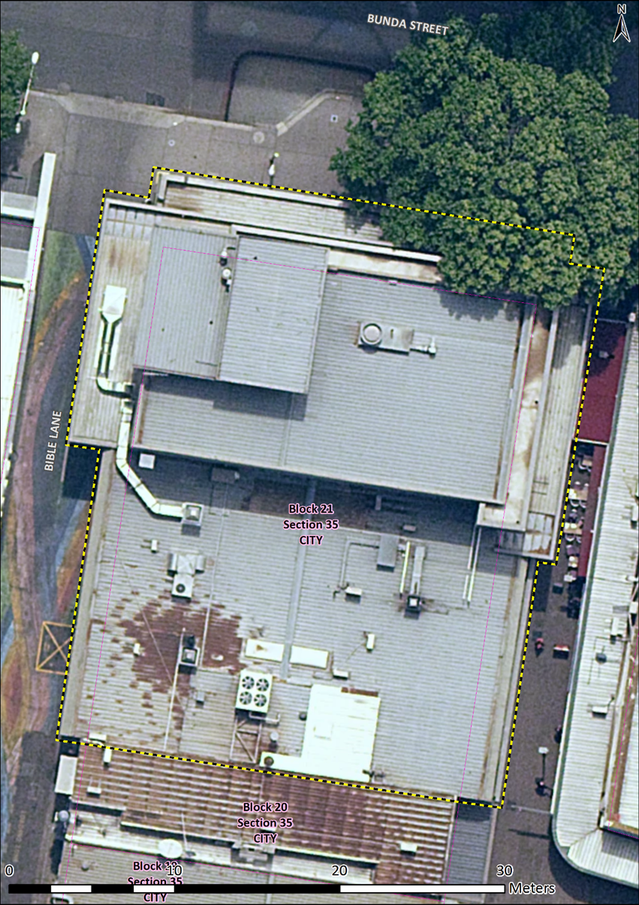
Image 1 Cinema Center registration boundary

