Australian Capital Territory
Heritage (Decision about Provisional Registration of Original Canberra Aerodrome, Dickson)
Notice 2021
Notifiable instrument NI2021–212
made under the
Heritage Act 2004, s34 (Notice of decision about provisional registration)

1 Name of instrument
This instrument is the Heritage (Decision about Provisional Registration of Original Canberra Aerodrome, Dickson) Notice 2021.
2 Decision about provisional registration
On 1 April 2021, the ACT Heritage Council (the Heritage Council) decided not to provisionally register Original Canberra Aerodrome, Park Block 25 and 26, Section 72; Part Block 33, Section 73; Park Block 6, Section 76, Dickson (the Place).
3 Description of the Place
The description of the Place is in the schedule.
4 Reasons for the decision
The Heritage Council is not satisfied on reasonable grounds that the Place is likely to have heritage significance as defined by section 10 of the Heritage Act 2004. A detailed statement of reasons, including an assessment against the heritage significance criteria, is provided in the schedule.
5 Date decision takes effect
The decision not to provisionally register the Place takes effect on 2 April 2021 (being the day after the Heritage Council made its decision in writing as set out in the schedule).

Edwina Jans
A/g Secretary (as delegate for)
ACT Heritage Council
1 April 2021

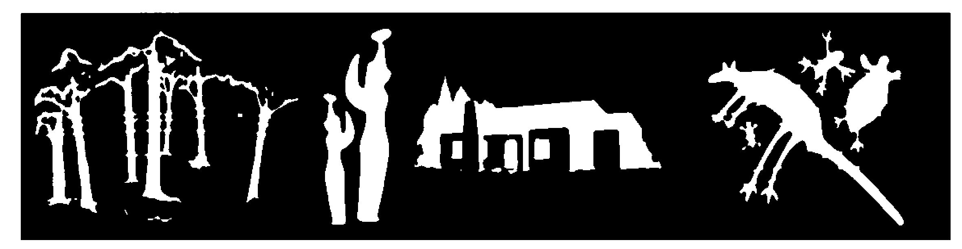
STATEMENT OF REASONS
DECISION NOT TO PROVISIONALLY REGISTER
Original Canberra aerodromeWamboinName of Place
part block 25 and 26 section 72; part block 33 section 73; part block 6 section 76, dickson
IN THE ACT HERITAGE REGISTER

In accordance with s32 of the Heritage Act 2004, the ACT Heritage Council has decided not to provisionally register Original Canberra Aerodrome, Dickson. This Statement of Reasons provides an assessment of Original Canberra Aerodrome, Dickson, and finds that the place does not meet any of the criteria under s10 of the Heritage Act 2004.

The presence of the Original Canberra Aerodrome that was previously located in the present-day suburb of Dickson is of historical note, as the first official aviation facility in the ACT and the location of Canberra’s first air fatalities. However, the physical remains have been significantly disturbed, removed or destroyed over the years. Consequently, there are no evident remains of the central ring marker, nor three of the four lockspits. Only one lockspit fragment potentially remains, but its provenance is not certain. The Heritage Council considers that the known physical remnants are too fragmentary to meet the criteria for heritage listing.

This statement refers to the location of the place as required in s34(5)(b)(ii) of the Heritage Act 2004.
LOCATION OF THE PLACE

The nomination refers to three specific locations based on map data relating to presumed remnants of the Original Canberra Aerodrome:
- Central ring marker location (part Block 25 and 26 Section 72): centroid coordinates -35.250306, 149.145610.
- Lockspit A (part Block 33 Section 73): centroid coordinates -35.252218, 149.149233.
- Lockspit B (part Block 6 Section 76): centroid coordinates -35.248639, 149.148896.

This section refers to the description of the place as required in s34(5)(b)(iii) of the Heritage Act 2004. The boundary of the place and extent of features listed below is illustrated at Image 1.

DESCRIPTION OF THE PLACE

The Original Canberra Aerodrome (also known as Canberra Aerodrome, Aerodrome at Canberra and the Northbourne Aviation Ground) consisting of the following attributes:
- The nomination refers to the central ring and the location of two of the four original lockspits (A and B). The other lockspits are presumed to have been destroyed during construction in the suburb of Dickson. The only known remnants belong to Lockspit A.
- Central ring marker location with a radius of 11.65m and a depth of 2 metres below ground.
- Lockspit A with a radius of 18m, and a depth of 1 metre below ground.
- Lockspit B with a radius of 9m, and a depth of 2 metres below ground.

This statement refers to the Council’s reasons for its decision as required in s34(5)(b)(iv) of the Heritage Act 2004.
REASONS FOR DECISION

The Council is not satisfied on reasonable grounds, there being only one element of discernible physical evidence, that the place is likely to have heritage significance as defined by s10 of the Heritage Act 2004; the Council, however, notes that the place may be renominated and reassessed if further physical evidence is discovered in the future.

This statement refers to the Council’s assessment of the place against the heritage significance criteria as a part of its reasons for its decision as required in s34(5)(b)(iv) of the Heritage Act 2004.
ASSESSMENT AGAINST THE HERITAGE SIGNIFICANCE CRITERIA

The Council’s assessment against the criteria specified in s10 of the Heritage Act 2004 is as follows.

In assessing the heritage significance of the Original Canberra Aerodrome, Dickson, the Council considered:
- the original nomination and documentary evidence supplied by the nominator;
- the Council’s Heritage Assessment Policy (March 2018);
- information provided by a site inspection on 16 February 2021 by the Council and ACT Heritage; and
- the report by ACT Heritage titled, Background Information Original Canberra Aerodrome, April 2021, containing photographs and information on history, description, condition and integrity; and
- Extent. 2020. Common Ground Dickson Cultural Heritage Assessment Report. Unpublished report for Housing ACT, Extent Heritage Advisors; and
- Extent. 2020. Historical Archaeological Test Excavation Report. Unpublished report for Housing ACT, Extent Heritage Advisors.

Pursuant to s10 of the Heritage Act, a place or object has heritage significance if it satisfies one or more of the following criteria. Future research may alter the findings of this assessment.
- importance to the course or pattern of the ACT’s cultural or natural history;
The Council has assessed the Original Canberra Aerodrome against criterion (a) and is not satisfied that the place meets this criterion.
The Original Canberra Aerodrome is the site of the first official aviation facility in the ACT and the location of Canberra’s first air fatalities. Consequently, it had potential to be an important site in understanding the course and pattern of the ACT’s cultural history. However, the physical fabric relating to the past land use is all but erased with the only known remains relating to one partially intact lockspit. Moreover, since the closure of this aviation facility the suburb of Dickson been built over the area, not only resulting in the aforementioned disturbance of the physical remains, but also substantially changing the landscape that was associated with the operations of the Original Canberra Aerodrome. Thus, the place does not meet this threshold as it is so altered that it can no longer provide evidence for its meaning.
- has uncommon, rare or endangered aspects of the ACT’s cultural or natural history;
The Council has assessed the Original Canberra Aerodrome against criterion (b) and is not satisfied that the place meets this criterion.
The Original Canberra Aerodrome was the earliest aviation facility in the ACT and thus representative of the expansion of early flight into the region. After operations ceased the official aviation grounds were moved to the Majura Valley on part of the site of the present-day airport. It is thus an uncommon aspect of the ACT’s cultural history, however, due to the lack of substantive physical remains it lacks intactness. This, combined with the construction of the suburb of Dickson, means that the integrity of the place is too low to meet the threshold for this criterion.
- potential to yield important information that will contribute to an understanding of the ACT’s cultural or natural history;
The Council has assessed the Original Canberra Aerodrome against criterion (c) and is not satisfied that the place meets this criterion.
There is potential to uncover some further physical traces of Lockspits A and B relating to the Original Canberra Aerodrome, however the integrity of these remains is unknown. Detailed archaeological investigations at the site of the ring marker failed to find any intact remains demonstrating that the area has been significantly disturbed. Moreover, the operational set-up of the site is well-documented in other sources. Although there is some potential for buried remnants to be found in the location of Lockspits A and B there is no indication that such information, if ever unearthed, will significantly advance the body of knowledge about the history of the ACT, as required under this criterion. Therefore, the place does not meet the threshold for this criterion, as it lacks potential to yield new information relating to its cultural history as Canberra’s first official aviation facility.
- importance in demonstrating the principal characteristics of a class of cultural or natural places or objects;
The Council has assessed the Original Canberra Aerodrome against criterion (d) and is not satisfied that the place meets this criterion.
Had the physical remains been intact, the Original Canberra Aerodrome, potentially could have demonstrated characteristics relating to the course of aviation history in the ACT. However, the place no longer displays the high integrity or good condition needed to meet the threshold for this criterion.
- importance in exhibiting particular aesthetic characteristics valued by the ACT community or a cultural group in the ACT;
The Council has assessed the Original Canberra Aerodrome against criterion (e) and is not satisfied that the place meets this criterion.
There is no indication of the place having particular aesthetic characteristics that can be demonstrated to be linked to the physical fabric of the place, nor is there evidence to suggest that a community or cultural group in the ACT values the place on the basis of its aesthetic qualities.
The Council notes that the ‘ACT community’ encompasses the broad community of the ACT, across the full geographical context, and a broad spectrum of society; while ‘a cultural group’ has a narrower focus, taken to be a ‘group of people within a society with a shared ethnic or cultural background’ or ‘a group of people connected through the same way of living, which has been transmitted from one generation to another’. The definition specifically precludes professional organisations or special interest groups.
- importance in demonstrating a high degree of creative or technical achievement for a particular period;
The Council has assessed the Original Canberra Aerodrome against criterion (f) and is not satisfied that the place meets this criterion.
The place contains no visibly intact characteristics that clearly demonstrate creative or technical achievement relating to early aviation facilities. Moreover, although related to early aviation development, landing facilities at this time essentially consisted of open paddocks with simple markers to aid navigation and landing. Consequently, this place does not meet the thresholds demonstrating a high degree of creative or technical achievement.

- has a strong or special association with the ACT community, or a cultural group in the ACT for social, cultural or spiritual reasons;
The Council has assessed the Original Canberra Aerodrome against criterion (g) and is not satisfied that the place meets this criterion.
Although the history of the Original Canberra Aerodrome is of known interest to local historians and to members of the No. 3 Squadron RAAF, the place does not meet the threshold relating to a strong or special association with the ACT community or a cultural group. This is because, for the purposes of this criterion, professional and special interest groups do not constitute the community or a cultural group. Furthermore, there is not sufficient evidence to suggest that the broader ACT community, or a cultural group in the ACT has a strong or special association with this site.
- has a special association with the life or work of a person, or people, important to the history of the ACT.
The Council has assessed the Original Canberra Aerodrome against criterion (h) and is not satisfied that the place meets this criterion.
In its role as Canberra’s first official aviation facility the Original Canberra Aerodrome has an incidental association with many prominent figures in the early planning and development of Canberra, but these associations were not enduring.
It was also the site of Canberra’s first aviation fatalities in which the lives of Flying Officer Philip Mackenzie Pitt and Aircraftsman AC1 William Edward Callander were lost. Both men belonged to the No. 3 Squadron RAAF that regularly flew into and out of the Original Canberra Aerodrome during its operational period. This group consequently maintains an historical interest in the site. However, the physical and landscape features are missing that would demonstrate clear evidence associating the people/group and the place. Furthermore, the place is so altered that it no longer provides evidence for this association.
Efforts have been undertaken to memorialise the men who died, including a plaque installed by the ACT Heritage Committee at the front entrance of the Dickson Library. In addition, Canberra Tracks signage explaining the history of the Original Canberra Aerodrome and the crash that occurred there will be installed in 2021.
SITE PLAN

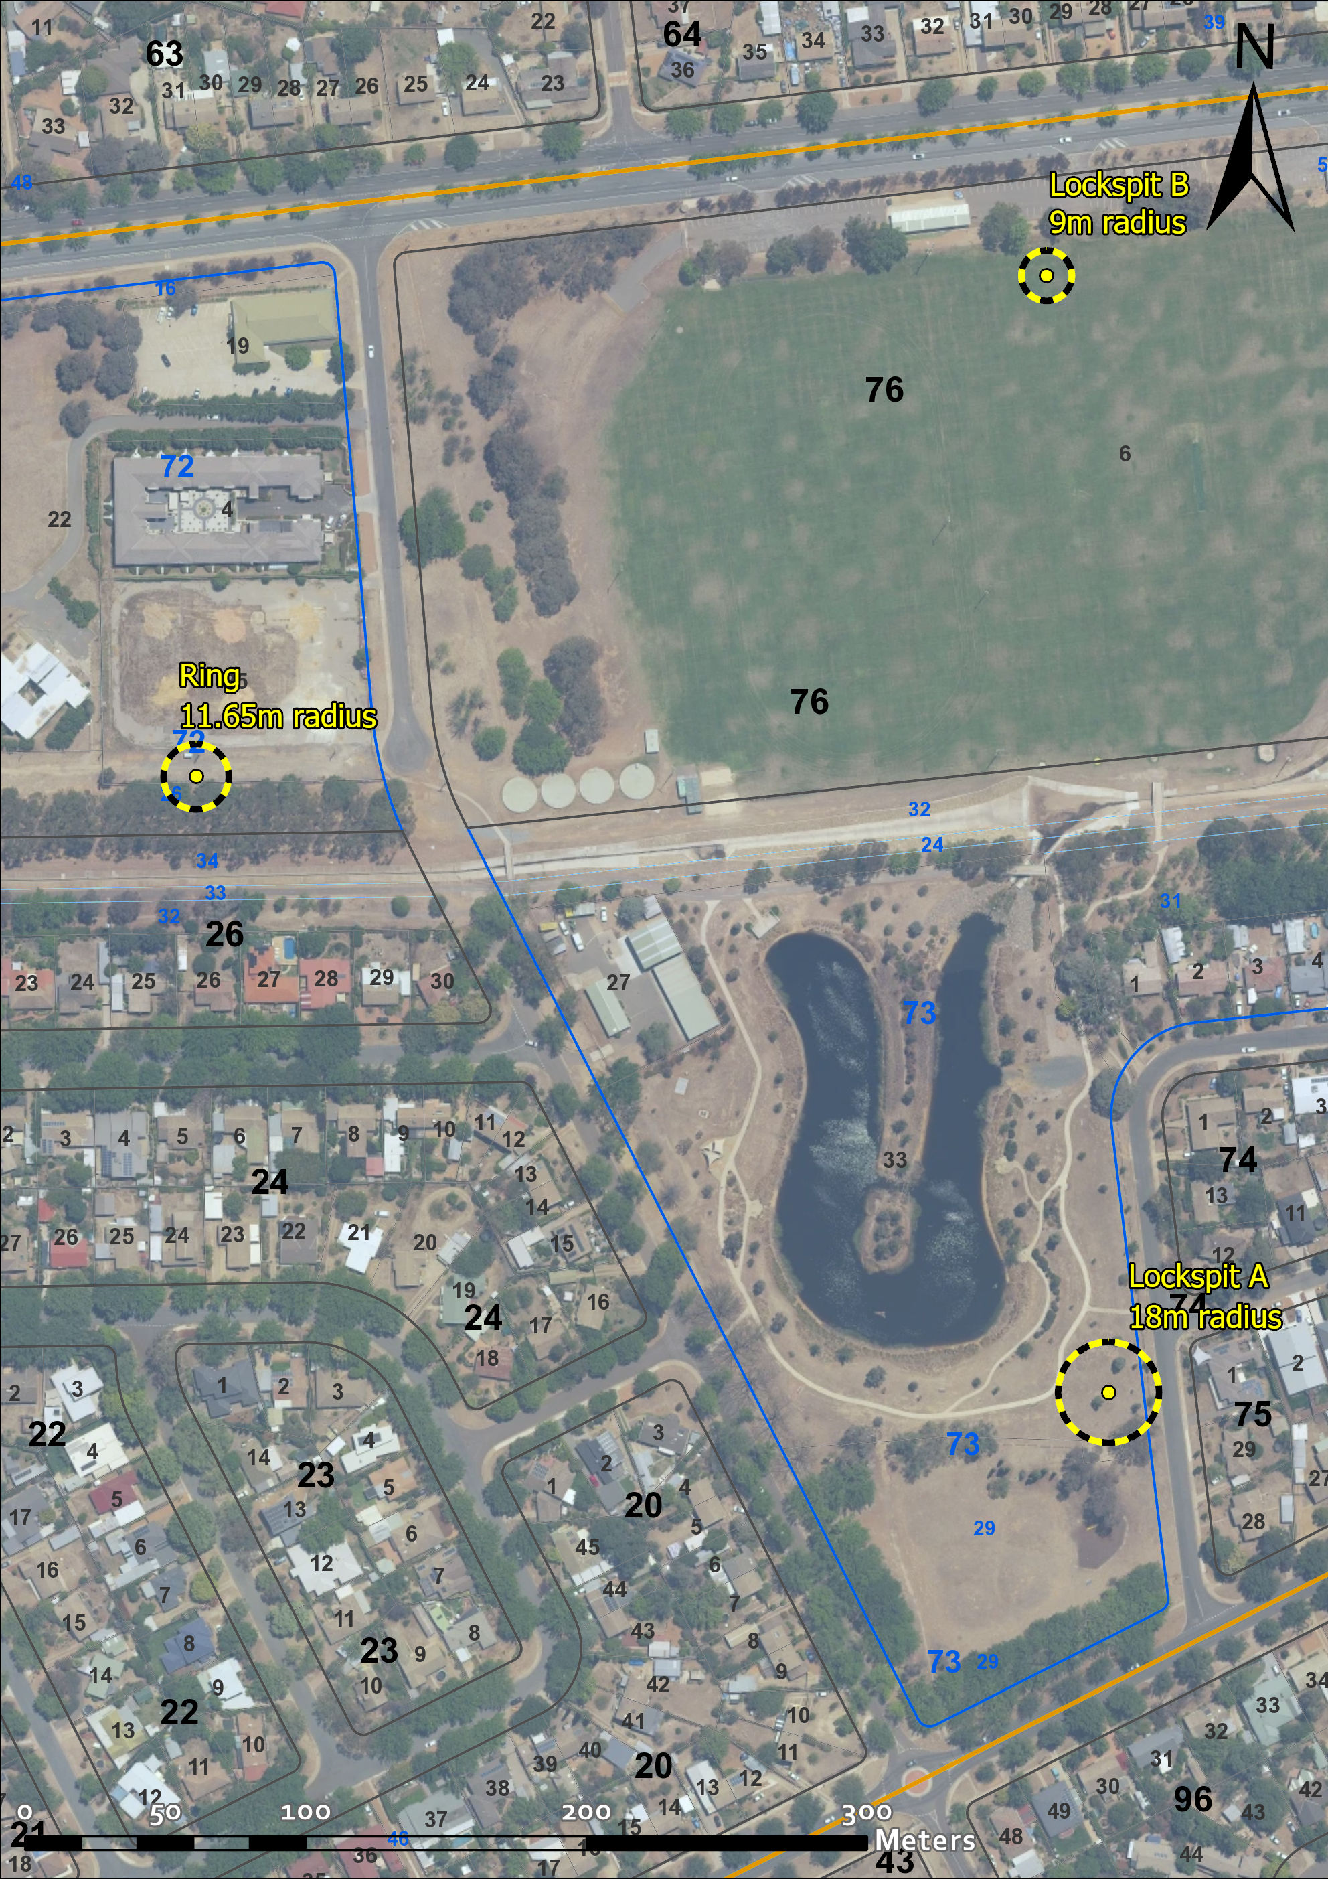

Image 1 Original Canberra Aerodrome remnants at Dickson nominated locations

