Australian Capital Territory
Veterinary Practice (Inspector) Appointment 2021 (No 1)
Notifiable instrument NI2021-223
made under the
Veterinary Practice Act 2018, section 109 (Inspector)

1 Name of instrument
This instrument is the Veterinary Practice (Inspector) Appointment 2021 (No 1).

2 Commencement
This instrument commences the day after it is notified.

3 Appointments
The ACT Veterinary Practitioners Board appoints Steven Ferguson as an inspector under the Veterinary Practice Act 2018.

4 Term of Appointment
The appointment commences the day after notification of this instrument for a period of three (3) years.

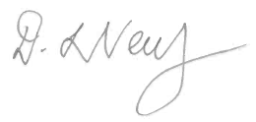

Dr Deborah Neutze

President

ACT Veterinary Practitioners Board
12 April 2021

