Australian Capital Territory
Planning and Development (Technical Amendment – Code Amendments) Plan Variation 2021 (No 1)

Notifiable instrument NI2021—290
Technical Amendment 2021-02
made under the
Planning and Development Act 2007, s 89 (Making technical amendments)

- Name of instrument
This instrument is the Planning and Development (Technical Amendment – Code Amendments) Plan Variation 2021 (No 1).
2 Commencement
This instrument commences on the day after its notification day.
3 Technical amendment
I am satisfied under section 89(1)(a) of the Planning and Development Act 2007 (the Act) that the Code Amendments is a technical amendment to the Territory Plan.
4 Dictionary
In this instrument:
Code Amendments means the technical amendment to the Territory Plan, variation 2021-02, in the schedule.
Note Limited consultation was undertaken in relation to the plan variation in accordance with section 90 of the Planning and Development Act 2007.

Lesley Cameron
Delegate of the planning and land authority
12 May 2021

Planning and Development Act 2007

Technical Amendment
to the Territory Plan

2021-02

Code Amendments
Single Dwelling Housing Development Code
Whitlam Precinct Map and Code

May 2021

Commencement version
under section 89 of the Planning and Development Act 2007

Table of Contents
1. INTRODUCTION 2
1.1 Purpose 2
1.2 Public consultation 2
1.3 National Capital Authority 3
1.4 Process 3
1.5 Types of technical amendments under the Act 3
2. EXPLANATORY STATEMENT 5
2.1 Background 5
2.2 Variation to the Single Dwelling Housing Development Code 5
2.3 Variation to the Whitlam Precinct Map and Code 8
3. TECHNICAL AMENDMENT 10
3.1 Variation to the Single Dwelling Housing Development Code 10
3.2 Variation to the Whitlam Precinct Map and Code 11

INTRODUCTION
    - Purpose
This technical amendment changes the Territory Plan as follows:
- Single Dwelling Housing Development Code:
- rule R37A is amended to:
  - exclude the eaves of a dwelling from an assessment of solar access
  - use the defined term ‘habitable room’ for the assessment of this rule, rather than ‘daytime living area’, which excludes a bedroom
- Whitlam Precinct Map and Code:
- side boundary setback requirements for dwellings and garages are revised
- amends the legend of figures 1-4, which refer to setbacks
    - Public consultation
Under section 87 of the Planning and Development Act 2007 (the Act) this type of technical amendment is subject to limited public consultation.
TA2021-02 was released for limited public consultation from 9 March 2021 to 9 April 2021. One public submission about rule R37A was received. No submissions were received about changes to the Whitlam Precinct Map and Code.
Further information on the submission received and response to the comments are contained in the report on consultation.
Comments received from the public and the National Capital Authority have been considered in the preparation of the final version of TA2021-02. Some changes were made to the technical amendment as a result of consultation.

    - National Capital Authority
The Australian Capital Territory (Planning and Land Management) Act 1988 established the National Capital Authority (NCA) with two of its functions being to prepare and administer a National Capital Plan (the Plan) and to keep the NCP under constant review and to propose amendments to it when necessary.
The Plan, which was published in the Commonwealth Gazette on 21 January 1990, is required to ensure Canberra and the Territory are planned and developed in accordance with their national significance. The Australian Capital Territory (Planning and Land Management) Act 1988 also requires the Territory Plan not be inconsistent with the Plan. The areas covered by this technical amendment are within urban areas identified in the Plan.
The National Capital Authority advised that it has no concerns with this technical amendment.
    - Process
This technical amendment has been prepared in accordance with section 87 of the Planning and Development Act 2007 (the Act).
    - Types of technical amendments under the Act
The following categories of technical amendments are provided under section 87 of the Act:
- Each of the following territory plan variations is a technical amendment for which no consultation is needed before it is made under section 89:
(a) a variation (an error variation) that –
- would not adversely affect anyone’s rights if approved; and
- has as its only object the correction of a formal error in the plan;
(b) a variation to change the boundary of a zone or overlay under section 90A (Rezoning – boundary changes);
(c) a variation, other than one to which subsection (2)(d) applies, in relation to an estate development plan under section 96 (Effect of approval of estate development plan);
(d) a variation required to bring the territory plan into line with the national capital plan;
(e) a variation to omit something that is obsolete or redundant in the territory plan.

- Each of the following territory plan variations is a technical amendment for which only limited public consultation is needed under section 90:
- a variation (a code variation) that –
- would only change a code; and
- is consistent with the policy purpose and policy framework of the code; and
- is not an error variation;
- a variation to change the boundary of a zone under section 90B (Rezoning – development encroaching on adjoining territory land);
- a variation in relation to a future urban area under section 90C (Technical amendments – future urban areas);
- a variation in relation to an estate development plan under section 96 (Effect of approval of estate development plan) if it incorporates an ongoing provision that was not included in the plan under section 94 (3) (g);
- a variation to clarify the language in the territory plan if it does not change the substance of the plan;
- a variation to relocate a provision within the territory plan if the substance of the provision is not changed.
TA2021-02 has been prepared as a code variation in accordance with section 87(2)(a) of the Act.

EXPLANATORY STATEMENT
    - Background
This part of the technical amendment document explains the changes to be made to the Territory Plan, the reasons for the change, and a statement of compliance against the relevant section of the Act.
    - Variation to the Single Dwelling Housing Development Code
Variation 346, which introduced rule R37A into the Single Dwelling Housing Development Code commenced in September 2016. Rule R37A contains provisions about solar access for blocks that were approved on or after 5 July 2013.
The intent of the provision was to require appropriate northern glazing to the main living areas of a dwelling, without the glazing being overshadowed by other structures on the site (such as fences, sheds and retaining walls) or a compliant building on the block to the north (determined by the shadow created by a ‘solar fence’).
However, the current wording of the rule can imply that the eaves of the dwelling must be considered in the overshadowing and that the solar fence is applied to the northern boundary, even if it is the front boundary (and therefore will not have an adjoining residence on that block boundary).
There is a preference of many homeowners to have a bedroom (such as the master bedroom) at the front of the block for security reasons as well as being separated from main living areas. Where this dwelling layout is used, and the northern boundary is the street boundary, the requirements of the rule are difficult to meet. While the intention of the provision was to improve solar access into a dwelling, it was not intended to significantly restrict the floor plan preferred by many homeowners on blocks where the frontage is oriented to the north.

Existing rule R37A in the Single Dwelling Housing Development Code
Rules | Criteria
5.1A Solar access – blocks which were approved on or after 5 July 2013
R37A  This rule applies to blocks approved under an estate development plan on or after 5 July 2013 for:  a) new dwellings  b) additions and alterations, only if the addition or alteration affects a daytime living area  A daytime living area is provided with a minimum of 4m² of transparent vertical glazing that:  a) is oriented between 45° east of north and 45° west of north; and  b) is not overshadowed at noon on the winter solstice (21 June) by:  i) buildings and structures on the subject block  ii) the ‘solar fence’ on the northern boundary of the subject block  For this rule:  Daytime living area means a habitable room other than a bedroom  The height of the ‘solar fence’ is:  i) in the primary building zone – 3m  ii) all other parts of the boundary – 2.3m  Note: Compliance with this rule may be demonstrated through plans, elevations and supporting documentation (e.g. shadow diagrams) showing that the required minimum area of glazing is not overshadowed. | C37A  One or more daytime living areas is provided with reasonable access to direct sunlight between the hours of 9am and 3pm on the winter solstice (21 June).  For this criterion:  Daytime living area means a habitable room other than a bedroom

Changes to R37A in Single Dwelling Housing Development Code in the consultation version of TA2021-02, showing revisions made as a result of consultation in red text
Rules | Criteria
5.1A Solar access – blocks which were approved on or after 5 July 2013
R37A  This rule applies to blocks approved under an estate development plan on or after 5 July 2013 for:  a) new dwellings  b) additions and alterations, only if the addition or alteration affects:  - habitable room (see 1 below)  ii) habitable room other than a bedroom (see 2 below)  1. Where the front boundary of the block is the northern boundary:  A habitable room is provided with a minimum of 4m² of transparent vertical glazing that:  a) is oriented between 45° east of north and 45° west of north; and  b) is not overshadowed at noon on the winter solstice (21 June) by buildings and structures on the subject block, excluding the eaves of the building.  2. For all other blocks:  A habitable room other than a bedroom is provided with a minimum of 4m² of transparent vertical glazing that:  - is oriented between 45° east of north and 45° west of north; and  - is not overshadowed at noon on the winter solstice (21 June) by:  i) buildings and structures on the subject block, excluding the eaves of the building  ii) the ‘solar fence’ on the northern boundary of the subject block.  For this rule:  - The height of the ‘solar fence’ is:  i) in the primary building zone – 3m  ii) all other parts of the boundary – 2.3m.  - A roofed outdoor area (e.g. an alfresco area) is not considered to be an eave.  Note: Compliance with this rule may be demonstrated through plans, elevations and supporting documentation (e.g. shadow diagrams) showing that the required minimum area of glazing is not overshadowed. | C37A  One or more daytime living areas is provided with reasonable access to direct sunlight between the hours of 9am and 3pm on the winter solstice (21 June).  For this criterion:  Daytime living area means a habitable room other than a bedroom.

Compliance with the Planning and Development Act 2007
Section | Statement
s87(2)(a)  (a) a variation (a code variation) that—  (i) would only change a code; and  (ii) is consistent with the policy purpose and policy framework of the code; and  (iii)is not an error variation | Compliant.  The changes facilitate intended development outcomes on blocks. The changes are consistent with the policy purpose and policy framework of the code.
    - Variation to the Whitlam Precinct Map and Code
Rule R5 in the Whitlam precinct code requires dwellings to have a minimum setback of 3m from both side boundaries, and garages to have a minimum side boundary setback of 1.5m. This rule is consistent with the approved estate development plan, but it does not correctly specify the provisions that were intended to apply.
Rule R21 in the Single Dwelling Housing Development Code allows for blocks which have an area between 500m² and 550m² to be nominated in a precinct code as
mid-sized blocks. As such, nominated blocks are subject to provisions for mid-size blocks, rather than large blocks. The minimum boundary setbacks for
mid-sized blocks are less than those required on large blocks.
Rule R5 in the Whitlam precinct code applies to large blocks, which have an area greater than 500m². Side boundary setbacks for large blocks are described in Table 5 in the Single Dwelling Housing Development Code. The minimum side boundary setback for lower floor level is 3m on side boundary 1 and 1.5m on side boundary 2.
The intent of rule R5 is to prevent nil setbacks for dwellings on large blocks which have been nominated as mid-sized blocks. The rule also intends to prevent nil setbacks for garages on large blocks which have not been nominated as mid-size blocks for the purposes of the Single Dwelling Housing Development Code.
Rule R5 is amended to make it clear that for blocks identified in figures 1, 2, 3 and 4, the following side boundary setbacks apply to the lower floor level of a dwelling: 3m on side boundary 1 and 1.5m on side boundary 2. For a garage, a minimum side boundary setback of 1.5m is required on side boundary 2.
The description in the legend which relates to setbacks in Figures 1, 2, 3 and 4 is amended in line with the changes to rule R5. The existing description ‘Side setbacks are minimum 3.0m and 1.5m for garages. No zero side setback’ is amended to ‘Dwelling and garage side boundary setbacks as specified’.

Existing rule R5
R5  This rule applies to blocks or parcels in locations identified in Figures 1, 2, 3 and 4.  The northern boundary of section 11 blocks 13 and 17 are considered side setbacks for the purposes of this rule.  Side setbacks are minimum 3m and 1.5m for garages. | This is a mandatory requirement. There is no applicable criterion.

Changes to R5 in the Whitlam Precinct Map and Code in the consultation version of TA2021-02, showing revisions made as a result of consultation in red text

R5  This rule applies to blocks or parcels in locations identified in Figures 1, 2, 3 and 4.  Lower floor level complies with the following side boundary setbacks within the primary building zone and the rear zone:  - minimum setback of 3m from side boundary 1  - minimum setback of 1.5m from side boundary 2  Garage setback is a minimum of 1.5m from side boundary 2.  The lower floor level minimum rear boundary setback and all upper floor level setbacks in Table 5 and Table 6B of the Single Dwelling Housing Development Code apply.  The northern boundary of section 11 blocks 13 and 17 are considered side setbacks for the purposes of this rule. | This is a mandatory requirement. There is no applicable criterion.

Compliance with the Planning and Development Act 2007
Section | Statement
s87(2)(a)  (a) a variation (a code variation) that—  (i) would only change a code; and  (ii) is consistent with the policy purpose and policy framework of the code; and  (iii)is not an error variation | Compliant.  The changes facilitate intended development outcomes on blocks within the division of Whitlam. The changes are consistent with the policy purpose and policy framework of the code.

TECHNICAL AMENDMENT
This section of the technical amendment document provides the actual instructions for implementing the changes to the Territory Plan.

    - Variation to the Single Dwelling Housing Development Code
- Element 5: Amenity, 5.1A Solar access – blocks which were approved on or after 5 July 2013, Rule R37A

Substitute rule R37A with
Rules | Criteria
5.1A Solar access – blocks which were approved on or after 5 July 2013
R37A  This rule applies to blocks approved under an estate development plan on or after 5 July 2013 for:  a) new dwellings  b) additions and alterations, only if the addition or alteration affects:  i) habitable room (see 1 below)  ii) habitable room other than a bedroom (see 2 below)  1. Where the front boundary of the block is the northern boundary:  A habitable room is provided with a minimum of 4m² of transparent vertical glazing that:  a) is oriented between 45° east of north and 45° west of north; and  b) is not overshadowed at noon on the winter solstice (21 June) by buildings and structures on the subject block, excluding the eaves of the building.  2. For all other blocks:  A habitable room other than a bedroom is provided with a minimum of 4m² of transparent vertical glazing that:  - is oriented between 45° east of north and 45° west of north; and  - is not overshadowed at noon on the winter solstice (21 June) by:  i) buildings and structures on the subject block, excluding the eaves of the building  ii) the ‘solar fence’ on the northern boundary of the subject block.  For this rule:  - The height of the ‘solar fence’ is:  i) in the primary building zone – 3m  ii) all other parts of the boundary – 2.3m.  - A roofed outdoor area (e.g. an alfresco area) is not considered to be an eave.  Note: Compliance with this rule may be demonstrated through plans, elevations and supporting documentation (e.g. shadow diagrams) showing that the required minimum area of glazing is not overshadowed. | C37A  One or more daytime living areas is provided with reasonable access to direct sunlight between the hours of 9am and 3pm on the winter solstice (21 June).  For this criterion:  Daytime living area means a habitable room other than a bedroom.
    - Variation to the Whitlam Precinct Map and Code
- Additional rules and criteria, RC1 – Whitlam Residential, Element 1 Building and site controls, Rule R5

Substitute rule R5 with

R5  This rule applies to blocks or parcels in locations identified in Figures 1, 2, 3 and 4.  Lower floor level complies with the following side boundary setbacks within the primary building zone and the rear zone:  - minimum setback of 3m from side boundary 1  - minimum setback of 1.5m from side boundary 2  Garage setback is a minimum of 1.5m from side boundary 2.  The lower floor level minimum rear boundary setback and all upper floor level setbacks in Table 5 and Table 6B of the Single Dwelling Housing Development Code apply.  The northern boundary of section 11 blocks 13 and 17 are considered side setbacks for the purposes of this rule. | This is a mandatory requirement. There is no applicable criterion.

- Additional rules and criteria, RC1 – Whitlam Residential, Figure 1 Whitlam residential area 1

Substitute

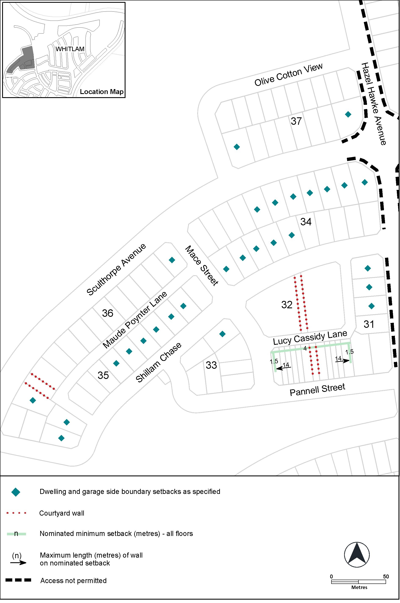

Figure 1 Whitlam residential area 1
- Additional rules and criteria, RC1 – Whitlam Residential, Figure 2 Whitlam residential area 2

Substitute

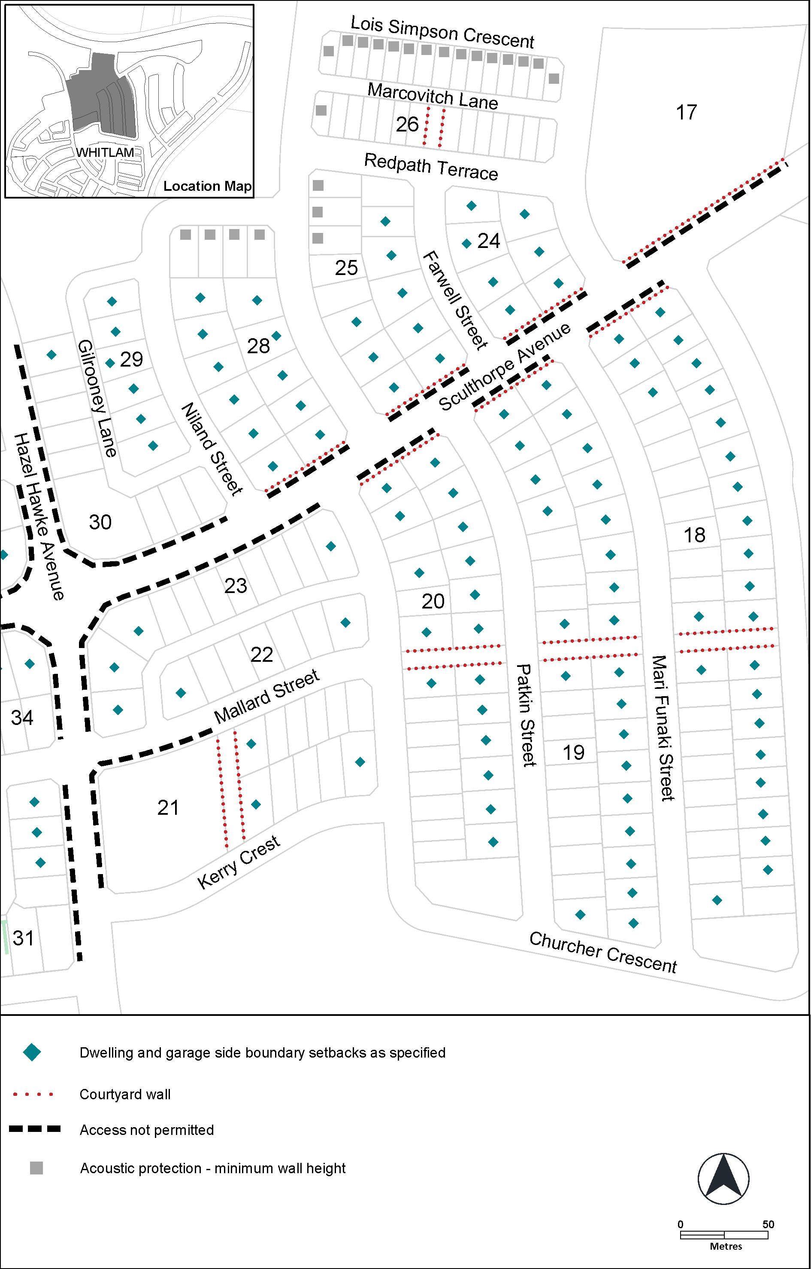

Figure 2 Whitlam residential area 2

- Additional rules and criteria, RC1 – Whitlam Residential, Figure 3 Whitlam residential area 3

Substitute

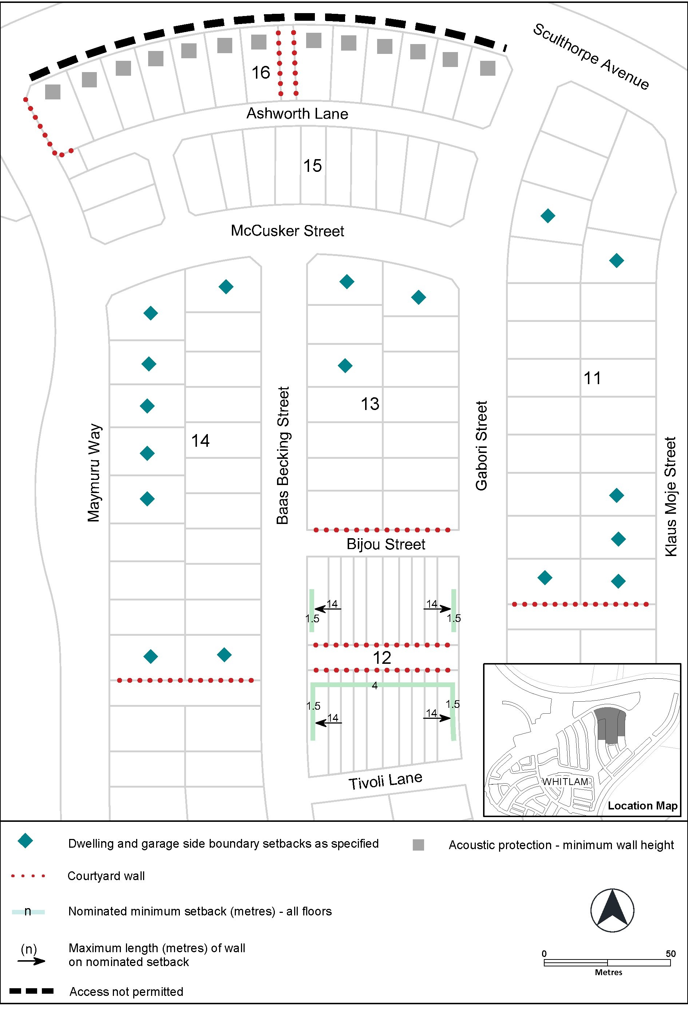

Figure 3 Whitlam residential area 3

- Additional rules and criteria, RC1 – Whitlam Residential, Figure 4 Whitlam residential area 4

Substitute

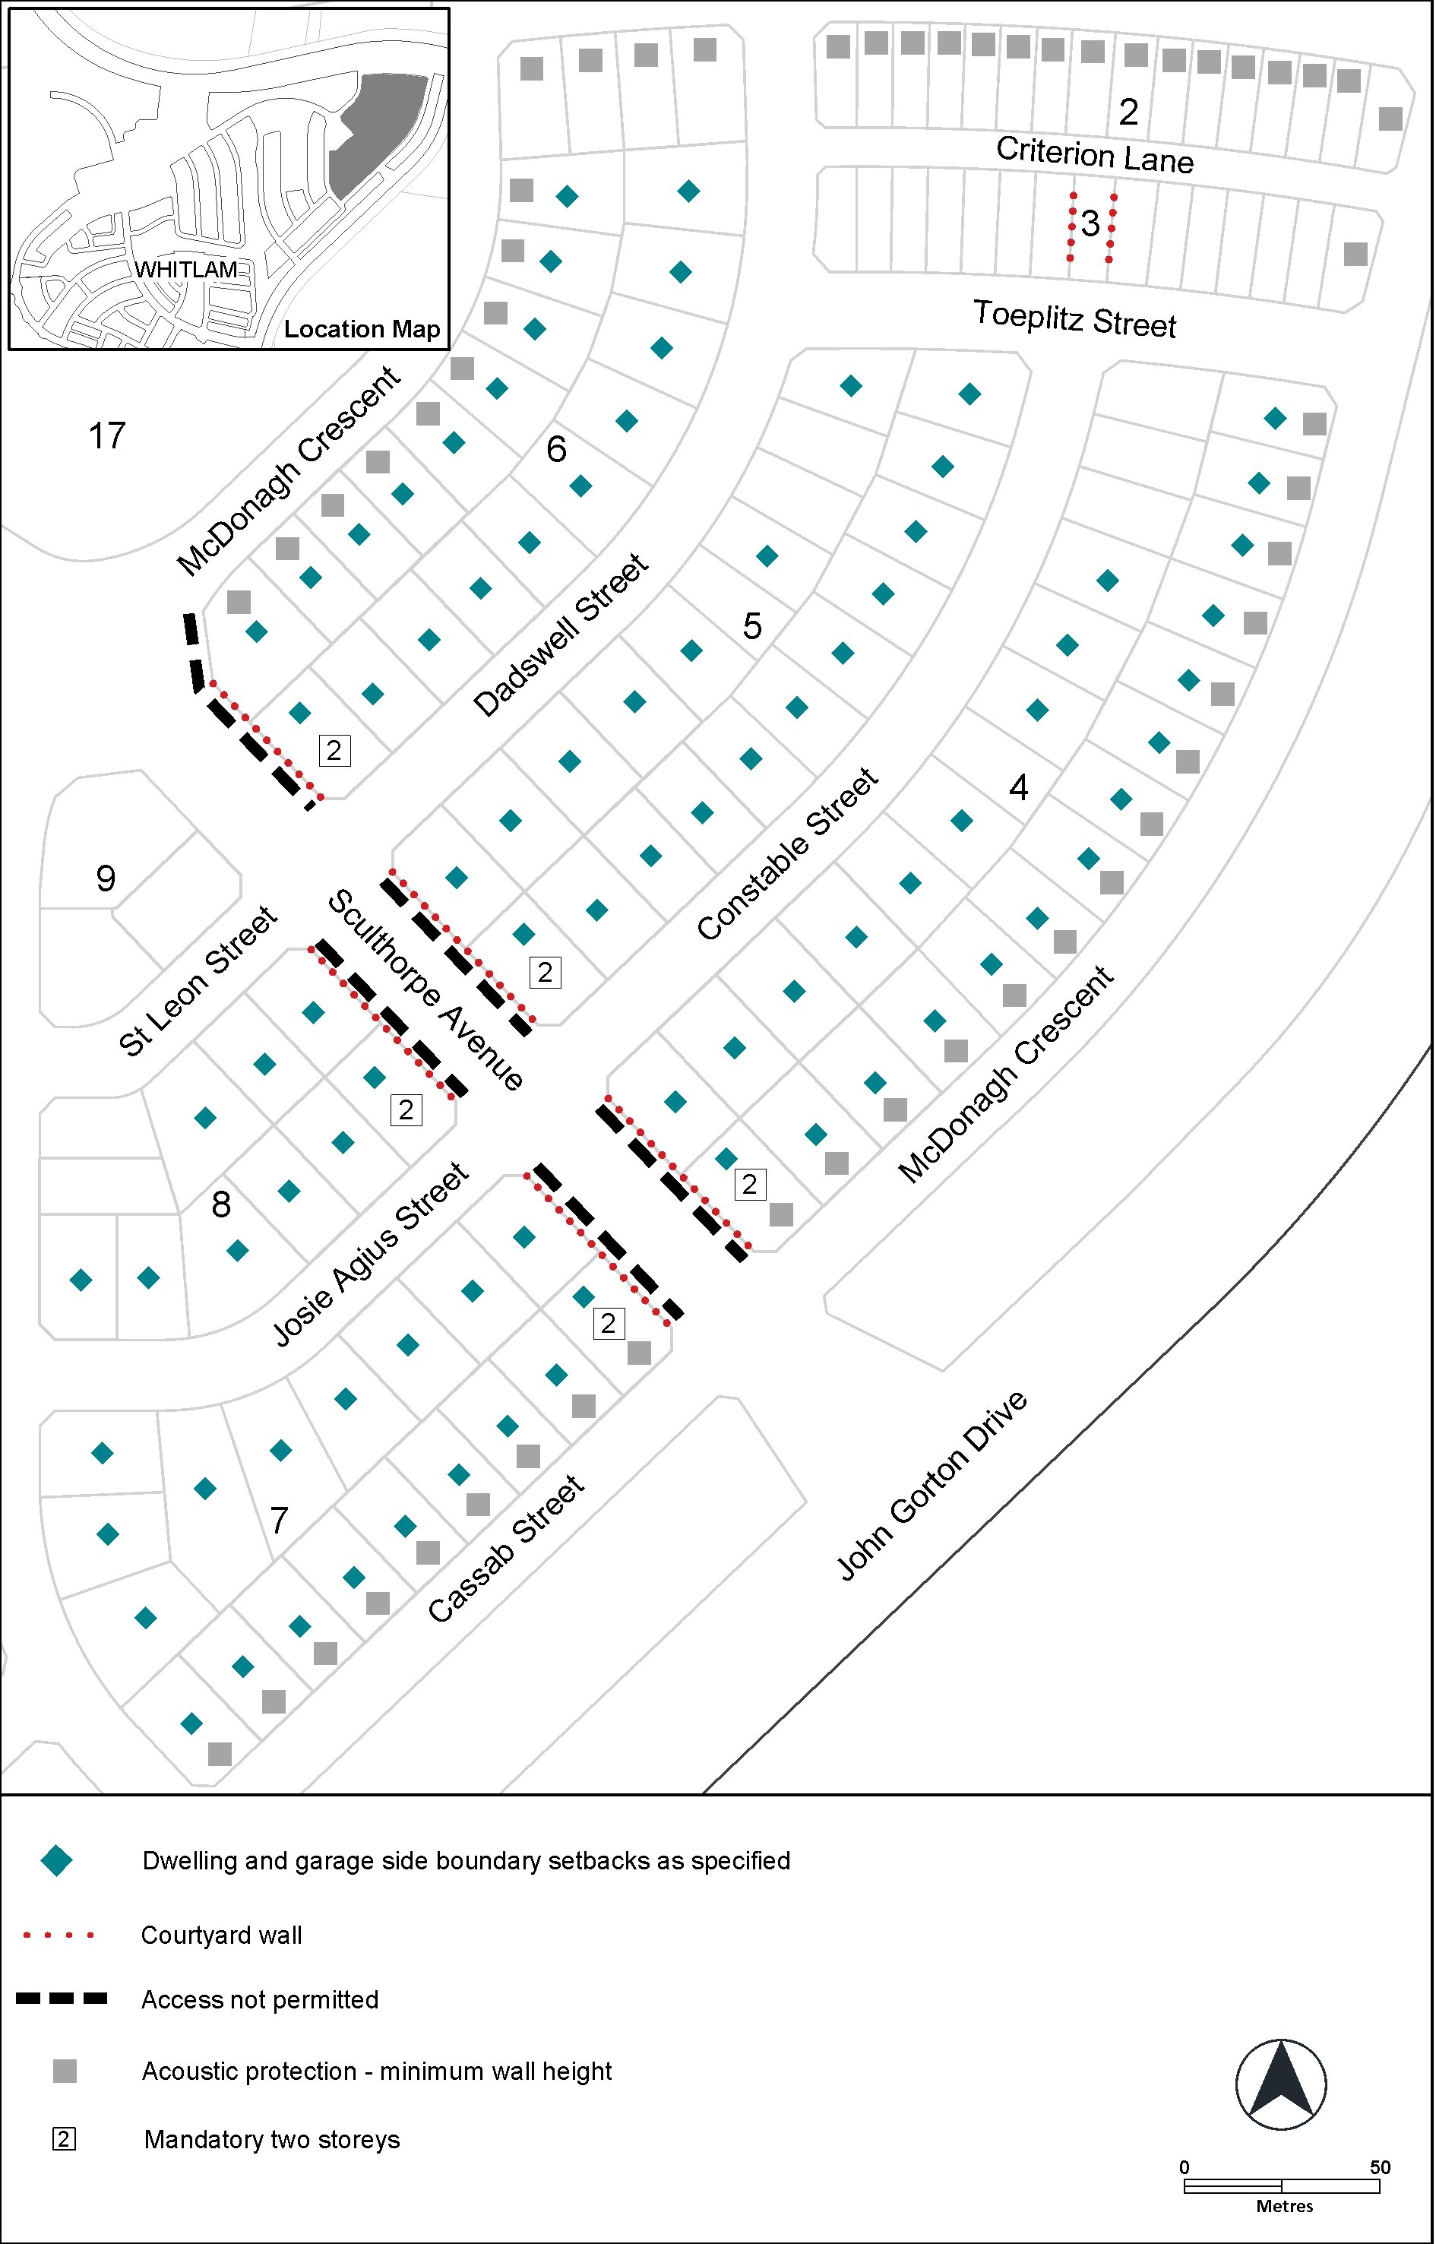

Figure 4 Whitlam residential area 4

Interpretation service
