Australian Capital Territory
Electoral (Place of Nomination – Aboriginal and Torres Strait Islander Elected Body Election) Approval 2021 (No 1)
Notifiable instrument NI2021–309
made under the
Electoral Act 1992, s 108 (Place and hour of nomination) as applied by the Aboriginal and Torres Strait Islander Elected Body Act 2008, s 31 (Application of Electoral Act)

1 Name of instrument
This instrument is the Electoral (Place of Nomination – Aboriginal and Torres Strait Islander Elected Body Election) Approval 2021 (No 1).
2 Commencement
This instrument commences on the day after it is notified.
3 Approval

I approve the following places to be places of nomination for the 2021 Aboriginal and Torres Strait Islander Elected Body election:

Village Centre Forecourt

National Arboretum Canberra

Forest Drive, Molonglo Valley ACT 2611

Boomanulla Oval

169 Goyder Street

Narrabundah ACT 2604

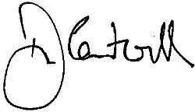

Damian Cantwell AM CSC
Electoral Commissioner
24 May 2021

