Australian Capital Territory
Planning and Development (Technical Amendment—Curtin) Plan Variation 2021
(No 1)
Notifiable instrument NI2021-324
Technical Amendment 2021-05
made under the
Planning and Development Act 2007, section 89 (Making technical amendments)

- Name of instrument
This instrument is the Planning and Development (Technical Amendment—Curtin) Plan Variation 2021 (No 1).
2 Commencement
This instrument commences on the day after its notification day.
3 Technical amendment
I am satisfied under section 89(1)(a) of the Planning and Development Act 2007 (the Act) that the Curtin plan variation is a technical amendment to the Territory Plan.
4 Dictionary
In this instrument:
Curtin plan variation means the technical amendment to the Territory Plan, variation 2021-05, in the schedule.
Note: No consultation was required in relation to the Curtin plan variation under section 87 of the Act.

Lesley Cameron
Delegate of the planning and land authority
1 June 2021

Planning & Development Act 2007

Technical Amendment
to the Territory Plan

2021-05

Changes to the Territory Plan Map to bring
in line with the National Capital Plan for
North Curtin Diplomatic Estate and Urban Area

May 2021

Table of Contents
1. INTRODUCTION 2
1.1 Purpose 2
1.2 Public consultation 2
1.3 National Capital Authority 2
1.4 Process 2
1.5 Types of technical amendments under the Act 3
2. EXPLANATORY STATEMENT 4
2.1 Background 4
2.2 Variation to the Territory Plan Map 6
3. TECHNICAL AMENDMENT 8
3.1 Variation to the Territory Plan Map 8

- INTRODUCTION
    - Purpose
This technical amendment has been prepared to bring the Territory Plan in line with the National Capital Plan following the approval of Amendment 95 to the National Capital Plan for the North Curtin Diplomatic Estate and Urban Area.
This technical amendment changes the Territory Plan Map to:
- identify the following parcels of land in Curtin as Designated Areas:
  - Section 106 Block 4
  - Section 121 Blocks 12 and 13
  - Section 114 Block 1
  - Section 77 Block 1
Note: these areas are currently shown as Non-Urban NUZ1 Broadacre zone on the Territory Plan map.
- Section 106 Blocks 5, 6, 7, 8,10,11
- Section 121 Blocks 3, 6, 7, 8, 9, 10
Note: these areas are currently shown as Parks and Recreation PRZ1 Urban Open Space zone on the Territory Plan map.
- a portion of Yarra Glen (arterial road)
Note: this area is currently shown as Transport and Services TSZ1 Transport zone on the Territory Plan map.
    - Public consultation
Under section 87 of the Planning and Development Act 2007 (the Act) this type of technical amendment is not subject to public consultation.
    - National Capital Authority
The National Capital Authority (NCA) has been provided with a copy of this technical amendment.
    - Process
This technical amendment has been prepared in accordance with section 87 and made in accordance with section 89 of the Act.
    - Types of technical amendments under the Act
The following categories of technical amendments are provided under section 87 of the Act:
- Each of the following territory plan variations is a technical amendment for which no consultation is needed before it is made under section 89:
(a) a variation (an error variation) that –
- would not adversely affect anyone’s rights if approved; and
- has as its only object the correction of a formal error in the plan;
(b) a variation to change the boundary of a zone or overlay under section 90A (Rezoning – boundary changes);
(c) a variation, other than one to which subsection (2)(d) applies, in relation to an estate development plan under section 96 (Effect of approval of estate development plan);
(d) a variation required to bring the territory plan into line with the national capital plan;
(e) a variation to omit something that is obsolete or redundant in the territory plan.
- Each of the following territory plan variations is a technical amendment for which only limited public consultation is needed under section 90:
- a variation (a code variation) that –
- would only change a code; and
- is consistent with the policy purpose and policy framework of the code; and
- is not an error variation;
- a variation to change the boundary of a zone under section 90B (Rezoning – development encroaching on adjoining territory land);
- a variation in relation to a future urban area under section 90C (Technical amendments – future urban areas);
- a variation in relation to an estate development plan under section 96 (Effect of approval of estate development plan) if it incorporates an ongoing provision that was not included in the plan under section 94 (3) (g);
- a variation to clarify the language in the territory plan if it does not change the substance of the plan;
- a variation to relocate a provision within the territory plan if the substance of the provision is not changed.
TA2021-05 has been prepared in accordance with section 87(1)(d) of the Act.
- EXPLANATORY STATEMENT
    - Background
This part of the technical amendment document explains the changes to be made to the Territory Plan, the reasons for the change, and a statement of compliance against the relevant section of the Act.
North Curtin Diplomatic Estate and Urban Area
Amendment 95 to the National Capital Plan - North Curtin Diplomatic Estate and Urban Area was prepared to provide suitable land to accommodate the long term growth of diplomatic missions in the nation’s capital city, Canberra.
Amendment 95 changed the land use policy of Curtin section 106 block 4 and section 121 blocks 12 and 13 (including a portion of the north Curtin horse paddocks) to facilitate the development of a new diplomatic estate, and to create a new urban area adjacent to the estate.
On 19 October 2020, the Assistant Minister for Regional Development and Territories approved National Capital Plan Amendment 95, and it took effect on 28 October 2020. These parcels of land were incorporated into the Designated Areas under the National Capital Plan.
Amendment 95 can be viewed at www.nca.gov.au/amendment-95-north-curtin-diplomatic-estate-and-urban-area.
This technical amendment brings the Territory Plan in line with the National Capital Plan by indicating on the Territory Plan Map the parcels of land which are Designated Areas and that were subject to Amendment 95. All the parcels of land subject to identification as designated land are shown in Figures 3 and 4 at Section 2.2 of this document.
Compliance with the Planning and Development Act 2007
Section | Statement
s87(1)(d) a variation required to bring the Territory Plan into line with the national capital plan. | Compliant. The change to the Territory Plan Map is consistent with Amendment 95 to the National Capital Plan – North Curtin Diplomatic Estate and Urban Area which identifies the land as Designated Areas. The changes to the Territory Plan Map for Woden Valley and Weston Creek will show the land as being in Designated Areas in line with the National Capital Plan.

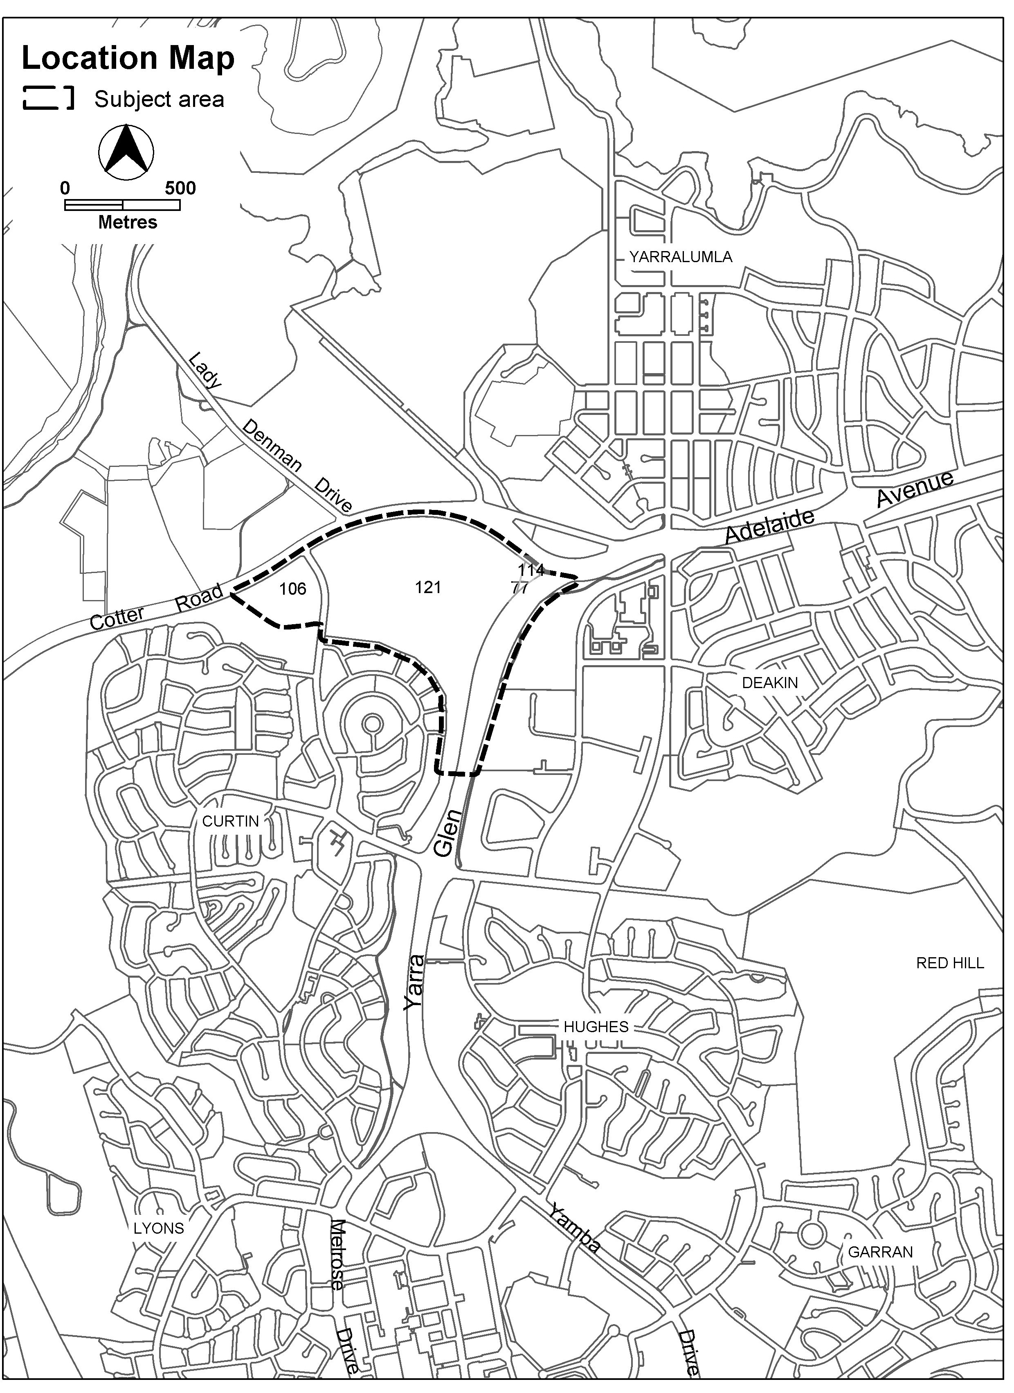
Figure 1 Location map – North Curtin Diplomatic Estate and Urban Area

    - Variation to the Territory Plan Map
This technical amendment changes the Territory Plan Map as follows:

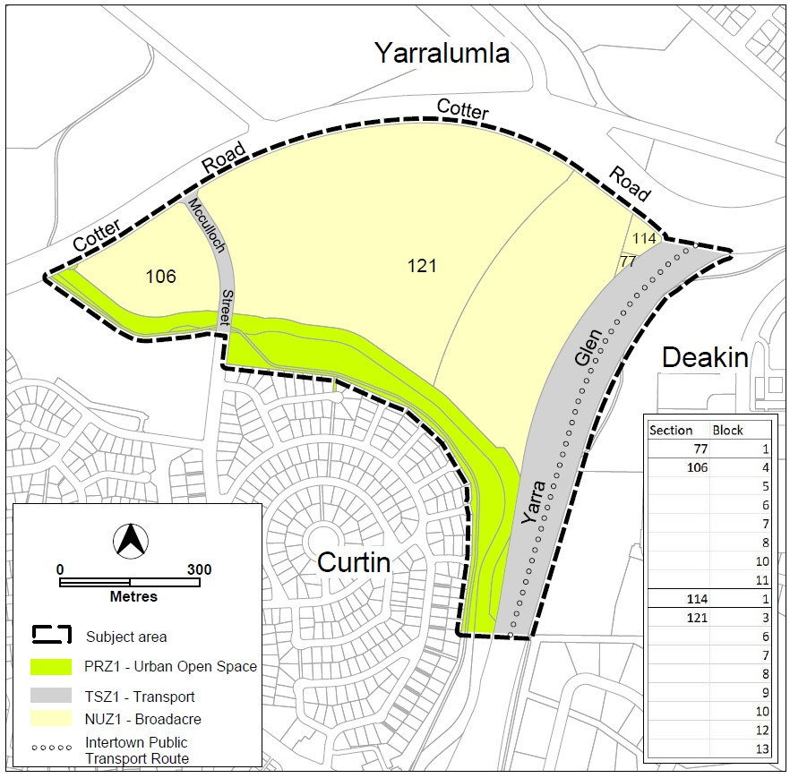
Figure 2 Existing Territory Plan Map Curtin

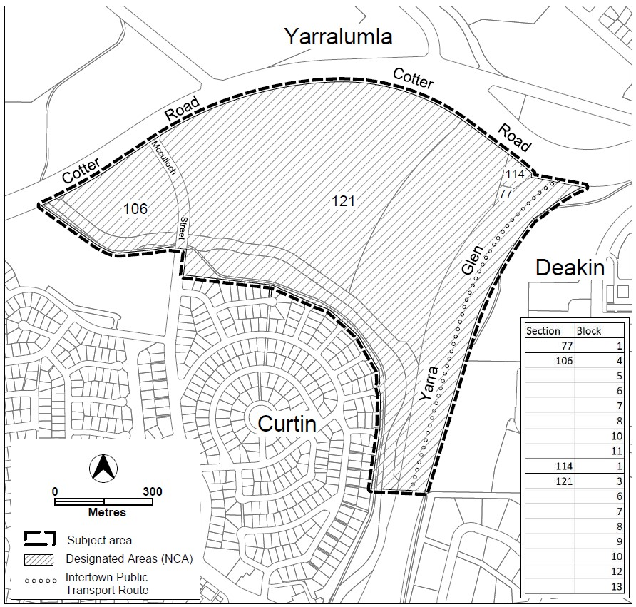
Figure 3 Proposed Territory Plan Map Curtin

- TECHNICAL AMENDMENT
This section of the technical amendment document provides the actual instructions for implementing the changes to the Territory Plan.

    - Variation to the Territory Plan Map
- Territory Plan Map

The Territory Plan map is varied as indicated below:

Interpretation service
