Australian Capital Territory
Planning and Development (Draft Variation 328) Consultation Notice 2021
Notifiable instrument NI2021-463
made under the
Planning and Development Act 2007, s 63 (Public consultation—notification)

- Name of instrument
This instrument is the Planning and Development (Draft Variation 328) Consultation Notice 2021.

- Draft variation to the Territory Plan
The planning and land authority (the Authority) has prepared a draft plan variation 328 – Oaks Estate: Zone changes and amendments to the Oaks Estate Precinct Map and Code (revised) (the draft variation) to vary the Territory Plan. The draft variation proposes amendments to the Territory Plan Map for Oaks Estate and the Oaks Estate Precinct Map and Code to implement recommendations from the Oaks Estate Master Plan and to respond to public comments received during previous consultation.

- Documents available for public inspection
(1) The Authority gives notice that the following documents are available for public inspection and purchase:
(a) the draft variation; and
(b) the background papers relating to the draft variation.
(2) Copies of the documents mentioned in section 3 (1) are available for inspection and purchase at Access Canberra, Land Planning and Building Services Shopfront, 8 Darling Street Mitchell ACT, Monday to Friday (except public holidays) between 8:30am and 4:30pm for the period commencing on the day this notice commences and ending on Friday 17 September 2021 (the consultation period).
(3) Copies of the documents mentioned in section 3 (1) are also available for inspection during the consultation period online at www.act.gov.au/draftvariations

- Invitation to give written comments
(1) The Authority invites written comments about the draft variation during the consultation period. Comments should include reference to the draft variation and be addressed to the Territory Plan Section of the Environment, Planning and Sustainable Development Directorate (EPSDD). Please also provide your name and contact details to assist in the assessment of the comments provided and to enable the Authority to contact you in relation to your comments, if required.
(2) Written comments should be provided to the Authority by:
(a) email to terrplan@act.gov.au; or
(b) mail to Territory Plan Section, EPSDD, GPO Box 158, Canberra, ACT 2601; or
(c) hand delivery to Access Canberra, Land Planning and Building Services Shopfront, 8 Darling Street, Mitchell ACT.
Note All personal information will be managed in accordance with the Information Privacy Act 2014 and the EPSDD Information Privacy Policy which are available through the EPSDD website.

- Public inspection of written comments
(1) Copies of written comments about the draft variation given in response to the invitation in section 4, or otherwise, or received from the National Capital Authority will be available (unless exempted) for public inspection for a period of at least 15 working days starting 10 working days after the day the consultation period ends, at Access Canberra, Land Planning and Building Services Shopfront, 8 Darling Street, Mitchell, Monday to Friday (except public holidays) between 8:30am and 4:30pm and may be published on the EPSDD website at www.planning.act.gov.au.
(2) You may apply under section 411 of the Planning and Development Act 2007 (the Act) for part of your consultation comments to be excluded from being made available to the public. A request for exclusion under this section must be in writing, clearly identifying what you are seeking to exclude and how the request satisfies the exclusion criteria. Please note that your name and contact details and other personal information will not be made public unless you request otherwise.

- Effect of the draft variation
Section 65 of the Act applies to the draft variation. This means that the Territory, the Executive, a Minister or a territory authority must not, during the defined period, do or approve the doing of anything that would be inconsistent with the Territory Plan if it were varied in accordance with the draft variation.
Note Defined period, for a draft variation—see the Planning and Development Act 2007, section 65 (3).

- Obtaining further information
Further information about the draft variation can be obtained through email correspondence with the Territory Plan Section, EPSDD, at mailto:terrplan@act.gov.au A reference to the draft variation should be included in any email.

- Dictionary
In this instrument:
draft plan variation 328 – Oaks Estate: Zone changes and amendments to the Oaks Estate Precinct Map and Code (revised) means the draft plan variation in Schedule 1.

Dr Erin Brady
Delegate of the planning and land authority
30 July 2021

Planning and Development Act 2007

Draft
Variation to the
Territory Plan
328

Oaks Estate:
Zone changes and amendments to the Oaks Estate precinct map and code (revised)

August 2021

Draft variation for public consultation prepared
under s60 of the Planning and Development Act 2007

This page is intentionally blank.

Contents
1. INTRODUCTION 1
1.1 Summary of the Proposal 1
1.2 Outline of the process 2
1.3 Public Consultation 3
2. EXPLANATORY STATEMENT 4
2.1 Background 4
2.1.1 Public submissions 4
2.1.2 Historical context 5
2.1.3 Heritage values 5
2.1.4 Commercial zone changes 6
2.1.5 Contamination studies 6
2.1.6 Restrictions on uses 7
2.1.7 Views and rural surrounds 8
2.1.8 Future development and desired character 8
2.1.9 ACT Government Land Release Program 8
2.2 Site Description 9
2.3 Current Territory Plan Provisions 9
2.4 Proposed Changes 10
2.4.1 Proposed Changes to the Territory Plan Map 10
2.4.2 Proposed Changes to Territory Plan 11
2.5 Reasons for the Proposed Draft Variation 12
2.6 Planning Context 12
2.6.1 National Capital Plan 12
2.6.2 ACT Planning Framework 13
2.7 Interim Effect 14
2.8 Consultation with Government Agencies 15
3. DRAFT VARIATION 18
3.1 Variation to the Territory Plan Map 18
3.2 Variation to the Territory Plan 19

FIGURES
Figure 1: Location map and area subject to the variation and rezoning 10
Figure 2: Current Territory Plan Zones Map 11
Figure 3: Proposed changes to the Territory Plan Map 12
Figure 4: Proposed Territory Plan Map for Oaks Estate 18

This page is intentionally blank.
- INTRODUCTION
  - Summary of the Proposal
The revised draft variation to the Territory Plan 328 implements the recommendations of the endorsed Oaks Estate Master Plan 2014, as well as responding to concerns raised during initial public consultation undertaken in early 2015. The draft variation proposes amendments to the Oaks Estate Precinct Map and Code to provide opportunities for limited growth and change in the suburb and to preserve the history and character of Oaks Estate.
The main changes from the previously notified 2015 version of the draft variation include:
- rezoning the Commercial CZ5 Mixed Use area to Commercial CZ4 Local Centre to reflect the intended use of the area and future desired character of a small commercial area to service the needs of the local community and provide opportunities for appropriate levels of development
- permitting apartments only where located over ground floor commercial development in the commercial local centre
- limiting development within the commercial local centre to a maximum of two storeys
- introducing provisions to protect the village character including:
  - restricting site coverage of development on blocks
  - allowing for varied setbacks
  - allowing low, transparent fencing to the front boundary in the residential area where vehicle and pedestrian sightlines are maintained
  - introducing a ‘statement of desired character’ for the commercial area and residential area into the precinct code.
Other changes include rectifying errors in the Assessment Tracks in the Oaks Estate Precinct Map and Code for additional permitted and prohibited uses. These errors occurred during the transition from the former Territory Plan to the restructured Territory Plan in 2008.

  - Outline of the process
The Commonwealth’s Australian Capital Territory (Planning and Land Management) Act 1988 allows for the Legislative Assembly to make laws to establish a Territory Planning Authority and for that Authority to prepare and administer a Territory Plan. The Planning and Development Act 2007 (the Act) establishes the planning and land authority as the Authority that prepares and administers the Territory Plan, including continually reviewing and proposing amendments as necessary. The functions of the planning and land authority are administered by the Environment, Planning and Sustainable Development Directorate (EPSDD). The Director-General of EPSDD is the planning and land authority.
The Territory Plan is comprised of a written statement and a map. The written statement contains a number of parts, namely governance; strategic directions; zones (including objectives and development tables and zone or centre development codes); precinct codes; general codes; overlays; definitions; structure plans, concept plans and development codes for future urban areas.
The Territory Plan Map graphically represents the applicable land use zones (under the categories of residential, commercial, industrial, community facility, urban parks and recreation, transport and services and nonurban), precincts and overlays. The zone, precinct and overlay requirements are detailed in the Territory Plan.
Draft variations to the Territory Plan are prepared in accordance with the Act. Following the release of the draft variation under section 63 of the Act, submissions from the public are invited. At the conclusion of the consultation period the EPSDD (planning and land authority) submits a report on consultation and a recommended final variation to the Minister responsible for planning for referral to the Legislative Assembly standing committee responsible for planning. The Minister must consider any recommendations of the committee before deciding whether to approve the draft variation. If the Minister approves the variation, the variation and associated documents will be tabled in the Legislative Assembly. Unless disallowed by the Legislative Assembly within five sitting days, the variation commences on a day nominated by the Minister.

  - Public Consultation
Written comments about the draft variation are invited from the public by Friday 17 September 2021.
Comments should include reference to the draft variation and be addressed to the Territory Plan Section, EPSDD. Please also provide your name and contact details to assist in the assessment of the comments provided, and to enable EPSDD to contact you in relation to your comments, if required. Your personal information will be managed in accordance with the Information Privacy Act 2014 and the EPSDD Information Privacy Policy, which is available for viewing on EPSDD’s website.
Comments can be:
- emailed to terrplan@act.gov.au
- mailed to Territory Plan Section, GPO Box 158, Canberra, ACT 2601
- delivered to the Access Canberra Land, Planning and Building Services Shopfront, 8 Darling Street, Mitchell ACT.
Copies of written comments received with respect to the draft variation will be made available for public inspection for no less than 15 working days starting 10 working days after the closing date for comment. The comments will be available at the Access Canberra Land, Planning and Building Services Shopfront, 8 Darling Street, Mitchell ACT and will be published on EPSDD’s website. Comments made available will not include personal contact details unless you request otherwise.
A request may be made for parts of a submission to be excluded under section 411 or 412 of the Planning and Development Act 2007. A request for exclusion under these sections must be in writing, clearly identifying what parts of your submission you are seeking to exclude and how the request satisfies the exclusion criteria.
Further Information
The draft variation is available online at www.act.gov.au/draftvariations until the closing date for written comments.
Printed copies of the draft variation (this document) is available for inspection and purchase at the Access Canberra Land, Planning and Building Services Shopfront, 8 Darling Street, Mitchell ACT, Monday to Friday (except public holidays) between 8:30am and 4:30pm. Please call 6207 1923 to arrange a copy for purchase.

- EXPLANATORY STATEMENT
  - Background
The ACT Government prepared a series of master plans for selected areas that identified the existing character and opportunities and constraints affecting each area. The master plans made recommendations for each area to protect or develop desired character while providing future development opportunities.
The Oaks Estate Master Plan, covering the suburb of Oaks Estate, was developed with input from the local community during 2012 to 2014 and endorsed by the ACT Government in November 2014. One of the key measures for implementing the recommendations of the Oaks Estate master plan as to prepare a draft variation to the Territory Plan.
The Oaks Estate master plan is accessible at:
https://www.planning.act.gov.au/tools_resources/plans-registers/plans/master-plans/oaks_estate_master_plan
A draft variation was prepared in 2015 to implement the outcomes and recommendations of the Oaks Estate master plan into the Territory Plan.
    - Public submissions
Comments were initially invited from the public from 30 January 2015 till 16 March 2015.Thirty-two (32) submissions were received from local residents and others with an interest in the suburb.
The main issues raised in the public consultation relating to the draft variation were:
- concerns about proposed bulk and scale of development in the commercial area – it was suggested that apartments be prohibited and that development be limited to two storeys
- protection of the history and heritage character of the suburb – the inclusion of a range of additional rules to control the built form and reflect the desired character for the suburb were requested
Following public consultation, the draft variation was put on hold while the heritage nomination status of the suburb was considered by the ACT Heritage Council and other matters were resolved.
These issues were taken into consideration and addressed in this revised draft variation.
    - Historical context
Oaks Estate is a village suburb of Canberra located to the east of the city, on the border with the New South Wales city of Queanbeyan. The area was first inhabited by Aboriginal people, including the Ngunnawal, Ngarigo and Walgalu. European history in the area began with a large estate, named ‘The Oaks’, established in 1837. After changing ownership numerous times, the estate was eventually subdivided into 300 building allotments in 1887. It was initially developed as part of Queanbeyan and was later amalgamated into the ACT in 1911 following the decision that the boundary should follow the railway line rather than the river.
In the early part of the 20th century, Oaks Estate was a temporary workers’ settlement, housing the builders who constructed the early parts of Canberra. After World War II, migrants from Eastern Europe and the Mediterranean arrived in Oaks Estate, with many establishing home-based businesses and industries.
More detailed information about the historical background of Oaks Estate is contained in the Oaks Estate Master Plan and also in the ACT Heritage Council Statement of Reasons referred to in section 2.1.3 below.
    - Heritage values
Two sites within Oaks Estate are registered on the ACT Heritage Register – being ‘the Oaks’ (section 2 block 15 and 16) and ‘Robertsons’ House’ (section 7 blocks 11 and 12).
At the time the draft variation was originally released for consultation, there were a number of locations within Oaks Estate nominated for inclusion on the Heritage Register. These sites were identified as having potential heritage significance, or otherwise contributing to the character of the suburb. A number of submissions received during consultation on the draft variation were about the heritage character of Oaks Estate and the nomination of the entire suburb for inclusion on the ACT Heritage Register.
In April 2017, the ACT Heritage Council resolved not to register the nominated sites, determining that the suburb was not historically or architecturally significant enough to meet the criteria for listing.
This decision and a detailed Statement of Reasons is contained in Notifiable Instrument NI2017-173 accessible on the Legislation Register at:
https://www.legislation.act.gov.au/View/ni/2017-173/current/PDF/2017-173.PDF
The heritage citation for Robertsons’ House includes section 7 block 11 and block 12 of Oaks Estate. Any proposal to develop surrounding sites would need to consider the heritage citation, and requirements for a buffer to the heritage site was introduced as a provision in the Oaks Estate precinct code in line with previous advice from the ACT Heritage Council. These provisions were incorporated into the 2015 public consultation version of the draft variation and are retained in this version.
    - Commercial zone changes
Some submissions contended that the existing Commercial CZ5 Mixed Use zone for the commercial area is not appropriate to the area.
The CZ5 zoning was introduced in the 2008 Territory Plan, replacing the A9 Residential Mixed Use land use policy from the previous Territory Plan. While the Oaks Estate master plan did not propose changing the CZ5 Mixed Use zone, a further review of the zone objectives and development tables concluded that the CZ4 Local Centre zone would be a more appropriate zone for the commercial area of Oaks Estate. This is because the CZ4 zone limits heights to two storeys and provides for a local centre to serve the needs of the community while enabling the village ambience of Oaks Estate to be maintained.
The draft variation also includes some of the recommendations of the Oaks Estate Master Plan for certain development opportunities along Railway Street. Allowable merit assessable uses are limited to those listed in the CZ4 development table and any additional permitted or prohibited uses currently listed in the precinct code. The additional permitted and prohibited uses listed in the precinct code take precedence over the CZ4 development table. The revised Oaks Estate precinct map and code is located at Appendix 1 of this document. The CZ4 development table is located in the Territory Plan under section 4 Commercial Zones and can be accessed at:
https://www.legislation.act.gov.au/ni/2008-27/Current
Issues such as traffic generation and management, parking and streetscape character are assessed as part of a development application that will be required for any future development proposals on blocks in the CZ4 zone within Oaks Estate.
    - Contamination studies
A number of sites were identified by the Environment Protection Authority (EPA) as requiring contamination studies to be undertaken. Initial contamination assessment studies have been undertaken on unleased Territory owned blocks that are on the Government’s Land Release Program.
A new provision has been added to the Oaks Estate Precinct Map and Code requiring an environmental assessment into the site’s suitability from a contamination perspective to be undertaken in accordance with the ACT Contaminated Sites Environment Protection Policy and to be endorsed by the Environment Protection Authority prior to development or a change in use.
    - Restrictions on uses
The draft variation proposes to rectify errors in the uses currently listed as prohibited and/or permitted on certain blocks in the Oaks Estate precinct map and code. This anomaly occurred when the old Territory Plan was superseded by the restructured Territory Plan in 2008.
Light industrial use will be restricted to the blocks where it is already a permitted use in a lease, and some uses will either be prohibited or restricted in accordance with the master plan recommendations. As a result of the change of zone from CZ5 to CZ4, some allowable uses in the CZ4 zone will also be prohibited in the relevant tables as these are considered to be incompatible with the village character of Oaks Estate.
The 35% site coverage restriction for residential blocks proposed in the precinct code is in line with the recommendations of the master plan. This will enable the retention of substantial areas of open space on residential blocks for deep root planting, whilst allowing a moderate developable area for a dwelling and other structures.
Some additional provisions are proposed for the residential area of Oaks Estate to maintain its village character. These provisions are included in the precinct code under the new ‘RC2 – Residential Area’ sub-precinct (see Appendix 1). The provisions include controls on the redevelopment of multi-unit sites, site coverage restrictions, landscaping requirements for deep root plantings, and allowances for front fencing.
Other controls applying to residential development are contained in the Single Dwelling Housing Development Code and Multi-Unit Housing Development Code in the Territory Plan. These codes can be found at parts 3.3 and 3.4 of the Territory Plan respectively: https://www.legislation.act.gov.au/ni/2008-27/Current
By way of explanation, if the codes contain provisions which are inconsistent with each other, a precinct code, such as the Oaks Estate precinct map and code provisions takes precedence over a development code (in accordance with the hierarchy of codes specified in the Planning and Development Act 2007.
    - Views and rural surrounds
Views and vistas are protected by existing street alignments, a maximum two storey building height limit and existing zone development controls in the Non-Urban Zone development code. The rural surrounds are also protected from inappropriate development through the Non-Urban Zone development code.
    - Future development and desired character
There are a number of changes proposed in the draft variation responding to concerns about the nature of future development and protecting the village character. These include:
- retaining the two storey maximum building height in the commercial area
- limiting new apartments in the commercial area to only be permitted where located above ground floor commercial use
- rezoning the commercial area from CZ5 Mixed Use zone, which permits a wide range of uses with limited controls, to CZ4 Local Centre zone, which permits uses that are more appropriate for a small commercial area to serve local residents
- encouraging new commercial uses, where permitted, to address Railway Street and/or McEwan Avenue and provide active frontages to these streets where possible, such as shop fronts, entrances, windows and the like
- introducing a ‘statement of desired character’ for the commercial area and residential area into the precinct code.
    - ACT Government Land Release Program
There are a number of vacant, unleased blocks in Oaks Estate that are on the Government’s Indicative Land Release Program for 2021-2022. These are:
- Residential: Blocks 1,2, and 3 Section 5; Blocks 14 and 15 Section 11 and Block 31 Section 8 Oaks Estate
- Commercial: Blocks 5,6 and 9 Section 7 Oaks Estate
The EPSDD Development and Implementation Division has completed the due diligence studies on the sites (including contamination reports for the commercial sites) to prepare them for sale. The draft variation has interim effect so the proposed provisions in the Oaks Estate Precinct Map and Code will apply to the blocks to be sold.
  - Site Description
The subject area is located between the Molonglo River to the north, the Queanbeyan River to the east and the ACT/NSW border to the south and is directly adjacent to the NSW township of Queanbeyan. The residential area predominantly contains single dwellings, with a number of two to four storey multi-unit developments. The compact commercial area is generally single storey, with some bulkier industrial buildings, and several undeveloped blocks.
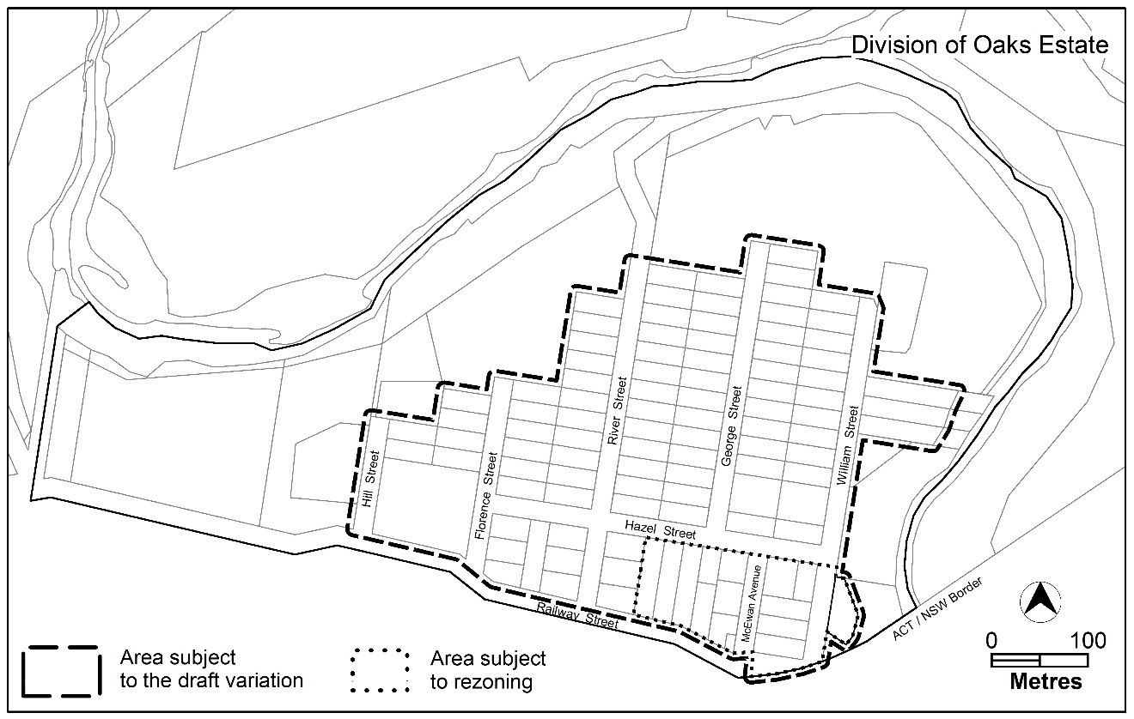
Figure 1: Location map and area subject to the variation and rezoning

  - Current Territory Plan Provisions
The Territory Plan Map zones for the area subject to this draft variation are shown in Figure 2. Oaks Estate is primarily zoned Residential RZ1 Suburban area, with Commercial CZ5 Mixed Use and Parks and Recreation PRZ1 Urban Open Space zones to the south and east. To the north of the RZ1 residential area is the Non Urban NUZ2 Rural zone and NUZ4 River Corridor zone, which contains the Molonglo River and Queanbeyan River corridors.
The Oaks Estate precinct map and code applies to the subject area, as well as various development codes in the Territory Plan applicable to the residential, commercial, urban open space and non-urban zones. Various general codes may also apply for specific types of development.
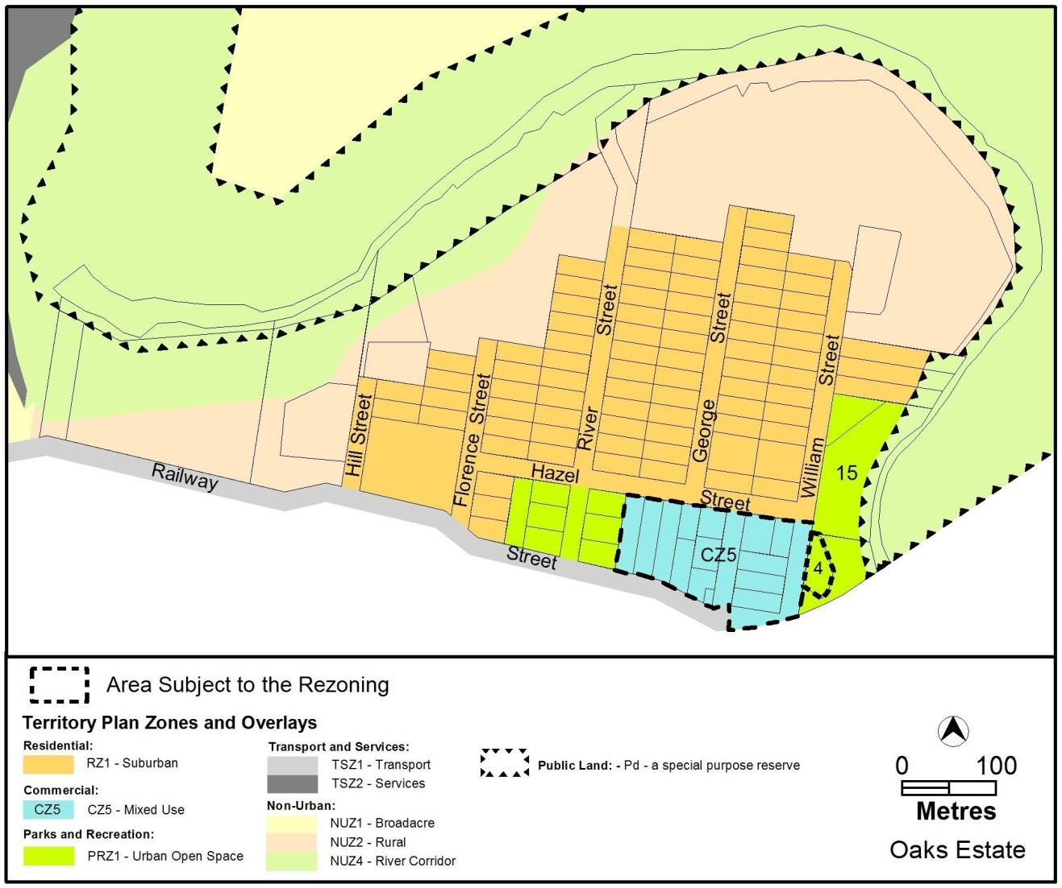
Figure 2: Current Territory Plan Zones Map
  - Proposed Changes
    - Proposed Changes to the Territory Plan Map
The proposed changes to the Territory Plan Map are indicated in Figure 3 below and Figure 4 at Part 3 of this document and are detailed as follows:
- rezone the block containing the community hall from Parks and Recreation PRZ1 Urban Open Space zone to CFZ Community Facility zone to reflect the existing use of the site being community use
- rezone the Commercial CZ5 Mixed Use zone to CZ4 Local Centre zone to reflect that the commercial area should function as a local centre to mainly serve the residents of Oaks Estate.
The draft variation map indicates the proposed zone boundaries as accurately as possible but may be subject to adjustments following detailed surveys.
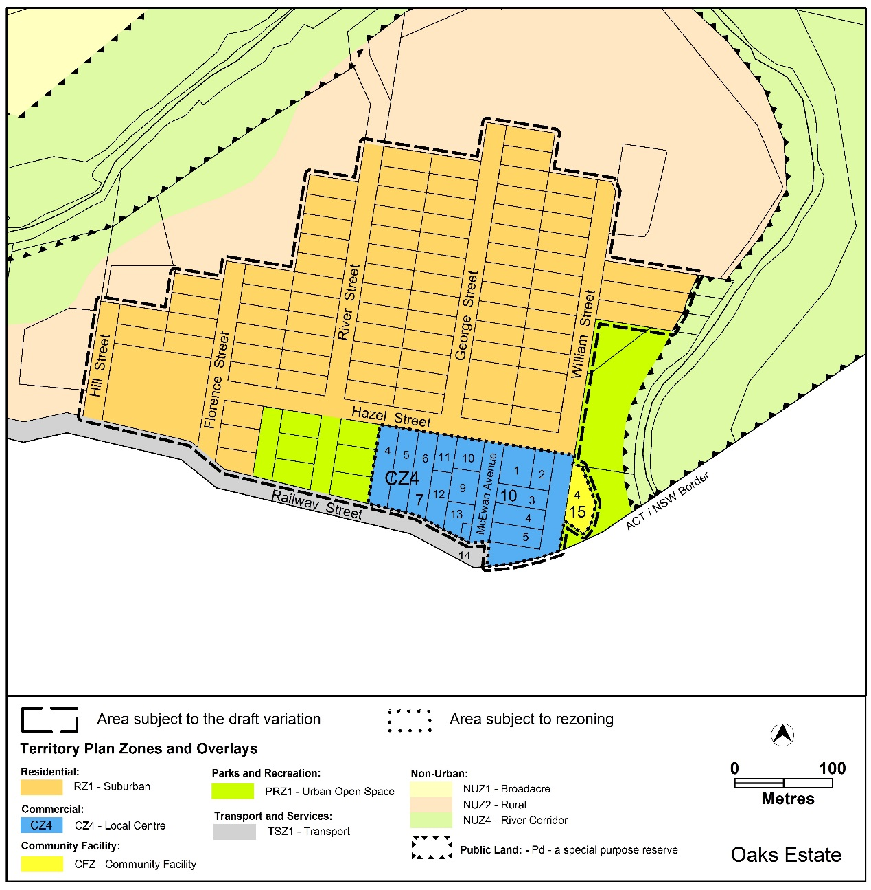
Figure 3: Proposed changes to the Territory Plan Map
    - Proposed Changes to Territory Plan
It is proposed to amend the Oaks Estate Precinct Map and Code as follows:
- allow light industry, industrial trades and warehouses only on blocks where these uses are already allowed in the lease
- permit shops, non-retail commercial use (such as offices), small-scale craft workshops and restaurants where located adjacent to and addressing Railway Street and/or McEwan Avenue
- prohibit indoor entertainment facilities, service stations and veterinary hospitals in the commercial area
- prohibit apartments in the commercial area, except where located over ground floor commercial development
- require parking in the commercial area to be behind the building line, or screened with landscaping
- require articulation of commercial building facades, with front setbacks to reflect the existing block patterns and character of the commercial area
- permit low transparent fencing in front of the building line in the residential area, whilst protecting vehicle and pedestrian sightlines
- introduce site coverage restrictions on commercial blocks and single dwelling housing blocks in the residential area and provide space for deep root planting areas as part of any new development
- introduce provisions to protect the heritage values of Robertson’s House on Section 7 Blocks 11 and 12 Oaks Estate
  - Reasons for the Proposed Draft Variation
The reasons for the draft variation are
- to implement the recommendations which relate to the Territory Plan provisions of the Oaks Estate master plan
- to provide new opportunities for limited growth and change while maintaining the history and character of Oaks Estate, its setting and association with the Molonglo and Queanbeyan rivers
- to respond to concerns raised by the Oaks Estate community in the previous consultation on the draft variation, including changes to the zoning of the commercial centre, restrictions on future commercial development, and protecting the desired character of the suburb by introducing suburb-specific provisions
- to rectify errors in the uses listed as prohibited and/or permitted on certain blocks in the Oaks Estate Precinct Map and Code
  - Planning Context
    - National Capital Plan
The Australian Capital Territory (Planning and Land Management) Act 1988 established the National Capital Authority (NCA) with two of its functions being to prepare and administer a National Capital Plan (NCP) and to keep the NCP under constant review and to propose amendments to it when necessary.
The NCP, which was published in the Commonwealth Gazette on 21 January 1990 is required to ensure that Canberra and the Territory are planned and developed in accordance with their national significance. The Planning and Land Management Act 1988 also required that the Territory Plan is not inconsistent with the NCP.
    - ACT Planning Framework
Statement of Strategic Directions
The Statement of Strategic Directions sets out the principles for giving effect to the main objective of the Territory Plan as required by the Planning and Development Act 2007.
The proposal is consistent with the Territory Plan’s statement of strategic directions in terms of environmental, economic and social sustainability and spatial planning and urban design principles.
1.9 Urban expansion will be contained in order to minimise impacts on valuable natural and rural areas
The draft variation is consistent with this requirement as it retains the existing limit of development within Oaks Estate to protect the river corridor and rural agricultural area from development pressure and will enable sites within the estate to be released for development.
1.25 Heritage and cultural values will be safeguarded, including in particular those of the Territory’s Aboriginal peoples and those derived from both its rural history and urban development as the National Capital. The distinctive qualities of residential areas and other places, as well as elements of community heritage, will also be recognised and their conservation promoted.
This principle is met through the protection of the distinctive character of the land by constraining the level of development permitted and encouraging limited levels of development restricted to the commercial area. The heritage aspects of the area are protected through heritage registration and citations approved under the ACT’s Heritage Act 2004.
Provisions in the precinct code for Oaks Estate have been amended to reflect the comments provided by ACT Heritage by requiring greater building setbacks on blocks adjacent to the block containing Robertsons’ House, a heritage registered site. This is to make sure that development provides reasonable physical and visual separation to Robertsons’ House to protect the heritage character of the site, and protect existing trees associated with the heritage site. ‘Area A’ – the Robertson’s House site shown in Figure 1 in the precinct code – has also been extended to include part of Block 12 (to the south of Robertson’s House) to further protect the heritage values of the Robertsons’ House site while still allowing development towards Railway Street and McEwan Avenue as recommended by the master plan.
2.16 Retention of Canberra’s unique landscape setting, including the integration of natural and cultural elements that create its ‘garden city’ and ‘bush capital’ qualities, will be accorded the highest priority. Special attention will be given to safeguarding visual amenity, protecting vegetation and other important features within the established urban landscape, and ensuring the high quality of environmental design in new developments or redevelopment.
The draft variation complies with this principle through the protection of the character of the area, including limits on building heights and measures to reflect the existing built form, to reduce potential impacts on the physical and visual character of the area.
ACT Planning Strategy 2018
The draft variation is consistent with the ACT Planning Strategy 2018, specifically Strategic Direction 4 Liveable Canberra:
- Section 4.3 Strengthen neighbourhoods and support their diverse character by creating strong local activity hubs.
The draft variation proposes to implement the recommendations and directions of the Oaks Estate Master Plan and incorporate the outcomes from previous public consultation to support the preservation of the unique characteristics of the estate and support the development of a strong and active local centre for the suburb.
The ACT Planning Strategy 2018 can be viewed at:
https://www.planning.act.gov.au/__data/assets/pdf_file/0007/1285972/2018-ACT-Planning-Strategy.pdf
  - Interim Effect
Section 65 of the Planning and Development Act 2007 applies to the draft variation. This means that the provisions of Draft Variation 328 have interim effect and apply to development applications lodged on or after 6 August 2021.
During the period of interim effect the ACT Government must not do or approve anything that would be inconsistent with the Territory Plan as if it were amended by the draft variation.
Interim effect will end on the day the earliest of the following happens:
- the day the public availability notice under section 70 for the draft variation being recommended to the Minister is notified in accordance with the Legislation Act
- the day the draft variation, or the corresponding variation, is withdrawn under section 68 (1)(b) or section 76 (3)(b)(v)
- 1 year after the date of the consultation notice.
  - Consultation with Government Agencies
EPSDD is required to, in preparing a draft variation under section 61(b) consult with each of the following in relation to the proposed draft variation:
- the national capital authority
- the conservator of flora and fauna
- the environment protection authority
- the heritage council
- if the draft variation would, if made, be likely to affect unleased land or leased public land – each custodian for the land likely to be affected
National Capital Authority
The National Capital Authority provided the following comments on 11 November 2019:
“The proposed land uses and variations are not inconsistent with the Urban Areas policy of the National Capital Plan. The NCA has no further comment.”

Response
Noted.
Conservator of Flora and Fauna
The Conservator of Flora and Fauna made the following comments on 15 November 2019:
“In accordance with Section 61(b) of the Planning and Development Act 2007 I advise that I have examined Draft Variation No 328 Oaks Estate (revised).
I support the Draft Variation and have no comment.”
Response
Noted.
Environment Protection Authority
The Environment Protection Authority provided the following comments on 3 March 2021:
“Thank you for the opportunity to review and provide comment on the Draft Variation 328: Oaks Estate (revised) to implement to changes recommended in the Master Plan for the Oaks Estate precinct.

The Environment Protection Authority has reviewed the documentation and supports the draft variation.”
Response
Noted.
Heritage Council
The Heritage Council provided the following comments on 4 November 2019:
Background:
“On 29 October 2019 the ACT Heritage Council was referred a Draft Variation to the Territory Plan (DV328) incorporating the recommendations of the endorsed Oaks Estate Master Plan, and community consultation into the existing Oaks Estate Precinct Map and Code (the Precinct Code).

DV328 proposes the following changes to the Precinct Code: rezone the commercial CZ5 mixed use area to commercial CZ4 local centre to service the needs of the local community; permit apartments only where located over commercial development in the commercial local centre; limit development within the commercial local centre to two storeys; introduce provisions to the protect the village character of Oaks Estate; and rectify errors in the Assessment Tracks.

The ‘Oaks Estate Precinct’ in the Precinct Code contains one place which is registered on the ACT Heritage Register, the ‘Robertsons’ House’ at Blocks 11 and 12, Section 7, Oaks Estate. Another registered heritage place, ‘The Oaks’, is located on Blocks 16, 19 and 22, Section 2, Oaks Estate, immediately adjacent to the ‘Oaks Estate Precinct’.

Robertsons’ House is located in the proposed CZ4 zone, where development will be limited to 2 storeys with a focus of community facilities. Criteria C10a requires that development adjacent to Blocks 11 and 12 also maintain physical and visual separation from Robertsons’ House. These proposed changes will help to promote a village centre with a buffer zone to retain a context appropriate to Robertsons’ House.

The Council appreciates that the land adjacent to ‘The Oaks’ will remain zoned as RZ1 suburban residential, retaining the historic context for the place; and Criteria C10b requires that the existing trees on The Oaks block are not significantly impacted by adjacent development.

Advice:
In light of the above, the Council raises no objection to DV328, and Heritage Act 2004 approvals are not required to implement the proposed planning variation.”

Response
Noted.

Land Custodian Territory and Municipal Services
The land custodian provided the following comments on 22 November 2019:
“TCCS supports Draft Variation 328: Oaks Estate (revised).”

Response
Noted.
Land Custodian Community Services Directorate
The land custodian provided the following comments on 30 October 2019:
“Nil comment from Housing ACT.”
Response
Noted.

- DRAFT VARIATION
  - Variation to the Territory Plan Map

The Territory Plan map is varied as indicated in figure 4

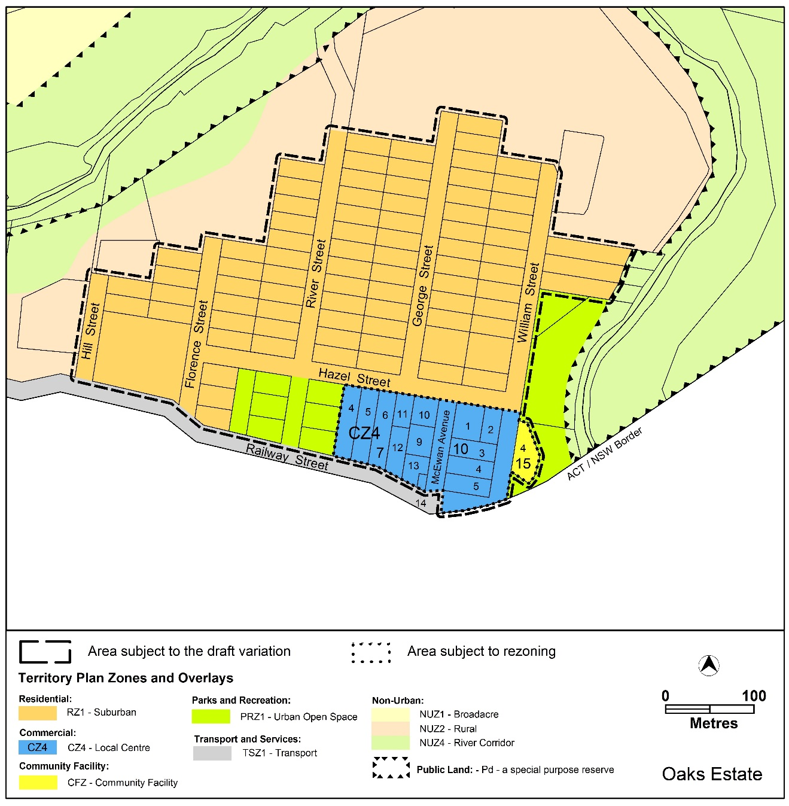
Figure 4: Proposed Territory Plan Map for Oaks Estate

  - Variation to the Territory Plan

The Territory Plan written document is varied as follows:

Variation to the Oaks Estate precinct code
Part 10. Precinct Maps and Codes; Oaks Estate Precinct Map and Code
Substitute
The Oaks Estate Precinct Map and Code – Appendix 1

Interpretation service
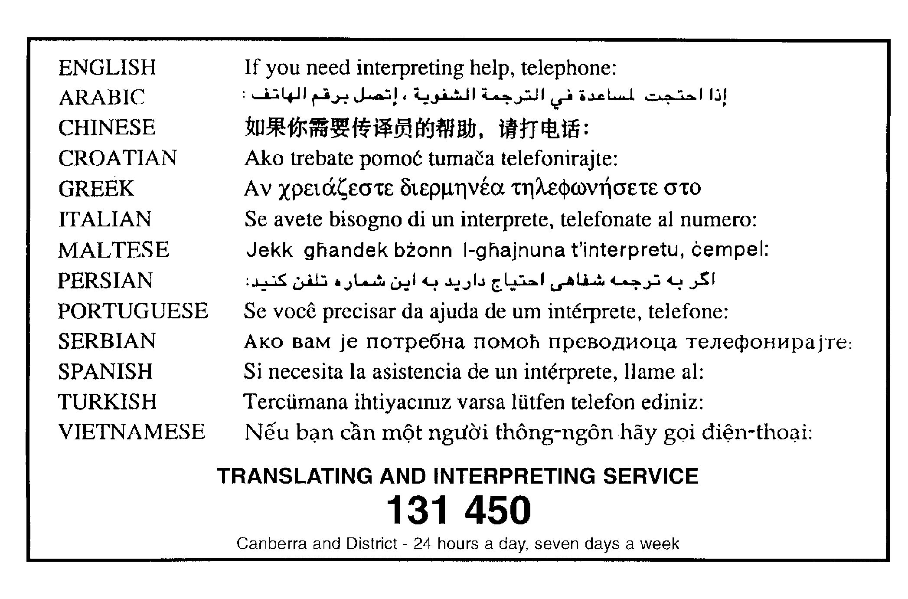

Oaks Estate Precinct Map and Code

This page is intentionally blank.

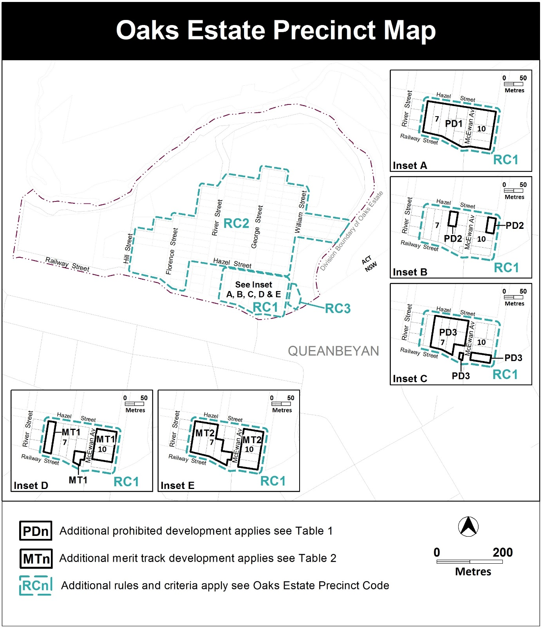

Assessment Tracks

The following tables identify the additional prohibited development and additional merit track development for blocks and parcels shown in the Oaks Estate Precinct Map (identified as PDn or MTn). Development that is exempt from requiring development approval, other prohibited development and the minimum assessment track applicable to each development proposal is set out in the relevant zone development table.

The following tables constitute part of the relevant zone development table.

Table 1 – Additional prohibited development
Additional prohibited development
Suburb precinct map label | Zone | Development
PD1 | CZ4 | indoor entertainment facility  industrial trades  service station  veterinary hospital
PD2 | CZ4 | restaurant  SHOP
PD3 | CZ4 | light industry  industrial trades

Table 2 – Additional merit track development
Additional merit track development that may be approved subject to assessment
Suburb precinct map label | Zone | Development
MT1 | CZ4 | warehouse
MT2 | CZ4 | craft workshop

Oaks Estate Precinct Code

Contents
Introduction 2
Additional rules and criteria 4
RC1 – Commercial Local Centre 4
Element 1:Use 4
1.1 Residential use 4
1.2 Railway Street and McEwan Avenue restrictions 4
1.3 Restrictions on use 5
1.4 Contamination 5
Element 2:Buildings 5
2.1 Built form 5
2.2 Building design 6
2.3 Site coverage 6
2.4 Vehicle parking 6
2.5 Landscaping 7
2.6 Active frontage 7
RC2 – Residential Area 9
Element 3:Buildings 9
3.1 Multi-unit sites 9
Element 4:Site 9
4.1 Site coverage 9
4.2 Landscaping 9
4.3 Front setbacks 9
Element 5:Fencing 10
5.1 Front fencing 10
RC3 – Community Hall 10
Element 6:Use 10
6.1 Contamination 10

Figures
Figure 1 – Area A

Introduction

Name
The name of this code is Oaks Estate Precinct Code.
Application
The code applies to the Division of Oaks Estate.
Purpose
This code provides additional planning, design and environmental controls for specific areas or blocks and may also contain references to provisions in other codes.
In conjunction with other relevant codes it will be used by the Authority to assess development applications and offer guidance to intending applicants in designing development proposals and preparing development applications.
Structure
This code contains additional rules and/or criteria for particular blocks or parcels identified as areas RCn on the precinct map, to be read in conjunction with the relevant development code. It may also contain sub-parts.
Each element has one or more rules and, unless the respective rule is mandatory, each rule has an associated criterion. Rules provide quantitative, or definitive, controls. By contrast, criteria are chiefly qualitative in nature.
In some instances rules are mandatory. Such rules are accompanied by the words “This is a mandatory requirement. There is no applicable criterion.” Non-compliance with a mandatory rule will result in the refusal of the development application. Conversely, the words “There is no applicable rule” is found where a criterion only is applicable.
Code hierarchy
Under the Planning and Development Act 2007, where more than one type of code applies to a development, the order of precedence if there is inconsistency of provisions between codes is: precinct code, development code and general code.
If more than one precinct code applies to the site, the most recent precinct code takes precedence to the extent of any inconsistency.
Definitions
Defined terms, references to legislation and other documents are italicised.
Definitions of terms used in this code are listed in part 13 of the Territory Plan or, for terms applicable only to this code, associated with the respective rule.
Acronyms
EPA ACT Environment Protection Authority
ESA ACT Emergency Services Agency
EPSDD Environment, Planning and Sustainable Development Directorate
NCA National Capital Authority
P&D Act Planning and Development Act 2007
TCCS Transport Canberra and City Services Directorate

Additional rules and criteria
This part applies to blocks and parcels identified in the Oaks Estate Precinct Map (RCn). It should be read in conjunction with the relevant zone development code and related codes.
RC1 – Commercial Local Centre
This part applies to blocks and parcels identified in area RC1 shown on the Oaks Estate Precinct Map.
Desired character
- small scale business opportunities providing services for the local community
- facades are articulated to provide interest to the street frontage
- development addresses each street frontage with pedestrian entrances and/or windows to shops or habitable rooms at the ground level, with upper floor level balconies to one or more habitable rooms
- residential development provides interest through articulation, pitched roofs and use of materials reflective of existing surrounding residential development

- Use
Rules | Criteria
  - Residential use
There is no applicable rule. | Residential development is designed to mitigate the potential impacts on future residents from the operation of existing commercial uses.
Apartments are only permitted at the second storey, and only where located directly above ground floor commercial development. | This is a mandatory requirement. There is no applicable criterion.
There is no applicable rule. | C3  Residential development is permitted to replace commercial / retail uses provided that the centre remains commercially viable after the proposed development.
  - Railway Street and McEwan Avenue restrictions
R4  The following uses, where permitted, are located adjacent to and addressing Railway Street and/or McEwan Avenue:  - craft workshop  - NON RETAIL COMMERCIAL  - Restaurant  - SHOP. | This is a mandatory requirement. There is no applicable criterion.
  - Restrictions on use
R5  The maximum gross floor area of SHOP where permitted is: 200m² | This is a mandatory requirement. There is no applicable criterion.
  - Contamination
R6  An environmental assessment into the site’s suitability from a contamination perspective must be undertaken in accordance with the ACT Contaminated Sites Environment Protection Policy and be endorsed by the Environment Protection Authority prior to development or a change in use.  This rule does not apply if the Environment Protection Authority has provided written advice that the site has been assessed for contamination to its satisfaction. | This is a mandatory requirement. There is no applicable criterion.

- Buildings
Rules | Criteria
  - Built form
R7  The maximum height of building is the lesser of two storeys and 8.5 metres.  Building height measurement excludes all of the following:  - roofs with a pitch not more than 36°  - roof top plant  - lift overruns  - antennas  - photovoltaic panels  - air conditioning units  - chimneys, flues and vents  Minimum setback of items b) to g) from the building facade of the floor directly below is 3m. | This is a mandatory requirement. There is no applicable criterion.
R8  Minimum front setback to Hazel Street is 4m. | C8  Front setbacks:  - reflect existing block patterns  - provide landscaping between the building and the front boundary  - are consistent with the desired character.
R9  Minimum front setback to Railway Street, McEwan Avenue and William Street is:  - for commercial development – 0m  - for residential development – 2m. | This is a mandatory requirement. There is no applicable criterion.
R10  This rule applies to buildings on blocks directly adjoining area A in Figure 1.  Buildings provide a minimum 6m setback to area A. | C10  Development achieves all of the following:  - Development provides reasonable physical and visual separation to Robertsons’ House to protect the heritage character of the site.  - Existing trees on section 7 blocks 11 and 12 Oaks Estate, are not significantly impacted, including any parts of trees that overhang the boundaries of the blocks.
  - Building design
R11  Maximum length of unarticulated street front facade is 10m  Minimum articulation depth: 2m | C11  Development provides an interesting facade to the street compatible with surrounding built form.
  - Site coverage
R12  Maximum site coverage: 45%. | This is a mandatory requirement. There is no applicable criterion.
  - Vehicle parking
R13  Vehicle parking areas are located behind the front building line. | C13  Parking areas are screened from the street by suitable landscaping wholly contained within the leased block boundaries.
  - Landscaping
R14  Development provides a minimum of 15% of the block area for deep root planting. | C14  Development retains sufficient open space for deep root plantings wholly contained within the block boundaries.
  - Active frontage
R15  This rule applies to commercial development located along Railway Street and/or McEwan Avenue.  Frontages and building design comply with all of the following:  - buildings incorporate clear display windows and shop fronts at the ground floor level  - buildings incorporate direct pedestrian access at grade with the verge level for access and egress for persons with disabilities. | C15  Development:  - avoids extensive lengths of blank walls unrelieved by doors, windows or the like  - provides suitable pedestrian access for persons with disabilities.
R16  This rule applies to residential development located along Railway Street, Hazel Street and/or McEwan Avenue.  Ground floor street frontages and building design includes windows to habitable rooms.  Street frontages above ground floor include windows to habitable rooms and/or balconies addressing the street. | This is a mandatory requirement. There is no applicable criterion.

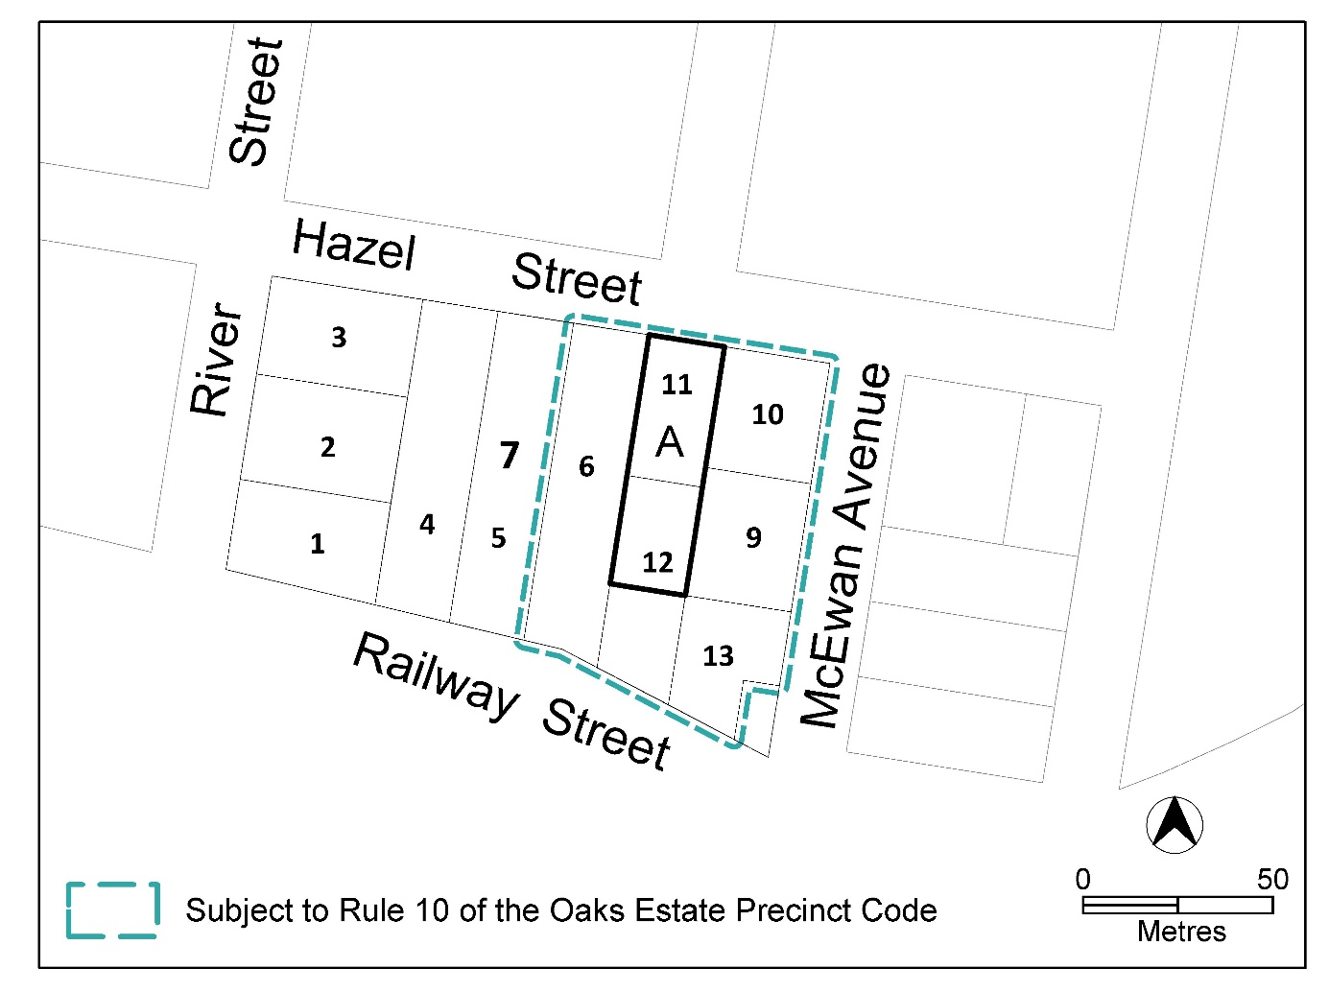
Figure 1 – Area A Robertson’s House

RC2 – Residential Area
This part applies to blocks and parcels identified in area RC2 shown on the Oaks Estate Precinct Map.
Desired character
- front boundary setback for development on single dwelling blocks reflect the existing varied setbacks in the area
- front fences reflect the existing character of the area, provide opportunities for views into and out of the site and ensure safe vehicle and pedestrian movement
- Buildings
Rules | Criteria
  - Multi-unit sites
There is no applicable rule. | C17  The redevelopment of multi unit dwelling sites respects the existing east-west orientation of the blocks and provides a built form width compatible with surrounding residential development.
R18  Maximum unarticulated street front facade length: 10m  Minimum articulation depth: 2m | C18  Front facades of multi unit development are articulated to provide interest and ensure compatibility with the surrounding built form.

- Site
Rules | Criteria
  - Site coverage
R19  Maximum site coverage of single dwelling blocks: 35%. | This is a mandatory requirement. There is no applicable criterion.
  - Landscaping
R20  Development provides a minimum of 15% of the block area for deep root planting. | C20  Development retains sufficient open space for deep root plantings wholly contained within the block boundaries.
  - Front setbacks
There is no applicable rule. | C21  Front setbacks can differ in depth but must be consistent with the existing variations.

- Fencing
Rules | Criteria
  - Front fencing
R22  Transparent fences setback a minimum 1m to the front boundary are permitted, with a maximum height above datum ground level of 1.2m.  Note: for the purposes of this rule, transparent fences has the same meaning as in the Residential Boundary Fences General Code. | C22  Fencing setback to the front boundary may be reduced to 0m where it complies with all of the following:  - provides opportunities for passive surveillance of the street from the dwelling  - is compatible with the desired character  - does not obstruct sight lines for vehicles and pedestrians on verge areas in accordance with Australian StandardAS2890.1- Off-Street Parking.

RC3 – Community Hall
This part applies to blocks and parcels identified in area RC3 shown on the Oaks Estate Precinct Map.
- Use
Rules | Criteria
  - Contamination
R23  An environmental assessment into the site’s suitability from a contamination perspective must be undertaken in accordance with the ACT Contaminated Sites Environment Protection Policy and be endorsed by the Environment Protection Authority prior to development or a change in use.  This rule does not apply if the Environment Protection Authority has provided written advice that the site has been assessed for contamination to its satisfaction. | This is a mandatory requirement. There is no applicable criterion.

