Australian Capital Territory
Corrections Management (Handcuffs – Electronic Storage and Issue) Procedure Revocation 2021
Notifiable instrument NI2021-5
made under the
Corrections Management Act 2007, s 14 (Corrections policies and operating procedures)

1 Name of instrument
This instrument is the Corrections Management (Handcuffs – Electronic Storage and Issue) Procedure Revocation 2021.

2 Commencement
This instrument commences on the day after its notification day.
3. Revocation
This instrument revokes the Corrections Management (Handcuffs – Electronic Storage and Issue) Operating Procedure 2020 [NI2020-798].

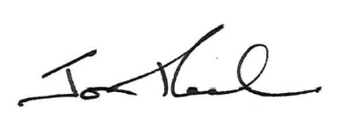

Jon Peach
Commissioner
ACT Corrective Services
24 December 2020

