Australian Capital Territory
Planning and Development (Plan Variation 370) Approval 2021

Notifiable instrument NI2021-574
made under the
Planning and Development Act 2007, s 76 (Minister’s powers in relation to draft plan variations)

1 Name of instrument
This instrument is the Planning and Development (Plan Variation 370) Approval 2021.
2 Commencement
This instrument commences on the day after its notification day.
3 Approval of draft plan variation
(1) Under section 76 (2) (a) of the Act, I approve draft plan variation 370 to the Territory Plan.
(2) In this section:
draft plan variation 370 to the Territory Plan means the plan variation in the schedule.

Mick Gentleman MLA
Minister for Planning and Land Management
17 September 2021

Planning and Development Act 2007
Variation to the
Territory Plan
370

East Yowani Estate
Lyneham section 67 part block 7

Zone change and amendments to the
Lyneham precinct map and code

August 2021

Final variation prepared under s76 of the
Planning and Development Act 2007
This page is intentionally blank.

Contents
1. EXPLANATORY STATEMENT 1
1.1 Background 1
1.2 Summary of the proposal 2
1.3 The National Capital Plan 3
1.4 Site Description 3
1.5 Current Territory Plan Provisions 5
1.6 Changes to the Territory Plan 6
1.7 Consultation on the Draft Variation 6
1.8 Revisions to the Draft Variation Recommended to the Minister 6
2. VARIATION 7
2.1 Variation to the Territory Plan Map 7
2.2 Variation to the Territory Plan 8
Appendix A: Lyneham Precinct Map and Code

This page is intentionally blank.

- EXPLANATORY STATEMENT
  - Background
Lyneham, Section 67, Block 7
Lyneham, section 67, block 7 is currently occupied by the Yowani Country Club which was established in 1954 and provides both golf and a bowling green to members and the public.
Due to a decline in traditional revenue sources the Yowani Country Club is seeking to diversify its revenue base to ‘future proof’ their club. The addition of a mixed-use development (which is permitted by this variation) will allow for additional revenue which in turn will enable the redevelopment of the club facilities including a redesigned golf course, new clubhouse and bowling green.
The subject area currently contains the Yowani Country Club clubhouse, carpark and bowling green. Upon redevelopment of the site, V370 requires these facilities to be provided elsewhere on the site or within close proximity to the golf course.
Draft map only

The City and Gateway Draft Urban Design Framework
The Australian Government through the National Capital Authority (NCA) and the ACT Government share planning responsibility in the ACT. The Framework was jointly prepared by the NCA and ACT Government to set the principles for development and growth in the city centre and along the gateway corridor of Northbourne Avenue and Federal Highway. The Framework provides a long-term vision and principles for this important location, drawing upon the legacy of historic planning and contemporary design.
Implementation of the planning recommendations of the Framework will require amendments to the Territory Plan. This draft variation seeks to implement the relevant planning controls recommended in the Framework for the site such as active travel routes, building heights and building setbacks.

Amendment 91 and 93 to the National Capital Plan
In April and September 2019, the National Capital Authority (NCA) amended its National Capital Plan (NCP) with Amendments 91 (A91) and 93 (A93) respectively. A91 and A93 implemented parts of the Framework which were of interest to the NCA. Prior to this the Yowani Country Club was subject to the NCA’s Development Control Plan for the site which essentially restricted the block to its current use.
The changes made through A91 and A93 allow the eastern portion of the Yowani Country Club to be used more intensely in line with the principles of the Framework.
This variation makes minor changes or clarifications to provisions to better align with the special requirements of the National Capital Plan, particularly Part 4.28 City and Gateway Corridor.

ACT Climate Change Strategy 2019-2025 & Canberra’s Living Infrastructure Plan: Cooling the City
The ACT Climate Change Strategy 2019-2025 (CCS) & Canberra’s Living Infrastructure Plan: Cooling the City (LIP) outlines the high and mid-level principles to reduce greenhouse gas emissions and support community resilience to the effects of climate change.
This variation includes environmentally sustainable design measures and living infrastructure provisions which align with the objects of the CCS and LIP.

  - Summary of the proposal
The variation makes the following changes:
- allow the redevelopment of the eastern portion of the Yowani Country Club for a mix of commercial and residential uses. To permit this change in use:
  - Lyneham, section 67, part block 7 (between Northbourne Avenue and Sullivans Creek) is rezoned from Parks and Recreation PRZ2 restricted access recreation and Transport and Services TSZ1 Transport (south east corner) to Commercial CZ5 mixed use zone
  - amend the Lyneham Precinct Code by introducing new rules and criteria to guide future Estate Development Plan and individual building Development Applications which include:
    - limitations on the scale of residential and non-residential uses
    - flood impacts, flood mitigation and protection of the values of Sullivans Creek
    - the location and design of open space areas and internal pedestrian connections
- implement the relevant planning recommendations of the City and Gateway Urban Design Framework (the Framework) which include active travel routes, building heights and building setbacks
- implement the relevant planning recommendations of the ACT Climate Change Strategy 2019-2025 and Canberra’s Living Infrastructure Plan: Cooling the City. These provisions relate to tree canopy cover, urban heat and sustainable building design assessments
- incorporating changes and updates to the Territory Plan to better align with the special requirements of the National Capital Plan.

  - The National Capital Plan
The Australian Capital Territory (Planning and Land Management) Act 1988 established the National Capital Authority (NCA) with two of its functions being to prepare and administer a National Capital Plan (NCP) and to keep the NCP under constant review and to propose amendments to it when necessary.
The NCP, which was published in the Commonwealth Gazette on 21 January 1990 is required to ensure that Canberra and the Territory are planned and developed in accordance with their national significance. The Planning and Land Management Act 1988 also requires that the Territory Plan is not inconsistent with the NCP.

  - Site Description
The subject area consists of the 8.66ha eastern portion (see Figure 1) of Lyneham, section 67, block 7 between Northbourne Avenue and Sullivans Creek. The subject area is bounded by Barton Highway, Northbourne Avenue, the centreline of Sullivan’s Creek stormwater easement and the southern limit of the proposed Swinden Street extension which generally runs along the common boundary with Lyneham, section 59, block 50.
The subject area currently contains the Yowani Country Club clubhouse, carpark and bowling green. These facilities are proposed to be relocated to Lyneham, section 64, blocks 14 and 15 as part of a separate process to this variation. This separate process is related to but does not necessarily rely on this variation as blocks 14 and 15 already possess suitable zoning for these uses to be undertaken.

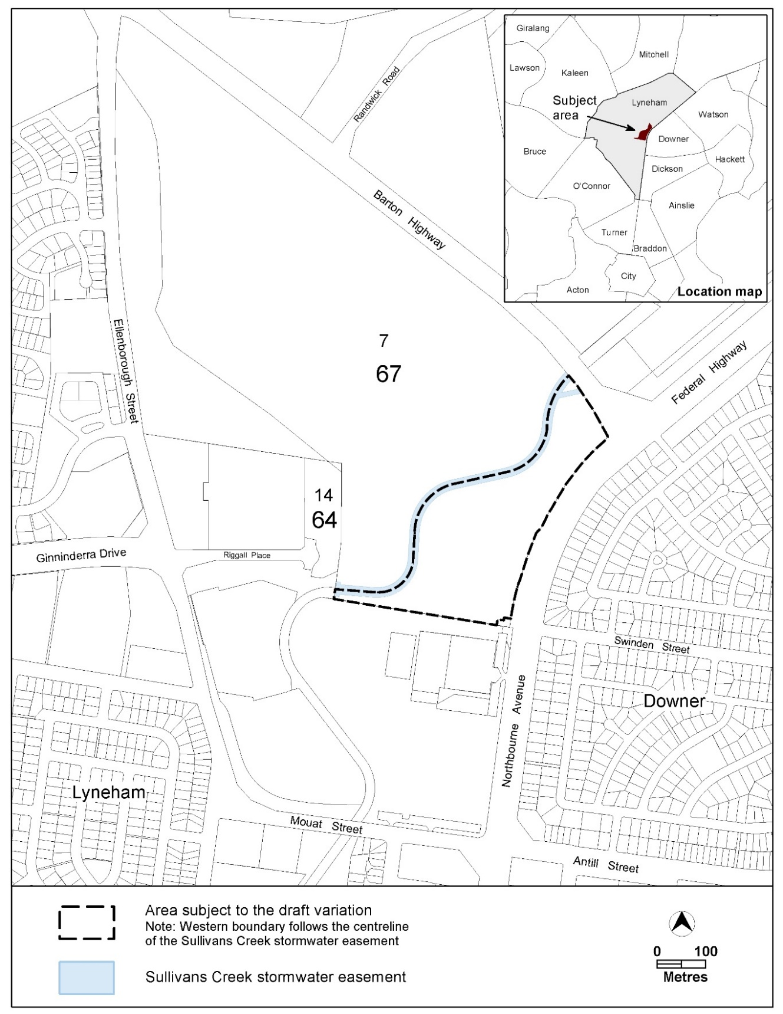
Figure 1: Location map

  - Current Territory Plan Provisions
The Territory Plan map for the area subject to this variation is shown in Figure 2.
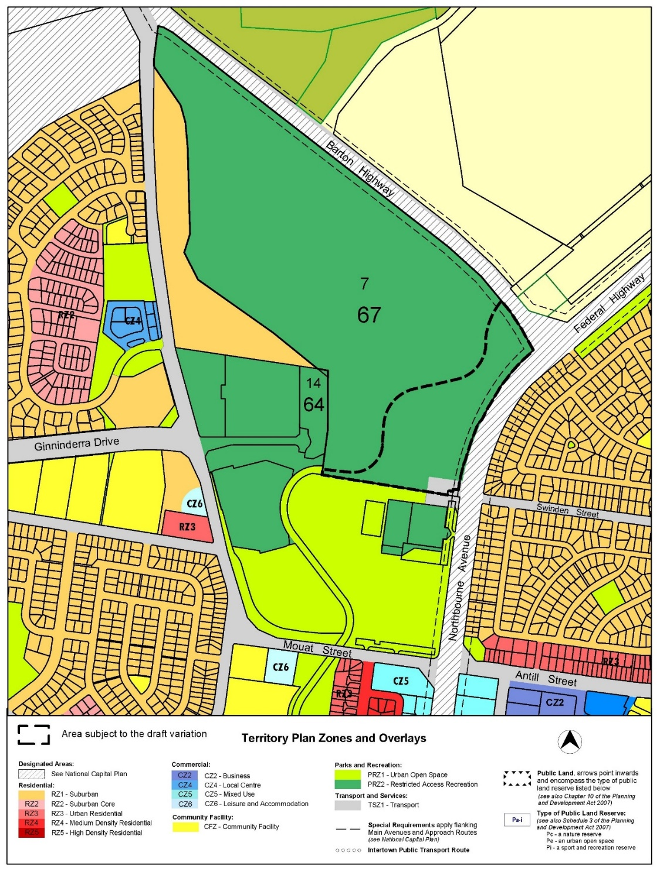Figure 2 Territory Plan Zones Map

  - Changes to the Territory Plan
Detailed changes to the Territory Plan are noted in section 2 of this document.
  - Consultation on the Draft Variation
The draft variation was released for public comment between Saturday 20 February 2021 and Friday 16 April 2021. A consultation notice under section 63 of the Planning and Development Act 2007 (P&D Act) was published on the ACT Legislation Register on Friday 19 February 2021. A public notice was placed on the ACT Government public notices website on Friday 19 April 2021.
A total of 17 written submissions (including 2 late submissions) were received. One submission was from the Yowani Country Club and another was from their development partner, TP Dynamics. The remaining submissions were from individuals from the community.
Comments related to the following:
Issue | Number of Submissions
Support for the draft variation and associated community benefits | 11
Request to remove lower building heights adjacent to Sullivans Creek | 2
Support for lower building heights adjacent to Sullivans Creek | 1
Concern about the loss of greenspace and lack of parkland and trees | 3
Desire to support climate change principles | 2
Request changes to the requirements of a ‘suitably qualified professional’ to advise on flood management | 2
Request to remove the requirement for the replacement of the club house, bowls facilities and car park | 1
Further development not required or desired | 2
Request to clarify a number of proposed provisions | 1
Concern about loss of amenity for surrounding residents and request for a landscape buffer | 1
The above issues were considered and are detailed in a report on consultation. Changes were informed by the issues raised. The outcomes of consultation were considered by the Minister responsible for planning prior to approval of this variation.
  - Revisions to the Draft Variation Recommended to the Minister
No changes were made to the draft variation recommended to the Minister.
- VARIATION
  - Variation to the Territory Plan Map
The Territory Plan map is varied in all of the following ways:
Substitute the current Territory Plan zoning (Parks and Recreation PRZ2 Restricted Access) with the zoning indicated below for the ‘area subject to the variation’ only.
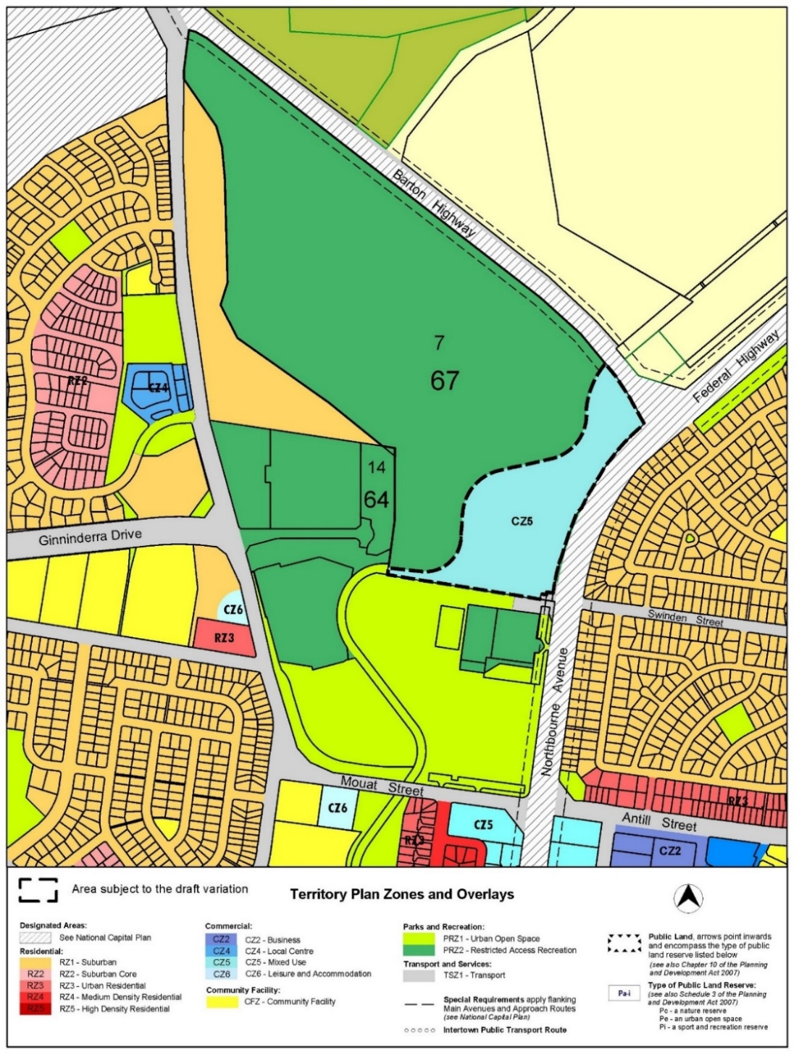
Figure 3 Proposed Territory Plan Zones Map
  - Variation to the Territory Plan
- 10 Precinct Maps and Codes

Substitute the current Lyneham Precinct Map and Code with Appendix A.

Interpretation service
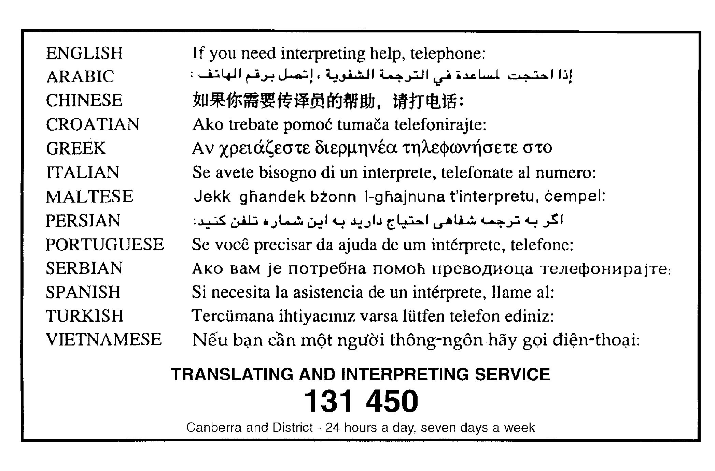

Lyneham Precinct Map and Code

This page is intentionally blank.

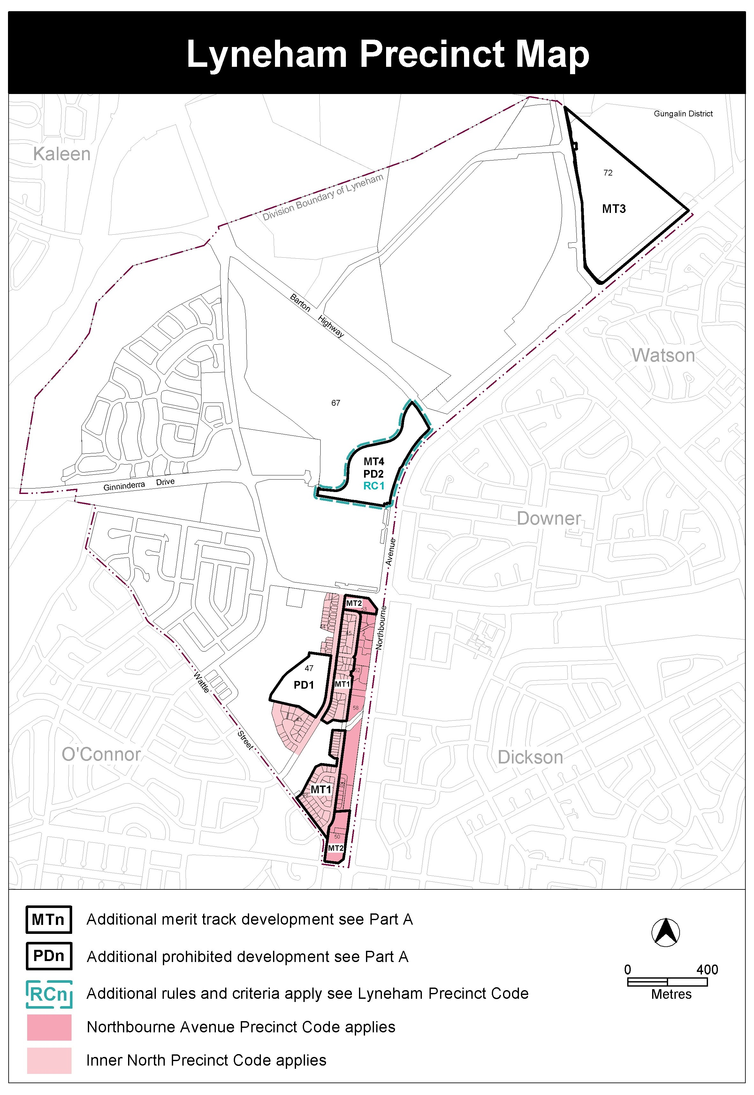

Assessment Tracks
The following tables identify the additional prohibited development and additional merit track development for blocks and parcels shown in the Lyneham Precinct Map (identified as PDn or MTn). Development that is exempt from requiring development approval, other prohibited development and the minimum assessment track applicable to each development proposal is set out in the relevant zone development table.

The following tables constitute part of the relevant zone development table.

Table 1 – Additional prohibited development
Additional prohibited development
Suburb precinct map label | Zone | Development
PD1 | CFZ | retirement village  supportive housing
PD2 | CZ5 | bulky goods retailing  department store  secondary residence  single dwelling housing

Table 2 – Additional merit track development
Additional merit track development that may be approved subject to assessment
Suburb precinct map label | Zone | Development
MT1 | RZ4 | business agency  office  restaurant  SHOP
MT2 | CZ5 | club  place of assembly  scientific research establishment
MT3 | NUZ1 | place of assembly
MT4 | CZ5 | drink establisment

Lyneham Precinct Code

Contents
Introduction 3
Additional rules and criteria 5
RC1 – East Yowani Estate 5
Element 1: Estate planning 5
1.1 Sullivans Creek 5
1.2 Site access and internal road layout 9
1.3 Location of non-residential uses 10
1.4 Open space areas and travel routes - General 10
1.5 Estate open space areas 11
1.6 Mid-block links 12
1.7 Internal pedestrian and bicycle network 13
1.8 Active travel connection 13
1.9 Recreation 14
1.10 Tree retention and canopy cover 17
1.11 Block address 17
1.12 Educational facilities planning 18
Element 2: Restrictions on use 19
2.1 Number of dwellings 19
2.2 Retail 19
2.3 Commercial 20
2.4 Food and Entertainment 20
2.5 Community Use 21
2.6 Non-RESIDENTIAL USE – ground floor 21
Element 3: Building controls and design 22
3.1 National Capital Plan 22
3.2 Height of building 22
3.3 Front boundary setback 23
3.4 Building separation 23
3.5 Floor to ceiling heights 25
3.6 Building address 25
3.7 Building Length 26
3.8 Pedestrian shelters 26
3.9 Internal dwelling and building design 26
3.10 Housing diversity 27
Element 4: Site controls and design 28
4.1 Landscape design – Deep soil zones 28
4.2 Courtyard Walls 28
Element 5: Amenity 29
5.1 Solar Access – apartments 29
5.2 Solar Access to adjoining development 29
5.3 Principal private open space 29
5.4 External facilities 31
5.5 Noise 31
Element 6: Parking and vehicular access 31
6.1 Vehicular access 31
6.2 Parking 32
6.3 Parking structures 33
Element 7: Environment 34
7.1 Erosion and sediment control 34
7.2 Environmental assessment 34
7.3 Environmentally sustainable design 34
7.4 Microclimate 35
7.5 Permeability 36
7.6 Heritage 36

Figures
Figure 1 Mid-Block Links and Active Travel Connections 16
Figure 2 Areas not covered by the National Capital Plan 24
Table 1 Minimum building separation 25
Table 2 Principal private open space area requirements 30

Introduction
Name
The name of this code is Lyneham Precinct Code.
Application
The code applies to the Division of Lyneham
National Capital Plan
Where a development is subject to special requirements under the National Capital Plan, or any relevant development control plan prepared under the National Capital Plan, the development must not be inconsistent with the special requirements or development control plan. Where any provision of this code is inconsistent with special requirements under the National Capital Plan, or any relevant development control plan prepared under the National Capital Plan, that provision has no effect, to the extent of the inconsistency.
Purpose
This code provides additional planning, design and environmental controls for specific areas or blocks and may also contain references to provisions in other codes.
In conjunction with other relevant codes it will be used by the Authority to assess development applications and offer guidance to intending applicants in designing development proposals and preparing development applications.
Structure
This code contains additional rules and/or criteria for particular blocks or parcels identified as areas RCn on the precinct map, to be read in conjunction with the relevant development code. It may also contain sub-parts.
Each element has one or more rules and, unless the respective rule is mandatory, each rule has an associated criterion. Rules provide quantitative, or definitive, controls. By contrast, criteria are chiefly qualitative in nature.
In some instances rules are mandatory. Such rules are accompanied by the words “This is a mandatory requirement. There is no applicable criterion.” Non-compliance with a mandatory rule will result in the refusal of the development application. Conversely, the words “There is no applicable rule” is found where a criterion only is applicable.
Code hierarchy
Under the Planning and Development Act 2007, where more than one type of code applies to a development, the order of precedence if there is inconsistency of provisions between codes is: precinct code, development code and general code.
If more than one precinct code applies to the site, the most recent precinct code takes precedence to the extent of any inconsistency.
Definitions
Defined terms, references to legislation and other documents are italicised.
Definitions of terms used in this code are listed in part 13 of the Territory Plan or, for terms applicable only to this code, either associated with the respective rule or listed below:
TCCS Transport Canberra and City Services Directorate
CMTEDD Chief Ministers, Treasury and Economic Development Directorate

Additional rules and criteria
This part applies to blocks and parcels identified in the Lyneham Precinct Map (RCn). It should be read in conjunction with the relevant zone development and general codes.
RC1 – East Yowani Estate
This part applies to blocks and parcels identified in area RC1 shown on the Lyneham Precinct Map.
- Estate planning
Rules | Criteria
  - Sullivans Creek
There is no applicable rule. | This criterion applies to land contained within the setback area to Sullivans Creek identified in C34.  Development complies with all of the following (where relevant):  - maintain or increase flood conveyance capacity and storage volume for Sullivans Creek  - create and maintain opportunity for flora and fauna habitat and movement  - provide a landscape setting to improve visual and environmental amenity  - provide an infrastructure corridor for existing and future utility services  - demonstrated adequate space for active travel routes and open spaces for the use and enjoyment of the local community and commuters  - increased or complete ‘naturalisation’ of Sullivans Creek through the use of natural construction materials and vegetation  - development of b) and d) is completed prior to or at the same stage as surrounding residential development.  For the purpose of this criterion ‘naturalisation’ means changing the appearance and functionality to more closely represent natural characteristics.  Note: The planning and land authority may consult, where relevant, with TCCS and other areas of EPSDD (or future relevant agencies) when determining compliance with this criterion.
There is no applicable rule. | This criterion applies to land contained within the setback area to Sullivans Creek specified in C34.  Development is limited to:  - works to mitigate flooding  - works which maintain or increase flood conveyance capacity and storage volume for Sullivans Creek  - landscaping or minor public infrastructure to improve visual and environmental amenity  - high quality and visually interesting screening of utility or flood mitigation works and infrastructure  - works relating to utility infrastructure that take place predominantly or entirely below natural ground level  - works to promote active travel and/or public open areas for recreation and leisure  - communal open space, private open space and courtyard walls required by a development code  - works to increase ‘naturalisation’ of Sullivans Creek through the use of natural construction materials and vegetation.  For the purpose of this criterion ‘naturalisation’ means changing the appearance and functionality to more closely represent natural characteristics.  Note: The planning and land authority may consult, where relevant, with TCCS and other areas of EPSDD (or future relevant agencies) when determining compliance with this criterion.
This rule applies to the following:  - filling within one of the following (whichever is greater):  - 1% AEP (once in 100 year) flood extent for Sullivans Creek  - 6 metres of Sullivans Creek stormwater easement  - compensatory excavation to offset filling specified in a)  - reducing or increasing flood conveyance capacity and storage volume for Sullivans Creek  - increased ‘naturalisation’ of Sullivans Creek.  Development complies with all of the following:  - is endorsed by TCCS  - is prepared by a ‘suitably qualified professional’  For the purpose of this rule ‘naturalisation’ means changing the appearance and functionality to more closely represent natural characteristics which may include the use of natural construction materials and vegetation.  For the purpose of this rule a ‘suitably qualified professional’ is familiar with analysis of flooding along watercourses and design of development to manage flood risks.  Note: The planning and land authority may consult, where relevant, with TCCS and other areas of EPSDD (or future relevant agencies) when determining compliance with this rule. | If TCCS endorsement is not provided the application will be referred to TCCS.
This rule applies to development wholly or partially within 1% AEP (once in 100 year) flood extent for Sullivans Creek.  Development of the RC1 area is consistent with a flood risk study, prepared by a ‘suitably qualified professional’ and endorsed by TCCS, which adequately demonstrates all of the following:  - protections for ongoing safety of the public against impacts of floods are provided  - protections for property against the impacts of floods are provided  - the RC1 area is planned and developed with consideration for flood risks  - where flood impacts on development exceed 6m from Sullivans Creek stormwater easement, identification of a minimum setback for development to inform C34.  For the purpose of this rule a ‘suitably qualified professional’ is familiar with analysis of flooding along watercourses and design of development to manage flood risks.  Note: The planning and land authority may consult, where relevant, with TCCS and other areas of EPSDD (or future relevant agencies) when determining compliance with this rule. | If TCCS endorsement is not provided the application will be referred to TCCS.

Rules | Criteria
  - Site access and internal road layout
The following is endorsed by TCCS:  - a transport impact assessment, prepared by a suitably qualified professional  - location, nature and number of new and existing external vehicular site access points to/from the RC1 area  - Sullivans Creek active travel connection.  Plans and drawings clearly demonstrate that the development is consistent with TCCS endorsements for a), b) and c).  Note: TCCS may endorse development or works in addition to items identified in this rule. | If TCCS endorsement is not provided with the application or the plans and drawings are not consistent with rule, the application will be referred to TCCS.
There is no applicable rule. | The number of new and existing vehicular access points from/to RC1 and to/from Northbourne Avenue is minimised.
There is no applicable rule. | The internal road layout for RC1 area complies with all of the following:  - incorporates a parallel access street generally along the Northbourne Avenue frontage  - prioritises pedestrians and cyclists particularly where the ‘internal pedestrian and bicycle network’ mentioned in C12 or ‘mid-block links mentioned in C11, intersects with internal roads  - minimises the amount of impervious surfaces within the road reserve in favour of soft landscape areas.

Rules | Criteria
  - Location of non-residential uses
There is no applicable rule. | This criterion applies to development other than RESIDENTIAL USE.  Development is located to comply with all of the following:  - in the south eastern portion of the site  - in close proximity to and easily accessible from site access points and the Swinden Street light rail stop  - after a) and b) has occurred or demonstrated that it will occur, along Northbourne Avenue and the Swinden Street extension, primarily adjoining or in close proximity to other non-residential development.  Note: this criterion does not preclude RESIDENTIAL USE from occurring in the above areas on the site.
  - Open space areas and travel routes - General
There is no applicable rule. | This criterion applies to:  - ‘open space areas’, ‘Sullivans Creek active travel connections’ and ‘mid-block links’ identified in Figure 1  - ‘internal pedestrian and bicycle network’ mentioned in C12.  Development within the areas mentioned above comply with all of the following:  - provide safe, efficient and unimpeded public access to pedestrian and cyclists at all times  - identifies and provides the recreational and leisure needs of the local community  - where these areas intersect with roads and vehicular access ways, demonstrate how priority is given to pedestrians and cyclists through traffic calming measures such as slow speed areas, shared spaces and refuge islands  - provides adequate amenity and safety for uses of the area including soft landscaping, shade for warmer weather, access to sunlight (particularly in colder weather), adequate lighting (that does not impact on the amenity of adjoining development) and passive and perceived surveillance at all times  - development within these areas is limited to planting area, surface landscaping, buildings and structures which are consistent with active travel pathways or are open and do not limit accessibility  - all areas provide adequate irrigation for landscaped areas and high-quality fit-for-purpose paving and finishes  - are completed prior to or at the same stage as surrounding residential development.
  - Estate open space areas
‘Open Space Areas’ comply with all of the following:  - RESIDENTIAL USE development within the RC1 is not more than 300m from an ‘open space area’  - has a minimum total ‘useable’ area across RC1 of 3200m² plus 4m² for each multi-unit housing dwelling within RC1 over 800 dwellings  - not more than four ‘open space areas’ are provided across the RC1 area  - the RC1 area provides a mix of open space areas and facilities in accordance with a ‘neighbourhood park and a ’micro park’.  For the purpose of this rule and associated criterion ‘usable’ does not include areas which limit the useability of open space such as regulated tree protection zones and high-risk flood zones etc.  Characteristics of ‘neighbourhood parks’ and ‘micro parks’ are outlined in ‘Municipal Infrastructure Standard 16 Urban Open Space’. | An open space needs assessment is undertaken by a ‘suitably qualified professional’ that:  - demonstrates that at least one open space area is within accessible walking distances for all RESIDENTIAL USE development within the RC1.  - specifies a minimum ‘usable’ area of open space across the RC1 area that is adequate to accommodate the current and future on-site population  - specifies the amount of open space areas to achieve equitable access and adequate space per area for all current and future RESIDENTIAL USE development  - identifies areas, facilities and equipment needed by the local community, including high quality children’s play spaces, kick-about area recreation facilities (such as barbeque facilities, picnic tables, benches, waste and recycling bins and exercise equipment).  Findings of the open space needs assessment are clearly shown on plans and drawings.  For the purpose of this criterion a ‘suitably qualified professional’ has qualifications and experience in urban planning, landscape architecture or other similar field.
  - Mid-block links
There is no applicable rule. | This criterion applies to the ‘mid-block links’ shown in Figure 1.  ‘Mid-block links’ comply with all of the following:  - are in a location generally in accordance with Figure 1 and aligns with the community path system through the area  - provides unimpeded public pedestrian and bicycle access at all times from Northbourne Avenue to the Sullivans Creek ‘external active travel route'  - connects with ‘internal pedestrian and bicycle network’ to provide a safe and efficient pedestrian and bicycle network  - a landscape corridor, not less than 10 metres wide at any point, which includes a path of a suitable with to accommodate all likely users  - vehicular access is not permitted within or along the ‘mid-block links’.  Development of and within ‘mid-block links’ are to be endorsed by TCCS.

Rules | Criteria
  - Internal pedestrian and bicycle network
There is no applicable rule. | Internal pedestrian and bicycle network through the RC1 area complies with all of the following:  - provides an efficient and legible pedestrian and bicycle network through the site  - predominantly utilises routes which are not also used by vehicles  - aligns with light rail stations and crossing points to reduce informal light rail crossings for cyclists and pedestrians  - allows pedestrian and cyclists to travel between ‘open space areas’, ‘external active travel connections’, ‘mid-block links’, the existing light rail stops, light rail crossing points and community path system in the area  - a landscape corridor, not less than 5 metres wide at any point, which includes a path of a suitable width to accommodate all likely users.  Development of and within the internal pedestrian and bicycle network are to be endorsed by TCCS where relevant.
  - Active travel connection
There is no applicable rule. | This criterion applies to the ‘Sullivans Creek active travel connection’ shown in Figure 1.  ‘Sullivans Creek active travel connection’ complies with all of the following:  - ‘Sullivans Creek active travel connection’ is either:  - in a location generally in accordance with Figure 1 or  - allows users of the Sullivans Creek pedestrian and cycle network who enter the RC1 area from the south-west to transit through the RC1 area safely and efficiently towards a formal pedestrian and bicycle crossing point across Barton Highway to facilitate their journey north along Sullivans Creek  - aligns and connects with the community path system and internal pedestrian and bicycle network through the area  - provide unimpeded public pedestrian and bicycle access at all times for the length of the active travel connection shown in Figure 1  - exclusively utilises routes which are not also used by vehicles  - is a landscape corridor which is not less than 5 metres wide at the narrowest point and contains all of the following:  - a shared path for pedestrians and cyclists  - the landscape corridor and path are both of adequate width to meet the current and future usage demand.
  - Recreation
There is no applicable rule. | Demonstrate that there is adequate and suitable land for an 18-hole golf course to be provided within sections 64 and/or 67 Lyneham.
This criterion applies to the redevelopment of the area which contains one or more of the following, existing or proposed:
    - golf clubhouse
    - bowling facilities
    - car park related to the uses mentioned in a) and b).
The development complies with all of the following:
    - demonstrates that existing or proposed development for that area can be relocated within the RC1 area or:
      - for the golf clubhouse, adjacent to the golf course
      - for the bowling facilities and the car parking within close proximity to the RC1 area
    - demonstrate that the development has adequate space and zoning to accommodate all the following:
      - the entirety of the development which is being relocated, including ancillary development required by the Territory Plan or relevant government agencies such as waste areas, waste access and vehicular parking
      - adequate vehicular, pedestrian and bicycle access
      - not predominantly located within the 1% AEP (once in 100 year) flood extent for Sullivans Creek or the flood area indicated by the flood study in R4
    - identification of and endorsement from relevant government agencies with respect to the scale, nature and location of the relocated facilities.
Note: For the purpose of this criterion Sports and Recreation (S&R) within CMTEDD and TCCS are considered relevant government agencies. Other government agencies may be identified by the proponent or S&R.

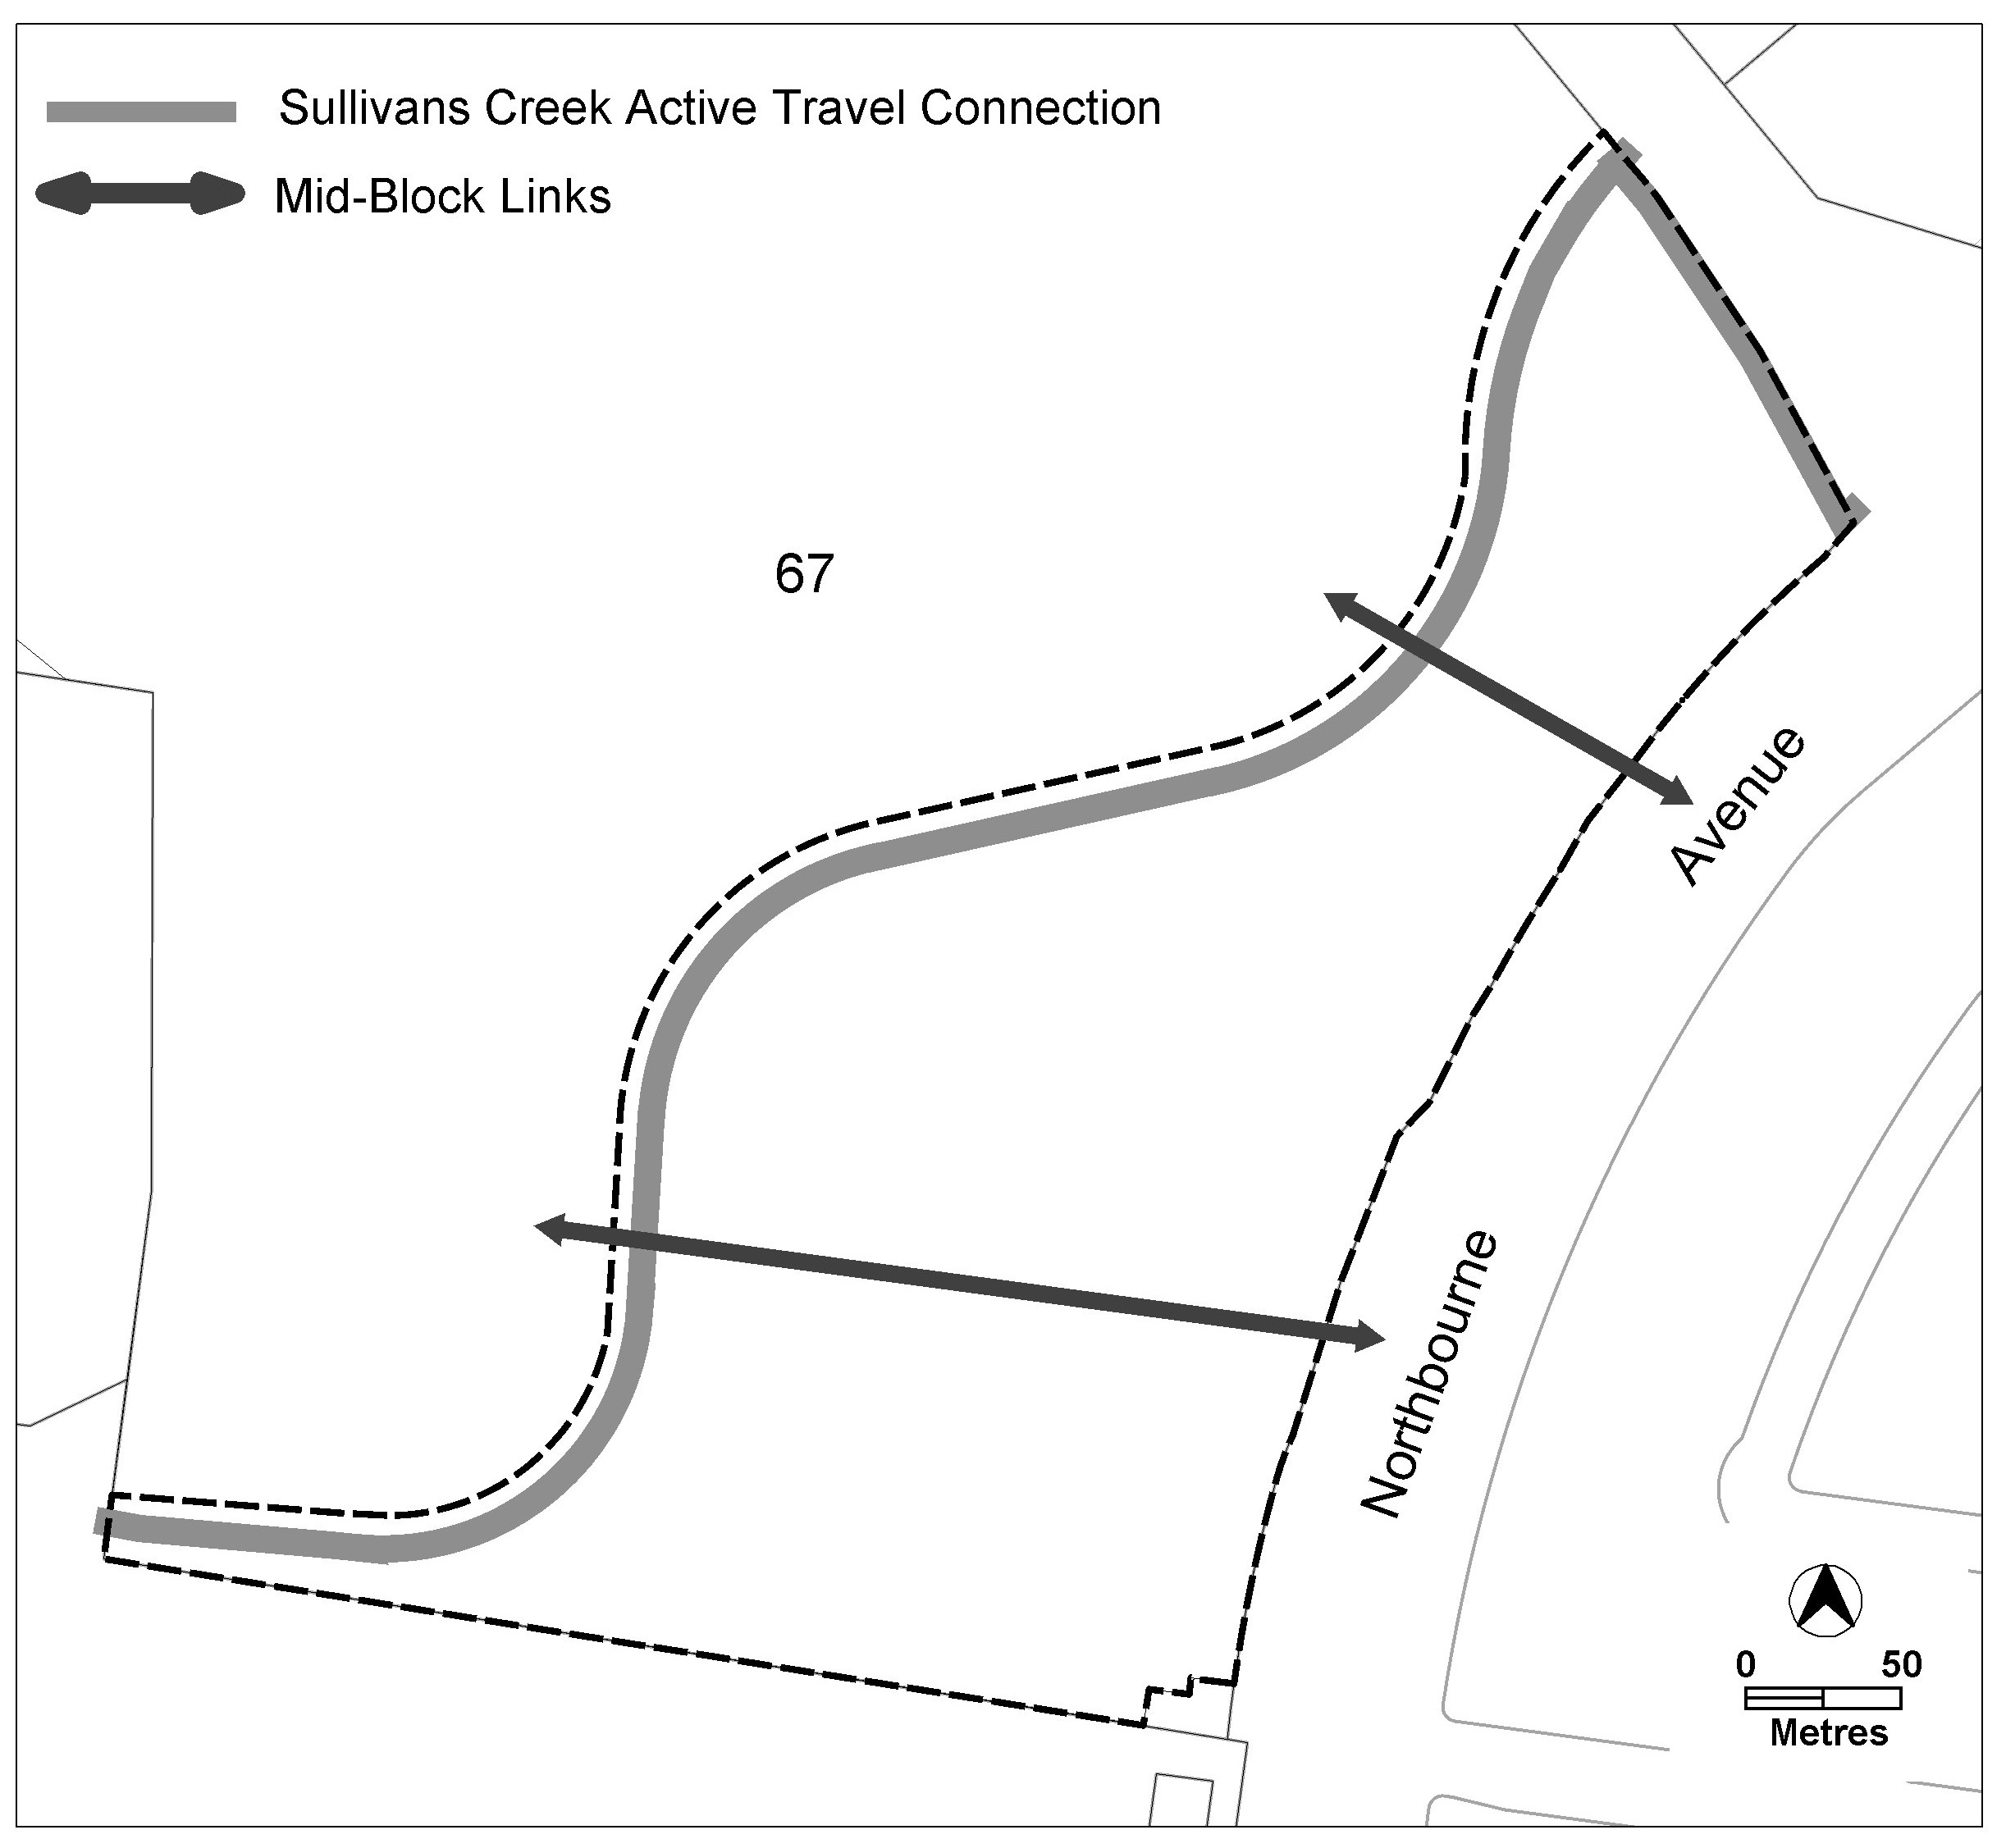

Figure 1 Mid-Block Links and Active Travel Connections

Rules | Criteria
  - Tree retention and canopy cover
There is no applicable rule. | Subdivision, block, building and site design demonstrates the following:  - retention of existing trees  - where shown that a) cannot be achieved, adequately replaced  Note: This criterion does not replace the provisions relating to tree protection in the relevant development code.
There is no applicable rule. | Development achieves all of the following:  - has or will achieve a minimum of 30% canopy tree cover across the RC1 area measured at a mature height  - inclusion of irrigation and maintenance systems to support canopy trees and ensure they remain a part of the development  - equitable distribution of canopy tree cover across the private and public realm within the RC1 area.  Note: existing trees contribute towards the minimum 30% canopy tree cover mentioned in a).
  - Block address
There is no applicable rule. | The size and subdivision pattern of blocks demonstrates that a building with a high quality and interesting façade can be accommodated which addresses the following:  - ‘open space areas’, mid-block links’ shown in Figure 1 and ‘internal pedestrian and bicycle network’ mentioned in C12  - ‘external active travel connections’ and block boundaries to Northbourne Avenue, Barton Highway, Sullivans Creek and the Swinden Street extension.
There is no applicable rule. | Dwellings provide a high quality, interesting façade by providing active or passive surveillance through the use of balconies, screened and unscreened windows and access stairs to address the following:  - ‘open space areas’, mid-block links’ shown in Figure 1 and ‘internal pedestrian and bicycle network’ mentioned in C12  - Sullivans Creek active travel connection and block boundaries to Northbourne Avenue, Barton Highway, Sullivans Creek and the Swinden Street extension.  Where a building contains multiple dwellings, which face the areas listed in a) and b), dwellings in a development predominately provide occasional surveillance rather than passive surveillance of those areas.
  - Educational facilities planning
A statement of acknowledgement from the ‘government agency responsible for future planning of educational enrolments and facilities’ is provided, which confirms that the following information has been provided:  - number and mix of dwellings that will be constructed per year  - estimated number of preschool, primary, high school and college students per development year  Note: for the purpose of this rule and associated criterion the ‘government agency responsible for future planning of educational enrolments and facilities’ is the Education Directorate or a future relevant agency that is responsible for these functions. | If a statement of acknowledgement is not provided the application will be referred to the government agency responsible for future planning of educational enrolments and facilities.

- Restrictions on use
Rules | Criteria
  - Number of dwellings
There is no applicable rule. | This criterion applies to multi-unit housing only.  Demonstrate that a minimum of 800 dwellings have already or will be provided across the RC1 area.
This rule applies to multi-unit housing only.  Total maximum number of dwellings across the RC1 area – 1000. | This is a mandatory requirement. There is no applicable criterion.
  - Retail
This rule does not apply to take-away food shop.  Total maximum gross floor area for all SHOP (including supermarket) across the RC1 area – 850m². | SHOP complies with all of the following:  - limited to a scale appropriate to providing convenience shopping and personal services for the local workforce and residents  - demonstrates that the amount of SHOP gross floor area provided across the RC1 area does not have a material adverse impact on surrounding local, group and town centres.
Total maximum gross floor area for all supermarkets across the RC1 area– 350m². | Supermarkets comply with all of the following:  - limited to a scale appropriate to providing convenience shopping and personal services for the local workforce and residents  - demonstrate that surrounding commercial centres are not adversely impacted  - demonstrate that the amount of supermarket gross floor area provided across the RC1 area does not have a material adverse impact on surrounding local, group and town centres.

Rules | Criteria
  - Commercial
Total maximum gross floor area across the RC1 area for all NON-RETAIL COMMERCIAL USE – 2000m². | This is a mandatory requirement. There is no applicable criterion.
There is no applicable rule. | This criterion applies if there is less than 1000m² of NON-RETAIL COMMERCIAL USE across the RC1 area.  Demonstrate that at least 1000m² of gross floor area of NON-RETAIL COMMERCIAL USE can and will be provided on site:  - directly through purpose-built buildings or spaces within buildings for NON-RETAIL COMMERCIAL USE  - providing ‘fully adaptable’ buildings or spaces within buildings  - a combination of a) and b).  For the purposes of this rule ‘fully adaptable spaces’ demonstrate:  - ability to cater for a wide variety of NON-RETAIL COMMERCIAL USE  - ability to have compliant, efficient and convenient services, goods and waste facilities and areas  - commercial grade and flexible façade design.
  - Food and Entertainment
Total maximum gross floor area for all take-away food shop, restaurant and drink establishment across the RC1 area – 550m².  Note: This rule also applies where take-away food shop, restaurant and drink establishment are considered an ancillary use. | Scale of development appropriate to providing convenient services for the local workforce and residents.  Take-away food shop, restaurant and drink establishment complies with all of the following:  - limited to a scale appropriate to providing convenience shopping and personal services for the local workforce and residents  - demonstrate that the amount of combined take-away food shop, restaurant and drink establishment gross floor area provided across the RC1 area does not have a material adverse impact on surrounding local, group and town centres.
  - Community Use
There is no applicable rule. | Development must demonstrate all of the following:  - a minimum gross floor area of 1500m² of COMMUNITY USE has already and/or will be provided across the RC1 area  - actual, proposed or indicative location/s for COMMUNITY USES are shown as mentioned in a).
  - Non-RESIDENTIAL USE – ground floor
Where non-RESIDENTIAL USE occurs, they are located at ground floor level. | Non-RESIDENTIAL USE located at upper floor levels complies with all of the following:  - may only occur where the floor below and the ground floor level of the building have a non-RESIDENTIAL USE  - where it is demonstrated that buildings in areas mentioned in C8 already have or will have a non-residential ground floor  - provide at least two of the following:  - direct, inviting and legible pedestrian access  - a passive and active surveillance of nearby internal and external public areas  - an interesting and activated address and façade to all nearby internal and external public areas which represents its non-RESIDENTIAL nature.

- Building controls and design
Rules | Criteria
  - National Capital Plan
This rule applies to development which is subject to the National Capital Plan  Development applications are supported by written documentation demonstrating compliance against the relevant special requirements of the National Capital Plan. | This is a mandatory requirement. There is no applicable criterion.
  - Height of building
The height of building is:  - minimum height of building fronting Northbourne Avenue – 14.5m  - minimum number of storeys for a building fronting Sullivans Creek – 2  - maximum height of building – 18m  For the purpose of this rule and associated criterion height of building means the vertical distance between datum ground level at the front boundary to Northbourne Avenue and the highest point or points of the building. Where there is a culvert or other localised earthworks impacting the datum ground level of the front boundary to Northbourne Avenue the datum ground level is normalised five metres either side of a culvert or localised earthworks. | ‘Minor building elements’ may exceed the maximum height of building where they do not increase the scale of the building when viewed from a public street.  The minimum height of building is a mandatory requirement. There is no applicable criterion.  For the purpose of this criterion ‘minor building elements’ include but are not limited to rooftop plant, photo-voltaic panels, antennas, pergolas and rooftop garden structures. Habitable room, or part thereof, are not ‘minor building elements’.
There is no applicable rule. | Generally, a smooth transition of building heights across the RC1 area is provided with:  - higher buildings predominately located in close proximity to the Swinden Street light rail stop and secondarily along Northbourne Avenue  - lower buildings predominantly located along Sullivans Creek.

Rules | Criteria
  - Front boundary setback
This rule applies to the following front boundaries:  - Barton Highway  - proposed, approved or built Swinden Street extension  Minimum front boundary setback – 6m.  Note: The front boundary setback to Northbourne Avenue is contained within the National Capital Plan. | This is a mandatory requirement. There is no applicable criterion.
There is no applicable rule. | This criterion does not apply to development mentioned in C2.  The minimum setback from Sullivans Creek stormwater easement to development provides all of the following:  - adequate space for development in C1  - a minimum setback (whichever is greater):  - 6 metres  - as recommended by the TCCS endorsed flood risk study mentioned in R4
  - Building separation
This rule applies to Area A shown in Figure 2. Area A applies to land contained with the site that is greater than 200m from the centreline of Northbourne Avenue.  Minimum separation distances between:  - a dwelling and another dwelling or non-RESIDENTIAL USE both on the subject block – Table 1  - a dwelling or non-RESIDENTIAL USE on the subject block to a dwelling or non-RESIDENTIAL USE on an adjacent block – half the minimum separation distance stated in Table 1, measured from the common boundary or boundaries between the blocks  For the purpose of this rule and associated criterion, building separation is measured to the outer face of external walls, external windows or outer edge of balconies where relevant.  Notes:  1. This rule replaces building separation requirements in the relevant development code.  2. Building separation provisions for the area outside Area A are contained within the National Capital Plan. | Building separation may be reduced where the building complies with all of the following:  - reasonable levels of visual and acoustic privacy  - suitable areas for soft landscaping and deep root planting between buildings.

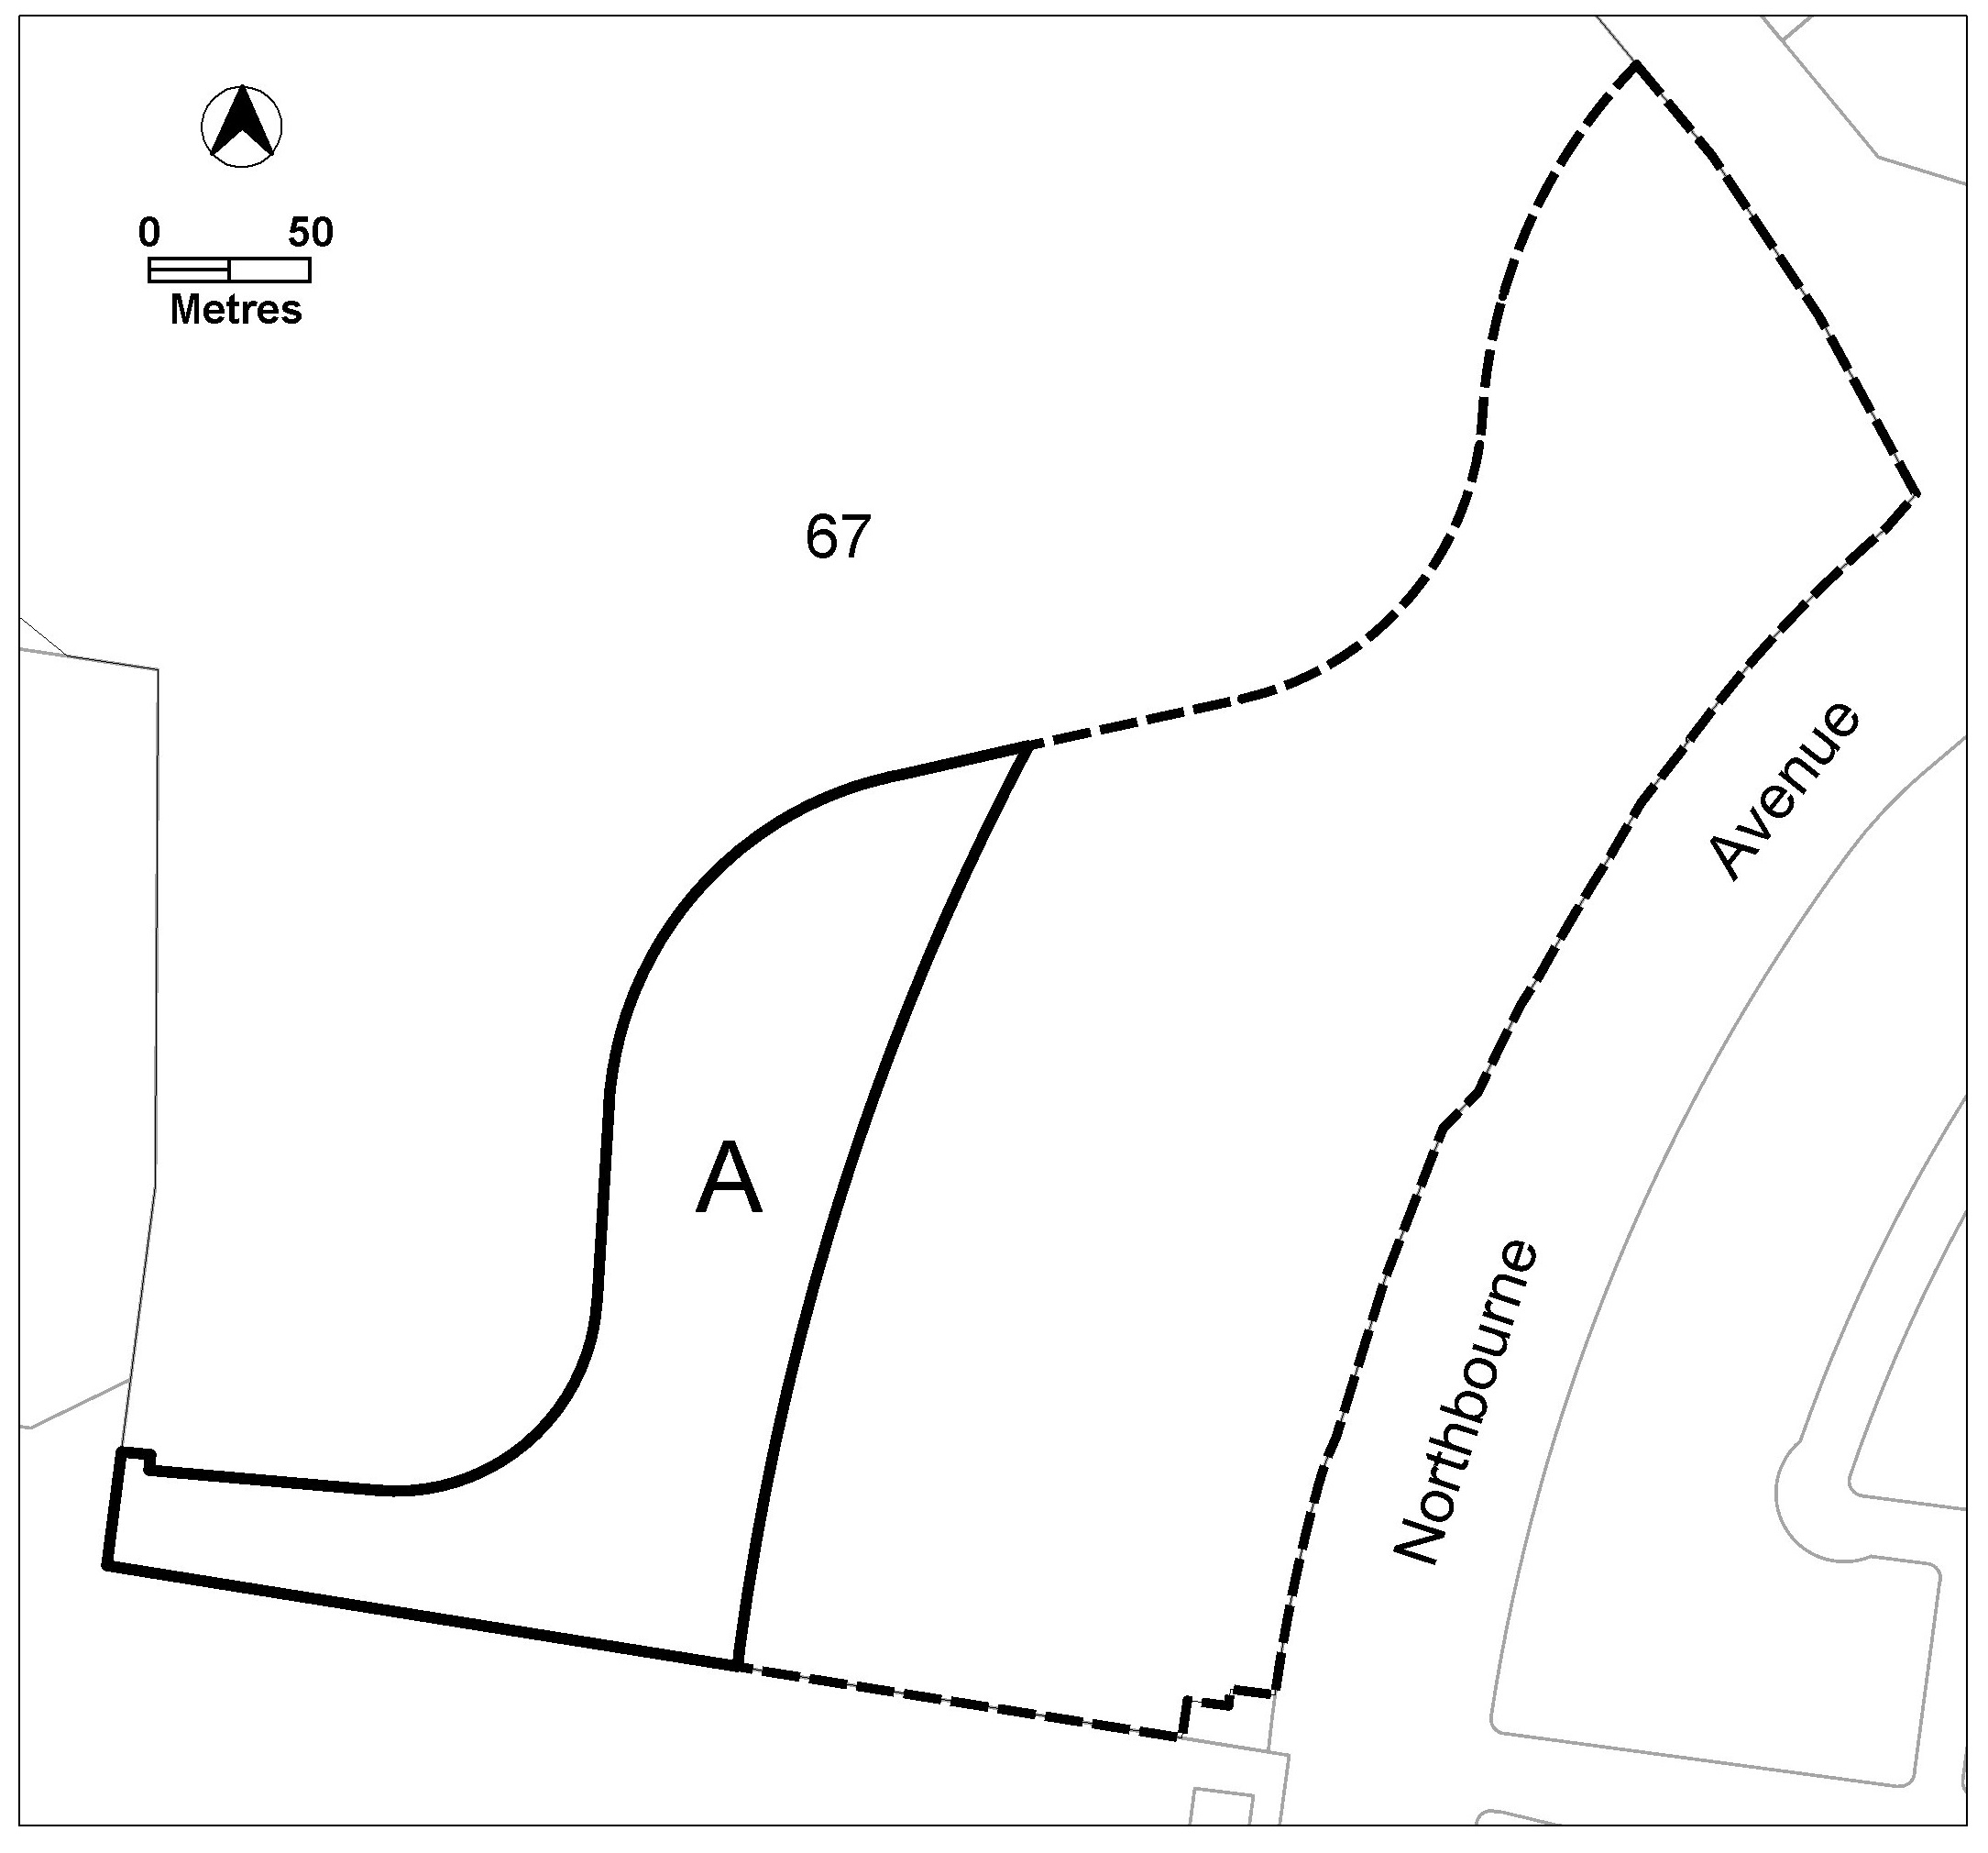
Figure 2 Areas not covered by the National Capital Plan

Table 1 Minimum building separation
Number of storeys | Between windows in habitable rooms/unscreened balconies | Between windows in habitable rooms/unscreened balconies and windows in non-habitable rooms | Between windows in non-habitable rooms
Up to 4 storeys | 12 metres | 9 metres | 6 metres
5 to 8 storeys | 18 metres | 12 metres | 9 metres

Rules | Criteria
  - Floor to ceiling heights
This rule applies to Area A in Figure 2. Area A applies to land contained with the site that is greater than 200m from the centreline of Northbourne Avenue.  Minimum finished floor level to ceiling heights are as follows:  - storey of dwelling containing the main daytime living area – 2.7m  - non-habitable rooms in a dwelling – 2.4m  - non-residential development – 3.3m  Note: finished floor level to ceiling heights for the remainder of the RC1 area are contained within the National Capital Plan. | This is a mandatory requirement. There is no applicable criterion.
  - Building address
There is no applicable rule. | This criterion applies to a frontage of a building which faces one or more of the following:  - an ‘open space area’ or ‘mid-block link’ shown in Figure 1  - the internal pedestrian and bicycle network connections mentioned in C12  - Northbourne Avenue, Barton Highway, Sullivans Creek and/or Swinden Street extension.  The building frontage complies with all of the following:  - provides passive surveillance  - provides a high quality and interesting façade which activates and addresses the area  - provides direct pedestrian and bicycle access from the building, all ground floor dwellings and communal open space to all adjoining ‘open space areas’, ‘mid-block links’, ‘internal pedestrian and cycle network connections and/or ‘Sulllivans Creek active travel routes’.
  - Building Length
Buildings are no more than 55m in length and width at their longest/widest point. | Buildings exceeding 55m in length and/or width comply with all the following:  - strong design justification  - provide continuous active street frontage  - at least every 55 metres of building, provide a pedestrian link between 5 and 10 metres wide.
  - Pedestrian shelters
Awnings, canopies or colonnades are provided at each active travel entrance to a building and each active travel path along a building edge. | Awnings, canopies or colonnades achieve all of the following:  - provide protection from natural elements along buildings and building entrances  - are integrated with the design of the building.
  - Internal dwelling and building design
Habitable rooms comply with the following:  - master bedrooms have a minimum area of 10m² and other bedrooms 9m² (excluding wardrobe space)  - bedrooms have a minimum dimension of 3m (excluding wardrobe space)  - living rooms or combined living/dining rooms have a minimum width of:  - 3.6m for studio and 1 bedroom apartments  - 4m for 2 or more bedroom apartments  - the width of cross-over or cross-through dwellings are at least 4m internally to avoid deep narrow dwelling layouts. | Habitable rooms are of a size suitable to accommodate the daily activities of their occupants and visitors.
Habitable rooms limit depth to a maximum of 2.5m x the ceiling height. In open plan layouts (where the living, dining and kitchen are combined) the maximum habitable room depth is 8m, measured from an external window. | Habitable room depth may increase where finished floor level to ceiling height are above the minimum permitted, provided reasonable solar access to each habitable room is maintained.
The minimum gross floor area for a dwelling is:  - Studio – 40m²  - 1 bedroom – 50m²  - 2 bedroom – 70m²  - 3 bedroom – 100m²  - each additional bedroom after the 3rd – 12m²  - Each bathroom after the first – 5m²  The minimum area mentioned in a), b), c) and d) includes one bathroom. | This is a mandatory requirement. There is no applicable criterion.
  - Housing diversity
There is no applicable rule. | Buildings contain a variety of dwelling designs such as dual aspect apartments, shallow apartment layouts and two storey dwellings.
Demonstrate the following has already or will be provided across the RC1 area:  - not less than 320 two-bedroom dwellings  - not less than 160 three or more bedroom dwellings | This is a mandatory requirement. There is no applicable criterion.

- Site controls and design
Rules | Criteria
  - Landscape design – Deep soil zones
There is no applicable rule. | Deep soil zones are provided and comply with all of the following:  - minimum horizontal dimension of 5m  - incorporate any protected trees  - allow for the development of healthy root systems and provide anchorage and stability for mature trees  - co-located near deep soil zones on adjacent blocks and sites where possible.
  - Courtyard Walls
There is no applicable rule. | This criterion applies to courtyard walls for dwellings which have their private open space at ground floor level fronting Northbourne Avenue and Sullivans Creek ‘external active travel route’.  Courtyard walls comply with all of the following:  - not higher than 1.8m above datum ground level  - non-transparent components not higher than 1m above datum ground level  - constructed of high-quality materials, specifically excluding pre-coloured metal, unfinished timber panels, chain-link, barbed or razor wire  - integrated with landscaping  - designed and constructed to match or compliment the design of the associated building  - not occupy more than 40% of the façade at ground floor level.  Note: This criterion replaces the relevant rules and criterion relating to courtyard walls in the relevant development code.

- Amenity

Rules | Criteria
  - Solar Access – apartments
This rule applies to apartments only.  Not more than 15% of apartments within a development receive no direct sunlight between 9am and 3pm on the winter solstice (21 June).  Note: This rule applies in addition to the relevant provisions relating to solar access for apartments in the relevant development code. | This is a mandatory requirement. There is no applicable criterion.
This rule applies to all dwellings.  Habitable rooms have an operable window in an external wall with a total minimum glass area of not less than 15% of the gross floor area of the relevant habitable room.  Note: connecting habitable rooms to operable windows in external walls via a corridor, also known as a ‘snorkel’ arrangement, does not satisfy the requirement of this rule. | This is a mandatory requirement. There is no applicable criterion.
  - Solar Access to adjoining development
This rule applies to buildings of more than three storeys.  Buildings do not reduce the hours of direct sunlight between 9am-4pm on the winter solstice to any habitable room in any adjoining residential or COMMERCIAL ACCOMMODATION developments to less than 2 hours. | Reasonable solar access for adjoining residential or COMMERCIAL ACCOMMODATION developments is achieved.
  - Principal private open space
This rule applies to multi-unit housing and RESIDENTIAL USE components of commercial mixed use.  Each dwelling has at least one area of principal private open space that complies with all of the following:  - minimum area and dimensions as specified in Table 2  - maintains visual privacy of the occupants from adjoining public streets and public open space  - is directly accessible from, and adjacent to, a habitable room other than a bedroom  - is not located to the south, south-east or south-west of the dwelling, unless it achieves one or more of the following:  - not less than 3 hours of direct sunlight onto 50% of the minimum required area between the hours of 9am and 3pm on the winter solstice (21 June)  - located at an upper floor level and overlooks a public street, public open space. | This is a mandatory requirement. There is no applicable criterion.

Table 2 Principal private open space area requirements
Type | dwellings wholly or partially at lower floor level or on a podium or similar structure |  | dwellings located entirely on an upper floor level
 | minimum area | minimum dimension | minimum area | minimum dimension
studio apartment | 18m² | 4m | 4m² | nil
1 bedroom dwelling | 24m² | 4m | 8m² | 2m
2 bedroom dwelling | 24m² | 4m | 10m² | 2m
3 or more bedroom dwelling | 36m² | 6m | 12m² | 2m

Rules | Criteria
  - External facilities
There is no applicable rule. | This criterion applies to apartments.  Development complies with all of the following:  - storage units and plant equipment (including air-conditioning plant) are not permitted on balconies  - clothes drying facilities are only permitted on balconies when they are screened from view of streets and public areas.
  - Noise
There is no applicable rule. | This criterion applies to dwellings on the block and dwellings on adjoining blocks.  Transfer of noise between noise sources and habitable rooms, particularly bedrooms, are minimised through the siting, design and layouts of buildings.  For the purpose of this criterion noise sources include, but are not limited to, garage doors, driveways, service areas, plant rooms, building services, mechanical equipment, communal open space and circulation areas.
- Parking and vehicular access

Rules | Criteria
  - Vehicular access
There is no applicable rule | Vehicular access to individual development, including crossovers and driveways, are designed and constructed to be co-located/shared with adjoining current or future development.
There is no applicable rule. | Vehicular access arrangements comply with all of the following:  - ensure pedestrian and bicycle priority and desire lines and paths are maximised  - the width of the vehicular access is minimised  - materials integrate with relevant landscaping  - contain high quality public realm treatments that add visual interest, including tree planting, landscaping, materials, footpaths and lighting.  Note: This criterion, particularly b), does not replace TCCS requirements, standards and endorsements relating to waste collection and service vehicles.
There is no applicable rule. | Pedestrian and cyclist access to blocks are clearly separated from vehicular access and be distinguishable through surface materials, level changes, landscaping and/or slow-speed shared pedestrian road zones.
  - Parking
This rule applies to multi-unit housing.  The maximum parking provision rate is:  - studio or one-bedroom dwelling – 1 space maximum  - two-bedroom dwelling – 1.3 spaces maximum  - three or more bedroom dwelling – 1.5 spaces  - every 8 dwellings – 1 visitor space  Notes:  1. Minimum and maximum parking provision rates contained within the relevant development or general codes do not apply.  2. Parking calculations are rounded up to the nearest whole number. | This is a mandatory requirement. There is no applicable criterion.
There is no applicable rule. | Visitor car parking spaces are conveniently located for visitors to the development and are not allocated to any other purpose, including private spaces for dwellings or workers of the commercial components of the development.
There is no applicable rule. | Adequate spaces and areas, suitably screened from public view, are provided for the loading and unloading of service vehicles.
  - Parking structures
Vehicle parking is only permitted in a basement. On-grade, podium or other above ground vehicle parking is not permitted. | On grade, podium or other above ground parking is only permitted where the following is met:  - the parking area is located away from Northbourne Avenue and the Swinden Street extension and suitably screened through use of buildings, communal open space area, private open space and/or landscaping.  - on-grade car parking complies with all of the following:  - is incorporated into the landscape design for the block  - incorporates the use of materials, including permeable or light coloured paving, to prevent an increase of surface temperature  - includes shade trees planted at least every 5 vehicle spaces to reduce car park surface temperature.

- Environment

Rules | Criteria
  - Erosion and sediment control
For sites less than 3,000m², the development complies with the Environment Protection Authority Environment Protection Guidelines for Construction and Land Development in the ACT.  Note: If no evidence of compliance with the above guideline is provided, the application may be referred to the relevant agency in accordance with the requirements of the Planning and Development Act 2007. | This is a mandatory requirement. There is no applicable criterion.
  - Environmental assessment
An environmental assessment report for the development is endorsed by the Environment Protection Authority.  Note: A condition of development approval may be imposed to ensure compliance with the endorsed site assessment report. | This is a mandatory requirement. There is no applicable criterion.
  - Environmentally sustainable design
There is no applicable rule. | The development incorporates measures recommended by an environmentally sustainable design (ESD) assessment undertaken by a ‘suitably qualified professional’.  The assessment must consider ESD principles and best practice ESD, which at a minimum must include:  - energy efficiency, including passive design  - water efficiency  - reducing greenhouse gas emissions  - active and sustainable transport,  - living infrastructure  - urban design, including building materials and finishes.  All recommended measures determined by the assessment are:  - not inconsistent with the relevant development and general codes of the Territory Plan  - identified on plans and endorsed by the relevant authority to ensure delivery and retention as a feature of the development.  For the purpose of this criterion a ‘suitably qualified professional’ is a person with qualifications, experience and/or skills relevant to ESD and the requirements of the Guideline.  Note: The Planning and Land Authority may consult with EPSDD Climate Change and Sustainability (or future relevant agency responsible for the same functions) when determining compliance with this criterion.
  - Microclimate
There is no applicable rule. | The development incorporates mitigation measures recommended by a microclimate assessment undertaken by a ‘suitably qualified professional’ The assessment must identify the urban heat risk factors that apply to the site and recommend appropriate urban heat mitigation measures.  All recommended measures determined by the assessment are:  - not inconsistent with the relevant development and general codes of the Territory Plan  - identified on plans and endorsed by the relevant authority to ensure delivery and retention as a feature of the development.  For the purpose of this criterion a ‘suitably qualified professional’ is a person with qualifications, experience and/or skills, relevant to urban climate science, urban heat modelling and microclimate assessment.  Note: The Planning and Land Authority may consult with EPSDD Climate Change and Sustainability (or future relevant agency responsible for the same functions) when determining compliance with this criterion.

Rules | Criteria
  - Permeability
This rule applies to at least one of the following:  - development on sites greater than 2000m² involving works that have potential to alter the stormwater regime for the site  - development within existing urban areas that increase the impervious area of the site by 100m² or more.  Development achieves all of the following:  - minimum of 30% of the site area to be permeable.  - generally equitable distribution of permeability across the RC1 area.  This rule and associated criterion overrides rules and/or criteria that require a percentage of an individual development site area to be permeable.  Note: Compliance with this rule and associated criteria is demonstrated through a report from a ‘suitably qualified professional’ consistent with the methods specified in the ACT Practice Guidelines for Water Sensitive Urban Design. | It is demonstrated that the development of the RC1 area achieves all of the following:  - increases permeable surfaces and living infrastructure though green spaces  - plants that require irrigation are supported by sustainable water systems such as onsite stormwater harvesting to achieve microclimate benefits  - promotes evapotranspiration to mitigate extreme temperatures, improve air humidity and overall human comfort  - equitable distribution of a), b) and c) across both the public and private realms of the RC1 area.
  - Heritage
An ‘Unanticipated Discovery Protocol’ which includes assessment and management of any unexpected heritage discoveries during construction is endorsed by the ACT Heritage Council.  Note: A condition of development approval may be imposed to ensure compliance with this rule. | If an ‘Unanticipated Discovery Protocol’ endorsed by ACT Heritage council is not provided the application will be referred to the ACT Heritage Council.

- Waste management

Rules | Criteria
  - Post occupancy waste management
Facilities for waste disposal, recycling and composting:  - complies with the Development Control Code for Best Practice Waste Management in the ACT 2019  - are suitably screened from public view.  Note: This rule does not replace the provisions relating to post occupancy waste management endorsement in the relevant development code. | This is a mandatory requirement. There is no applicable criterion.

